Web and Social Media Search and Analysis
Machine Translation Discourse on Bluesky
Bachelor of Science in Artificial Intelligence
Web and Social Media Search and Analysis - Prof. Marco Viviani
Authors: Linda Stalidzane, Pelinsu Topaloglu

1. Objective
Machine translation (MT) tools such as DeepL and Google Translate, along with LLM-based translation, have become part of everyday language work — used by casual social media users, professional translators, and developers alike. This project studies how Bluesky, a decentralized social network, talks about machine translation: whether it is framed as a helpful tool, a threat to professional translators, or both, and whether this framing differs between people who work in translation/localization and the general public.
Posts were collected around a fixed set of MT-related keywords and hashtags over a 12-month window, and analyzed along two complementary axes:
- Network Analysis — who talks to whom (centrality, community detection).
- Content Analysis — what is actually being said (sentiment, emotion, named entities).
The three guiding research questions, used throughout both analyses, are:
- RQ1 — Sentiment & framing: do people talk about MT as a tool, a threat, or both?
- RQ2 — Professional impact discourse: how do working translators discuss MT's effect on their careers, compared to the general public?
- RQ3 — Utility vs. displacement tension: do people acknowledge MT's utility while lamenting professional erosion?

2. Data

2.1 Collection strategy
Data was collected from Bluesky via the official API (Python atproto client), following a four-step pipeline:
- Seed search: a fixed list of text queries, compound queries, and hashtags (below) was searched over the last 12 months, sorted by recency.
- Thread crawl: each seed post's thread was crawled (up to depth 4) to recover reply structure, which is needed to build the reply network.
- Author/follower crawl: for authors with more than one collected post, their profile and up to 100 follower relationships were fetched, to build the follow network.
- Deduplication: posts and edges were deduplicated across all sources into the final dataset.
Seed queries used:
- Text queries: "machine translation", "AI translation", "post-editing", "human translation", "translation quality", "translator jobs", "translation industry", "DeepL", "MTPE", "neural machine translation"
- Compound queries: "post-editing" AI, "AI translation" threat, scraped translation, "machine translation" slop, "human translator" AI, "translation industry" AI
- Hashtags: #machinetranslation, #MTPE, #localization, #l10n, #SlowTranslation, #HumanTranslation, #PauseAI, #NoAI
The API client includes retry/backoff handling for rate limits (HTTP 429), and extracts hashtags, mentions, and links from each post's rich-text facets.

2.2 Preprocessing and labeling
Cleaning: post text has URLs stripped and whitespace normalized; posts with fewer than 10 characters of cleaned text are dropped.
Topical relevance filtering: because several seed queries (e.g. #localization, #PauseAI, #NoAI) can return off-topic posts, a keyword filter is applied requiring at least one of a fixed set of MT-related terms (translat*, interpret*, locali*e*, deepl, mtpe, post-edit, language model, nlp, multilingual, linguist, terminology, glossary) to appear in the cleaned text.
Author type labeling: each author is labeled general / professional / tech from their Bluesky bio, using a keyword match — professional if the bio contains translator/interpreter/localizer/linguist/terminology/lexicographer/subtitler/transcriber-related terms, tech if it contains developer/engineer/NLP/ML/researcher-related terms (checked only if no professional terms matched), general otherwise.
Limitation to note in the report: this is a simple keyword-over-bio heuristic, not a validated classifier — a professional translator whose bio doesn't mention their profession would be labeled "general". No manual validation of label accuracy was performed.

2.3 Final dataset
After collection, cleaning, and topical filtering, the dataset used for analysis is:
Artifact | Rows | Description
posts_clean.csv | 3,767 | Final cleaned, topically-filtered posts (June 2025 – June 2026)
author_profiles.csv | 1,009 | Author profiles (bio, followers, following, post count)
follow_edges.csv / graph.csv | 118,701 | Follow relationships between collected authors
reply_edges.csv | 4,479 | Reply relationships (raw, pre-resolution)
seeds.csv | 3,765 | Seed posts returned directly by the search queries

Author-type breakdown of the 3,767 posts:
User type | Posts | Share
general | 3,118 | 82.8%
professional | 530 | 14.1%
tech | 119 | 3.2%

2,133 posts (56.6%) are replies and 1,634 (43.4%) are top-level posts. Note the strong class imbalance between user types — all cross-group comparisons in this report use rates/proportions rather than raw counts for this reason.

3. Models

3.1 Network Analysis Models
[TO BE COMPLETED — network analysis (degree/betweenness/closeness centrality; Louvain, Greedy Modularity, FluidC and Girvan-Newman community detection) was carried out by [groupmate] in analysis.ipynb. Not included in this draft since it is not this author's work — see analysis.ipynb directly for the implementation.]

3.2 Content Analysis Models
For both sentiment and emotion, two methodologically different tools were deliberately used and cross-checked against each other, rather than trusting a single method — this surfaced real, reportable limitations in the lexicon-based tools (see Results).

Sentiment analysis
- VADER (Valence Aware Dictionary and sEntiment Reasoner) — lexicon- and rule-based, tuned for social media text (negation, punctuation emphasis, intensifiers). Produces a compound score in [-1, 1], bucketed into positive (≥0.05) / neutral / negative (≤-0.05).
- cardiffnlp/twitter-roberta-base-sentiment — a RoBERTa transformer fine-tuned on tweet sentiment (3-way: negative/neutral/positive), which reads full sentences instead of scoring words independently.

Emotion analysis
- NRCLex — dictionary-based, using the NRC Word-Emotion Association Lexicon (Plutchik's 8 basic emotions: fear, anger, anticipation, trust, surprise, sadness, disgust, joy). Each post's dominant emotion is the argmax of its per-word affect frequencies.
- j-hartmann/emotion-english-distilroberta-base — a DistilRoBERTa transformer fine-tuned for emotion classification (anger, disgust, fear, joy, neutral, sadness, surprise), sharing 6 of its 7 labels with NRCLex.
Methodological note: comparing the two emotion tools by restricting both to only the shared 6 labels (i.e. filtering out posts where NRCLex's dominant emotion is trust or anticipation) would introduce selection bias, since trust/anticipation are NRCLex's single most common calls. The comparison in this report instead conditions only on the transformer's output, then checks what NRCLex independently says about those same posts — this avoids manufacturing artificial agreement.

Named entity recognition
- spaCy (en_core_web_sm) — pretrained English NER pipeline, used to extract ORG, PRODUCT, PERSON, and GPE entities from post text.
- A curated list of known MT tools/companies (DeepL, Google Translate, Google, Amazon, Microsoft, YouTube, Mozilla Localization, ChatGPT, OpenAI, GPT, Meta, Claude) was additionally cross-referenced against the raw NER output, since the generic model mis-tags several domain acronyms (see Results, Limitations).

4. Results

4.1 Network Analysis Results
[TO BE COMPLETED — centrality rankings, community detection comparison, and network visualizations from analysis.ipynb, by [groupmate].]

4.2 Content Analysis Results

4.2.1 Sentiment Analysis
Overall, VADER classifies the discourse as 51.1% positive, 21.1% neutral, 27.8% negative:
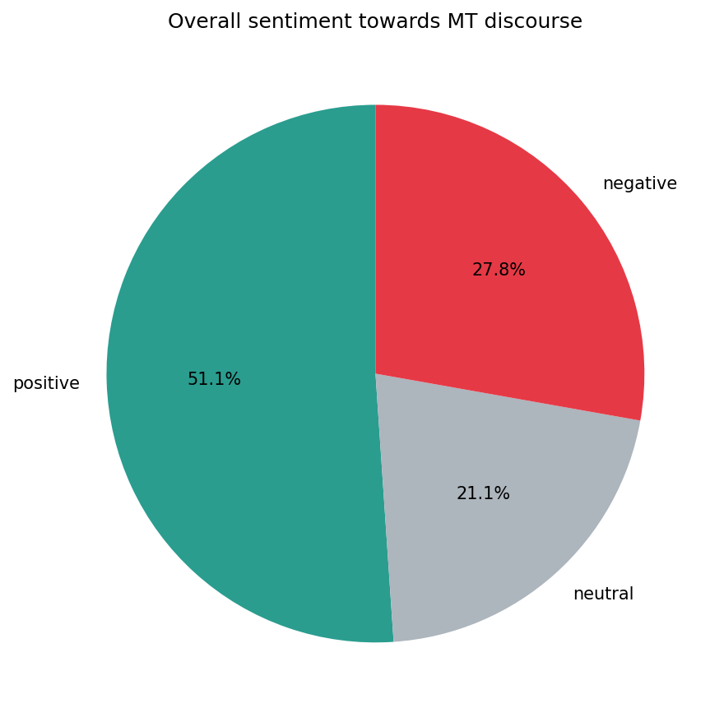
Figure 1 — Overall VADER sentiment distribution (n = 3,767 posts).
By user type, professionals are (slightly) the most positive group on average, not the most negative — consistent with acknowledging MT's day-to-day utility even while being most exposed to its downsides:
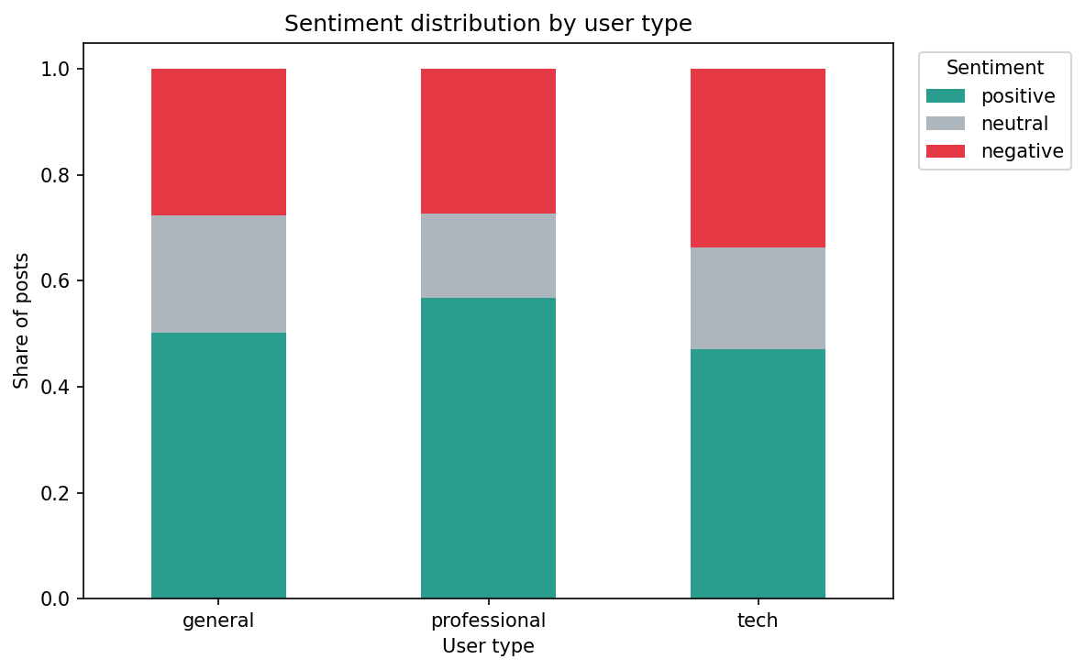
Figure 2 — VADER sentiment distribution by user type.
User type | Mean compound | Median compound | Posts
general | 0.138 | 0.052 | 3,118
professional | 0.196 | 0.266 | 530
tech | 0.097 | 0.000 | 119

Comparing VADER against the RoBERTa transformer model reveals the two disagree substantially — only 54.0% agreement, with 426 posts (11.3%) in outright opposite-polarity disagreement. RoBERTa's distribution is markedly less positive (23.0% positive / 46.5% neutral / 30.5% negative):
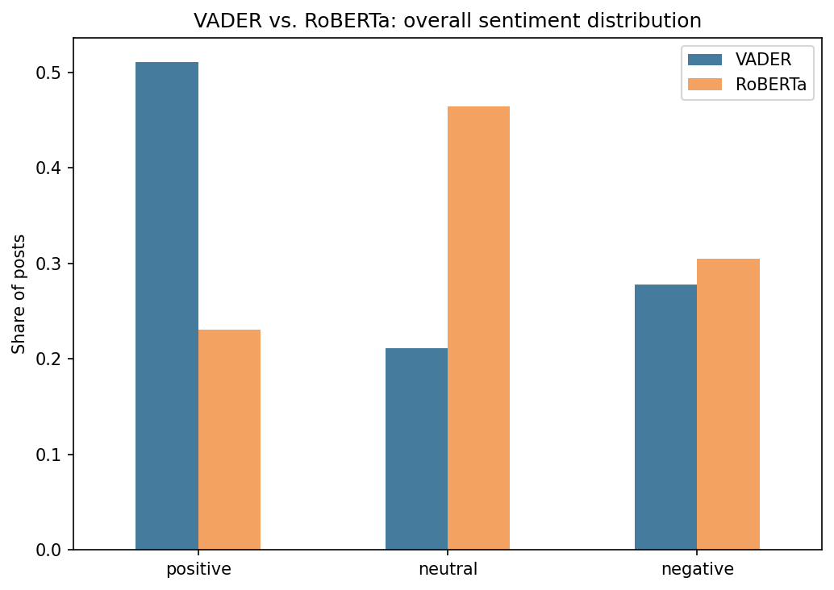
Figure 3 — VADER vs. RoBERTa overall sentiment distribution.
Manual inspection of disagreements shows a consistent pattern: VADER is fooled by individually-positive words in otherwise critical or sarcastic posts. For example, VADER scored “Google Translate is the laughing stock of the professional translation industry” as positive (no obviously “negative” words), while RoBERTa correctly read it as negative. This suggests RoBERTa's more balanced, less-positive distribution is the more trustworthy read of the discourse — the framing of MT is genuinely mixed, not predominantly positive as VADER alone would suggest.
Sentiment also varies over the 12-month collection window (VADER, monthly mean compound score):
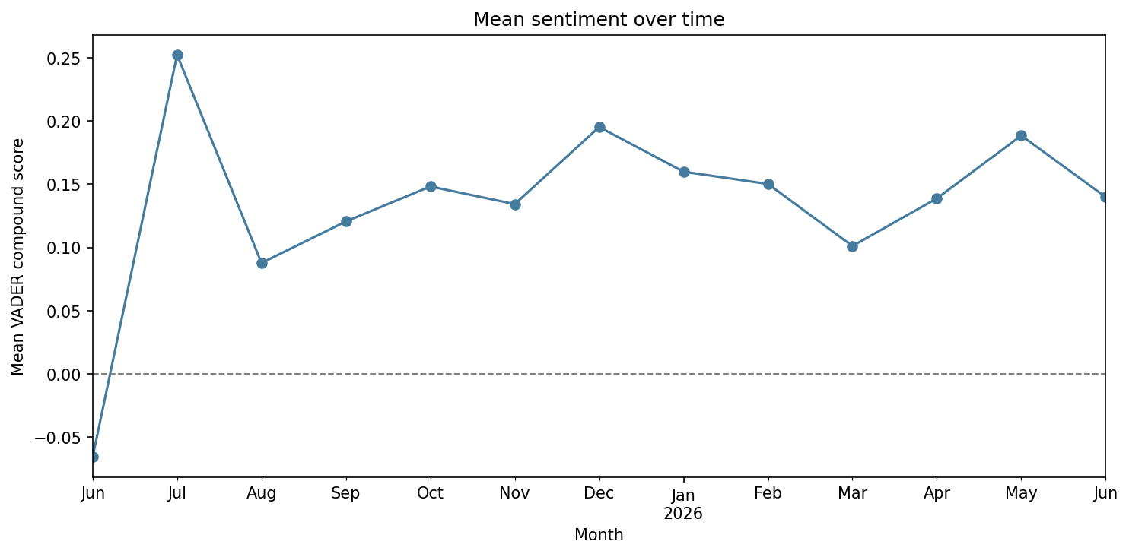
Figure 4 — Mean VADER sentiment by month.

4.2.2 Emotion Analysis
NRCLex's overall emotion profile is dominated by trust (mean affect frequency 0.262), well above every other category:
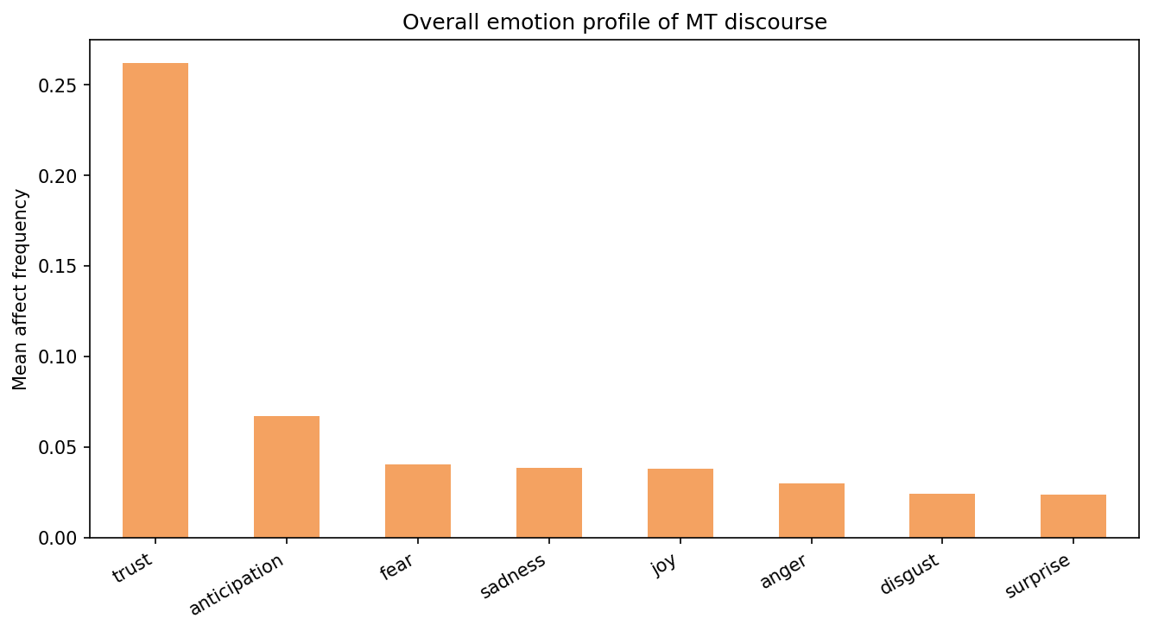
Figure 5 — Overall NRCLex emotion profile (mean affect frequency).
Differences between user types are small relative to the tool-to-tool differences described below — i.e. which emotion detector is used matters more here than which audience is examined:
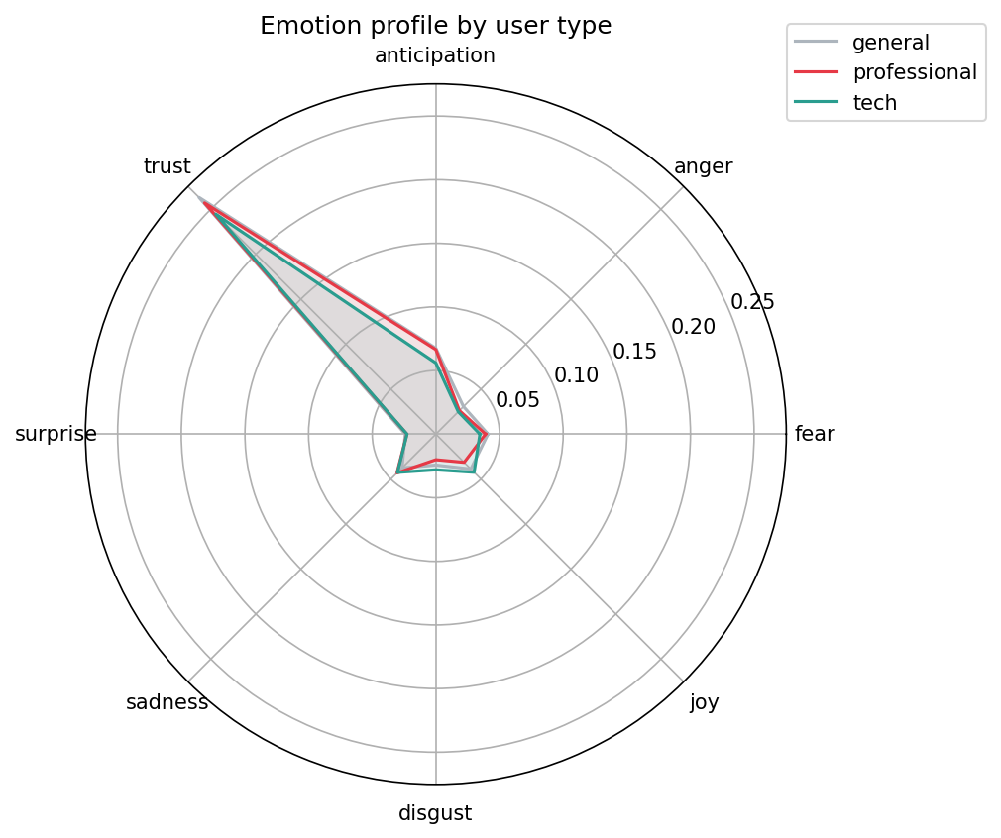
Figure 6 — NRCLex emotion profile by user type.
Looking at NRCLex's per-post dominant emotion (not just the mean), trust (49.1%) and fear (32.8%) together account for the large majority of posts, with anticipation a further 10.9% — every other emotion is under 4%. Comparing against DistilRoBERTa (whose dominant call is neutral for 56.0% of posts) shows the same pattern holds even when conditioning on posts where the transformer is confident enough to name a specific, non-neutral emotion: on that 44.0%-of-posts subset, NRCLex still calls trust 47.6% and fear 30.2% of the time, and the two tools agree on only 15.9% of posts:
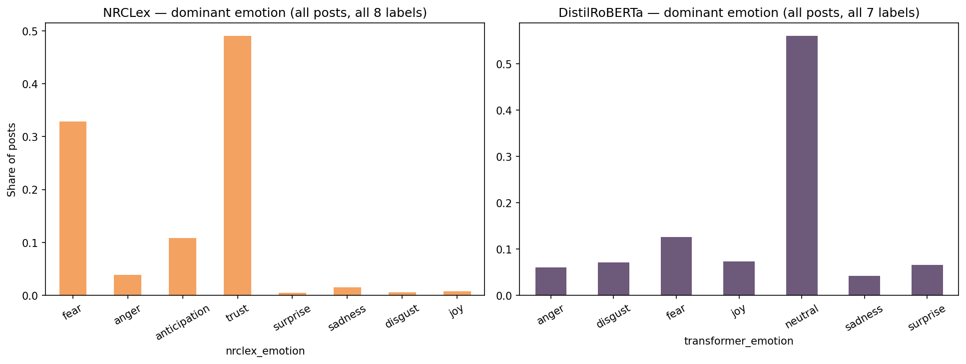
Figure 7 — NRCLex vs. DistilRoBERTa dominant-emotion distributions (each on its own full label set).
This indicates NRCLex's dominant-emotion output is close to invariant to what a post actually says — consistent with “trust” being an oversized category in the NRC lexicon that fires on ordinary vocabulary rather than genuine trust-related content. As a result, this report treats the sentiment comparison (RQ1) as the more reliable evidence for framing, and the emotion analysis as exploratory/secondary given this tool limitation.

4.2.3 Named Entity Recognition
spaCy extracted 5,481 entities in the tracked categories (ORG 2,497, PERSON 1,894, GPE 966, PRODUCT 124). The most frequently mentioned organizations/products are shown below — several of these (MTPE, LLM, MTL, MT, NMT, CAT, UI, NLP, L10N, QA) are domain acronyms mis-tagged as organizations by the generic model, not real entities, and are reported as-is rather than filtered out:
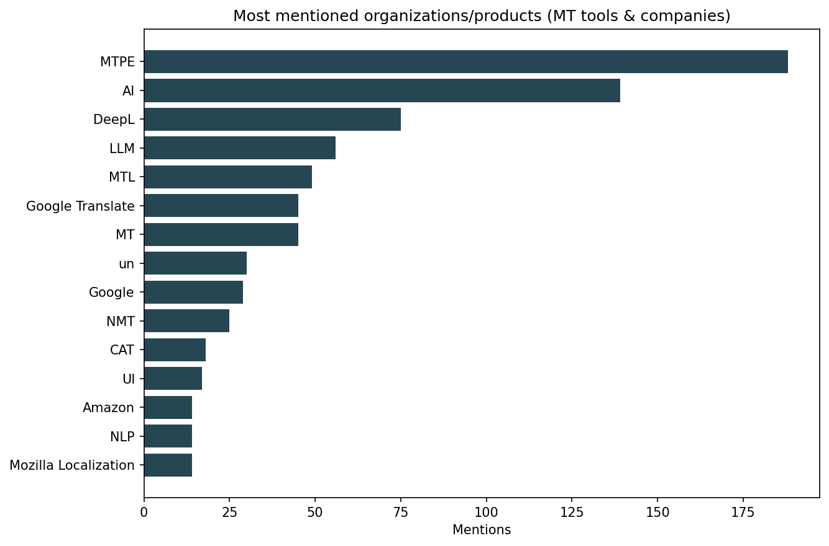
Figure 8 — Most-mentioned raw entities (ORG/PRODUCT), including acronym noise.
To get a cleaner answer to “which specific MT tools does each group discuss”, mentions of a small curated list of known tools/companies were counted and normalized per 1,000 posts within each user type (raw counts would otherwise just reflect that general has 26× as many posts as tech):
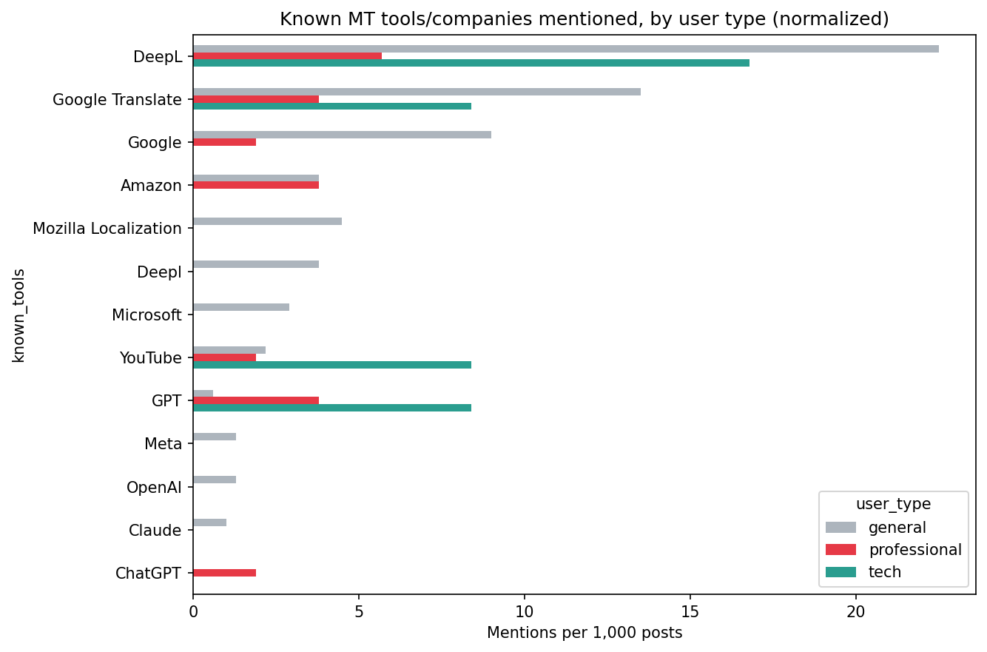
Figure 9 — Known MT tools/companies mentioned, per 1,000 posts, by user type.
Tool | General | Professional | Tech
DeepL | 22.5 | 5.7 | 16.8
Google Translate | 13.5 | 3.8 | 8.4
Google | 9.0 | 1.9 | 0.0
Amazon | 3.8 | 3.8 | 0.0
Mozilla Localization | 4.5 | 0.0 | 0.0
Microsoft | 2.9 | 0.0 | 0.0
YouTube | 2.2 | 1.9 | 8.4
GPT | 0.6 | 3.8 | 8.4
ChatGPT | 0.0 | 1.9 | 0.0

DeepL and Google Translate dominate mentions across all three groups. Tech users mention GPT and YouTube at a notably higher rate relative to their group size than general or professional users do, suggesting the tech audience's MT discussion leans more toward LLM-based and video-platform translation than the dedicated MT engines professionals and the general public focus on. These counts are small in absolute terms for professional/tech (119–530 posts total), so they should be read as suggestive rather than conclusive.

4.2.4 Word clouds by sentiment
A qualitative view of the vocabulary in positive vs. negative posts:
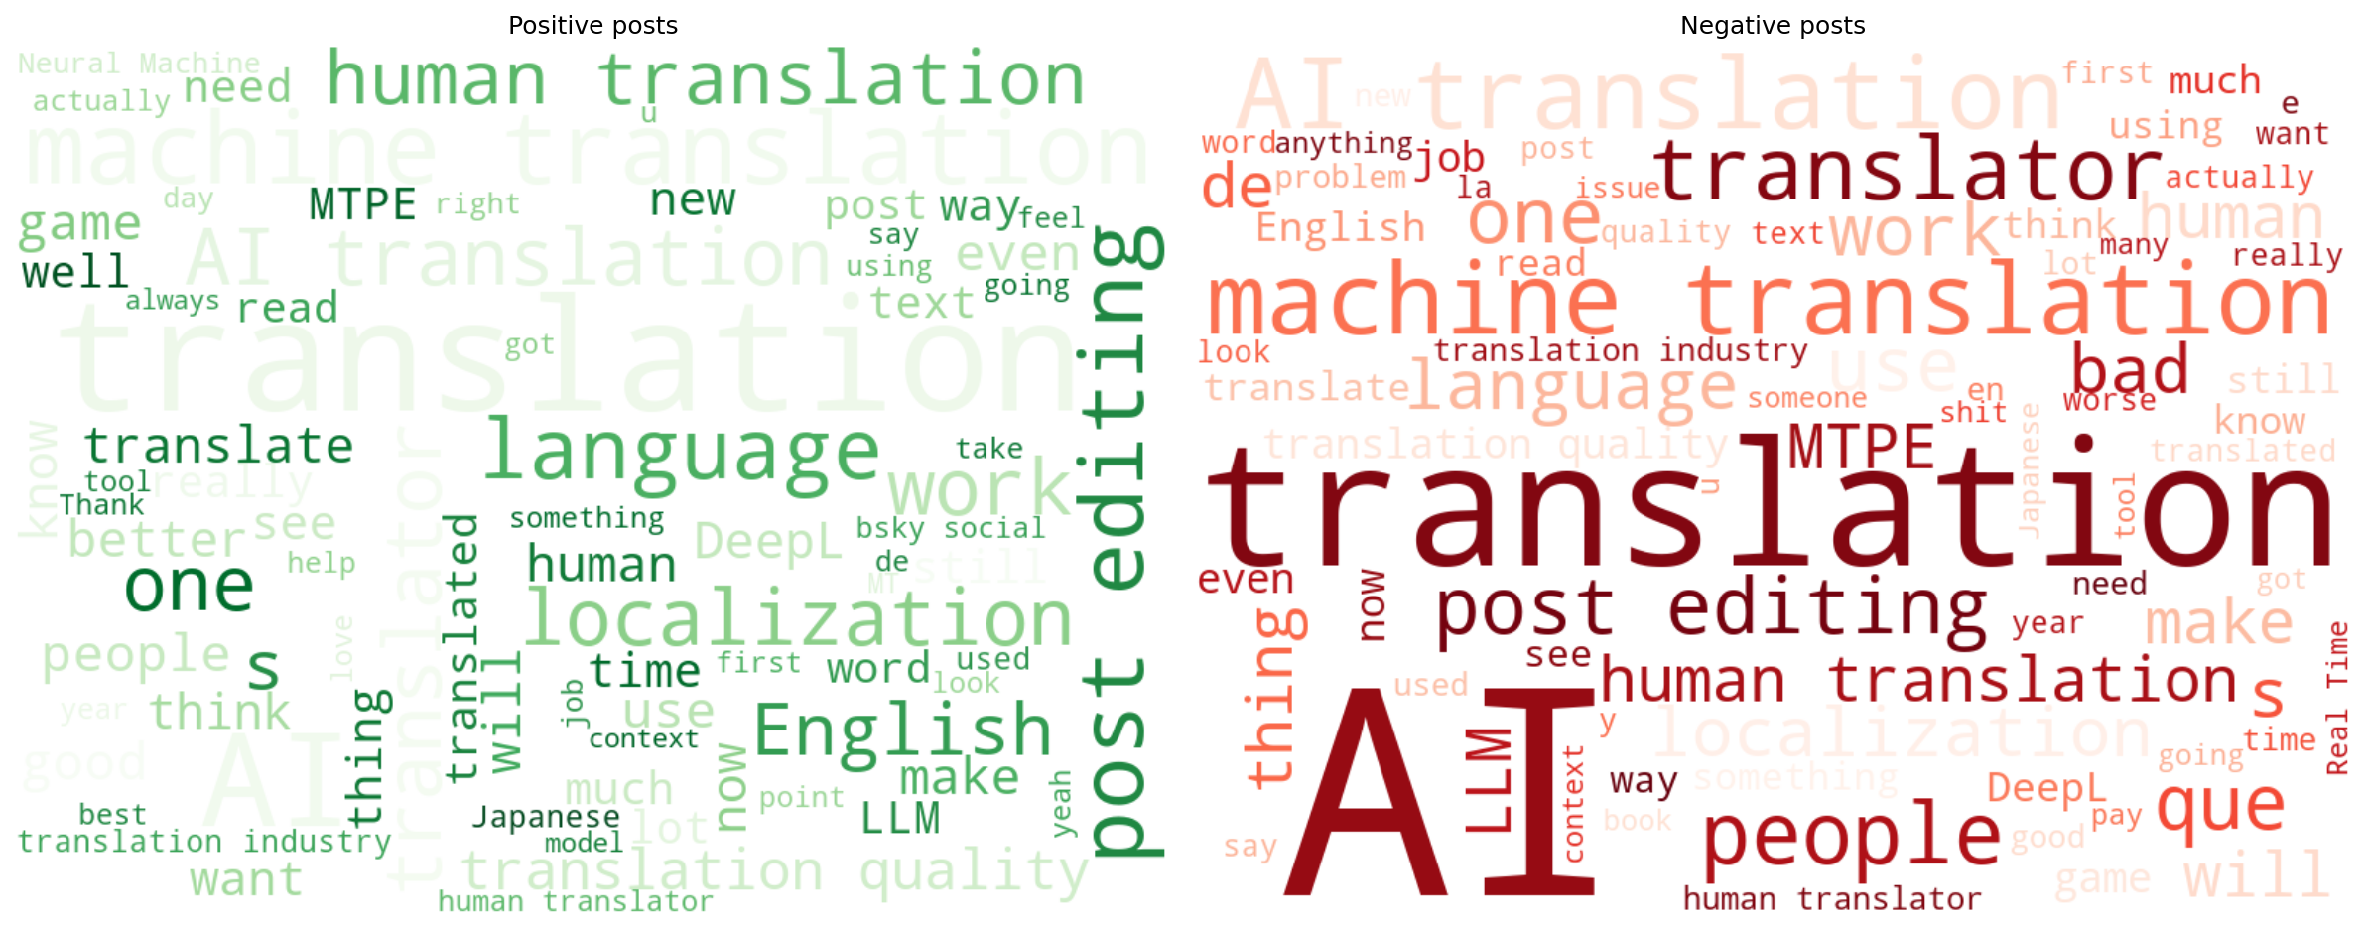
Figure 10 — Word clouds for VADER-positive (left) and VADER-negative (right) posts.

5. Discussion & Conclusions

5.1 Content analysis conclusions
RQ1 (tool vs. threat): the two sentiment tools disagree on 46% of posts. Taking the context-aware RoBERTa model as the more reliable signal, the discourse is genuinely mixed (23% positive / 46.5% neutral / 30.5% negative) rather than predominantly positive — MT is discussed as both a useful tool and, in a substantial minority of posts, negatively/critically.
RQ2/RQ3 (professional vs. general, utility vs. displacement): professionals score most positive on average by VADER (mean compound 0.196 vs. 0.138 for general and 0.097 for tech), which is consistent with professionals acknowledging MT's day-to-day utility (e.g. post-editing workflows, CAT tool integration) rather than uniformly framing it as a threat — though this is one lexicon-based signal and would benefit from being cross-checked with RoBERTa scores by user type in future work (not done in this draft).
The emotion analysis was not able to meaningfully support or refute RQ2/RQ3: differences between user types were small compared to the disagreement between NRCLex and DistilRoBERTa, and NRCLex's own output was shown to be largely invariant to content. This is reported as a methodological finding in itself rather than a substantive result about the discourse.
Named entity recognition shows DeepL and Google Translate as the dominant tools discussed by all groups, with tech users discussing GPT/LLM-based translation and YouTube-based translation at a disproportionately higher rate given their group size.

5.2 Overall project conclusion
[TO BE COMPLETED once the network analysis results are available — a full conclusion should relate community structure / centrality findings from analysis.ipynb to the framing and professional-vs-general differences found here.]

6. Limitations
- Single platform (Bluesky) and a single ~12-month window — findings may not generalize to other platforms or time periods.
- Topical relevance filtering and author-type labeling are both simple keyword-matching heuristics over text/bio, not validated classifiers; no manual accuracy check was performed.
- spaCy's en_core_web_sm was trained on general news text, not localization/MT jargon, and mis-tags several domain acronyms as organizations (reported transparently in Section 4.2.3 rather than filtered out).
- VADER and NRCLex are lexicon-based and were shown empirically to diverge substantially from transformer-based alternatives (RoBERTa, DistilRoBERTa). Without manual gold-standard annotation, we cannot say which tool is “correct” in absolute terms, only that they disagree — qualitative inspection of disagreement examples favored the transformer models.
- Professional (530 posts) and tech (119 posts) groups are much smaller than general (3,118 posts); all group comparisons use rates rather than raw counts for this reason, but per-entity counts for the smaller groups (Section 4.2.3) are still small enough to be noisy.

7. Tools and Libraries Used
Task | Tool / Model | Type
Data collection | atproto (Bluesky API client) | API client
Network analysis | networkx | [see groupmate's section]
Sentiment analysis | vaderSentiment | Lexicon-based
Sentiment analysis | cardiffnlp/twitter-roberta-base-sentiment | Transformer
Emotion analysis | NRCLex | Dictionary-based
Emotion analysis | j-hartmann/emotion-english-distilroberta-base | Transformer
Named entity recognition | spaCy (en_core_web_sm) | Pretrained pipeline
Visualization | matplotlib, wordcloud | -

Full source code, data dictionary, and setup instructions are in the project README and in notebook.ipynb / analysis.ipynb / content_analysis.ipynb.

