REPUBLIC OF CAMEROON
Peace - Work - Fatherland
MINISTRY OF HIGHER EDUCATION
University of Yaounde I
Institute Saint Jean (ISJ)

ACADEMIC INTERNSHIP REPORT

Elite Events: A Multi-Tenant Platform for Event
Reservation, Ticketing and QR Code Check-In

Internship carried out from 6 July 2026 to 4 September 2026
at HOOZON SARL, Douala, Cameroon
In fulfilment of the requirements for the degree of
Bachelor's Degree (Level 2), Computer Science

Prepared and presented by
DODGE Culhane
Second-year student

Academic supervisor: Mme EFFA Laure, Bachelor's Degree Coordinator
Professional supervisor: Mr Alfred JOHNSON, DevOps and Backend Developer

Academic Year 2025 - 2026

DEDICATION

We dedicate this report to our parents and family, whose constant encouragement and support made our academic journey possible. We also dedicate it to the teaching staff of the Institute Saint Jean, and to all the colleagues at HOOZON SARL who welcomed us during the internship.

ACKNOWLEDGEMENTS

We would like to express our sincere gratitude to Mme EFFA Laure, Bachelor's Degree Coordinator at the Institute Saint Jean, for her academic supervision and for the guidance she provided throughout this work. Our thanks also go to Mr Alfred JOHNSON, DevOps and Backend Developer at HOOZON SARL, who supervised our work on site and shared his expertise in software development and DevOps practices.
We are grateful to the management and the entire team of HOOZON SARL for granting us this internship opportunity and for the welcoming environment in which we were able to learn and contribute. Finally, we thank our fellow students and friends for their encouragement.

TABLE OF CONTENTS

Table of Contents
Right-click and choose "Update Field" to build the list.

LIST OF TABLES

- Table 1: Administrative and legal identity of HOOZON SARL
- Table 2: Technology stack of the Elite Events platform

LIST OF FIGURES

- Figure 1: Use-case diagram of the Elite Events platform
- Figure 2: Class diagram of the Elite Events domain model
- Figure 3: Sequence diagram - ticket creation and issuance
- Figure 4: Sequence diagram - QR code check-in at the gate

LIST OF ABBREVIATIONS

API: Application Programming Interface
HTTP: HyperText Transfer Protocol
JWT: JSON Web Token
ORM: Object-Relational Mapping
OTP: One-Time Password
PDF: Portable Document Format
QR: Quick Response (code)
RBAC: Role-Based Access Control
SME: Small and Medium-sized Enterprise
SQL: Structured Query Language
TLS: Transport Layer Security
UML: Unified Modeling Language

PREFACE

The Institute Saint Jean (ISJ), recently accredited by the CTI and awarded the EUR-ACE label, is the first Cameroonian Private Institution of Higher Education (IPES) and one of the very first private schools in sub-Saharan Africa to benefit from this prestigious recognition. This accreditation, granted for five years, allows holders of the Engineer diploma to claim the title of French State Graduate Engineer (in addition to the Cameroonian State title), a widely recognised international appellation that guarantees the quality of the training. ISJ is placed under the supervision of the National Advanced School of Engineering of Yaounde (ENSPY). Its programmes are delivered in French and English. Partner schools include UTT, 3IL, ISEP, EFREI, EPF, UMONS, ESTP, CESI, INP Grenoble, INP Clermont, ESME, ESIEA, BUILDERS, UTBM, Ontario Tech University and Northern Alberta Institute of Technology.
This internship report was produced as part of the Level 2 (Bachelor's Degree) curriculum in Computer Science, in the option of application development for the digital economy. It presents the work carried out during the academic internship at HOOZON SARL.

General Introduction
The organisation of events has become a strategic activity for many companies, particularly in a dynamic context such as that of Douala, where structures such as HOOZON SARL offer event-organisation services alongside their information-technology and digital-communication activities. However, the management of invitations, seat assignment, ticketing and guest control at the entrance is still frequently performed with manual or generic tools that are poorly suited to the specific constraints of each organiser.
In this report we define a few key concepts. A reservation is the allocation of a seat (or a couple of seats) to a guest for a given event. A ticket is the proof of reservation, here materialised by a unique QR code. Check-in is the act of validating a ticket at the gate using its QR code. Multi-tenancy designates a single software instance serving several independent clients, each seeing only its own data. Finally, RBAC (Role-Based Access Control) is a security model in which access rights depend on the role assigned to a user.
The problem we address is the following: without a dedicated platform, event organisers face double-booked seats, counterfeit or duplicated tickets, slow entry control, and a lack of reliable statistics. These difficulties reduce the quality of the service offered to clients and increase the operational risk during an event.
The interest of this study lies in the design and implementation of a tailored, multi-tenant solution that strengthens the event-organisation service line of HOOZON SARL while remaining reusable for its different clients. The platform, named Elite Events, covers reservation, QR-code ticketing and gate check-in.
The general objective is to deliver a functional prototype of the Elite Events platform, modelled with the Unified Modeling Language (UML) and built with a modern web stack. The specific objectives are to (i) model the domain and the main workflows, (ii) implement role-based authentication and secure reservation logic, and (iii) implement the QR-code ticket issuance and check-in flows.
This report is organised in three chapters. Chapter 1 presents the host company, HOOZON SARL, and the progress of the internship. Chapter 2 identifies the problem and analyses existing solutions. Chapter 3 presents the solution we propose, its modelling approach and its implementation.

Chapter 1: Presentation of the Company and Internship Progress
This chapter presents HOOZON SARL in its environment and describes the progress of the internship, the tasks performed, and the observations that motivated the work presented in the following chapters.

1.1 Presentation of the Company
HOOZON SARL is a Cameroonian company specialised in a variety of services intended to meet the professional and personal needs of its clients. It is a multidisciplinary structure whose areas of expertise include computer development and digital work, real estate, and event organisation. The company positions itself as a partner for innovation and excellence, emphasising quality, performance and customer satisfaction.

1.1.1 Legal and administrative identity
Field | Information
Company name | HOOZON SARL
Legal form | Societe a Responsabilite Limitee (SARL)
Year founded | 2014
Head office | Douala, Littoral Region, Cameroon (Logpom, Station TOTAL)
Country | Republic of Cameroon
Sector of activity | Information Technology, Digital Communication, Real Estate, Event Organisation
Website | https://hoozonsarl.com
Workforce | Approximately 29 employees (privately held company)
Main services | Graphic design, web & platform development, digital communication strategy, real estate brokerage, event organisation
Table 1: Administrative and legal identity of HOOZON SARL
Source: HOOZON SARL (hoozonsarl.com) and public company directories

1.1.2 History and evolution
Founded in 2014 and based in Douala, HOOZON SARL has grown from a versatile service provider into a structured company active in several complementary sectors. Its evolution reflects the diversification of Cameroonian small and medium-sized enterprises that combine information technology with service activities such as real estate and events. The company now promotes itself as a dynamic organisation serving businesses that wish to improve their digital presence and customer engagement.

1.1.3 Field of activity and services
The activity of HOOZON SARL covers four main areas. In information technology, the company carries out graphic design, the development of websites and platforms, and various digital works. In digital communication, it builds visibility and communication strategies for its clients. In real estate, it facilitates the purchase, sale, management and rental of properties. Finally, in event organisation, it plans and coordinates events on behalf of its clients. This last activity is directly concerned by the subject of this report, since it requires reliable tools for reservation and guest management.

1.1.4 Internal and external environment
Internally, HOOZON SARL is organised around functional poles that correspond to its areas of activity: an information-technology / development pole, a digital-communication pole, a real-estate pole, and an event-organisation pole. These poles collaborate on multidisciplinary projects. Externally, the company evolves in the Cameroonian market of small and medium-sized enterprises, where digitalisation is a growing expectation. The external environment is characterised by increasing competition on visibility and by a rising demand for tailored digital tools that support service delivery.

1.2 The Host Department and the Internship
The internship was carried out within the information-technology / development pole of HOOZON SARL, which is the department most directly concerned with the design and implementation of software platforms.

1.2.1 Organisational placement
The development pole is placed under the responsibility of Mr Alfred JOHNSON, DevOps and Backend Developer, who acted as our professional supervisor. This placement is important because the event-organisation activity of the company depends on reliable software; situating the internship in the development pole makes it possible to contribute directly to the tools that support that activity.

1.2.2 Internship period and framework
The internship took place from 6 July 2026 to 4 September 2026, for a duration of approximately nine weeks, within the premises of HOOZON SARL in Douala. It combined individual development work on the Elite Events project with collective activities such as team meetings.

1.2.3 Tasks performed
During the internship, we contributed to the Elite Events project as a developer. The main tasks were as follows:
- Working on the Elite Events project, a platform for event reservation, ticketing and QR-code check-in.
- Attending team meetings in order to follow the progress of the project and to align our work with the objectives of the pole.
- Carrying out standard developer duties: reading the existing code, implementing features, and respecting the conventions of the repository.
Nothing particular needed to be emphasised beyond the normal duties of a developer; the work was conducted as a standard contribution to a software project under professional supervision.

1.2.4 Observations and problems noted
Through this immersion we observed that the event-organisation activity lacks a dedicated software tool adapted to the company's needs. The reservation of seats, the issuance of tickets and the control of guests at the entrance are activities that, when performed manually or with generic tools, generate errors and inefficiencies. These observations led us to identify, in the next chapter, a precise problem to which the Elite Events platform proposes a solution.

Chapter 2: Identification of the Problem
This chapter identifies a precise problem encountered by the company and its clients in the management of events, analyses its impact, and studies the existing solutions together with their limits.

2.1 Statement of the problem
The problem we identified is the absence of an integrated, multi-tenant platform to manage the complete lifecycle of an event: from the definition of venues and seats, through the reservation by guests, to the issuance of tickets and their validation at the gate. In practice, organisers often rely on spreadsheets to track reservations and on paper or generic QR codes for entry control. This situation produces several concrete difficulties: a same seat can be assigned twice; a ticket can be duplicated or forged; the queue at the entrance slows down when control is manual; and no reliable statistics are produced for the organiser.

2.2 Impact on the company
For HOOZON SARL, this problem has a direct impact on the quality of the event-organisation service that it sells to its clients. Errors in reservation damage the company's credibility with its clients, while the lack of reliable control at the gate weakens security and can lead to unauthorised entries. The absence of centralised data also prevents the company from capitalising on the information collected during events, which limits its ability to improve its offers. Finally, the manual workload increases the operational cost of each event.

2.3 Existing solutions and their limits
Several categories of existing solutions can be considered. Generic ticketing platforms allow the sale and control of tickets, but they are generally not designed for multi-tenant, seat-level reservation management and they keep the data on external infrastructures that the company does not control. Spreadsheets are flexible but offer no concurrency control, no anti-fraud mechanism, and no automated check-in. Paper-based methods are simple but cannot prevent duplication and provide no traceability. Mobile-money-based payment options (for example CamPay in Cameroon) exist for subscriptions, but they are not integrated with a reservation and ticketing workflow. Consequently, none of these solutions jointly addresses multi-tenancy, seat-level reservation, QR anti-fraud control, and data sovereignty for the specific context of HOOZON SARL.

2.4 Added value of the proposed approach
The added value of the approach we propose lies in a single platform, Elite Events, that unifies these needs for several clients (tenants) within one instance. By modelling the domain explicitly with UML and by enforcing key invariants directly in the database (for example a constraint that rejects the double-booking of a seat), the solution provides stronger guarantees than application-level checks alone. The use of QR codes for tickets, validated at the gate by assigned staff, reduces fraud and accelerates entry. These contributions are detailed in the next chapter.

Chapter 3: Proposed Solution
This chapter presents the solution we propose: the Elite Events platform. We describe the modelling approach used, the models produced with the Unified Modeling Language, the architecture and technologies retained, and the two principal workflows implemented.

3.1 Modelling approach
To analyse and design the solution we used the Unified Modeling Language (UML), which is a standard graphical language for specifying, visualising and documenting software systems. Three types of diagrams were retained. A use-case diagram captures the functionalities expected by each category of actor. A class diagram describes the structure of the domain (the entities and their relationships). Sequence diagrams describe the dynamic behaviour of the two critical workflows: the creation of a ticket and the check-in at the gate. This modelling step preceded the implementation and guided the design of the database schema and the application programming interfaces.

3.2 Use-case model
The use-case diagram (Figure 1) distinguishes four actors: the Super Admin, the Client Admin, the Gate Staff, and the Visitor. The Super Admin manages client organisations, grants subscriptions and consults payments. The Client Admin manages buildings and rooms, creates and manages events, manages guests, assigns seats (single or couple), issues QR tickets, previews tickets in PDF and consults the dashboard; he may also request a subscription upgrade. The Gate Staff scans tickets and consults the scan result. The Visitor self-registers to create a free account that becomes a Client Admin account. Subscriptions are driven by a mobile-money payment transaction.
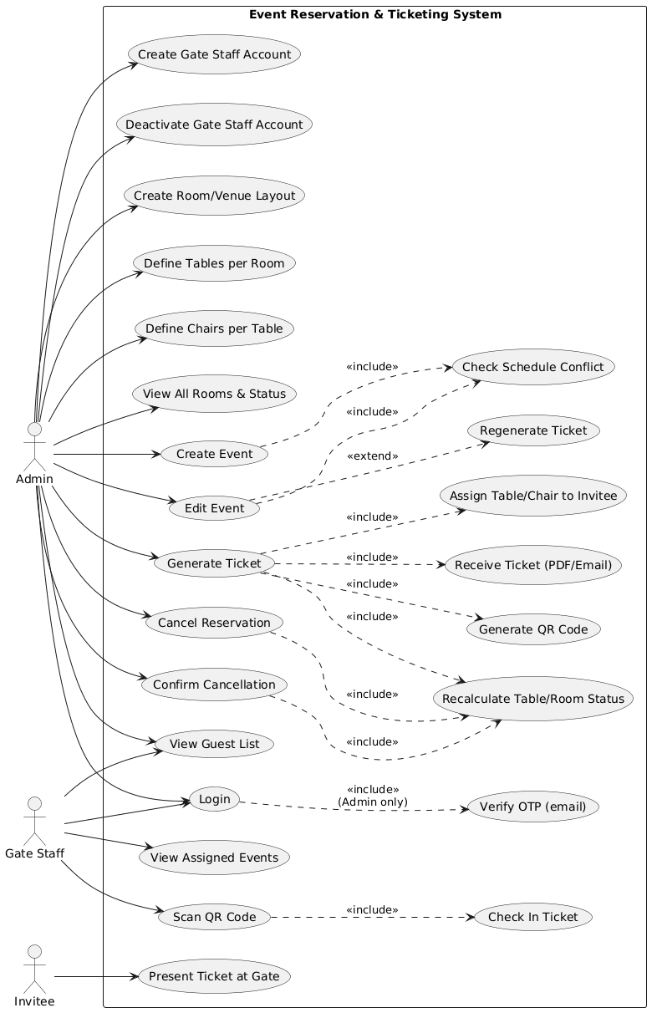
Figure 1: Use-case diagram of the Elite Events platform.

3.3 Domain / class model
The class diagram (Figure 2) structures the domain around the tenant (Client), which owns everything: users, buildings, events, invitees, subscriptions, payment transactions, gate-staff assignments and usage ledgers. A building contains rooms; a room can host an event. An event is composed of tables, each table containing chairs. A reservation allocates a chair (or a couple of chairs) to an invitee for an event and is linked to exactly one ticket. A ticket carries a unique QR token and a status (issued, checked-in, cancelled). Enumerations define the role of a user (Super Admin, Client Admin, Gate Staff), the type of a reservation (single, couple) and its status, as well as the status of a ticket. A couple reservation is modelled as two rows sharing a common couple group identifier, representing the selected seat and the partner seat.
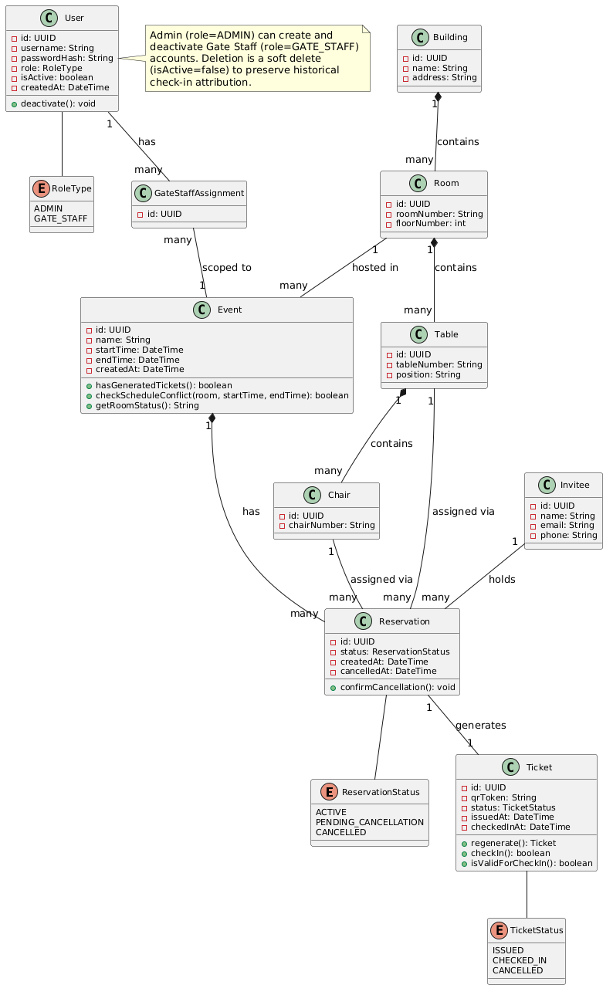
Figure 2: Class diagram of the Elite Events domain model.

3.4 Architecture and technologies
The platform is built as a web application with a clear separation between the backend (application programming interface) and the frontend (user interface). The multi-tenant design is implemented by associating every business record with a client identifier, so that a single instance serves several independent clients while isolating their data. The technology stack is summarised in Table 2.
Layer | Technology
Backend | Node.js, Express, TypeScript
Database | PostgreSQL 16 (Docker), raw SQL via node-postgres, node-pg-migrate
Web frontend | Angular 18 (standalone components)
Modelling | UML (use-case, class, sequence diagrams), PlantUML
Auth & security | JWT, e-mail OTP, Role-Based Access Control, rate limiting
Tickets | QR code generation, PDF generation (pdfkit)
Table 2: Technology stack of the Elite Events platform
Source: Author, based on the Elite Events project (README and source code)

In accordance with the security best practices observed in the project, role enforcement is performed by the backend middleware (requireRole), not only by the frontend route guards, which are a user-experience convenience. This ensures that a Gate Staff token is rejected (HTTP 403) when it attempts to reach an Admin-only route.

3.5 Ticket creation and issuance workflow
The ticket-creation sequence (Figure 3) begins when a Client Admin posts a reservation for an event, specifying the table, the chair, an optional partner chair for a couple reservation, the invitee and the type. The reservation service opens a database transaction, validates the room and the partner seat, inserts the invitee and the reservation (two rows for a couple, sharing a couple group identifier), generates a unique QR token, inserts the ticket, generates the QR code as a data URL, and commits. Later, the guest can preview or print the ticket as a PDF that embeds the QR code together with the event, invitee, room, table and chair details.
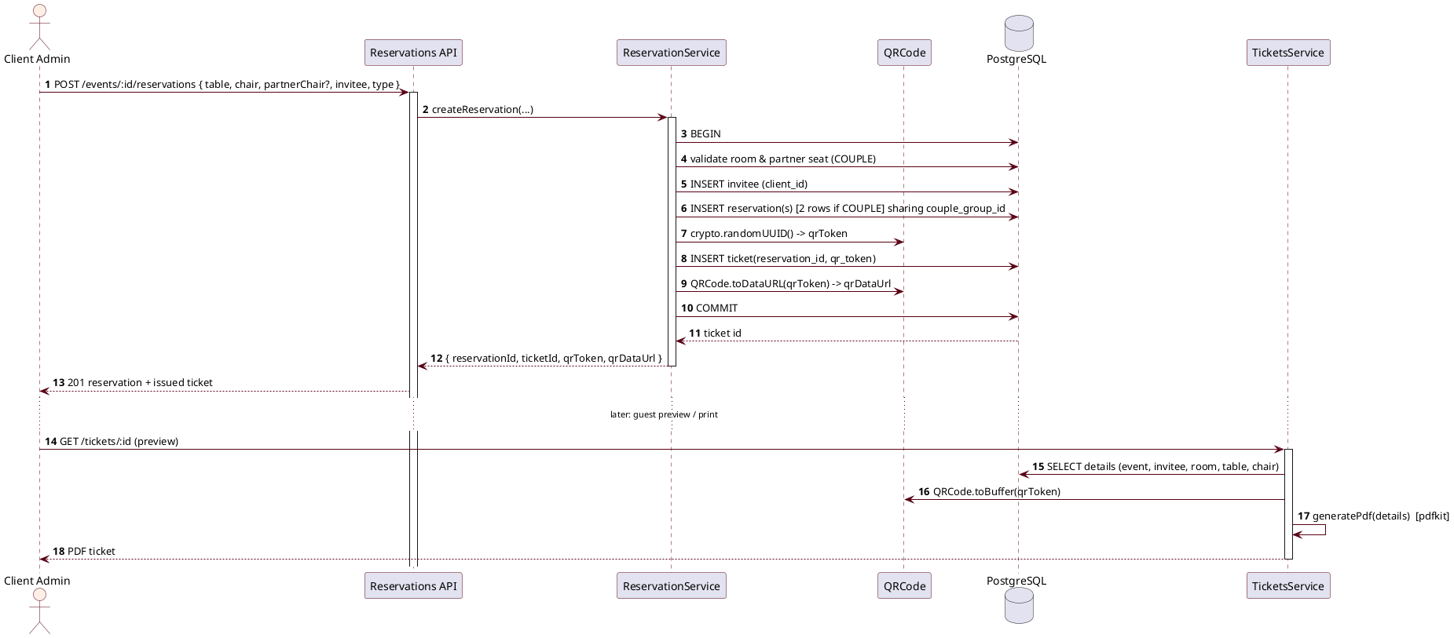
Figure 3: Sequence diagram - ticket creation and issuance.

3.6 QR code check-in workflow
The check-in sequence (Figure 4) begins when a Gate Staff member opens the scanner and aims at the QR code; the mobile client posts the QR token to the gate-staff scan endpoint. The ticket service retrieves the ticket with its reservation, event, invitee, chair, table and room. If no ticket is found, an error is raised. Otherwise the service checks whether the event has expired and whether the ticket status is already checked-in or cancelled. When the role is Gate Staff, the service verifies that the user is assigned to the event; if not, an error is raised. The ticket is then marked as checked-in with a timestamp, and a success result containing the guest name and seat is returned to the scanner.
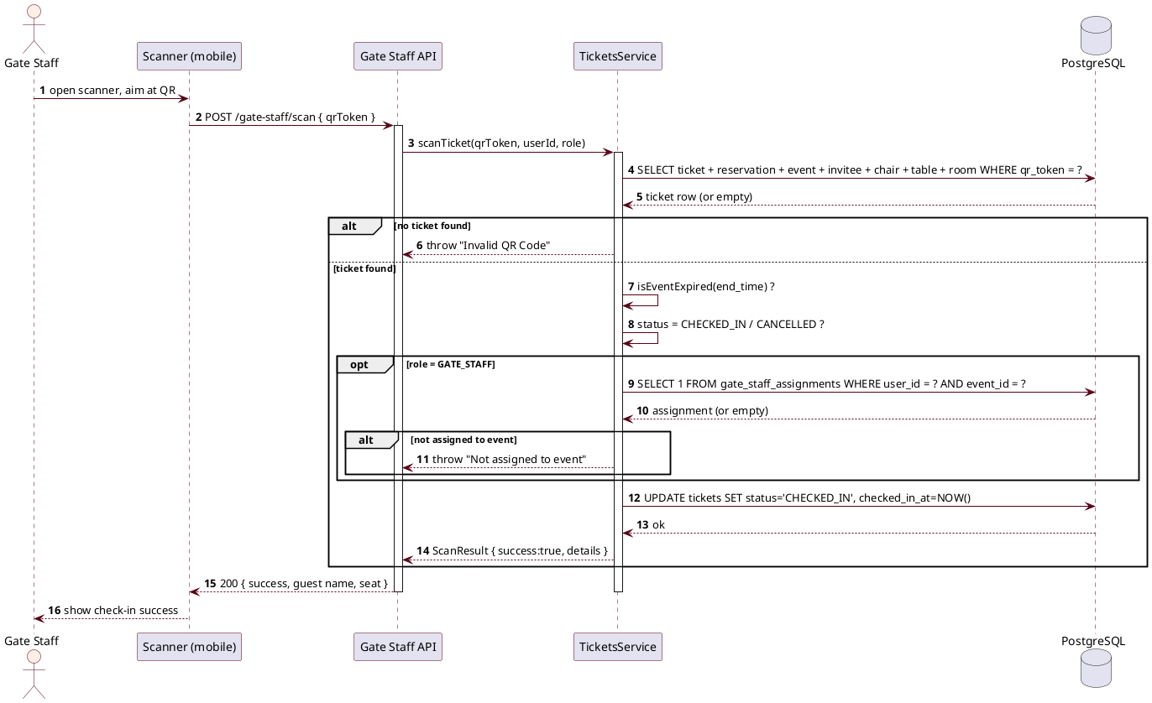
Figure 4: Sequence diagram - QR code check-in at the gate.

3.7 Security and data integrity
Beyond role-based access control, data integrity is guaranteed by database constraints. In particular, the reservations table carries a partial unique index on (event_id, chair_id) for active reservations; this means the database itself rejects the double-booking of a chair for the same event, even under concurrent requests, which is stronger than an application-level check alone. Authentication uses a role-branching login: an Admin authenticates with a username and a one-time password sent by e-mail, whereas a Gate Staff account authenticates directly and receives a token. Rate limiting protects the login and OTP endpoints against brute-force attempts.

General Conclusion
In this report we presented the work carried out during our internship at HOOZON SARL. After presenting the company and the progress of the internship in Chapter 1, we identified in Chapter 2 the problem of the absence of an integrated, multi-tenant platform for event reservation, ticketing and gate control, together with the limits of existing solutions. In Chapter 3 we proposed the Elite Events platform: a modelled, multi-tenant solution designed with UML and built with a modern web stack, implementing secure role-based authentication, seat-level reservation protected against double-booking, QR-code ticket issuance, and gate check-in.
The contribution of this work is a coherent foundation that strengthens the event-organisation service line of HOOZON SARL and that can be reused for its different clients. The modelling approach (UML) made it possible to clarify the domain and the critical workflows before implementation.
Several perspectives can improve the work. A mobile application for the gate staff scanner could be finalised and published. The integration of mobile-money payments (such as CamPay) for client subscriptions could be completed, as already sketched in the use-case model. Finally, analytics dashboards and automated tests would increase the reliability and the operational value of the platform.

References
- HOOZON SARL, official website, https://hoozonsarl.com (consulted August 2026).
- Elite Events project, source code and README (backend: Express + TypeScript; frontend: Angular 18), internship repository, 2026.
- Elite Events specification, Elite_Events_Specification.pdf and project1_updated.md, provided during the internship.
- Object Management Group, Unified Modeling Language (UML) specification, https://www.omg.org/spec/UML (consulted August 2026).
- Angular documentation, https://angular.dev (consulted August 2026).
- PostgreSQL documentation, https://www.postgresql.org/docs (consulted August 2026).
- Node.js documentation, https://nodejs.org/api (consulted August 2026).

Annexes

Annex A: UML model sources
The four UML diagrams presented in Chapter 3 are produced from PlantUML source files located in the project under frontend/public/Events/uml/: class-diagram.puml, use-case-diagram.puml, sequence-ticket-creation.puml and sequence-qr-checkin.puml. The exported images (ClassDaigram.png, useCase.png, sequenceForTicket.png, sequenceForQRScann.png) are included as figures in the report.

Annex B: Glossary
Client (tenant): an independent organisation using the platform and seeing only its own data. Client Admin: the administrator of a client organisation. Gate Staff: a user assigned to control entries at the gate. Reservation: allocation of a seat to a guest for an event. Ticket: proof of reservation materialised by a unique QR code. Check-in: validation of a ticket at the gate.

TABLE OF CONTENTS (COMPLETE)

Right-click and choose "Update Field" to build the list.

