James Stallkamp
Bram Lewis
CS 373
06/30/2024
Module 1 Write Up
Contents
Introduction 1
Findings 1
Homework 1 2
Conclusion 3
Appendix 3

Introduction
Module 1 was an introduction to the under-ground world of malware. These sessions introduced many terms, definitions, tools, and examples that begins to explore the many facets of modern malware. I was aware of some of the terms introduced but I will admit I had never seen some of the tools we got to use and the experience of playing with real samples so quickly was extremely interesting.

Findings
The first sessions covered a lot of terms and definitions in the AV world, but it also explored the motivations and many real-world examples of malware. The lectures introduced many definitions for types of malwares based on its behavior or its form. During the recorded videos I found it interesting that in some way the audience had a lot of misunderstanding or even disagreement about what “type” a sample really is. Because these samples take so many different shapes and do so many different things it becomes even more important to try and classify them, despite the difficulty.
The lectures also introduced many real-world examples of malware and even named some real hacking kits some which are even still used today. I will admit one of the first things I did was google some of the exploit kits and was shocked. I didn’t register or even explore any of these sites, but from the google results alone I quickly found sites that seemed like I could buy or download tools from.
After exploring some real examples of malware and their motivations we then covered some of the conventions and components of malware. First was the classification of malware based on its type, platform, family, variant, and sometimes information. We then started to dissect these files into components like their headers, directories, code sections, and data, in some ways this part was the most interesting because it started to return to the idea that fundamentally these malicious files are still just software that can be understood and controlled.

Homework 1
In the first homework I got to use real AV tools to investigate a real sample of malware, which was an amazing experience, no like literally, I showed my family and friends. The piece of malware did very interesting things and its behavior changed depending on how it was interacting with the system. The first thing that the sample did was create a pop up but using process monitor and process explorer I quickly found it had done much more. I found that the sample had hijacked many windows services and created a folder with an executable that eventually did many other tasks. See image of folder and file being created.
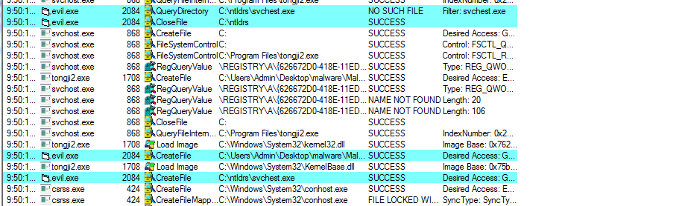
After further investigation I found that the sample had set itself to automatically run at start up in the registry as well as every 30 minutes using the windows task system. I then had the thought to see what exactly was happening at these intervals and found another executable that was gathering up system information and seemed to be trying to upload them to somewhere.

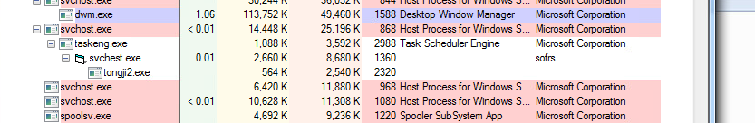

The lab was a very interesting introduction to investigating malware, but the tools that were introduced were in some ways the most interesting. I didn’t realize that software investigation tools like these were so easy to use and yet provide an enormous amount of information about what the system is doing.

Conclusion
In conclusion module 1 was a quick introduction to the world of malicious software, or malware, where we learned many important terms and definitions to try help understand these often-elusive pieces of software. The terms and ideas often seemed to overlap or be unclear, but that seems to be because malware itself takes many forms and often incorporates many different features to achieve its goals. Ultimately it is interesting to see that malware is fundamentally just humans exploring the possibilities of software, while it is often used for criminal purposes; much like many weapons, they first start out as tools.

Appendix
This write-up follows the MLA standard for expository essays.

