James Stallkamp
Bram Lewis
CS 373
7/17/2024
Module 3 Write Up
Contents
Introduction 1
Malware Process 1
Malware Defense 2
Yara Lab 1 2
Lab 2 Cuckoo 3
Lab 2 3
Conclusion 4
Appendix 4

Introduction
Module 3 was a presentation by Craig Schmugar that covered the basics of the malware lifecycle and an introduction to defense against malware. We then spent some time working on labs where we worked with Yara to create ruled based malware detection scripts. In the second part of the class we were introduced to the Cuckoo analysis tool that can be used to sandbox malware files. Next, I’m going to cover the malware process and basic defense.

Malware Process
First, we covered the lifecycle of a piece of malware. In general malware follows 4 basic steps, first contact, local execution, establish presence, and malicious activity. During the first contact phase the malware finds a way to get onto the target system. This first contact could be established many ways, some examples include unsolicited messages, accessing the targets LAN, inserting physical Media or more complicated attacks like man in the middle or remote exploits. Once first contact has been established the malware then goes into the local execution phase. The local executation phase is the first activities the malware does on the target system, such as getting the user to run or write files. Once the malware has started local execution it then moves into the establish presence phase. During the establish presence phase the malware does varies things to take control or establish itself on the target machine, this includes things like modifying system files, propagating to connected systems, or hiding and protecting its own source code. The final phase is the malicious activity phase, during this phase the malware begins to execute its real intended payload, this can include displaying ads, stealing of information including credentials, or performing a ransomware attack. The malicious activity phase continues until the malware is finally removed.

Malware Defense
Next, we began to discuss the basics of malware defense. Unfortunately, malware can be very complex and changes very rapidly, this makes malware defense difficult. The modern malware defense is based on a defense in depth strategy where systems utilized many different tools and many layers of tools to provide a sophisticated and broad defense against malware. This defense in depth includes things like network firewalls, message reputations, web reputations, host firewalls, and finally access control.

Yara Lab 1
Next, we began to work with a tool call Yara, which is a malware analysis tool. In the first Yara lab we used the Yara editor to create some Yara rules that can detect some given samples. Below are the Yara rules that I wrote.
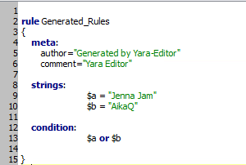
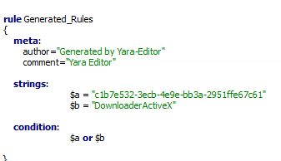
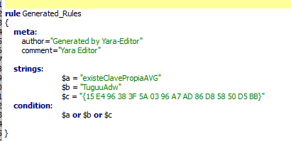

Lab 2 Cuckoo
In the second lab we used a malware analysis tool called Cuckoo. Cuckoo provides a sandbox to isolate malware and allow us to see real time information about what the malware is doing. We used a fakenet program to emulate a network and then ran the analyzer.py to launch Cuckoo. This created some log files looking like this.
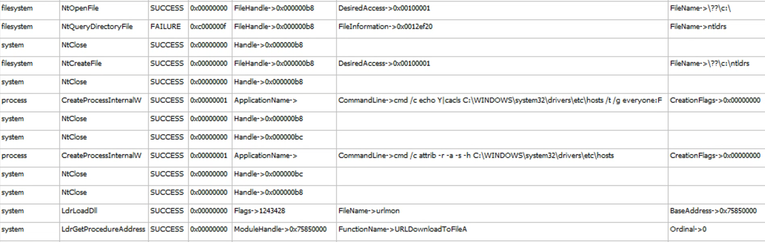
These logs can show us potentially harmful actions and give us information on what the malware is doing. In this case it was changing a bunch of permissions probably getting ready to change files, it then tries to download some information and write changes.

Lab 2

During this week I started on lab2, Windows exploitation Stack overflow. The lab involves an overflow exploit on a program called “Easy RM to MP3 Converter”. The exploit involved creating a file filled with junk data with the intention of taking control of. I started off with just a large file that crashed the application, but eventually found that 27072 As could be read in, and any more crashed. I added the string BBBB to my file to show that this overflow was giving me control of what is in EIP. I plan to use the python script mona to help me find an instruction. I plan to finish this assignment soon.

Conclusion
In conclusion module 3 was an introduction to how malware operates and some basics on how we can defend against it. The first major step in defending against malware is starting to understand how it works, this is what we did in this week. We used tools like Yara, and Cuckoo to start to investigate what malware is doing or gathering information about the malware so we can detect it.

Appendix
This write-up follows the MLA standard for expository essays.

