James Stallkamp
Bram Lewis
CS 373
07/21/2024
Module 4 Write Up
Contents
Introduction 1
Lesson 1 1
Lesson 2 2
Lesson 3 4
Lab 2 5
Conclusion 6
Appendix 6

Introduction
Week 4 focused on using winDBG to explore the FSExploit labs. winDBG allows us to debug certain windows process and explore how the process is interacting with the system. First we covered the basics of to use winDBG and introduced important some important registers. We are discussing windbg because one can use application crashes or bugs to try and create exploits, as we saw in this lab we were able to launch a calculator using the exploit. Some important registers that we were told to pay attention to are EAX(return val of func), EIP(where in memory cpu is), EDP, and ESP(start and end of stack frame). We then worked on lessons built into the FSExploitMe page, bellow are screenshots of my answers as I worked through the lessons. The main idea in all the lessons was to learn to use winDBG to investigate the way a bug caused a crash or could be used to take control of said application.

Lesson 1
These are the answers that I found following the lesson 1 questions.
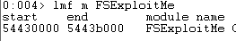
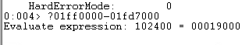
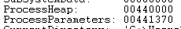
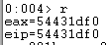
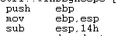
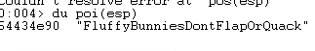
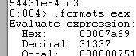
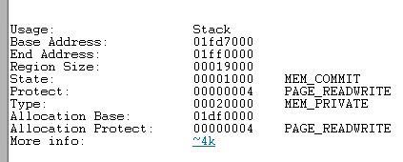

Lesson 2
Stack Behavior
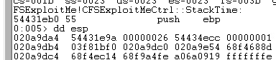
Arguments are passed in reverse order “push 1” is probably a bool, the second is a pointer to a string and the third is 38 in decimal so an int, func(int a, string *b, bool c)
Crash Triage
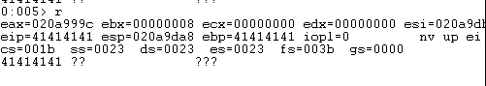\

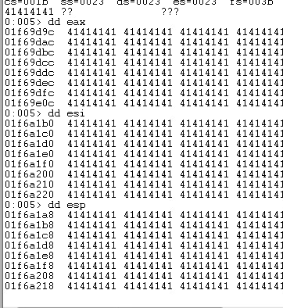
Lab Exploit!
This lab focused on finding an offset that would cause an overflow and let us overwrite EIP. I used byakugan to find the offset, which was 1028. Once I had the offset then I found a jmp esp instruction and added that to the input file. Finally adding the shellcode for a calculator I was able to create an input string that would crash the page and launch a calculator.
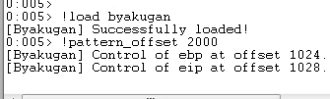
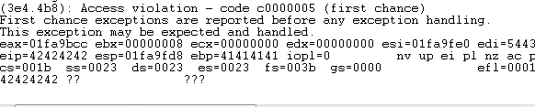
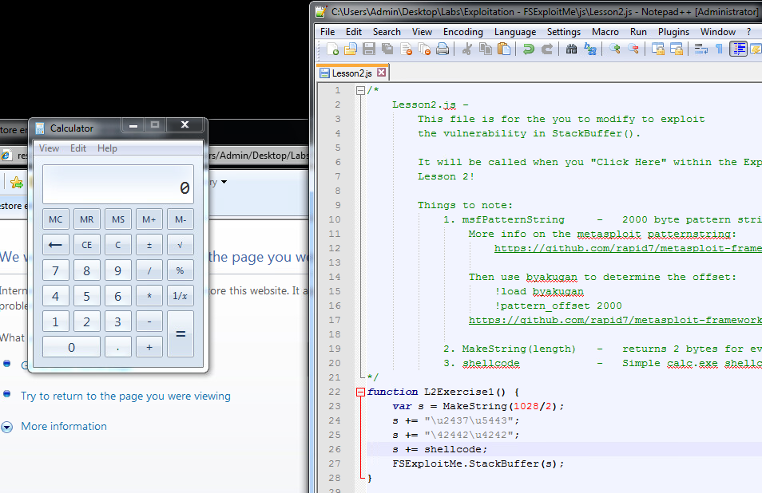

Lesson 3
This lesson focused on heap exploits, these are my answer to the questions in the lesson.
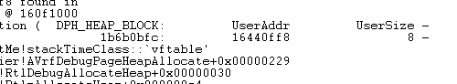
The heap block is of type virtual function table pointer as also seen in the above screenshot.
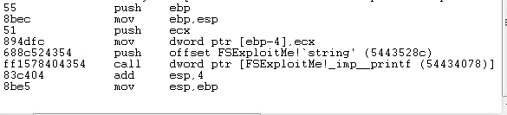
The call to heapFree is at 544324d0
The size of the freed element is 74
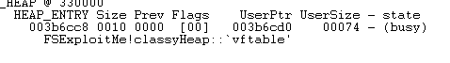

Lab 2
During this week I worked on lab2, Windows exploitation Stack overflow. The lab involved an overflow exploit on a program called “Easy RM to MP3 Converter”. The exploit involved creating a file filled with junk data with the intention of taking control of. I started off with just a large file that crashed the application, but eventually found that 27072 As could be read in, and any more crashed. I added the string BBBB to my file to show that this overflow was giving me control of what is in EIP. I then found a JMP ESP instruction to allow me to inject shell code. I used the python script mona to help me find an instruction at 0x01a8f23a. Knowing my offset and having a jmp command to load into EIP I then added in shellcode to start up a calculator, I then created a file with this string and loaded it into the application and TADA it crashed the application and opened a calculator.
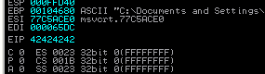
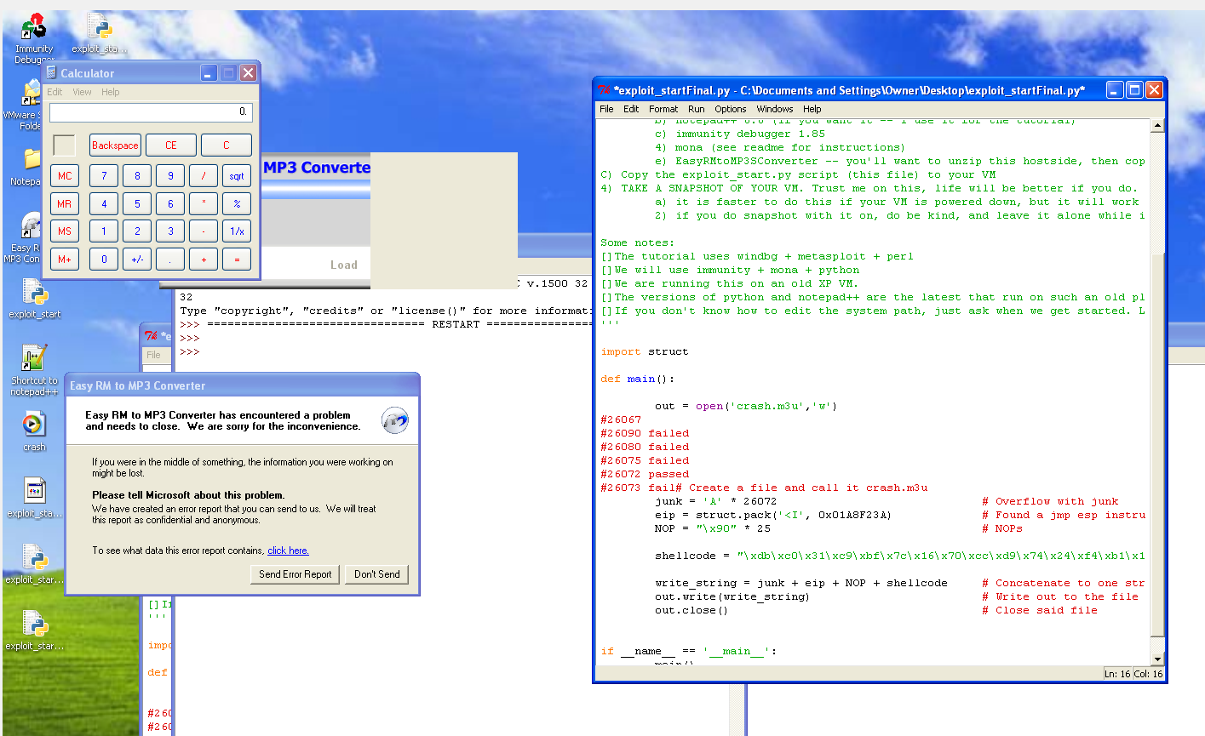

Conclusion
This week focused on how breaking or manipulating applications can give attackers control of the system. Using applications like winDBG we can poke around in windows applications and see what the application is doing in memory. Being able to see how these applications crashed gives us hints on how to craft inputs or interactions that create specific scenarios that say inject shellcode or any other payload that we desire.

Appendix
This write-up follows the MLA standard for expository essays.

