James Stallkamp
Bram Lewis
CS 373
08/14/2024
Module 7 Write Up
Contents
Introduction 1

Introduction
The initial lecture covered the history, specifications, and operating system structures of some of the earliest mobile phones. This content was primarily foundational and did not provide much new material for this blog.
Lab 1
In the first lab, we examined FakePlayer, the first SMS Trojan designed for Android smartphones. While it might not be the most relevant malware example today, it was still intriguing and served as a useful introduction to static analysis techniques for mobile malware.
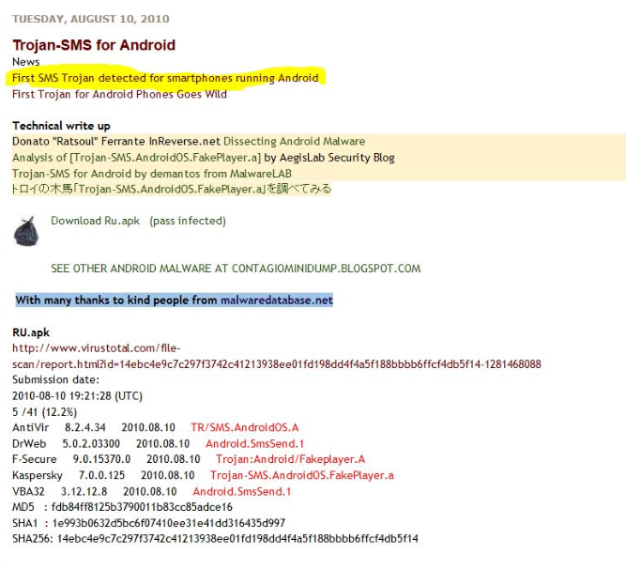
This malware pretended to be a media player for Android phones but was actually designed to send SMS messages to premium-rate numbers, costing users around $3-$5 per message. It appeared to send a message each time the app was launched.
To begin static malware analysis, you can check VirusTotal to see if the sample has been flagged as malware by various security vendors. VirusTotal also provides information on potentially suspicious permissions, highlighted in red text, and certificate details. In this case, the certificate is from “Android debug,” a development certificate that should not be used in a production release. The permission in question is highlighted in red because a media player or viewer typically does not need to send messages. Additionally, the app’s single activity—which represents the various screens of the app—raises suspicion, as having only one activity is unusual and potentially indicative of malicious intent.
Android executable files are distributed as APK files, which are essentially zip files containing the program’s components. You can decompile parts of the APK to access more detailed information. For instance, permissions, activities, and intents can be verified in the XML file.
For the RU.apk (Fake Player) malware, the program is configured to send a code of "798657" to several premium-rate text message numbers, "3353" and "3354". Although I'm not well-versed in Java, it appears that the malware attempts to send a message at least three times each time the Fake Player app is launched. The malware uses the SmsManager to handle message transmission. As previously mentioned, users infected by this malware will incur charges ranging from $3 to $5 for each message sent to these premium-rate numbers, which are controlled by hackers in Russia.
In the second part of the lab, we shifted our focus to dynamic analysis with a more straightforward malware sample, WalkTxt.apk. This process involved setting up an Android emulator and installing the malware on the virtual device. We also added a phone number contact to the device, as the malware is programmed to send messages to all contacts in the phone's address book. The malware application, as shown below, was then loaded onto the emulator.
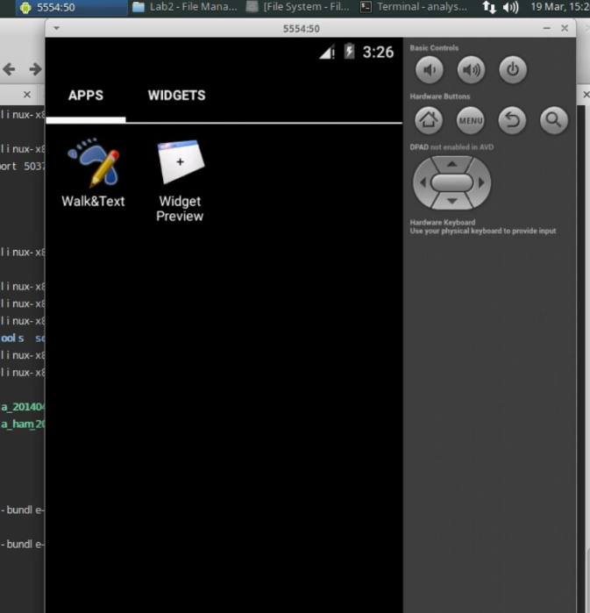
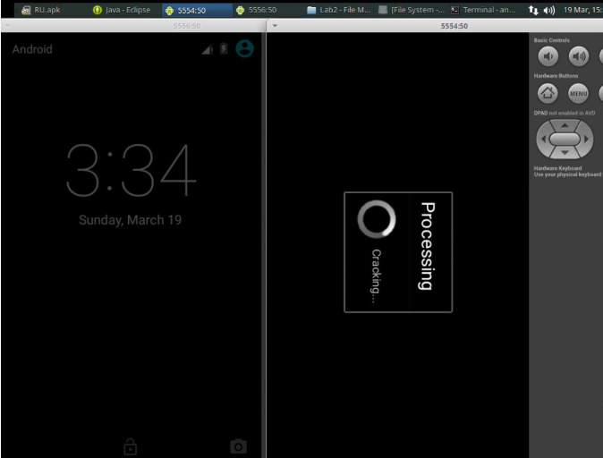
The malware displays a message on the original device (as shown on the right) informing the user that they have downloaded and installed a cracked or pirated version of the app and that their phone bill might have been charged. Additionally, the app sends a text message to all contacts, notifying them that someone they know has downloaded pirated software, in an attempt to embarrass the user who installed the unauthorized app.
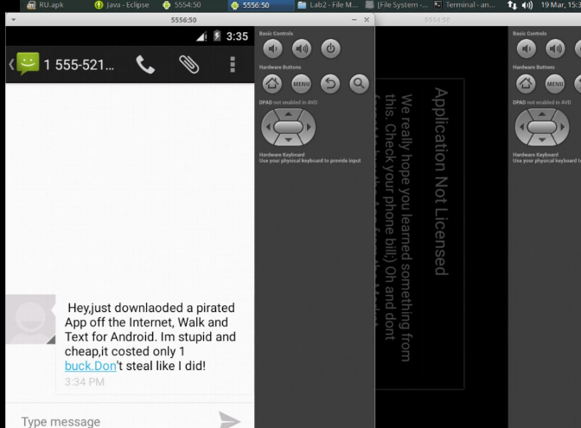
Appendix
This write-up follows the MLA standard for expository essays.

