James Stallkamp
CS373
Lab 1
I started off lab 1 using the strings command to find important pieces of the syntax and immediately saw things like phase_1 through phase_6, as well as a secret and much more useful information to defuse this bomb.
Strings bomb:
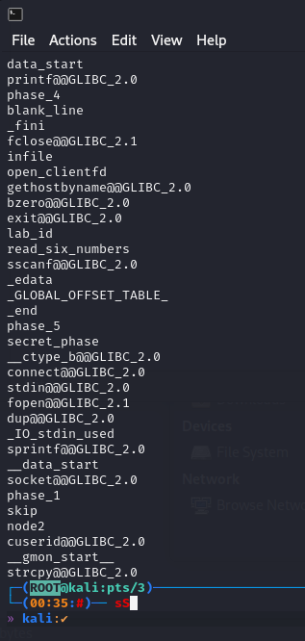
Phase 1
I then examined the object dump file for this file and quickly found sections in the assembly for each phase of the bomb.
Used objdump -d bomb > bomb-assembly
Looked at assembly code found

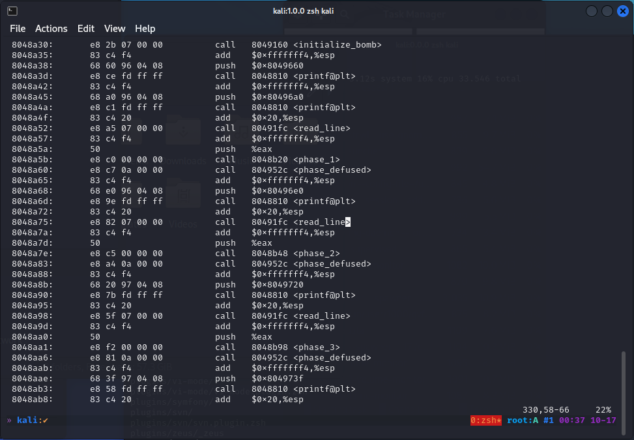

I found that for phase 1 it was comparing a string stored in eax so I decided to examine what charaters were in that register
Checking eax

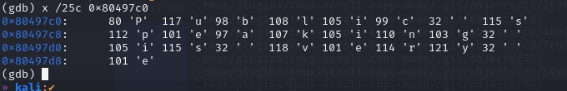
I found characters “public speaking is very e”
I checked strings and found “public speaking is very easy.” That is probably password 1.
Phase 1 password : public speaking is very easy.
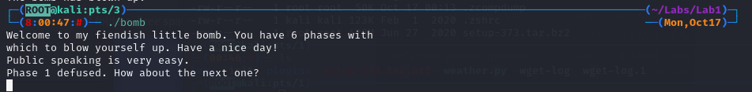
Phase 2
After successfully doing phase 1 I went back to object dump file and looked at phase 2 and found the read_six_numbers being called.
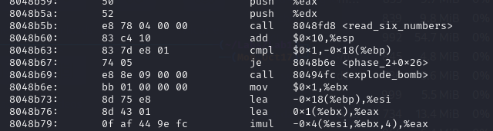
I checked Func read_six_numbers and found this. This is reading in 6 numbers in the format “1 2 3 4 5 6”
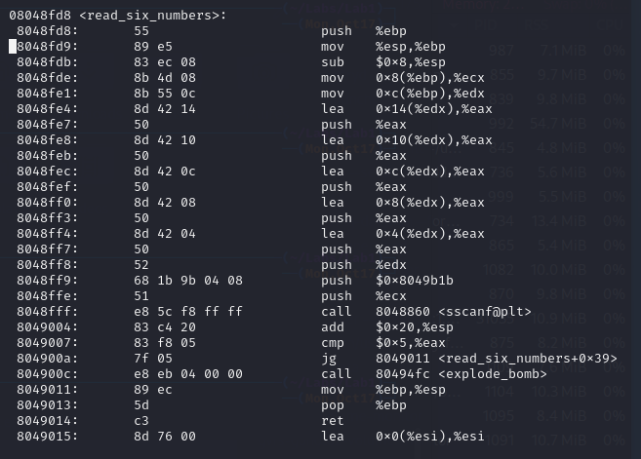
So using gdb I decided to debug what happens when I try six random numbers like 1 2 3 4 5 6.

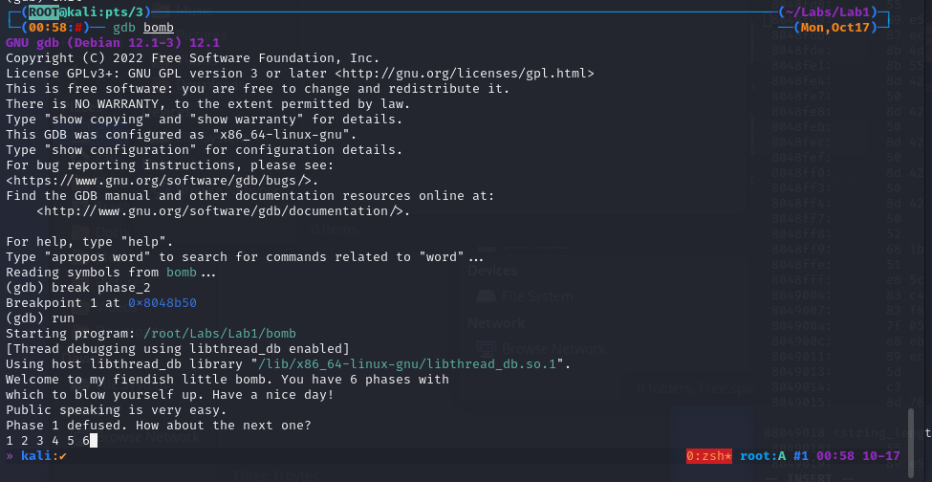
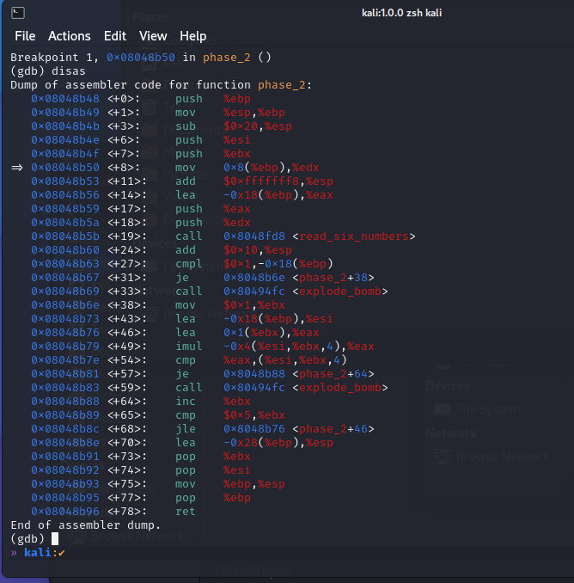
I found at 0x08048b63 it is comparing against 1 so first num must be 1! I then found a loop where it goes up to 5 and it probably comparing the rest of the numbers.

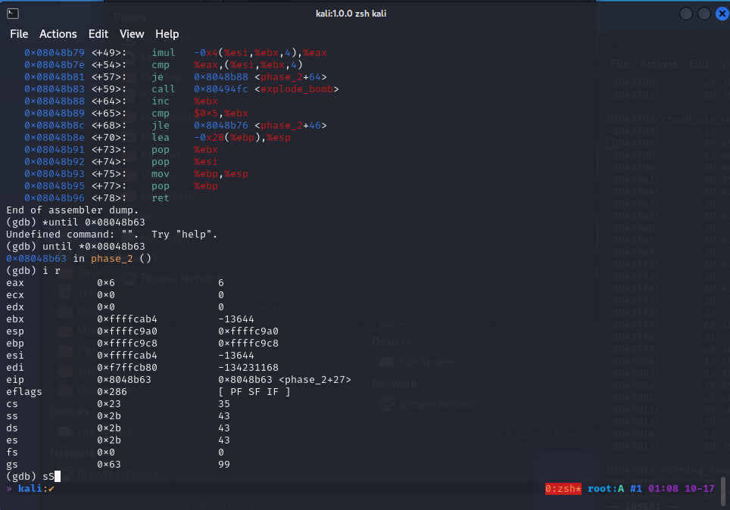
Use I r command to see contents of registers that was being compared, went through the loop and found 1 2 6 24 120 720. Which must be the password for the second phase

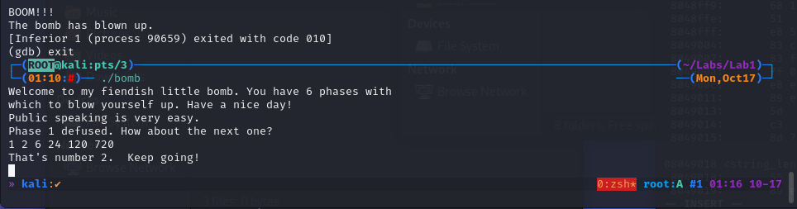
Phase 2 password: 1 2 6 24 120 720
Phase 3
Going back to the object dump file I went to the lines for phase 3 and noticed it was using scanf and then comparing several values in a certain location. So I decided to use a test string and look at what those values are.
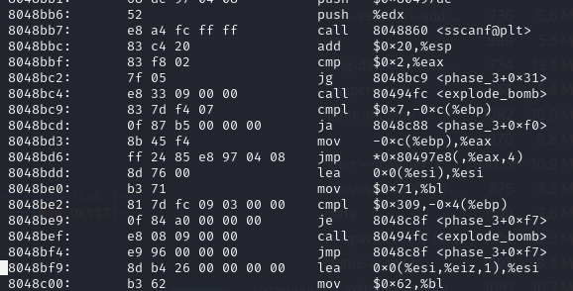

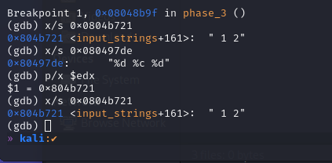
Here I was able to see that the format of the next key must be “int char int” and that the first number is 1 and followed by a 2, which seems odd since the format should have been int char int. This makes me think maybe 2 is actually part of the second number and the character is being checked elsewhere. I found that it was then comparing against the value $0xd6 which corresponds to value 214 which when combined with 2 means that the second integer must be 214.

For the character I found it was comparing to the value in -0x5(%ebp). 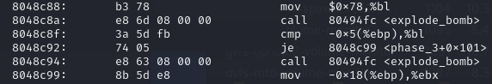
I exmained that register and found 62 in hex which corresponds to 98 in decimal and the character ‘b’.
So the password must be 1 b 214

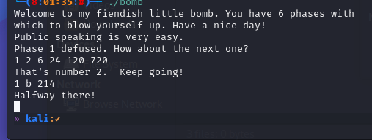
Phase 4
Looking at the assembly for phase 4 I found this func4 function that was being used. I also immediately recognized that func4 was calling itself so we are dealing with a recursive function.
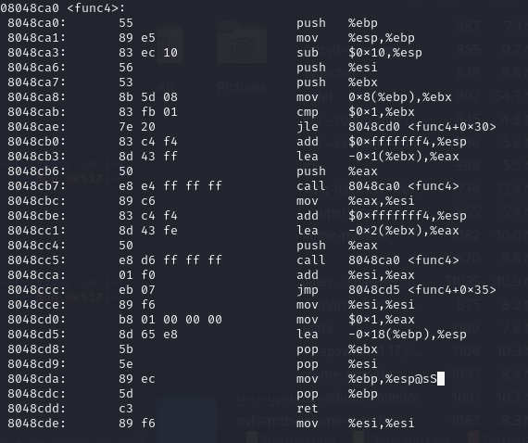
To solve this recursive function my first thought was to find the base case, which I found because the function was campaign its input to 1, so this must be the base case. During the recursive step the function calls itself twice and passes input-1 and input-2 into the calls. So it appears that f(x) = F(x-1)+f(x-2).
Going back to the assembly for phase 4 I found that whatever comes out of func4 has to equal hex 37 or dec 55. The function from func4 is clearly a Fibonacci sequence so we need a fib number to generate 55 and remember it will need to be n-1. So Fib number 10 corresponds to 55, meaning the password should be 9.

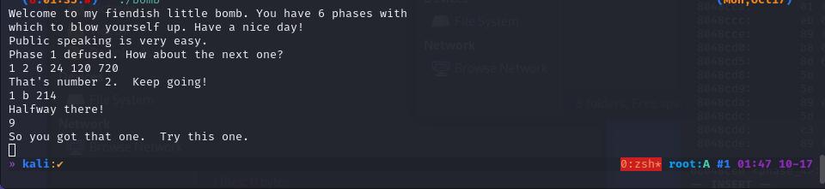
Phase 5
Staring on phase 5, looking at object code.
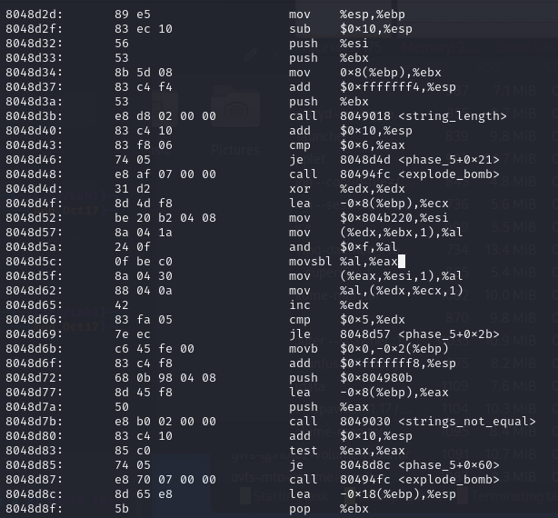
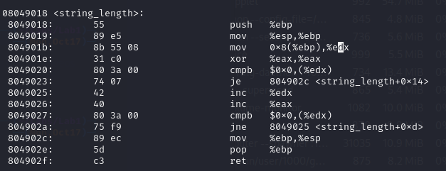
Looking at the assembly for phase 5 I quickly noticed several things. I found a string_length function and a register being used in a loop. I found the value being compared to be 6 which means the password for this phase must by 6 long. I also noticed that it was comparing against characters, so we are looking for 6 characters. I found it was comparing against a string located at 0x804980b which I decided to investigate while doing a test run.
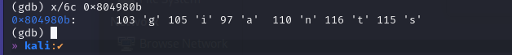
I found the string “giants” in the location and when I checked the compare I found that my input did not match the string that I entered. So the function here must be running some kind of cipher on my input and then comparing against the string “giants”
What I did notice was that the cipher seemed consistent and was therefore simply remapping letters. So I did some brute force mapping characters and found that “opekmq” mapped to giants’
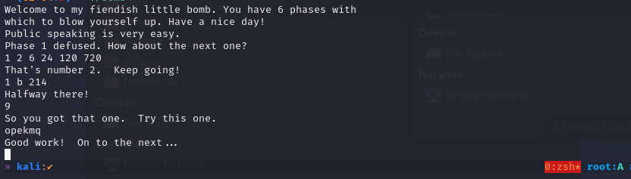
Password: opekmq
Phase 6
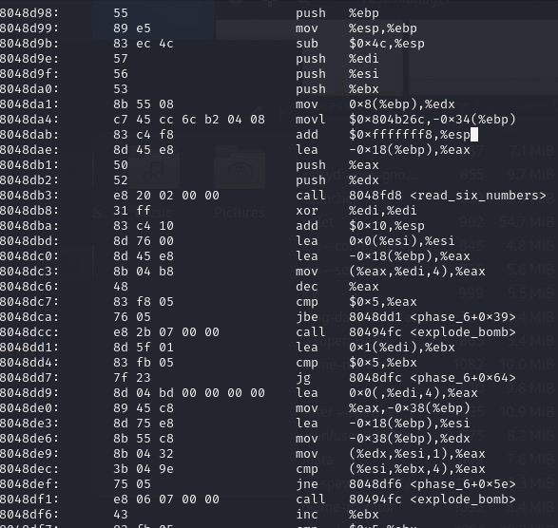
I started looking at the code for phase_6 and noticed that read_six_numbers is back so we are looking for 6 spaced out numbers again. I also noticed a compare that was checking if each number was larger than 5 and a bunch of loops that I didn’t understand. So far I know the password for this phase is 6 integers spaced out and they have to be less than 6, so I decided to go in and test.

I used the test string 1 2 3 4 5 6 and looked at the contents of %esi and %esi + 8. From This it appears that we are working with a linked list because each node has an element and a pointer to the next node. Based on the compare that I noticed earlier I tried putting the nodes in order from largest to smallest.
The values were node 1: 0x000000fd 2: 0x000002d5 3: 0x0000012d 4: 0x000003e5 5: 0x000000d4 6: 0x000001b0.
Putting those in order we get 4 2 6 3 1 5
