James Stallkamp
CS373
Lab 2
I started this lab by modifying the “exploit_start” script to produce 30,000 “A”s and then ran RM To MP3 with my input and with the immunity debugger attached. I found that EIP had been overwritten with A’s, HEX 41414141 = AAAA
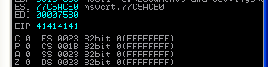

I then decided to try and find the exact number of As I had to fill the stack with to then fill EIP with whatever I wanted. To do this I used a string of As followed by 4 Bs and increased / decreased the number of As until I found the number where EIP would be filled with Bs. I found that number to be 26067.

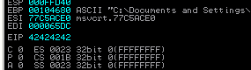
I then added trailing Cs to the string to see where this would land in memory. I quickly found the spot in memory that I could use to put my shell code.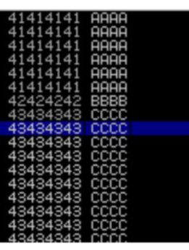
Rather than trying to directly overwrite $eip I went and found a jump esp instruction in one of the dll files. I found one at 0x01a8f23a.

Now all I must do is combine some NOPs with my junk, and shell code and this should cause the program to launch the calculator.
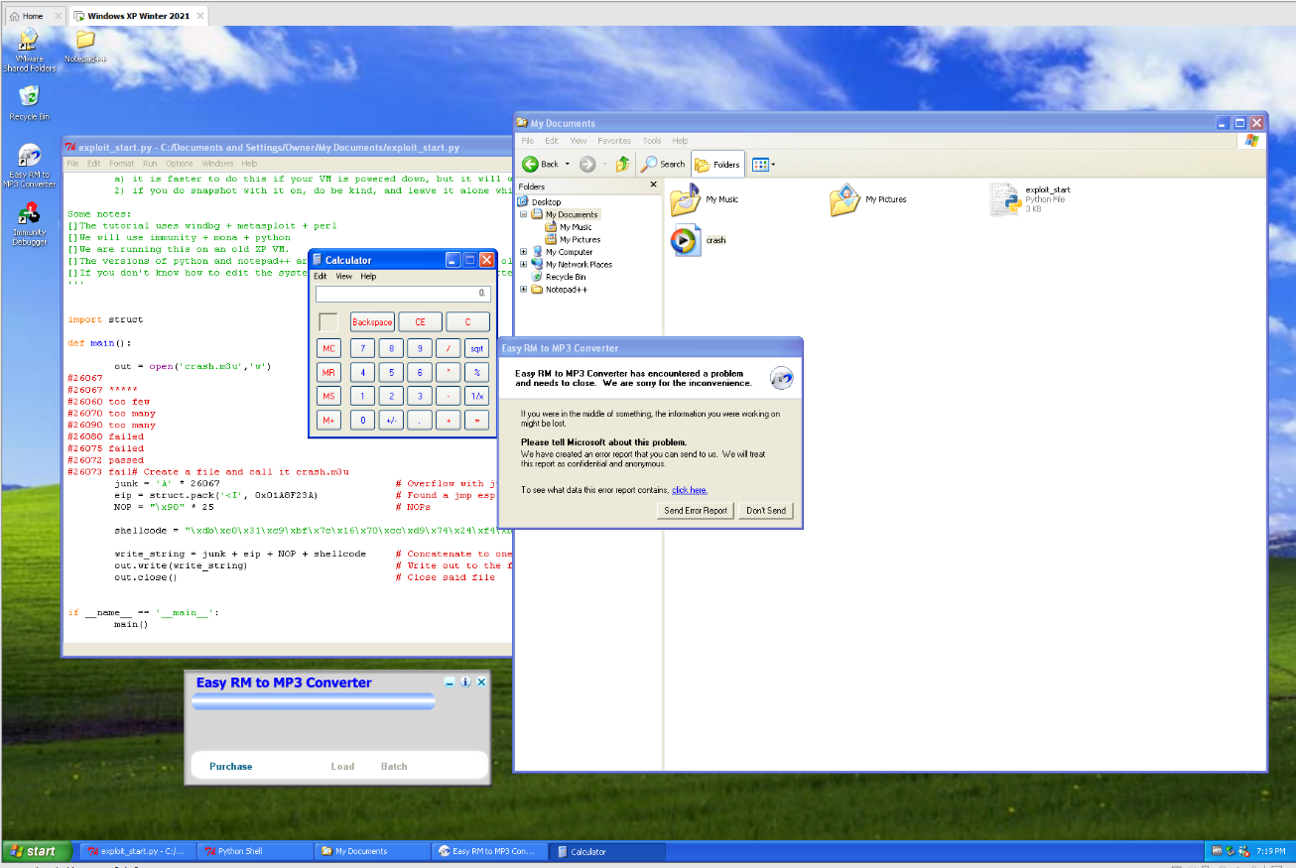
Success, as shown in the screenshot the calculator launches when my crash file is loaded into RM to MP3 Converter.
The main take away from this lab is how buffer overflows can be used to inject code that controls code execution and allow would be attackers to gain control of a system. Buffer overflows are one of the most common software vulnerabilities and developers and security experts need to be aware of them when designing software.

