James Stallkamp
CS373
Lab 3
Sample 1
For sample 1 I loaded up the file as an IQ file and set the input rate to 1000000 the bandwidth to 50.09 and then listened to the audio. Eventually I realized it was morse code and the code corresponded to
... .- -- .--. .-.. . /..---/.-- .- ... /-.-. .- .--. - ..- .-. . -.. / .- - / .---- ....- -.... ..... ..--- ----- -.- .... --.. / ... .- -- .--. .-. .--. / ..--- --
Translated to english.
“SAMPLE 2 WAS CAPTURED AT 146520KHZ SAMPRP 2M”
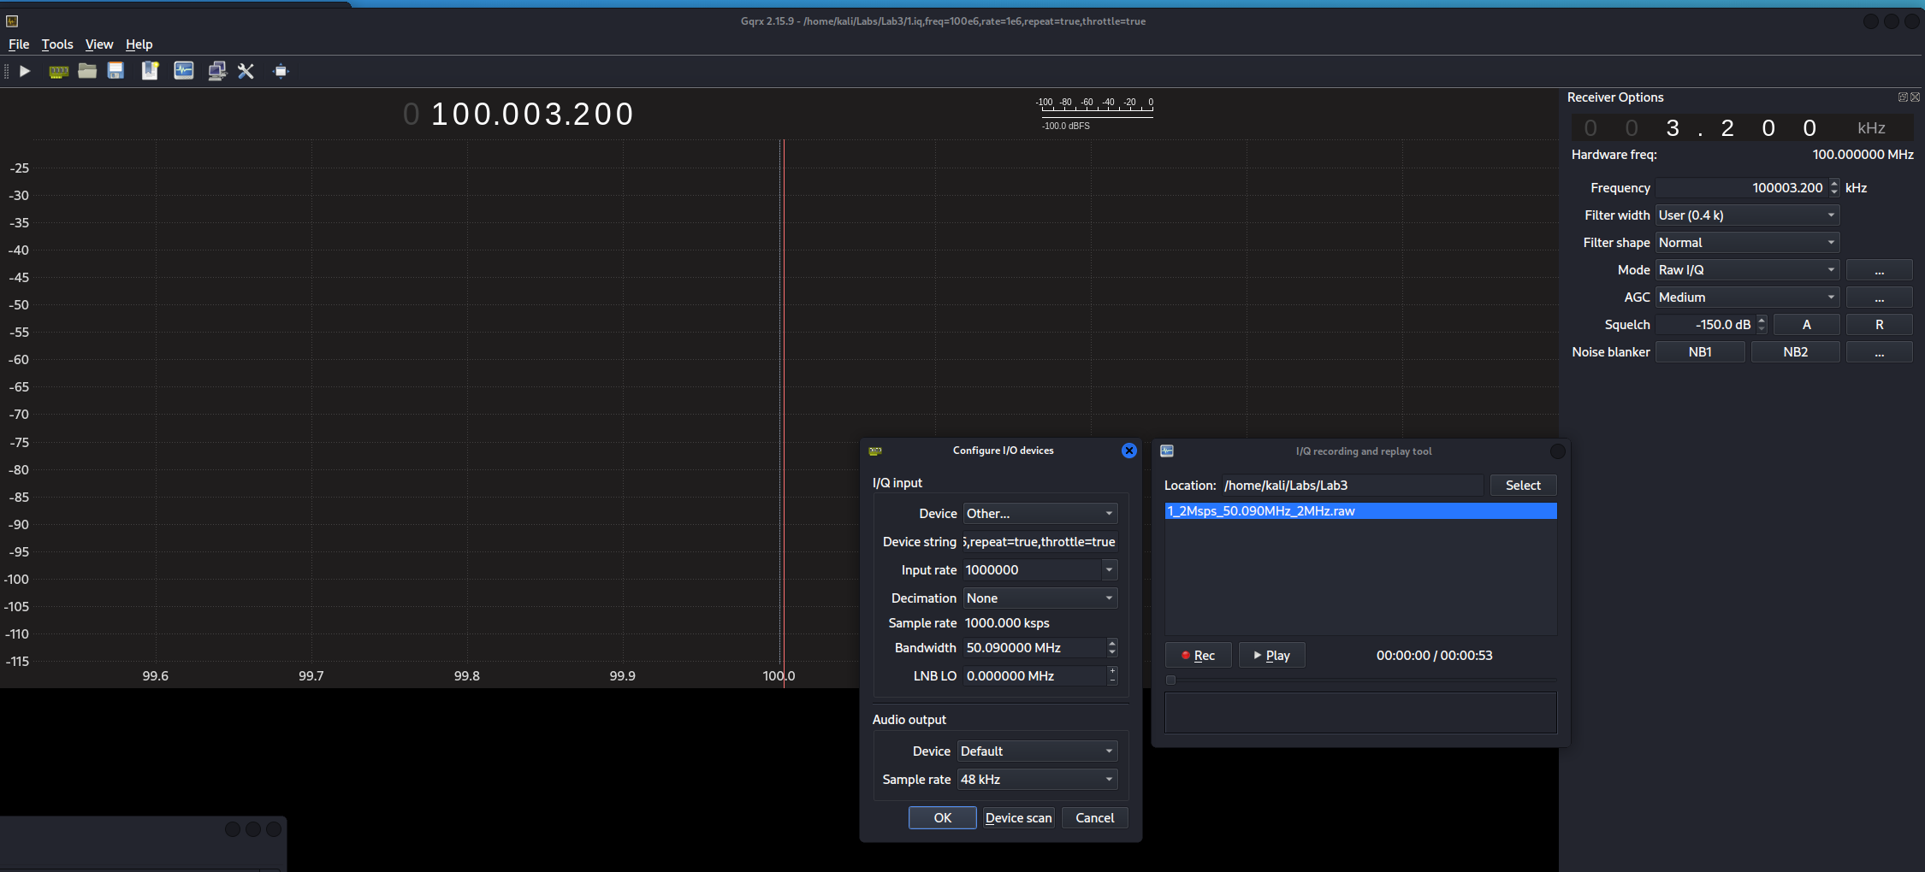
Here in the waterfall it becomes more clear that we are looking at dots and dashes.
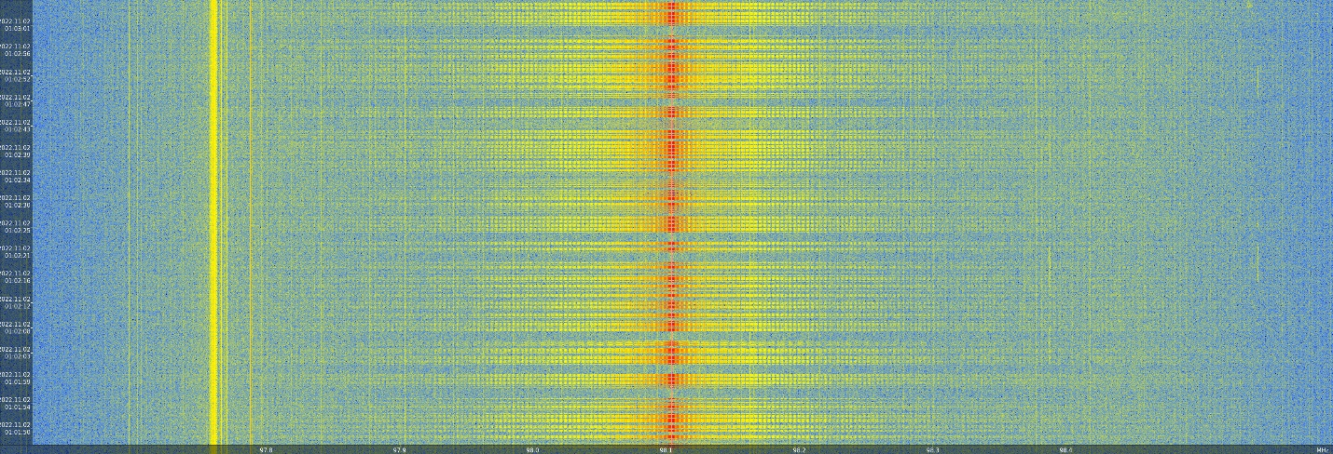
Sample 2
For sample 2 I loaded the iq file and set the input rate to 2000000 with the bandwidth set to 146520 KHM or 14.652 MHZ. I had to slightly adjust the frequency to actually make the audio understandable,
Eventually I was able to understand a message on repeat that says “The sample was captured at 7.171 MHZ and sampled 7m per second”
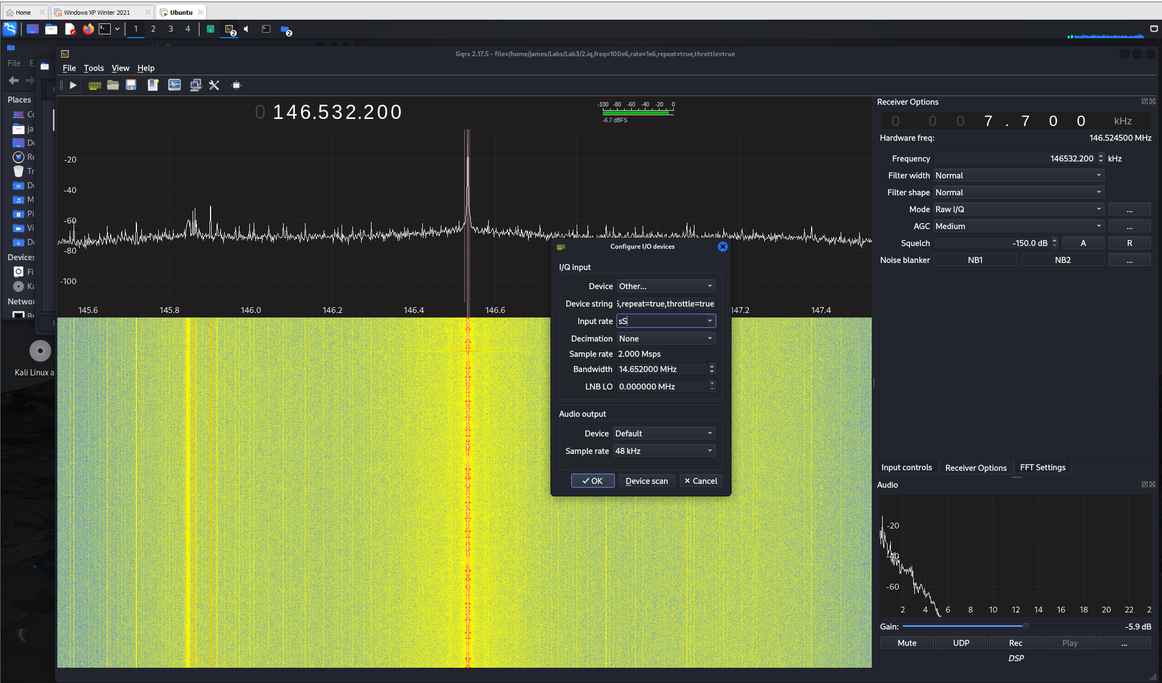

Sample 3
An error occurred when trying to extract files from the bz2 file and I was not able to get that working.

