James Stallkamp
CS373
Lab 4
Hardware Hacking
To start this lab my first thought was simply to try and identify which pins were active at all. I connected my logic analyzer and teenys and started up the logic software. At first, I tried connecting a random pin and checking for any signal, however after checking three or four pins I found nothing at all.
My next idea was to try and see if there was any signal on the pins at all, to do this I grabbed a digital multi meter and checked for voltage on each pin. I ended up on this idea because it was much faster to probe the pins rather than connect a pin and set up the logic analyzer. This did in fact reveal several pins that had signal on them.
I found several pins with line voltage on them, I tried connecting to those pins and using the logic analyzer, several of them had signals but I did find the 5v pin which stood out and some other pins that still gave no signal.
I attempted to use several of the analyzers built into the software to decode the signals but I was completely in the dark and nothing produced anything understandable.
I then went to this pin out diagram
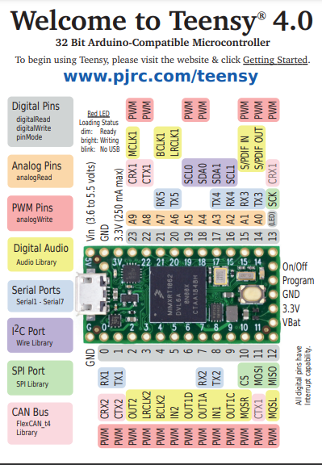
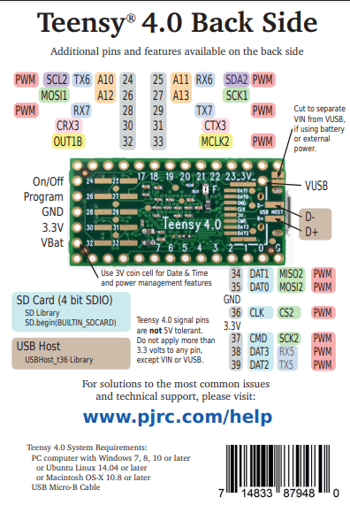
I quickly realized that most of the pins that yielded any signal were serial ports. I then set the analyzer to serial mode with all default settings and 9600 baud and one of them yielded a message!
I eventually was able to find the baud rates for each signal and found these results.

14 serial 4800 baud serial port This is not
17 serial 4800 baud serial port unfortunately try a different pin
15 nothing Rec/Trans
16 nothing Rec/Trans
20 serial port 9600 baurd When all else fails try serial ports
21 nothing
22 nothing
23 nothing
12 nothing
11 nothing
10 nothing
9 nothing
8 serial 19200 baud The secret message is THERE: IS NO SPOON Nearly Done with CS373
7 nothing
6 serial port 9600 baurd When all else fails try serial ports
5
4
3
2
1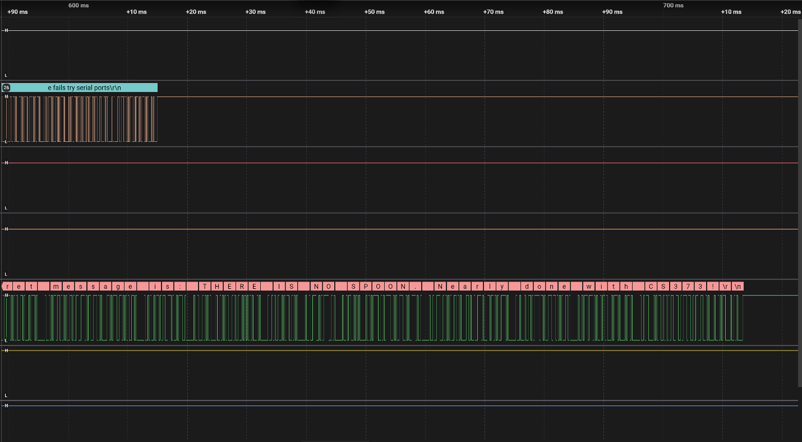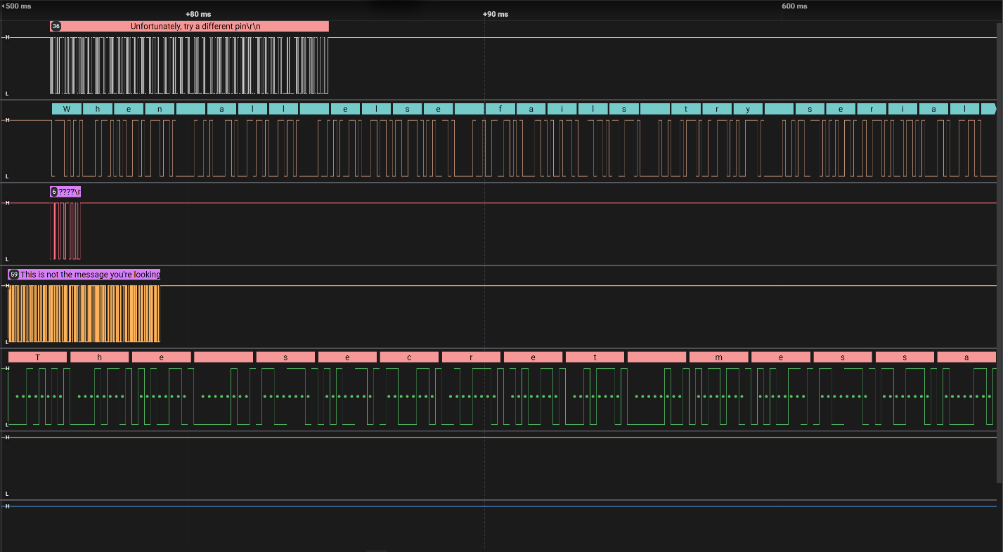

With that I was finished, The secret message is THERE: IS NO SPOON Nearly Done with CS373.

