James Stallkamp
CS444 Lab 1
Exercise 1:
Read assembly language materials
Exercise 2:
After jumping back from 0xffff0 the BIOS then does a few things first it resets the AX register and sets the ESP resgister. After that the BIOS then disables interrupts and resets the direction flag. After that the BIOS starts communicating with IO devices however im not certain what it is doing. Im assuming it is detecting / configuring present hardware.
Exercise 3:
First I found bootmain() in the boot.asm file, here is bootmain in assembly
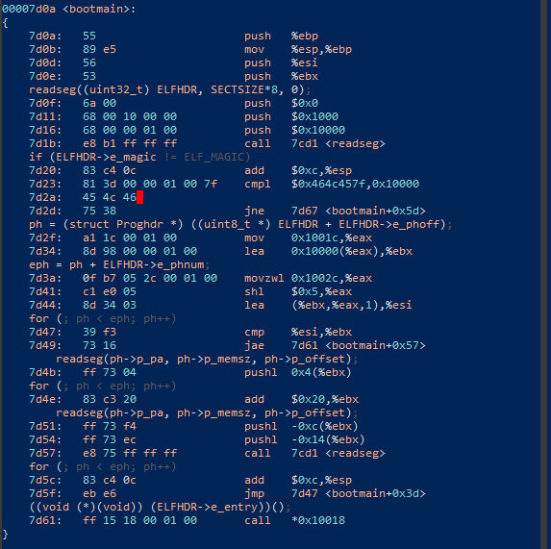
Then I repeated the process to find the readsect() section
The red box represents a line of c code that can be found in readsect() in main.c. The yellow box immediatly after a red box represents the assembly that corresponds to the c code.

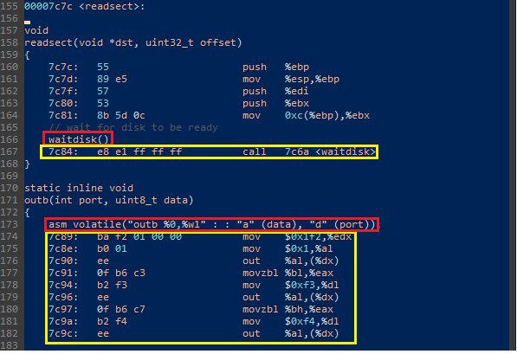

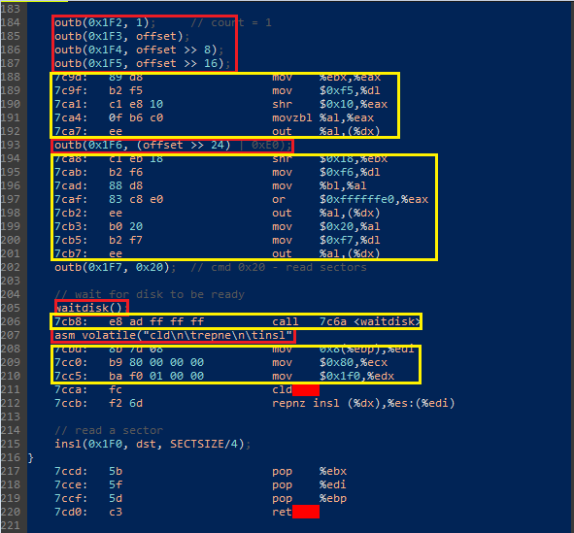
Exercise 4:
Reviewed how pointers work.
Exercise 5:
The first instruction that will break is the lgdt instruction because it loads data from an absolute address.
In my case the program wento an infinite loop because a fault was triggered.
Exercise 6
When bios enter boot loader
(gdb) x/8x 0x00100000
0x100000: 0x00000000 0x00000000 0x00000000 0x00000000
0x100010: 0x00000000 0x00000000 0x00000000 0x00000000
When boot loader enter kernel
(gdb) x/10x 0x00100000
0x100000: 0x1badb002 0x00000000 0xe4524ffe 0x7205c766
0x100010: 0x34000004 0x2000b812 0x220f0011 0xc0200fd8
0x100020: 0x0100010d 0xc0220f80
The set of data from the first breakbpoint is all 0s because the kernal hasnt been loaded. The data at the second break point contains information about the kernal
Exercise 7
The first instruction after the new mapping that would fail is:
f010002d: ff e0 jmp *%eax
This is becauase without paging it will jump to an invalid physical address or an address of all zeros.
Exercise 8
Code inserted
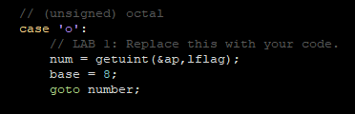

Exercise 9
The stack is initialized here in entry.S
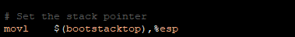
The address is shown in the .data section. The stack grows downward so bootstacktop is where the stack pointer will start at and grow down to the lower address of the .data section.
Bootstacktop:
Lower end of .data
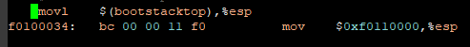
So the stack will be allocated from 0xf0108000 to 0xf0110000. $esp will start at 0xf0110000

Exercise 10
From looking at kernel.asm I put a break point at 0xf0100040
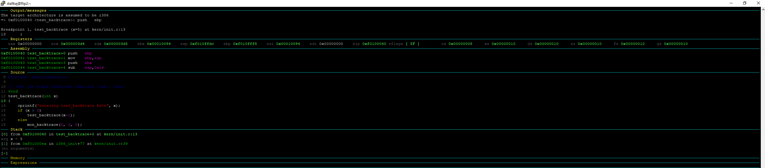
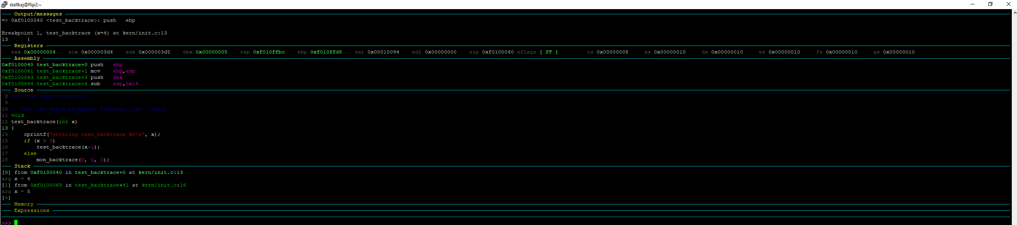
The difference between ebp between the two points is 0x20 so every time it is pushing 8 4 byte words. The words are
Return address
Saved ebp
Saved ebx
Abandoned
abandoned
abandoned
abandoned
var x for calling next test_backtrace

Exercise 11
Implemented backtrace function.
Exercise 12
Modified backtrace function to is display for each eip the function name, source file, and line number.

