Q1 .
p <- seq(1:1000)
c <- seq (1:2500)
pur_total <- seq (1:1000)
for (i in 1:1000) {
p<- rbeta(2500, 2,6)
for (j in 1:2500) {
c[j] <- rbinom(1,1,p[j])
}
pur_total[i] <- sum(c)
}
hist(pur_total)
# Min sales figure for prob less than that no is 0.05
min_sales <- quantile(pur_total, 0.05)
min_sales

On solving we get the min sales as 588.

Q2.
Note : I have included the random variate generation for both the distributions in the same code. But actually they will be run seapartely. I have comented at the appropriate location to this effect.

# for DE(0,1) random variate generate is as follows
mn <- 0
stdev <- sqrt(2)
# for Ln(0,1) , random variate generation is ::
mn <- exp(0.5)
stdev <- sqrt(exp(1)(exp(1)-1))
# initial sample size
n <- 0
# initial converence gap = 100
convergence_gap <- 100
while ( convergence_gap > .01) {
n <- n+10
s <- seq (1:n)
z <- seq (1:1000)
for (i in 1:1000) {
# for DE(0,1) random variate generate is ::
suniform <- runif(n, min=-0.5, max=0.5)
s<- mn-((abs(suniform)/suniform)*(log(1-2*(abs(suniform)))))
# for Ln(0,1) , random variate generation is ::
s <- rlnorm (n,meanlog=mn,sdlog=stdev)
# mean u = 0 , sd = sqrt(2)
xn<- mean(s)
z[i] <- ((xn-mn)*sqrt(n))/(stdev)
}
# decile calculation and comparision
decs <- seq (.1,.9,by=.1)
#for (i in decs) {
norm_values <- qnorm(decs,mean=mn, sd=stdev,lower.tail=TRUE, log.p = FALSE)
quant_values <- quantile(z, decs)
convergence_gap <- sum( abs( norm_values -quant_values))
}
print(n) ; print (convergence_gap)
Q4.
N <- seq (1:10000)
for ( i in 1:10000) {
x <- rgamma(1000,2,3)
# sample size of 1000 taken.
s<- 0
n<- 1
while (s <1) {
s <- s + x[n]
n<- n +1
}
N[i] <- n-1
}

hist (N)
Note : Visually the distribution seems to be a log-normal but cant concretely say to that effect, without analytical proof.

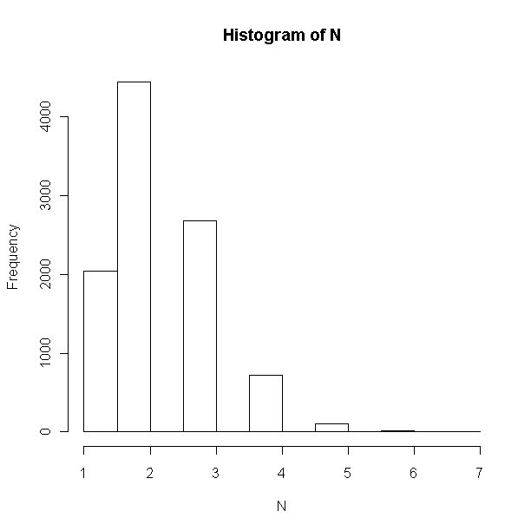

Q3.
- For the given pdf ,
sum(Pi) = ((1/3 –k)*2 )+ (1/3 +2k)=1
- 2/3 + 1/3 =1
- K is irrelevant and can take any real value
- E(X) = k-1/3 + 1/3 –k = 0
V(X) = E(x^2)-(E(x))^2
=E(x^2)-0 = E(x^2)
= 2*(1/3 –k)

- With method of moments (U^, sigma^) = (sum(Xi)/n , Sum(Xi^2)/n-(u^)^2

Since U^ from part (b) =0,

E(X^2) = sum(Xi^2)/n
- 2*(1/3-k) = sum(Xi^2)/n
- K = 1/3 – (sum(Xi^2)/2n

- Getting pdf in closed form , & letting 1/3-k =a , 1/3+2k =b

Note : Further proof written in hand

