Group C
Neosha Allen • Prince Hubbard • Nicholas Zankl

Bacchus Winery Milestone 2
This submission defines the winery database in MySQL, documents its revised entity relationships, and supplies sample records and a Python program to display every table. Three supplier records reflect the case study; all other tables contain six records.

Revised ERD
Figure 1 Procurement and production
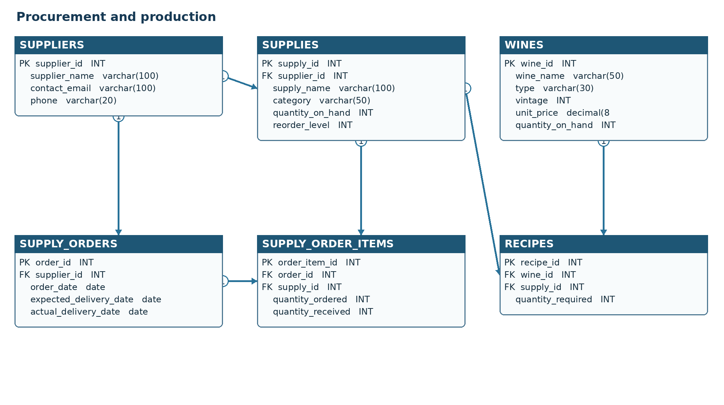
Figure 2 Distribution and labor
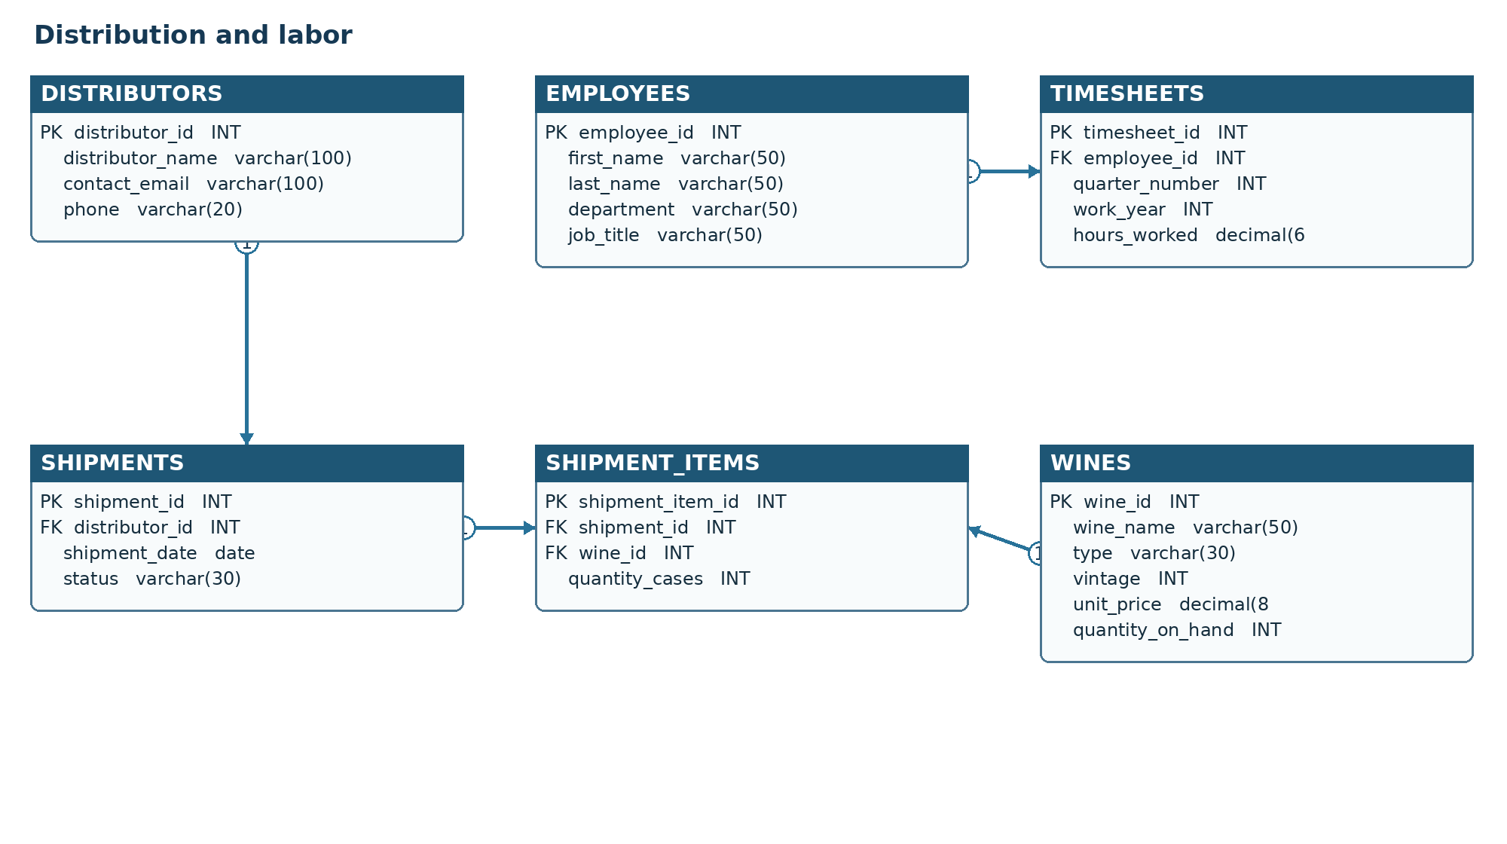
Both panels form one ERD. The wines box appears in each panel to show its links to recipes and shipment items; it represents one table. PK is a primary key, FK is a foreign key, and each arrow points from the one side to the many side. The table below lists every foreign key.
Parent | Child foreign key
suppliers | supplies.supplier_id
suppliers | supply_orders.supplier_id
supply_orders | supply_order_items.order_id
supplies | supply_order_items.supply_id
wines | recipes.wine_id
supplies | recipes.supply_id
distributors | shipments.distributor_id
shipments | shipment_items.shipment_id
wines | shipment_items.wine_id
employees | timesheets.employee_id

Business rules and normalization
- A supplier provides multiple supplies and may receive multiple supply orders. Each supply order has one supplier; its items name supplies and quantities.
- A wine may use multiple supplies, and a supply may appear in multiple wine recipes. The recipes table holds the quantity for each wine and supply combination.
- A distributor may receive multiple shipments. Each shipment contains wine line items with quantities in cases.
- Employees have quarterly timesheet records. The employee, year, and quarter combination is unique.
- Each table has atomic values and a primary key. Supplier, distributor, employee, and wine attributes live in their own tables; transaction headers hold header facts and line items hold item facts. Junction tables prevent repeating groups and keep non-key attributes dependent on their row key.

Data display screenshot
Tables 1 through 7
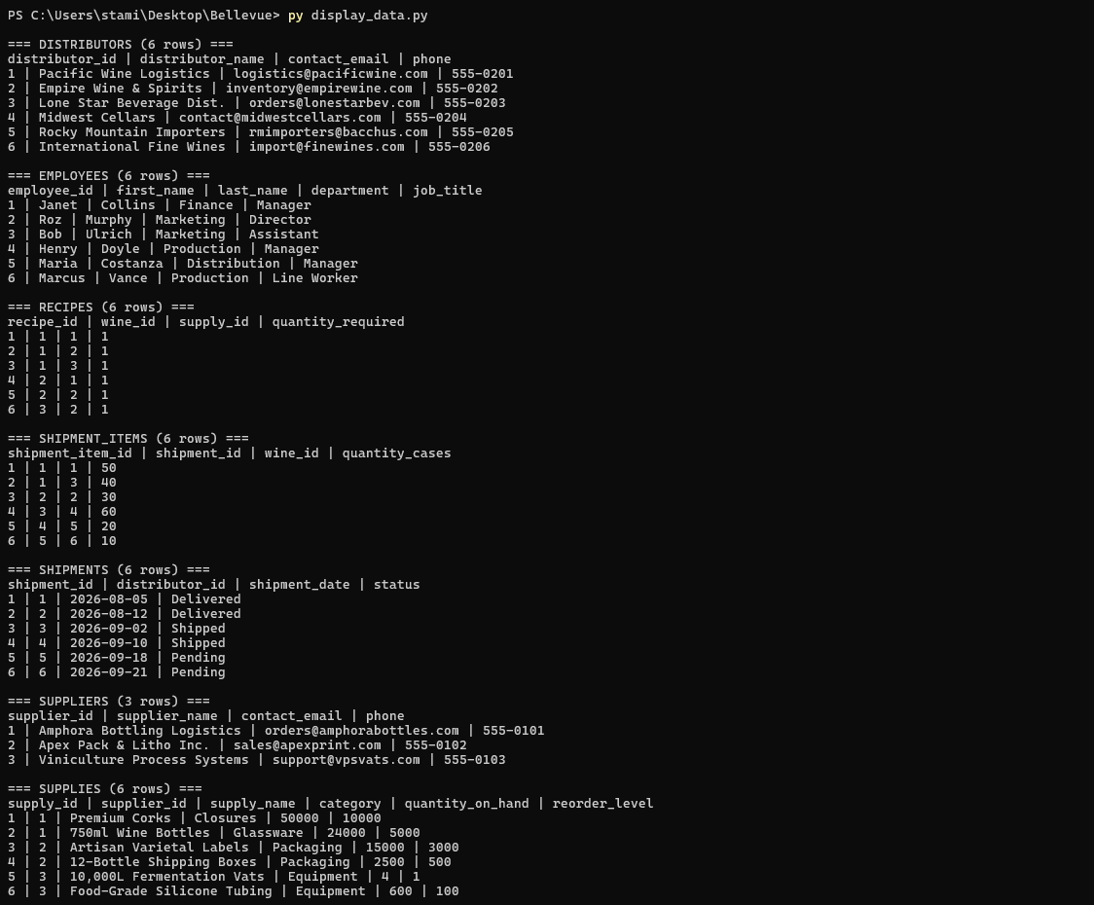
Tables 8 through 11 and completion
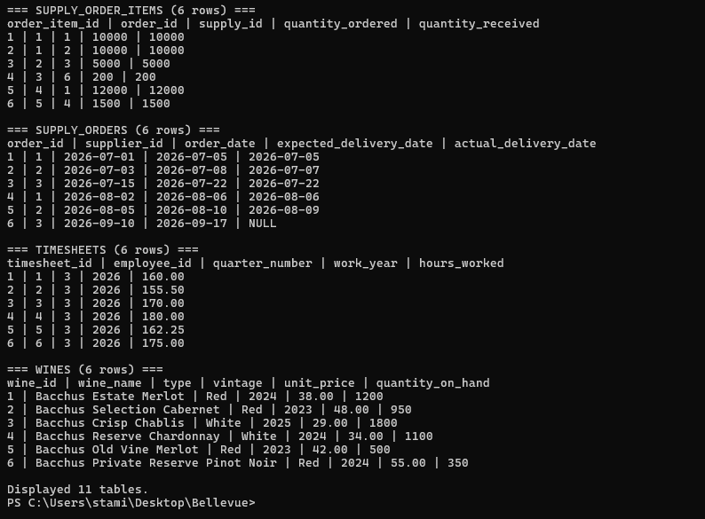
These screenshots document the Python run across all 11 tables and its completion message.

