Module 4.2 Assignment
MySQL Installation and SQL Functions
Prince Hubbard
CSD310-302E Database Development and Use
September 3, 2026

MySQL Installation and Initial Connection

MySQL Community Server 8.0.46 was installed and configured on a Windows computer. The command-line client connected successfully to the local MySQL server using the root account.
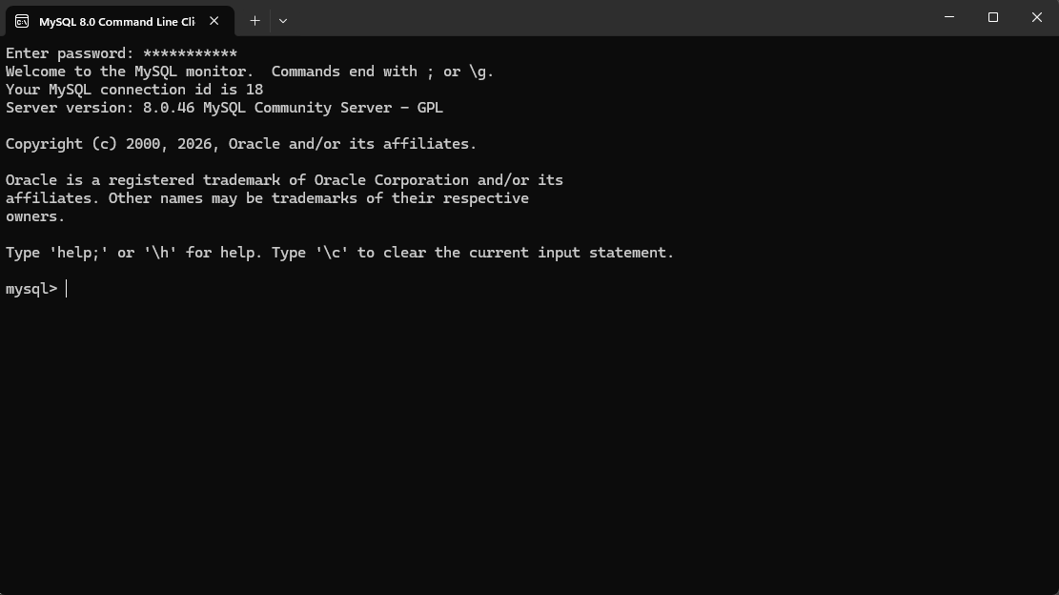
Figure 1. Successful initial connection to the MySQL server.

Movies Database

The following statements created the required database and displayed the databases available on the server:
CREATE DATABASE movies;
SHOW DATABASES;
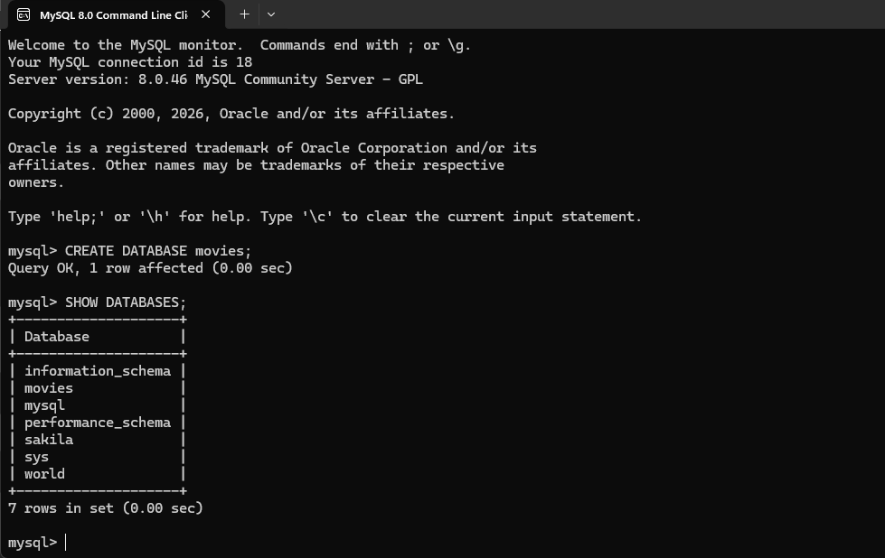
Figure 2. The SHOW DATABASES output confirms that the movies database was created.

SQL Function 1: UPPER()

The UPPER() function converts alphabetic characters in a text value to uppercase. It can be used to standardize names, abbreviations, codes, and other text before the data is displayed or compared.

SQL Statement
SELECT UPPER('Prince Hubbard') AS `Uppercase Name`;
Column alias: Uppercase Name
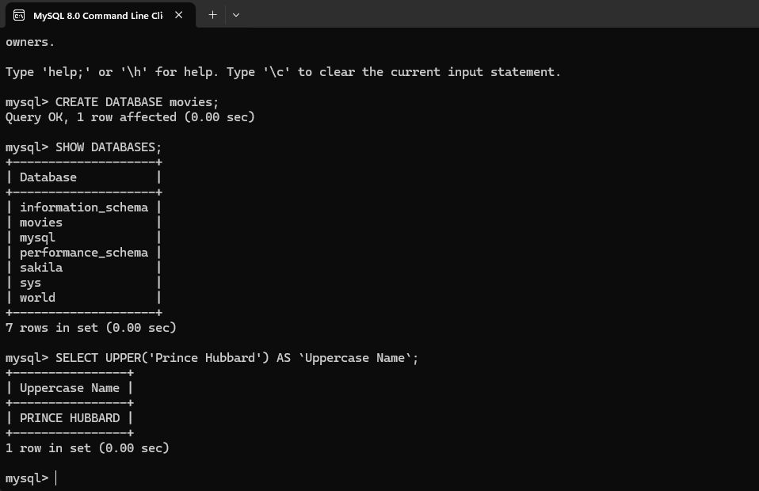
Figure 3. UPPER() converts the supplied name to uppercase.
Reference: https://www.w3schools.com/sql/func_mysql_upper.asp

SQL Function 2: CONCAT()

The CONCAT() function joins two or more text values into a single value. It can be used to combine first and last names, assemble addresses, or construct formatted course and identification numbers.

SQL Statement
SELECT CONCAT('CSD-', '310') AS `Course Number`;
Column alias: Course Number
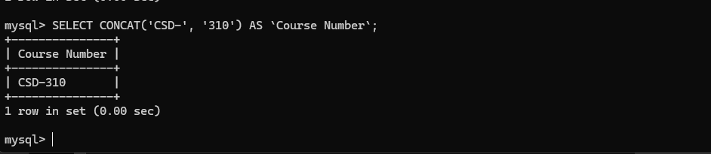
Figure 4. CONCAT() joins two text values to produce the course number CSD-310.
Reference: https://www.w3schools.com/sql/func_mysql_concat.asp

SQL Function 3: ROUND()

The ROUND() function rounds a numeric value to a specified number of decimal places. It is useful when displaying monetary amounts, averages, percentages, and measurements that should not include unnecessary digits.

SQL Statement
SELECT ROUND(123.4567, 2) AS `Rounded Value`;
Column alias: Rounded Value
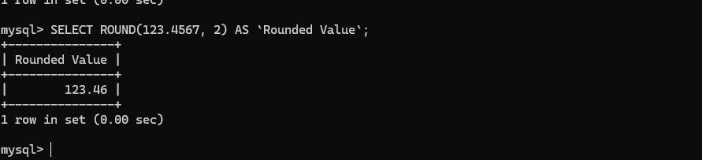
Figure 5. ROUND() rounds 123.4567 to two decimal places, producing 123.46.
Reference: https://www.w3schools.com/sql/func_mysql_round.asp

