Prince Hubbard
August 23, 2026
Module 2.2 Assignment: Visual Paradigm
Entity Relationship Diagram (ERD)
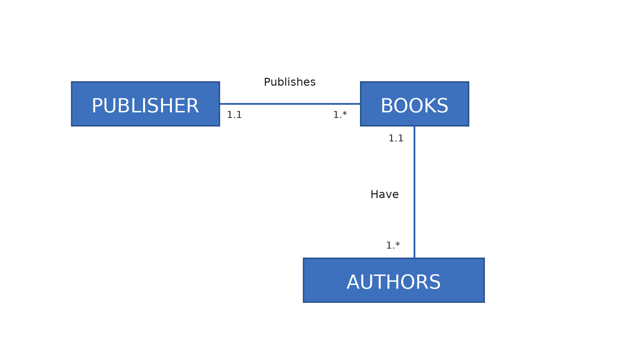
PUBLISHER publishes BOOKS; BOOKS have AUTHORS.

