DATABASE DEVELOPMENT AND USE
Movies!
Entity Relationship Diagram
STUDENT Prince Hubbard
ASSIGNMENT Module 4.3
COURSE CSD310-302E
DATE September 3, 2026

MOVIES DATABASE
Entity Relationship Diagram
This model places FILM at the center of the database. Its two foreign keys connect each film to one studio and one genre.
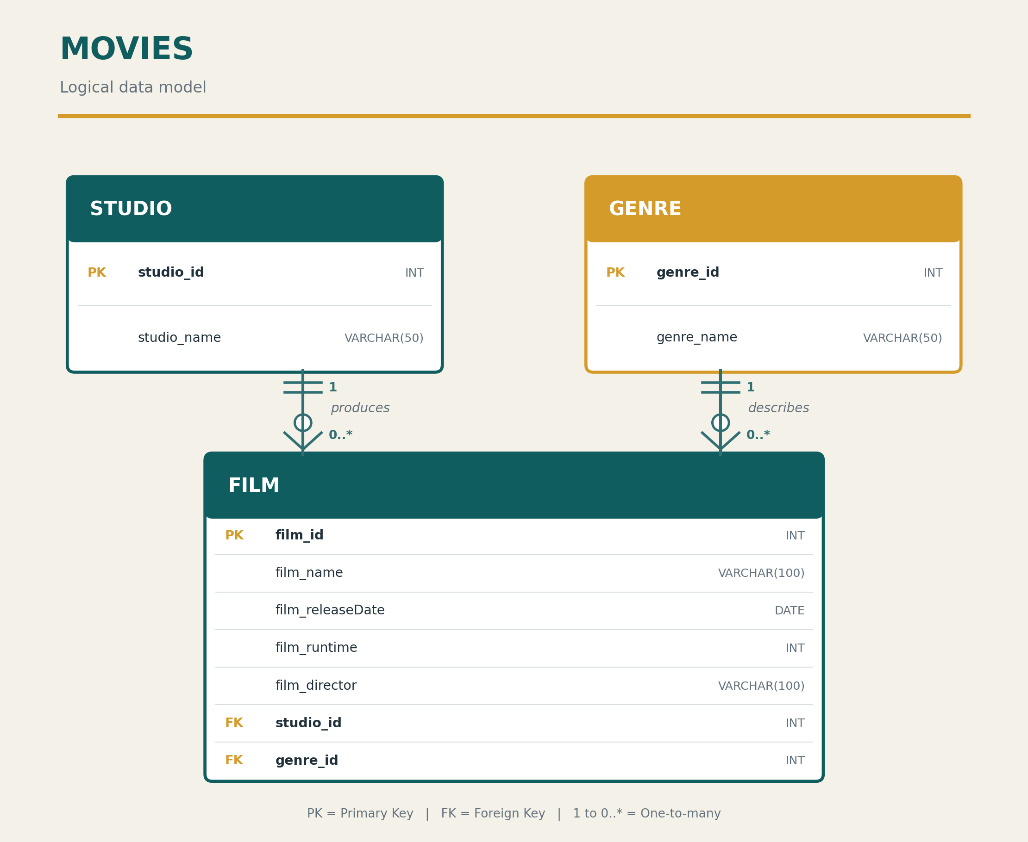
Figure 1. Movies database ERD in crow's-foot notation.
STUDIO TO FILM: One studio may produce zero or many films; every film belongs to exactly one studio.
GENRE TO FILM: One genre may describe zero or many films; every film uses exactly one genre.
KEY CONNECTIONS: FILM.studio_id references STUDIO.studio_id, and FILM.genre_id references GENRE.genre_id.

