Module 5.2 Assignment
Movies: Setup
Prince Hubbard
CSD310-302E Database Development and Use
September 3, 2026

Database Setup and Table Verification
The initialization script completed successfully. The final Query OK messages confirm that the sample film records were inserted. The SHOW TABLES statement confirms that the movies database contains the film, genre, and studio tables.
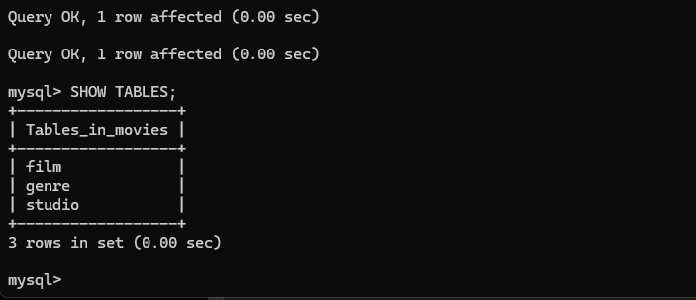
Figure 1. Successful script completion and the SHOW TABLES results.

Verified Tables
- film
- genre
- studio

Python Connection Test
The mysql_test.py program loaded the protected connection values from the local .env file and connected successfully to the movies database.
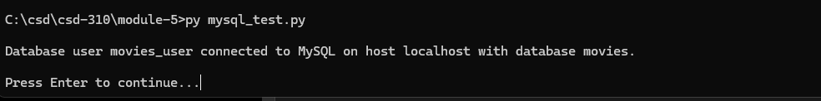
Figure 2. Successful Python connection to MySQL using the movies_user account.

GitHub Repository
Repository link: https://github.com/stamina4days/csd-310

