Design Overview
The Bacchus Winery database schema is designed to handle three core areas of the business: supply chain tracking, wine distribution, and employee labor management. To keep the system organized and prevent duplicate data, the database is normalized to Third Normal Form (3NF). The schema connects raw supply items (like corks, bottles, and labels) to finished wine products using a recipes bill-of-materials table. It also uses header and line-item tables (supply_orders/supply_order_items and shipments/shipment_items) so purchase orders and distributor shipments can include multiple items per transaction.
Client Requirements
- Supplier Delivery Performance: Stan and Davis Bacchus need a way to track vendor fulfillment times. Comparing expected_delivery_date against actual_delivery_date on supply orders lets management see vendor reliability and spot shipping delays.
- Inventory Tracking: The winery needs clear visibility into current supply stock and finished wine inventory. Storing current stock alongside reorder thresholds helps prevent running out of key materials during production.
- Wine Sales & Distribution: Maria Costanza needs sales tracking across distributor accounts. Recording case quantities by wine variety shows which distributors are buying the most and highlights low-performing wine lines.
- Quarterly Employee Hours: Janet Collins and department managers need structured labor reports. Tracking hours at the quarterly level makes it easy to review labor distribution across production, marketing, and finance.
Technical Assumptions & Constraints
- Foreign Keys: Every parent-child relationship uses explicit foreign key constraints to enforce referential integrity. Master tables use ON DELETE RESTRICT to protect core records, while line items use ON DELETE CASCADE.
- Delivery Gap Tracking: Delivery reports rely on complete date fields (expected_delivery_date and actual_delivery_date). A NULL actual delivery date indicates an open or pending order.
- Quarterly Reporting: Labor reports group timesheets data by quarter_number and work_year across departments.
- Engine Standard: Tables are created using the InnoDB storage engine in MySQL for foreign key support and transactional integrity.
Figure 1: Entity-Relationship Diagram (ERD) for Bacchus Winery Database Schema
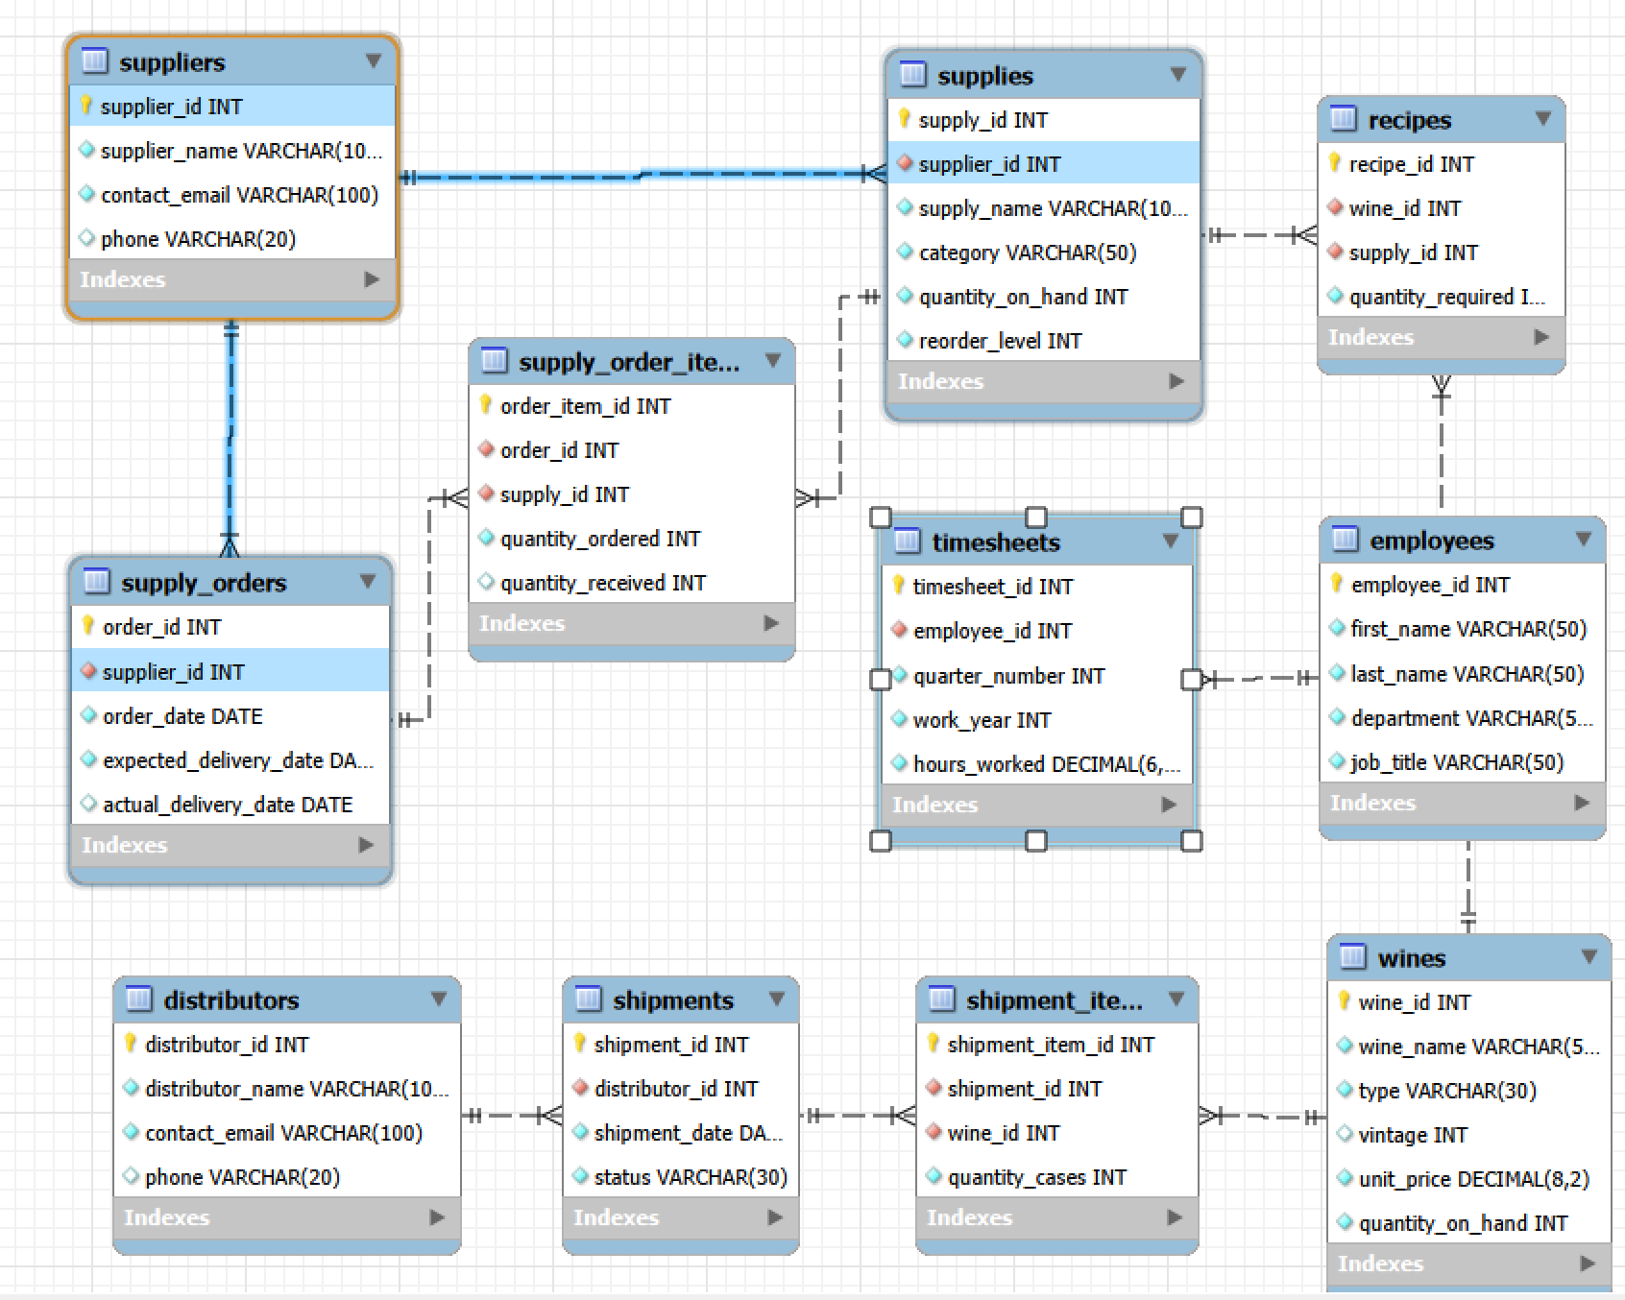
Note: This diagram illustrates the physical database architecture and entity relationships for the Bacchus Winery database using Crow's Foot notation. Primary keys (PK), foreign keys (FK), and 1:N cardinality constraints are organized across four operational modules: supply procurement, bill-of-materials recipe tracking, distributor wine shipments, and quarterly employee labor reporting.

Schema Structure by Module
1. Supply Chain & Raw Materials
- suppliers: Holds vendor contact information, including company names, emails, and phone numbers.
- supplies: Tracks raw materials like corks, bottles, labels, and boxes. It includes quantity_on_hand and reorder_level columns to flag low inventory before running out.
- supply_orders: Stores top-level order dates and vendor IDs, tracking when an order was placed, when it is expected, and when it actually arrived.
- supply_order_items: Acts as the line-item junction table for orders. This allows a single order to contain multiple supply items with distinct quantity_ordered and quantity_received values.
2. Wine Production & Bill of Materials
- wines: Stores finished wine product details (Merlot, Cabernet, Chablis, Chardonnay), including wine type, vintage, wholesale price, and cases on hand (quantity_on_hand).
- recipes: Serves as the bill of materials connecting supplies to wines. It defines how many units of each raw supply (quantity_required) are needed to make a specific wine, linking inventory directly to production.
3. Sales Distribution & Shipments
- distributors: Stores distributor account info and contact details.
- shipments: Tracks commercial delivery events sent to a distributor, including shipment_date and fulfillment status.
- shipment_items: Connects individual shipments to specific wines. This line-item layout allows the winery to send mixed case shipments with multiple wine types under one shipment ID.
4. Employees & Labor Tracking
- employees: Stores worker records, departments (Production, Finance, Marketing), and job titles.
- timesheets: Records employee work hours. Aggregating hours at the quarterly level (quarter_number, work_year, hours_worked) matches the client reporting requirements without filling the database with daily clock-in noise.
Database Normalization (3NF)
The schema satisfies Third Normal Form (3NF) across every table:
- 1NF: Every table uses a surrogate Primary Key (AUTO_INCREMENT), and every column holds single, atomic values.
- 2NF: The design eliminates partial key dependencies. Using standalone primary keys on line-item tables (order_item_id, shipment_item_id) ensures all non-key columns depend on the entire primary key.
- 3NF: Transitive dependencies are removed. Order headers only track order-level details (dates, vendor/distributor IDs), while line-item tables handle item-specific quantities. Shared attributes like vendor details or regions are stored in parent tables and retrieved using INNER JOIN operations when running queries.

