Bacchus Winery Management Reports
Case Study Project Milestone 3
Group | Group C
Members | Neosha Allen, Prince Hubbard, Nicholas Zankl
Date | September 25, 2026
Assignment | CSD-310 Module 10.1 Milestone #3

Executive Summary
This milestone presents three database reports that support the Bacchus Winery case study decisions. The reports evaluate supplier reliability, distributor sales activity, and quarterly labor usage. Together, they give management a clear view of operational performance using the normalized database created in the earlier milestones.
Management takeaway: Supplier deliveries are generally on time, Pacific Wine Logistics is the top distributor by cases and value, and Production has the highest quarterly labor demand.

Revised Entity Relationship Diagram
The revised ERD below preserves the Third Normal Form design from Milestone 2. It separates procurement and production from distribution and labor while retaining the foreign-key relationships required by the three reports.
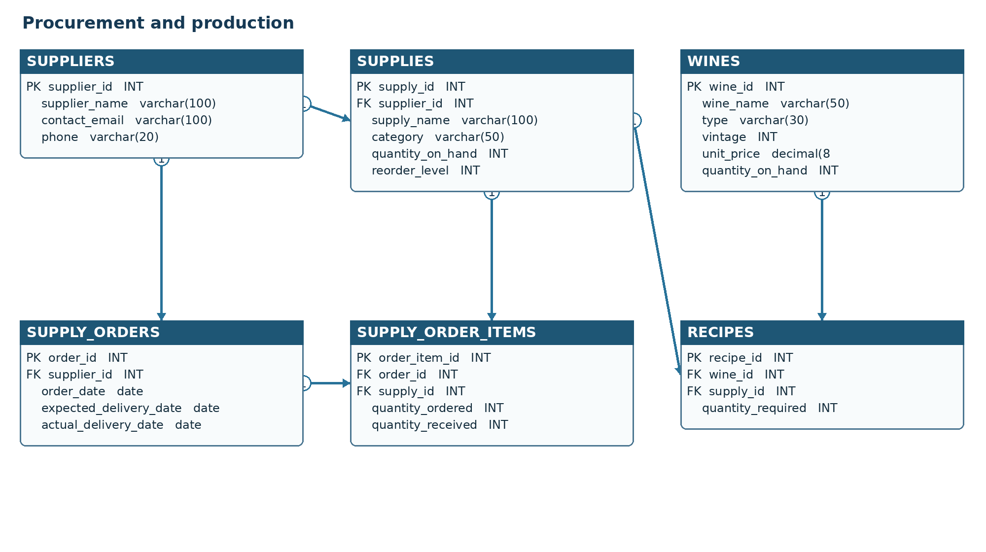
Figure 1A Procurement and production tables
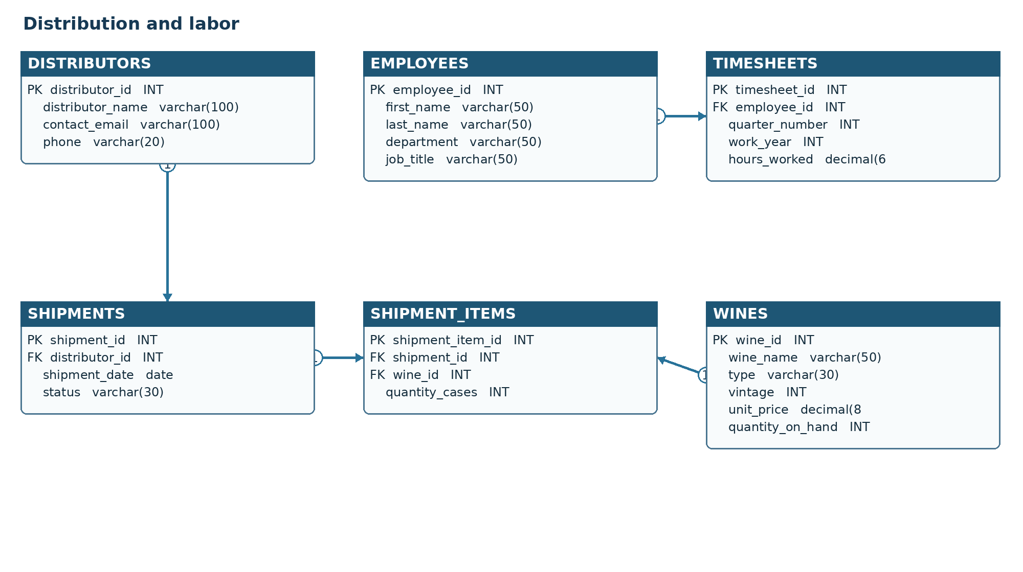
Figure 1B Distribution and labor tables

Report 1 Supplier Delivery Performance

Business Purpose
This report compares expected and actual delivery dates by supplier. It helps Stan and Davis Bacchus identify reliable vendors, monitor open orders, and recognize delivery delays before they affect production.
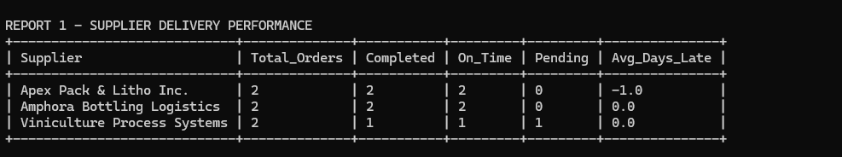
Figure 2 Results from supplier delivery performance
Result interpretation: Apex Pack and Litho delivered both completed orders one day early. Amphora delivered both completed orders on time. Viniculture Process Systems has one on-time completed order and one pending order that requires follow-up.

Report 2 Distributor Sales Performance

Business Purpose
This report totals shipped wine cases and estimated wholesale value for each distributor. Maria Costanza can use it to compare account activity, prioritize strong relationships, and identify accounts that need attention.
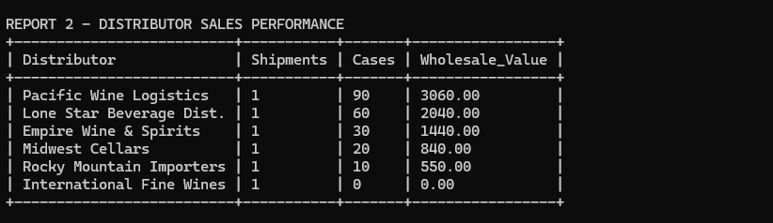
Figure 3 Results from distributor sales performance
Result interpretation: Pacific Wine Logistics is the leading account with 90 cases and an estimated wholesale value of $3,060. International Fine Wines has a shipment record but no associated cases, so its order should be reviewed.

Report 3 Quarterly Employee Hours by Department

Business Purpose
This report summarizes quarterly labor hours by department. Janet Collins and department managers can use it to compare staffing demands, review workload distribution, and plan future labor assignments.
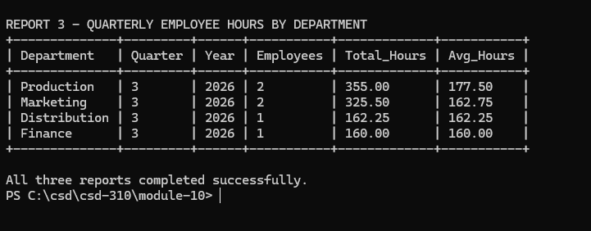
Figure 4 Results from quarterly employee hours by department
Result interpretation: Production recorded the most Q3 labor at 355 hours, followed by Marketing at 325.5 hours. Production also has the highest average hours per employee, which may justify reviewing workload and staffing capacity.

Assumptions and Query Notes
- A delivery is on time when the actual delivery date is on or before the expected delivery date.
- A NULL actual delivery date represents an open or pending supply order and is excluded from the average delivery variance.
- Wholesale value is estimated as shipped cases multiplied by the wine unit price stored in the wines table.
- Quarterly labor results use the quarter number and work year stored in each timesheet record.
- Distributor accounts with shipments but no shipment items remain visible so management can investigate incomplete transactions.

Files Included in Submission
File | Purpose
bacchus_reports.py | Runs all three management report queries.
Group_C_Milestone_3.docx | Documents the ERD, report descriptions, results, and assumptions.

