MODULE 7.2 ASSIGNMENT
Test Cases: city_country()
Student: Prince Hubbard
Course: CSD325-302E Advanced Python
Assignment: Module 7.2 -- Test Cases
Date: September 7, 2026

Initial Function and Test
1. Initial city and country output
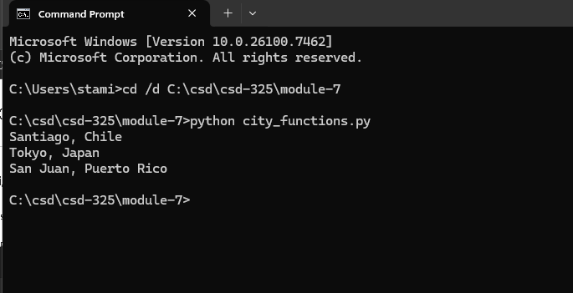
2. Initial unit test -- PASS
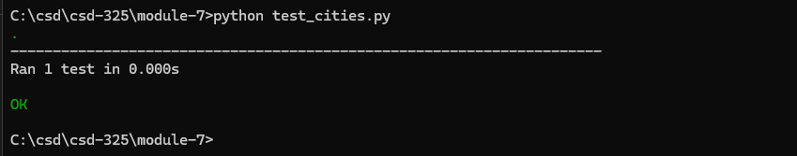

Adding Population
3. Population made required -- expected FAIL
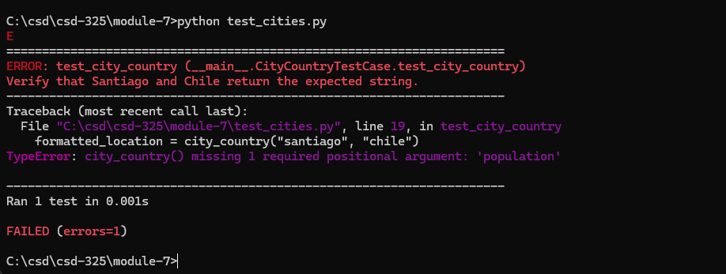
4. Population made optional -- PASS
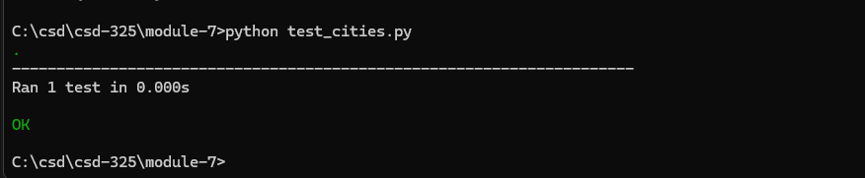

Adding Language
5. Language made required -- expected FAIL
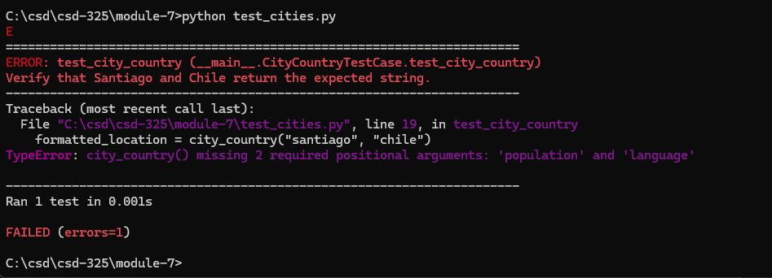
6. Language made optional -- PASS
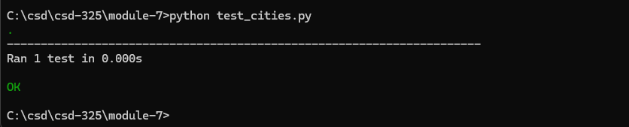

Final Program Output
The final program calls city_country() three ways: with city and country; with population added; and with both population and language added.
7. Final city_functions.py output
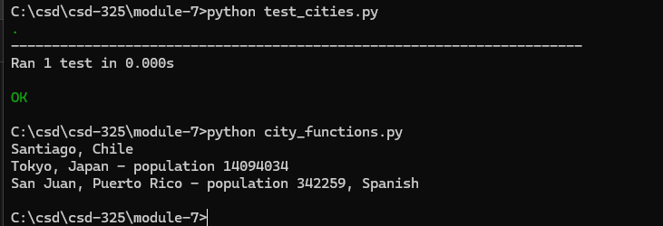

Final Verification
The final test passed with both optional parameters omitted. The final program also produced each required output format without errors.

