Module 9 API Assignment
Prince Hubbard
CSD-325 Advanced Python
Purpose. This assignment demonstrates how Python uses the requests library to connect to web APIs, read JSON responses, and present the same data in raw and formatted forms.

Open Notify Tutorial and Connection Test
The program uses the instructor-provided Open Notify URL, reports a successful HTTP status code, prints the raw JSON response, and formats the astronaut names and spacecraft.
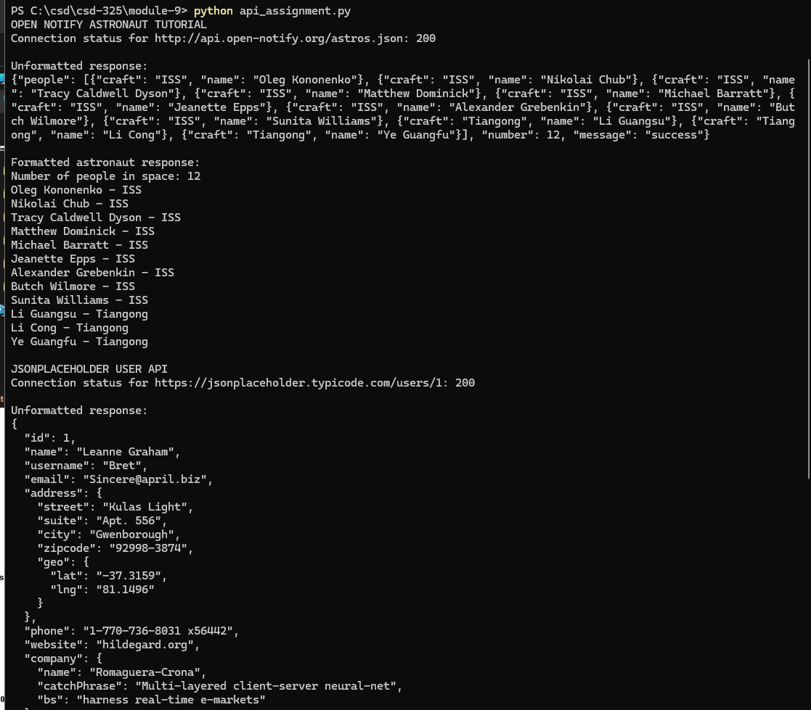
Figure 1. Open Notify connection, astronaut results, and custom API connection

Custom API Results
The custom example uses JSONPlaceholder. The program prints the raw JSON response and then displays selected user, address, and company fields in a readable format.
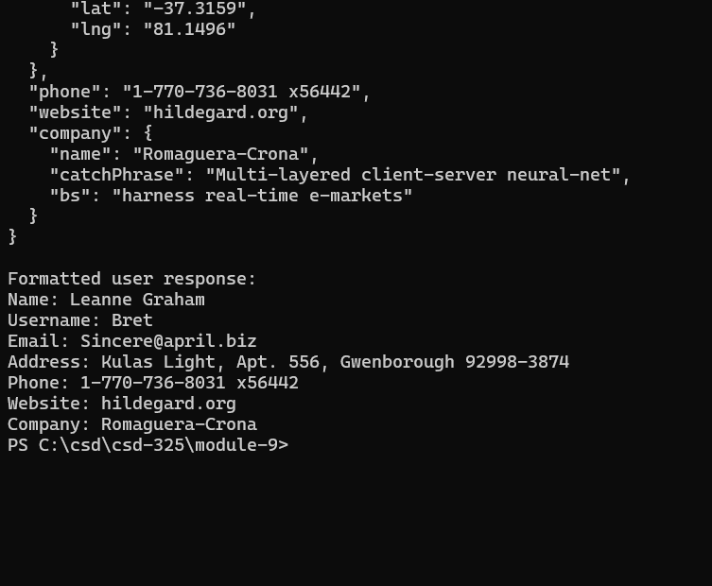
Figure 2. Completion of the raw response and formatted JSONPlaceholder results

Python Source Code
"""Module 9 API Assignment.

Author: Prince Hubbard
Course: CSD-325 Advanced Python
Assignment: Module 9 APIs

This program retrieves JSON data from the Open Notify and JSONPlaceholder
APIs. It tests each connection, prints the unformatted response, and then
prints selected fields in a readable format.
"""

import json

import requests

ASTRONAUT_URL = "http://api.open-notify.org/astros.json"
USER_URL = "https://jsonplaceholder.typicode.com/users/1"

def request_json(url):
"""Request JSON data and return the response and decoded object."""
response = requests.get(url, timeout=15)
print(f"Connection status for {url}: {response.status_code}")
response.raise_for_status()
return response, response.json()

def show_astronauts():
"""Retrieve and display the people currently reported in space."""
print("OPEN NOTIFY ASTRONAUT TUTORIAL")
response, astronaut_data = request_json(ASTRONAUT_URL)

print("\nUnformatted response:")
print(response.text)

print("\nFormatted astronaut response:")
print(f"Number of people in space: {astronaut_data['number']}")
for person in astronaut_data["people"]:
print(f"{person['name']} - {person['craft']}")

def show_jsonplaceholder_user():
"""Retrieve and display one sample user from JSONPlaceholder."""
print("\nJSONPLACEHOLDER USER API")
response, user_data = request_json(USER_URL)

print("\nUnformatted response:")
print(response.text)

address = user_data["address"]
company = user_data["company"]
print("\nFormatted user response:")
print(f"Name: {user_data['name']}")
print(f"Username: {user_data['username']}")
print(f"Email: {user_data['email']}")
print(
"Address: "
f"{address['street']}, {address['suite']}, "
f"{address['city']} {address['zipcode']}"
)
print(f"Phone: {user_data['phone']}")
print(f"Website: {user_data['website']}")
print(f"Company: {company['name']}")

def main():
"""Run both API demonstrations without hiding connection failures."""
try:
show_astronauts()
except requests.RequestException as error:
print(f"Open Notify request failed: {error}")
print("Verify the URL and internet connection, then run again.")

try:
show_jsonplaceholder_user()
except requests.RequestException as error:
print(f"JSONPlaceholder request failed: {error}")

if __name__ == "__main__":
main()

