Initial Program Flowchart
This diagram models the execution of the original sitka_highs.py program before any menu, low-temperature, or repetition features were added.
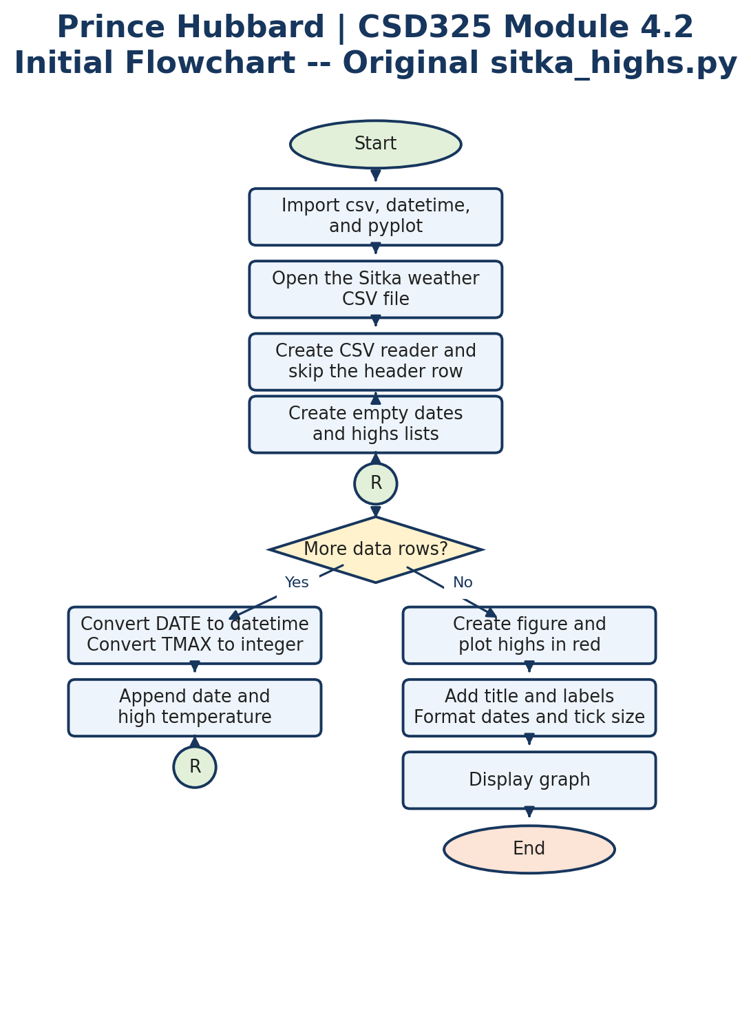
Figure: Program execution flow

Revised Program Flowchart
This diagram reflects the completed program: the CSV data is loaded once, the menu repeats, highs display in red, lows display in blue, invalid choices are handled, and Exit ends the program with a message.
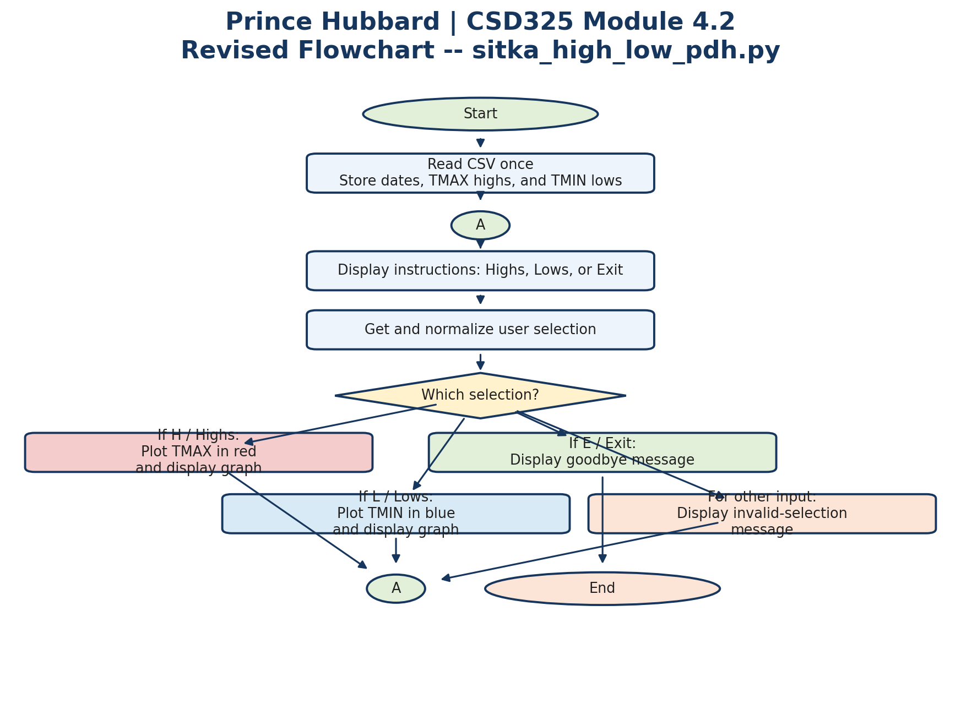
Figure: Program execution flow

