Module 10.2 GUI ToDo
Prince Hubbard
CSD-325 Advanced Python
This document records the tutorial stage and the completed Tkinter ToDo application. The final program changes the title, adds complementary colors, moves deletion to the right mouse button, displays deletion instructions, and adds File → Exit.

Tutorial Stage
The Section 2 scrolling ToDo stage accepts tasks and presents them in a scrolling list.
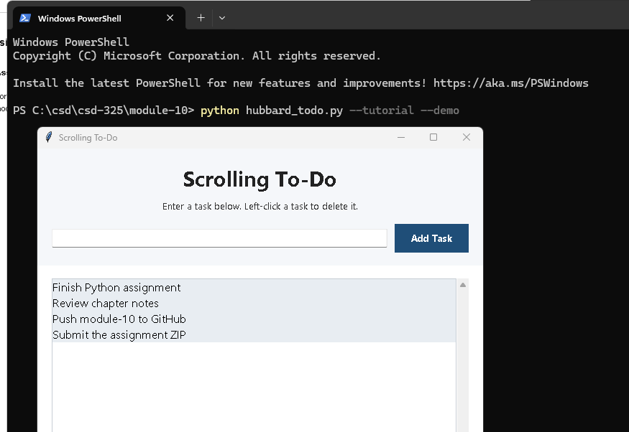
Figure 1. Tutorial-stage application with sample tasks

Modified Hubbard ToDo
The completed interface uses the required title, complementary colors, right-click instructions, and File menu.
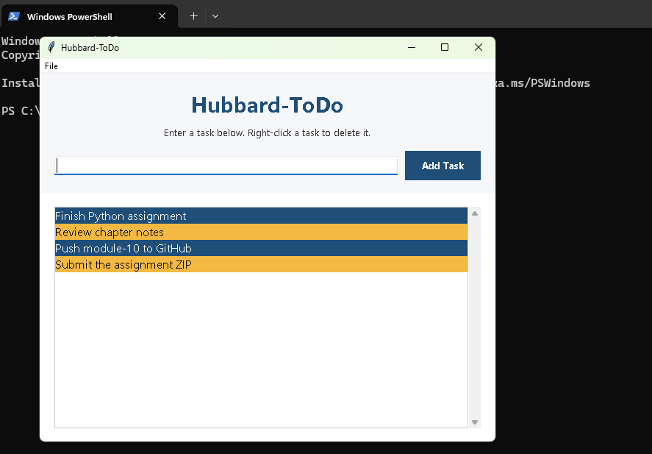
Figure 2. Modified Hubbard-ToDo application with four tasks

Task Deleted
The Review chapter notes item has been removed, demonstrating the state after a right-click deletion.
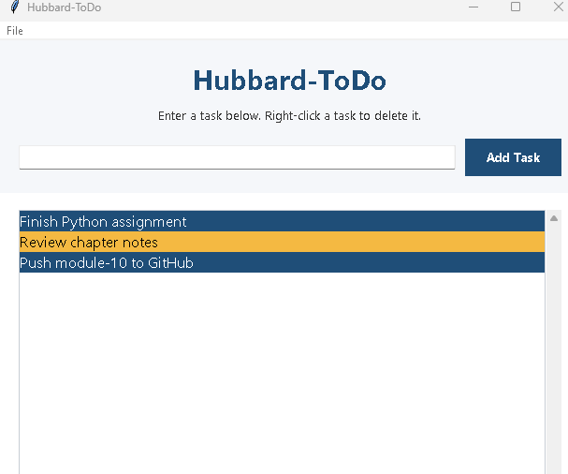
Figure 3. Modified application after deleting one task

Python Source Code
"""Module 10.2 GUI ToDo assignment.

Author: Prince Hubbard
Course: CSD-325 Advanced Python
Assignment: Module 10.2 GUI ToDo

This Tkinter application lets a user add scrolling to-do items, removes an
item with the right mouse button, and exits through the File menu.
"""

import argparse
import tkinter as tk
from tkinter import ttk

class ToDoApplication:
"""Create and manage the Hubbard-ToDo graphical interface."""

BLUE = "#1F4E78"
GOLD = "#F4B942"

def __init__(self, root, tutorial_mode=False):
"""Build the window, menu, input controls, and scrolling task list."""
self.root = root
self.tutorial_mode = tutorial_mode
self.root.title("Scrolling To-Do" if tutorial_mode else "Hubbard-ToDo")
self.root.geometry("620x500")
self.root.minsize(500, 380)

if not tutorial_mode:
self._build_menu()
self._build_header()
self._build_task_list()

def _build_menu(self):
"""Create the File menu and its Exit command."""
menu_bar = tk.Menu(self.root)
file_menu = tk.Menu(
menu_bar,
tearoff=False,
background=self.BLUE,
foreground="white",
activebackground=self.GOLD,
activeforeground="black",
)
file_menu.add_command(label="Exit", command=self.root.destroy)
menu_bar.add_cascade(label="File", menu=file_menu)
self.root.configure(menu=menu_bar)

def _build_header(self):
"""Create the title, deletion instructions, and task-entry controls."""
header = tk.Frame(self.root, background="#F5F7FA", padx=20, pady=18)
header.pack(fill=tk.X)

tk.Label(
header,
text="Scrolling To-Do" if self.tutorial_mode else "Hubbard-ToDo",
background="#F5F7FA",
foreground="#222222" if self.tutorial_mode else self.BLUE,
font=("Segoe UI", 22, "bold"),
).pack()

tk.Label(
header,
text=(
"Enter a task below. Left-click a task to delete it."
if self.tutorial_mode
else "Enter a task below. Right-click a task to delete it."
),
background="#F5F7FA",
foreground="#333333",
font=("Segoe UI", 10),
).pack(pady=(4, 14))

entry_row = tk.Frame(header, background="#F5F7FA")
entry_row.pack(fill=tk.X)
self.task_entry = ttk.Entry(entry_row, font=("Segoe UI", 11))
self.task_entry.pack(side=tk.LEFT, fill=tk.X, expand=True, padx=(0, 10))
self.task_entry.bind("<Return>", self.add_task)

tk.Button(
entry_row,
text="Add Task",
command=self.add_task,
background=self.BLUE,
foreground="white",
activebackground=self.GOLD,
activeforeground="black",
relief=tk.FLAT,
padx=18,
pady=6,
font=("Segoe UI", 10, "bold"),
).pack(side=tk.RIGHT)

def _build_task_list(self):
"""Create the scrolling list and bind right-click deletion."""
body = tk.Frame(self.root, background="white", padx=20, pady=18)
body.pack(fill=tk.BOTH, expand=True)

self.task_list = tk.Listbox(
body,
activestyle="none",
selectbackground="#D9E7F3",
selectforeground="black",
font=("Segoe UI", 12),
borderwidth=0,
highlightthickness=1,
highlightbackground="#C7CDD4",
)
scrollbar = ttk.Scrollbar(body, orient=tk.VERTICAL, command=self.task_list.yview)
self.task_list.configure(yscrollcommand=scrollbar.set)
self.task_list.pack(side=tk.LEFT, fill=tk.BOTH, expand=True)
scrollbar.pack(side=tk.RIGHT, fill=tk.Y)
delete_event = "<Button-1>" if self.tutorial_mode else "<Button-3>"
self.task_list.bind(delete_event, self.delete_task)

def add_task(self, event=None):
"""Add a nonempty task and apply alternating complementary colors."""
task = self.task_entry.get().strip()
if not task:
return

index = self.task_list.size()
self.task_list.insert(tk.END, task)
if self.tutorial_mode:
self.task_list.itemconfig(index, background="#E8EDF2", foreground="black")
elif index % 2 == 0:
self.task_list.itemconfig(index, background=self.BLUE, foreground="white")
else:
self.task_list.itemconfig(index, background=self.GOLD, foreground="black")
self.task_entry.delete(0, tk.END)
self.task_entry.focus_set()

def delete_task(self, event):
"""Delete the task beneath the pointer when right-clicked."""
if self.task_list.size() == 0:
return
index = self.task_list.nearest(event.y)
bounds = self.task_list.bbox(index)
if bounds and bounds[1] <= event.y <= bounds[1] + bounds[3]:
self.task_list.delete(index)
self._refresh_colors()

def _refresh_colors(self):
"""Restore alternating colors after a task is removed."""
for index in range(self.task_list.size()):
if self.tutorial_mode:
self.task_list.itemconfig(index, background="#E8EDF2", foreground="black")
elif index % 2 == 0:
self.task_list.itemconfig(index, background=self.BLUE, foreground="white")
else:
self.task_list.itemconfig(index, background=self.GOLD, foreground="black")

def load_demo_tasks(self):
"""Populate sample tasks when the program is launched with --demo."""
for task in (
"Finish Python assignment",
"Review chapter notes",
"Push module-10 to GitHub",
"Submit the assignment ZIP",
):
self.task_entry.insert(0, task)
self.add_task()

def main():
"""Start the Tkinter event loop."""
parser = argparse.ArgumentParser(description="Run Hubbard-ToDo.")
parser.add_argument("--demo", action="store_true", help="load sample tasks")
parser.add_argument(
"--tutorial",
action="store_true",
help="show the unmodified tutorial stage for its required screenshot",
)
args = parser.parse_args()

root = tk.Tk()
application = ToDoApplication(root, tutorial_mode=args.tutorial)
if args.demo:
application.load_demo_tasks()
root.mainloop()

if __name__ == "__main__":
main()

