CSD325 • ADVANCED PYTHON
Module 3.2 Assignment
Brownfield Development: Cho-Han Program Flowcharts
Prince Hubbard | CSD325-302E | August 31, 2026
Flowchart 1: Main Program and Wager Validation
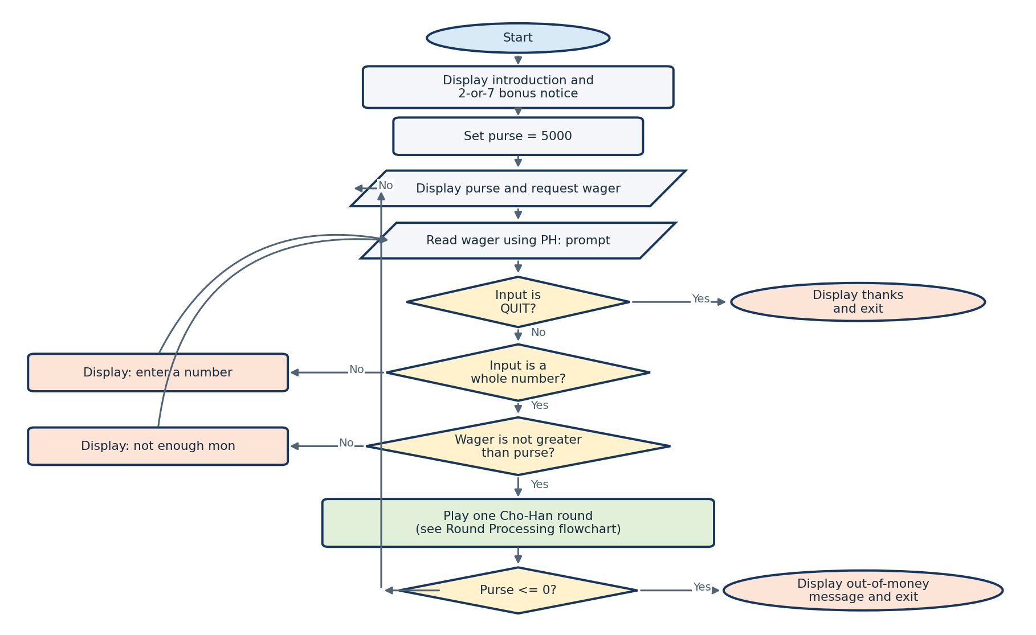

Prince Hubbard • Module 3.2 Assignment
Flowchart 2: Cho-Han Round Processing
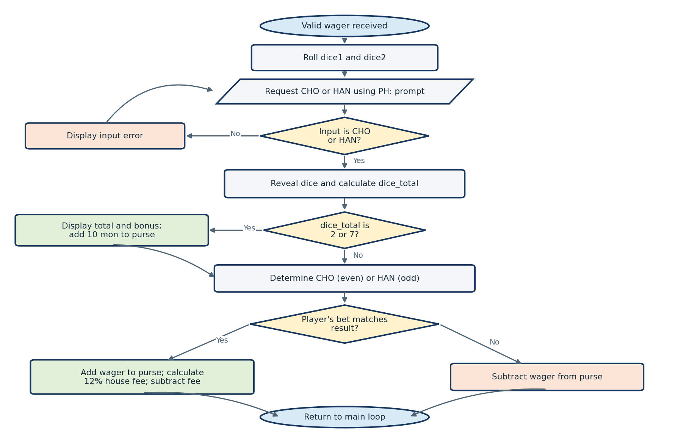
The second flowchart expands the round-processing step shown in the main program flowchart.

