Module 8.2 JSON Practice
Prince Hubbard
CSD-325 Advanced Python
Assignment documentation

Purpose. This document records the design and execution of a Python program that loads student records from JSON, prints the original list, appends a fictional student, prints the updated list, and writes the updated data back to student.json.

Item | Details
Program | student.py
Data file | student.json
Added record | Hubbard, Prince - ID 8675309
Flowchart | Module-8.2-Flowchart.pdf

Program Flowchart
The flowchart models the file input, list display, append operation, JSON output, and completion message.
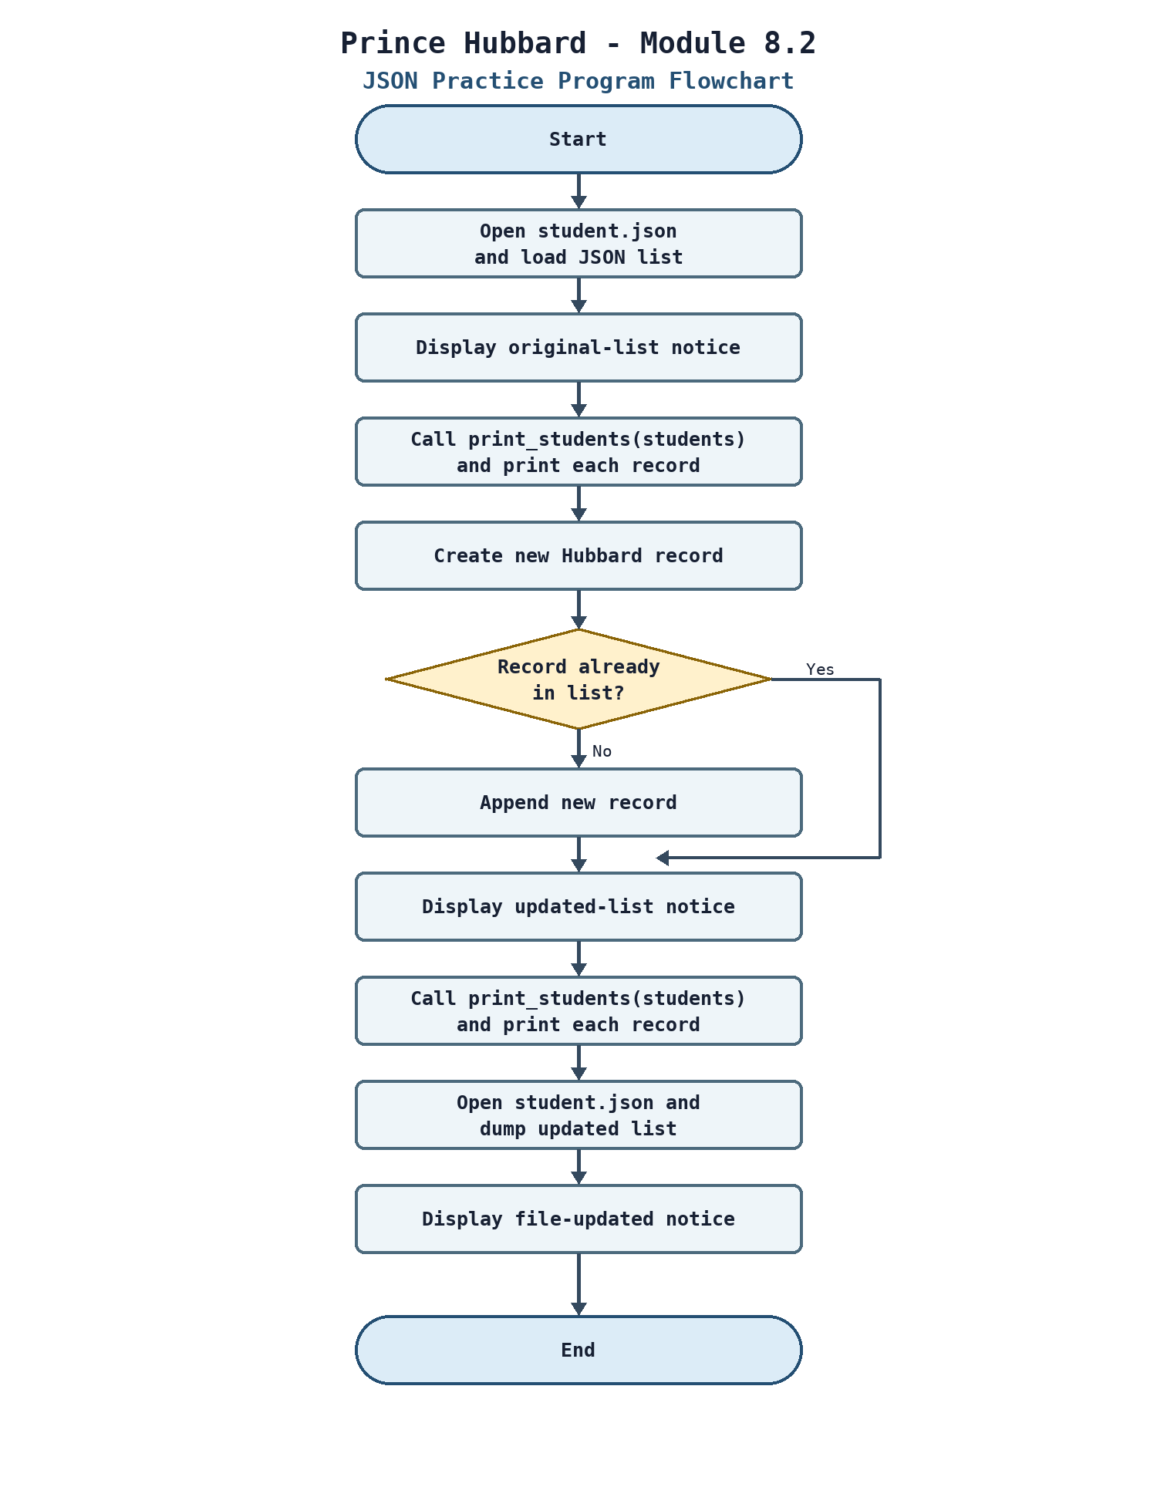

Program Output
Figure 1 shows the program running successfully from the terminal.
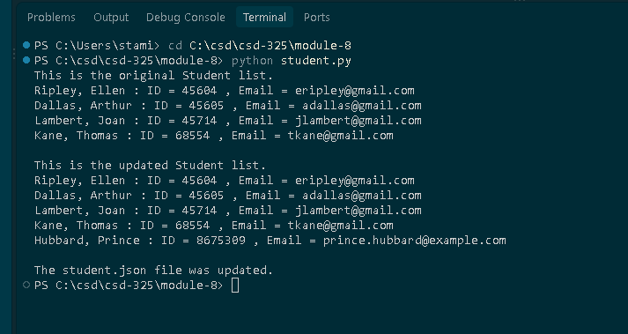
Figure 1. Console output from student.py

External File Change Notification
Insert your local editor screenshot here after running student.py while student.json is open. The screenshot should show the editor notification that the JSON file changed on disk.
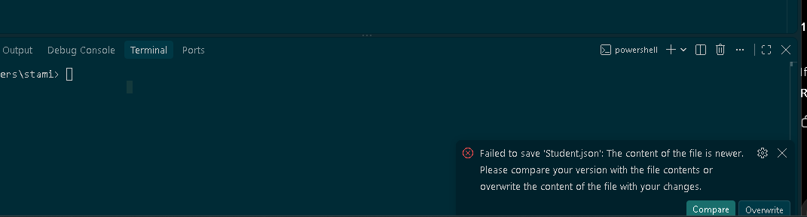
Figure 2. VS Code external file-change notification

Updated JSON File
The following is the complete content of student.json after the program update.
[
{
"F_Name": "Ellen",
"L_Name": "Ripley",
"Student_ID": 45604,
"Email": "eripley@gmail.com"
},
{
"F_Name": "Arthur",
"L_Name": "Dallas",
"Student_ID": 45605,
"Email": "adallas@gmail.com"
},
{
"F_Name": "Joan",
"L_Name": "Lambert",
"Student_ID": 45714,
"Email": "jlambert@gmail.com"
},
{
"F_Name": "Thomas",
"L_Name": "Kane",
"Student_ID": 68554,
"Email": "tkane@gmail.com"
},
{
"F_Name": "Prince",
"L_Name": "Hubbard",
"Student_ID": 8675309,
"Email": "prince.hubbard@example.com"
}
]

Python Source Code
"""Module 8.2 JSON Practice.

Author: Prince Hubbard
Course: CSD-325 Advanced Python
Assignment: Module 8.2

This program reads student records from a JSON file, displays the original
records, appends one fictional student, displays the updated records, and
writes the updated list back to the JSON file.
"""

import json
from pathlib import Path

JSON_FILE = Path(__file__).with_name("student.json")

def print_students(student_list):
"""Print each student record in the required display format."""
for student in student_list:
print(
f"{student['L_Name']}, {student['F_Name']} : "
f"ID = {student['Student_ID']} , Email = {student['Email']}"
)

def main():
"""Load, display, update, and save the student JSON data."""
with JSON_FILE.open("r", encoding="utf-8") as json_file:
students = json.load(json_file)

print("This is the original Student list.")
print_students(students)

new_student = {
"F_Name": "Prince",
"L_Name": "Hubbard",
"Student_ID": 8675309,
"Email": "prince.hubbard@example.com",
}

if new_student not in students:
students.append(new_student)

print("\nThis is the updated Student list.")
print_students(students)

with JSON_FILE.open("w", encoding="utf-8") as json_file:
json.dump(students, json_file, indent=4)

print("\nThe student.json file was updated.")

if __name__ == "__main__":
main()

