DOCUMENTED DEBUGGING
Breakpoint, Step Into, and Variable Inspection
Student: Prince Hubbard
Assignment: Module 2.2 - Documented Debugging + Flowchart(s)
Program: student_grade_analyzer.py

Debugging Objective
I ran the program with Python's built-in pdb debugger in a terminal. The screenshots below are direct captures of that debugging session. I paused execution before the average calculation, stepped into the calculate_average() function, inspected the values created on each line, and continued through the final output.

1. Breakpoint Before the Function Call
The command b 27 placed a breakpoint on the line that calls calculate_average(scores). After continue, execution stopped at line 27. The p scores command confirmed that the list was available before the function ran.
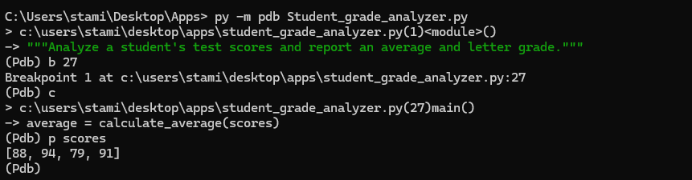
Figure 1. Execution paused at the breakpoint before calculate_average() runs.

2. Step Into calculate_average()
The s command stepped into calculate_average(). The n commands executed the function one line at a time, and p total confirmed that sum(scores) produced 352.
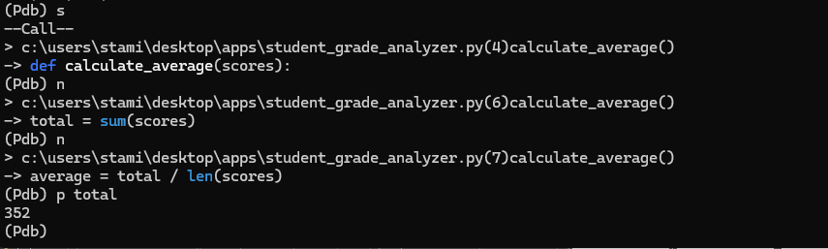
Figure 2. Debugger stepped into calculate_average() and inspected the calculated total.

What This Confirmed
The function received the complete list and sum(scores) produced the expected total. This isolates the average calculation from the rest of the program and makes it easier to locate a calculation error.

3. Inspect Variables and Continue
I advanced through the division and used p average to inspect the result, which equaled 88.0. After returning to main(), p letter_grade confirmed B. The continue command then printed all expected results.
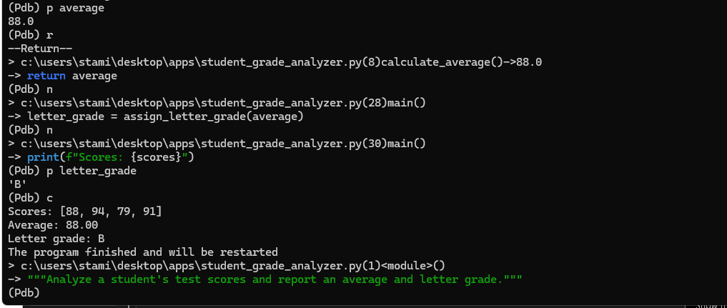
Figure 3. Average and final grade verified before program completion.

Debugging Result
The debugger verified that the functions received the correct data and returned the expected values. No defect was found in the final program: 352 divided by 4 equals 88.00, and an average of 88.00 correctly maps to a B.

