PROGRAM FLOWCHART
Student Grade Analyzer
Student: Prince Hubbard
Assignment: Module 2.2 - Documented Debugging + Flowchart(s)
Program: student_grade_analyzer.py

Program Purpose
The program stores four test scores, calculates their arithmetic mean, converts the result to a letter grade, and displays the scores, average, and grade.

Flowchart
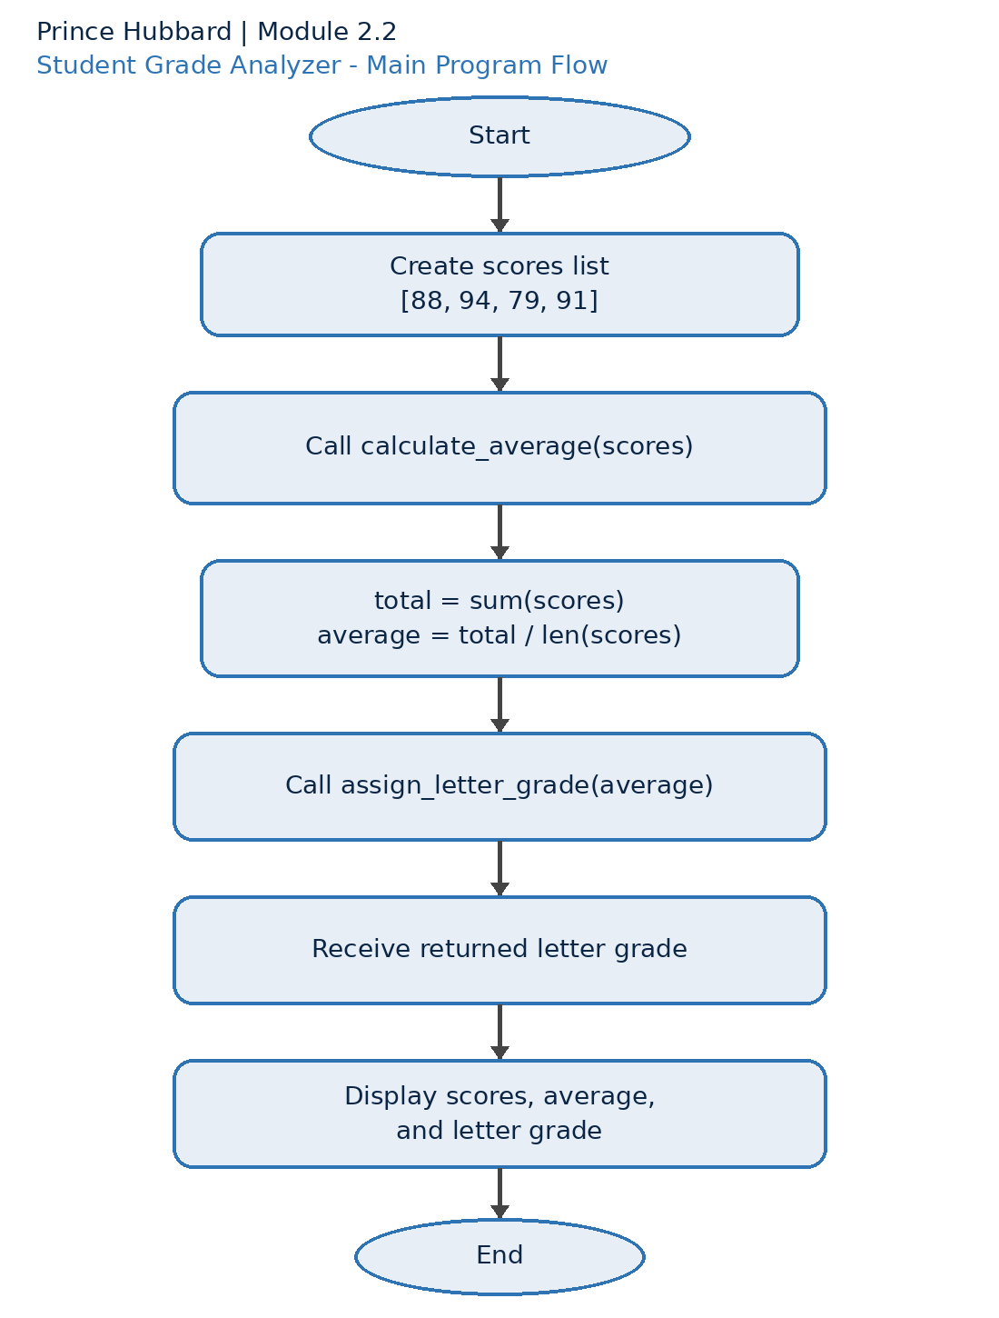
Figure 1. Control flow for student_grade_analyzer.py

Letter-Grade Decision Flow
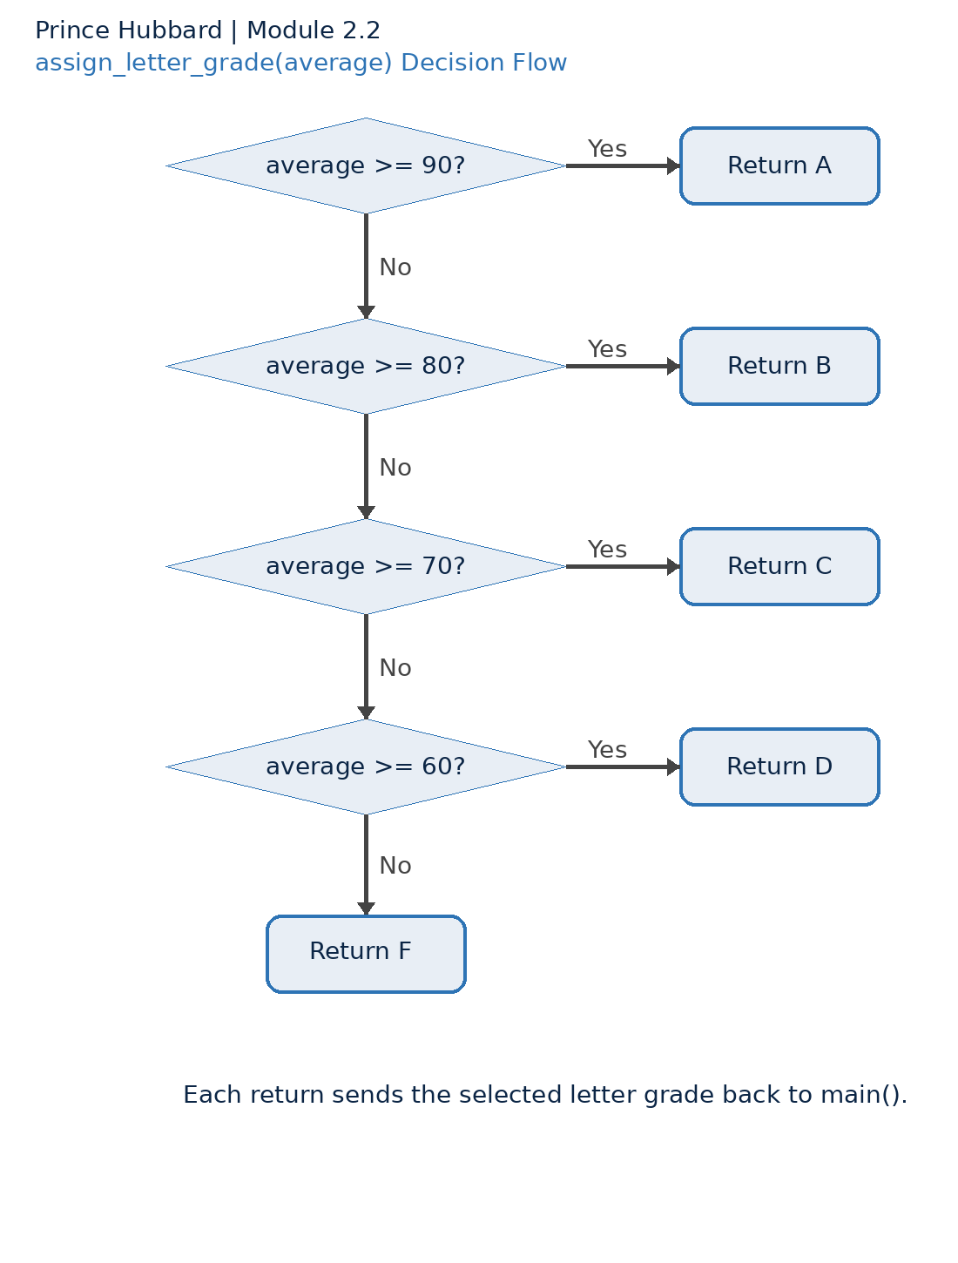
Figure 2. Threshold decisions inside assign_letter_grade().

