Module 11.2 Django Basics
Prince Hubbard | CSD325 Advanced Python | Assignment 11.2
The screenshots below show the Django project running locally before and after the greeting view was connected.

Django project startup
Figure 1. Initial Django welcome page at http://127.0.0.1:8000/ before the greeting view is connected.
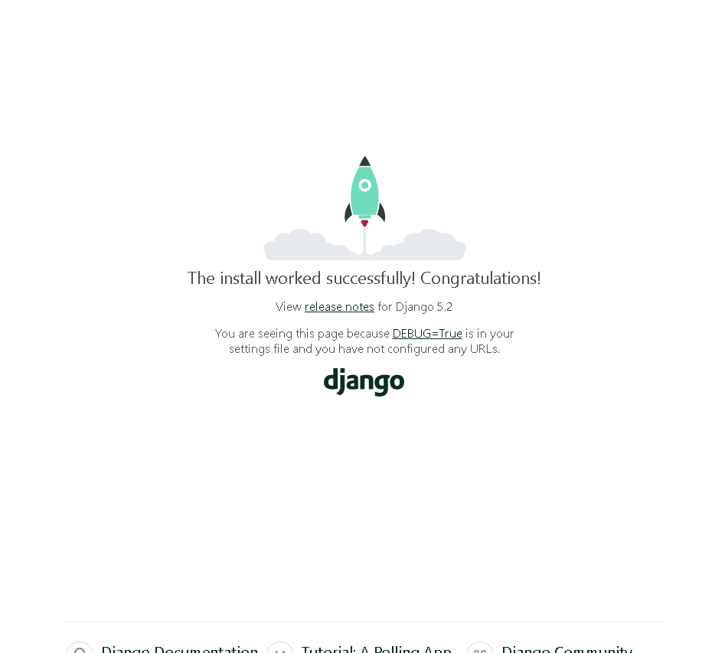

Modified greeting page
Figure 2. Final page at http://127.0.0.1:8000/ displaying Hubbard says Hello!
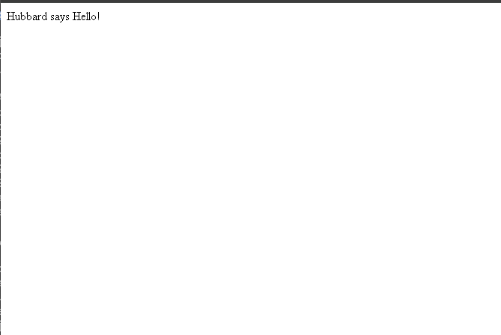

Verification
The project passed Django system checks. A local request to the final home page returned HTTP 200 and the exact text “Hubbard says Hello!”

