GitHub Repository Setup
Prince Hubbard
CSD 340 Web Development with HTML and CSS
Module 1.2 Assignment
Instructor Dr. Mortoza Abdullah
October 19, 2026
GitHub Repository: https://github.com/stamina4days/csd-340.git

GitHub Repository Screenshot
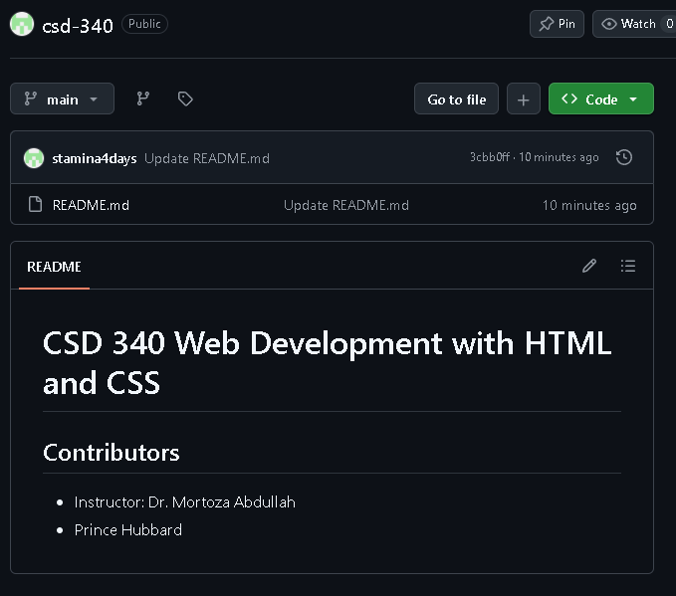

Local Directory Screenshot
The terminal output shows the repository clone and the module-1 folder in the local csd-340 directory.
