Building a Web Page Exercise Part 1
Prince Hubbard
CSD 340 Web Development with HTML and CSS
Assignment 1.3
October 19, 2026
GitHub repository: https://github.com/stamina4days/csd-340

Starter Code Validation
The starter code produced three errors: an empty title, an end tag after the body was closed, and a stray thml end tag.
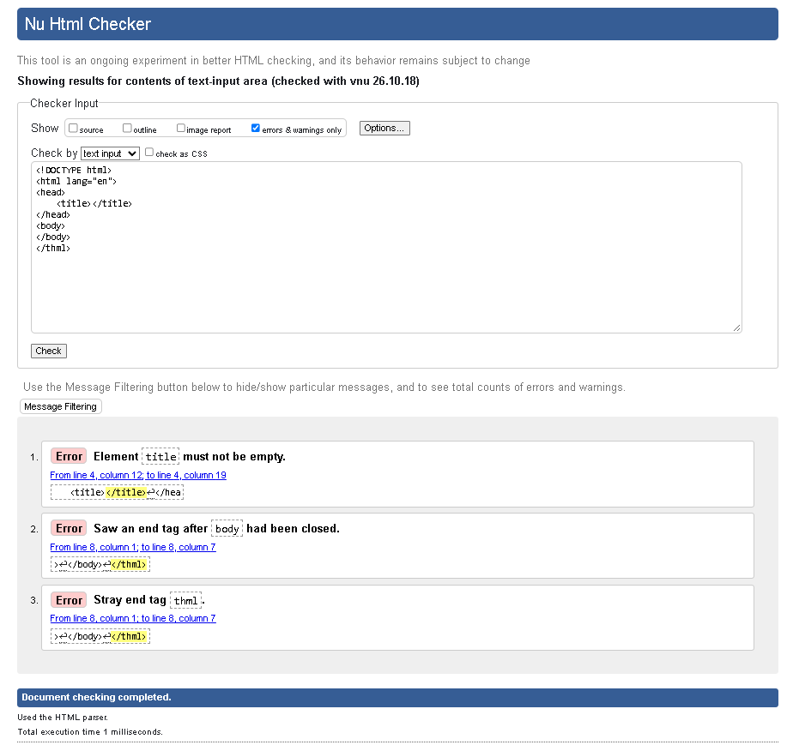

Corrected Structure Validation
The corrected document structure passed validation with no errors or warnings.
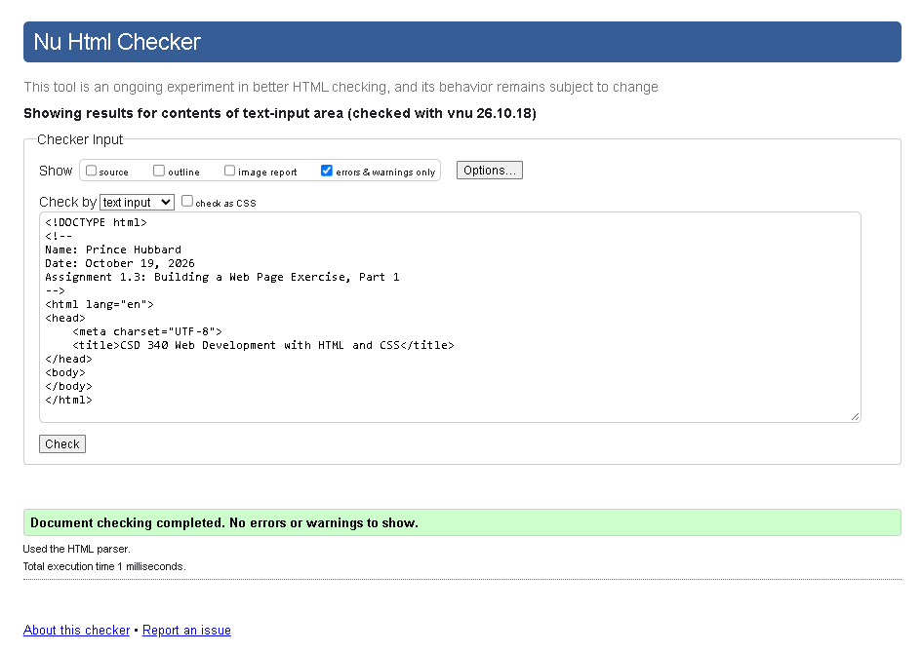

Final Page Validation
The completed page, including the heading and local weather sentence, passed validation with no errors or warnings.
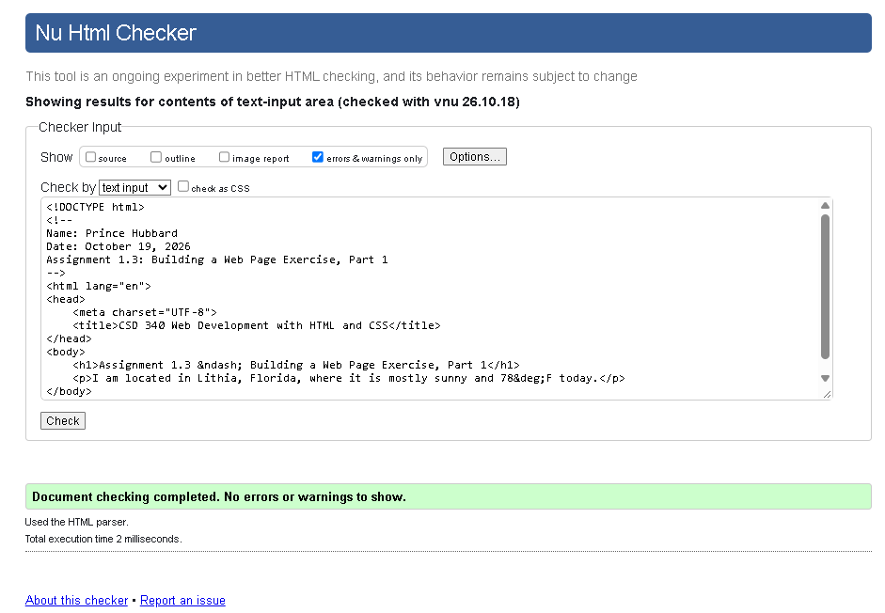

Browser Output
The completed HTML page displays the assignment heading and the location and weather sentence.
