BMS INSTITUTE OF TECHNOLOGY AND MANAGEMENT
Autonomous Institute under VTU, Belagavi, Karnataka - 590 018
Yelahanka, Bengaluru, Karnataka - 560 119


Information and Network Security (BCS701) CCA Report
On
Codecov Bash Uploader Supply-Chain Attack (2021): Analysis and SignGate, a Cryptographic Verify-Before-Execute Solution

BACHELOR OF ENGINEERING
in
INFORMATION SCIENCE AND ENGINEERING
by
NAME | USN

Under the Guidance of
Prof. Sonnegowda K
Assistant Professor

DEPARTMENT OF INFORMATION SCIENCE AND ENGINEERING
Avalahalli, Yelahanka, Bengaluru, Karnataka -560119
2025-26
Evaluation Sheet
Name | USN | Problem Understanding & Requirements | Design &  Implementation | Security Analysis  Testing | Innovation &  Application Relevance | Documentation &  Presentation | Total
Name | USN | 3 | 9 | 2 | 2 | 4 | 20

Content Page No.
- Introduction 1
- Abstract 3
- Problem Statement 4
- System Requirements 5
- Design and Implementation 6
- Security Analysis 12
- System Testing 14
- Innovation and Application Relevance 17
- Conclusion 19
- References 20

1. INTRODUCTION
1.1 Organisation and Sector
Codecov is a Software-as-a-Service (SaaS) code-coverage platform used by development teams across the software industry. After the automated tests of a project run inside a Continuous Integration / Continuous Delivery (CI/CD) pipeline, a small program called the Codecov uploader collects the coverage report and sends it to Codecov. In 2021 the most common way to run it was the Bash Uploader: a shell script downloaded and executed on every build with the one-liner bash <(curl -s https://codecov.io/bash). Codecov reported more than 29,000 customers at that time [3], including large technology and security companies.
The uploader runs inside the customer's CI job. That environment normally holds the organisation's most sensitive credentials: cloud access keys, GitHub/GitLab tokens, package-registry tokens, database URLs and sometimes release-signing keys. So the uploader is a highly trusted piece of third-party code. Anyone who can change it can read all of these secrets.
1.2 Incident Context
On 31 January 2021 an attacker began making unauthorised, periodic changes to the Bash Uploader stored in Codecov's Google Cloud Storage (GCS) bucket [1]. The modified script sent the full list of environment variables and the git remote URLs of every CI job that ran it to a server controlled by the attacker. The compromise went unnoticed for about two months, until 1 April 2021. That day a customer calculated the SHA-256 of the downloaded script, found it did not match the value Codecov published on GitHub, and reported it [1]. Codecov disclosed the incident publicly on 15 April 2021 [1]. Its post-mortem traced the root cause to an HMAC key for a GCS service account left in an intermediate layer of Codecov's public Self-Hosted Docker image [2]. Downstream victims such as HashiCorp had to rotate secrets, including a GPG key used to sign software releases [4], and investigators reported that hundreds of customer networks had been accessed [3].
1.3 Security Requirements Violated
The incident is a classic software supply-chain attack. The attacker did not break into each victim. They changed one trusted component that thousands of victims ran automatically. Table 1 maps the incident to the security requirements it violated.
Table 1: Security requirements violated in the Codecov incident
Requirement | How it was violated | Severity
Integrity (primary) | The uploader customers downloaded was not the one Codecov released. It had an extra exfiltration line. | Critical
Authentication (of origin) | Customers could not verify who produced the script. Anyone with bucket write access was effectively 'Codecov'. | Critical
Confidentiality | Environment variables (tokens, keys, credentials) and private repository URLs were leaked to the attacker. | High
Access control / key management | A long-lived storage HMAC key was left in a public image layer and had write permission on the distribution bucket. | High
Non-repudiation / accountability | Nothing recorded which releases were legitimate, so the tampering could not be detected or attributed for about 2 months. | Medium

This report analyses the attack and then designs and implements SignGate, a cryptographic 'verify-before-execute' gate. It uses digital signatures, SHA-256 hashing, a small public-key infrastructure with revocation, a hash-chained transparency log and least-privilege execution, so that a tampered uploader is never trusted or run.

2. ABSTRACT
Software supply-chain attacks compromise a trusted vendor component instead of the final target, so one breach spreads to thousands of organisations. This report studies the 2021 Codecov Bash Uploader compromise. An HMAC storage key leaked through a Docker image layer let an attacker quietly modify a script that customers ran in their CI/CD pipelines. For about two months it exfiltrated credentials from those pipelines. The analysis identifies six weaknesses: a secret left in a build artifact, a static over-privileged storage key, no code signing, the 'curl | bash' execution pattern, CI jobs exposing every secret to every tool, and no integrity monitoring.
As a solution we design and implement SignGate, a lightweight verify-before-execute gate for CI tools. Every release is hashed with SHA-256 and its manifest is signed with Ed25519, using a release key that is certified by an offline root key (a mini-PKI with 90-day key rotation and a signed revocation list). Every release is also recorded in an append-only hash-chained transparency log. Before running the uploader, the CI pipeline checks six things in order: key certificate, revocation status, signature, hash integrity, anti-rollback and log inclusion. If any check fails, the uploader does not run (fail-closed). When it does run, it sees only an allow-listed set of environment variables. A publisher-side monitor re-verifies the served file every few minutes.
A Python prototype (about 500 lines, using the pyca/cryptography library) was tested against seven attack scenarios, from the exact 2021 attack to a stolen signing key and a version rollback. All malicious variants were blocked and the legitimate release was accepted. Verification took about 0.6 ms per pipeline run. In an assume-breach test, the secrets readable by a malicious uploader fell from 8 of 8 to 1 of 8.
Keywords: software supply chain, code signing, Ed25519, SHA-256, PKI, key revocation, transparency log, CI/CD security, least privilege.

3. PROBLEM STATEMENT
CI/CD pipelines download third-party tools and execute them with full access to production secrets, but they have no enforced way to confirm that a tool is authentic and unmodified before running it. In the Codecov case, one leaked storage credential was enough to turn a trusted uploader into a credential stealer for thousands of pipelines. Nobody noticed for about two months.
3.1 Threats and Vulnerabilities Identified
Table 2: Vulnerabilities exploited in the Codecov attack
ID | Vulnerability | Exploited by attacker as
V1 | Secret (GCS HMAC key) left in an intermediate layer of a public Docker image | Initial access: key extracted from image layers [2]
V2 | Static, long-lived storage key with write access to the release bucket | Privilege: overwrite the Bash Uploader at will
V3 | No digital signature on the uploader. The SHA-256 was published but not signed, and few integrations checked it [1], [2] | Tampering went unchecked by clients
V4 | 'curl | bash' pattern executes whatever the server returns | Execution inside every customer CI job
V5 | Every step of a CI job can read every secret in the environment | Mass exfiltration of unrelated credentials (cloud, Git, GPG)
V6 | No monitoring of the served artifact against the released one | About 2 months of dwell time (31 Jan to 1 Apr 2021)

3.2 Objectives
- O1: Guarantee integrity: a modified uploader must be detected before execution.
- O2: Guarantee authenticity: only software signed by the genuine publisher key is accepted, even if the attacker controls the storage bucket and the published hash.
- O3: Provide key management: protected keys, periodic rotation and fast revocation of a leaked key without changing any customer pipeline.
- O4: Detect silent misuse of a stolen key and rollback to old vulnerable versions.
- O5: Limit the blast radius if malicious code ever runs (least privilege).
- O6: Keep it simple and cheap: millisecond overhead, standard algorithms, easy CI integration.

4. SYSTEM REQUIREMENTS
4.1 Functional Requirements
Table 3: Functional requirements
ID | Requirement
FR1 | Publisher can generate keys, sign a release manifest and publish it with the artifact.
FR2 | Root key can certify release keys (with validity period) and issue a signed revocation list.
FR3 | Every release is appended to a hash-chained transparency log with a signed head.
FR4 | CI gate verifies certificate, revocation, signature, hash, version and log inclusion, then executes the tool only if all checks pass.
FR5 | Tool is executed with an environment-variable allowlist defined in a policy file.
FR6 | Monitor compares the served artifact and log entries with known releases and raises alerts.

4.2 Security (Non-Functional) Requirements
Table 4: Security requirements mapped to objectives
ID | Requirement | Property
SR1 | Any single-bit change to the artifact is detected (SHA-256) | Integrity
SR2 | Signatures cannot be forged without the private key (Ed25519, about 128-bit security) | Authenticity
SR3 | Trust anchor (root public key) is pinned in the customer repo, never fetched from the bucket | Authentication
SR4 | Private keys never stored in plain text: HSM/KMS in production, AES-256 encrypted PKCS#8 in demo | Key confidentiality
SR5 | Gate is fail-closed: any error means no execution | Integrity / availability trade-off
SR6 | Verification overhead under 50 ms per pipeline run | Performance

4.3 Hardware and Software Requirements
Table 5: Hardware / software environment
Component | Prototype (this project) | Production deployment
Hardware | Any x86-64 / ARM machine, 2 GB RAM | Cloud CI runners, HSM or Cloud KMS
Language / libs | Python 3.9+, pyca/cryptography 41+, Bash | Same, packaged as a CI action
Key storage | AES-256 encrypted PKCS#8 files | AWS KMS / GCP Cloud KMS / YubiHSM (root offline)
Distribution | Local folder simulating a GCS bucket | GCS / CDN over TLS 1.3, workload identity
CI platform | Any shell (demo), GitHub Actions example | GitHub Actions, GitLab CI, CircleCI

5. DESIGN AND IMPLEMENTATION
5.1 Incident Description: Timeline and Attack Vector
Figure 1 shows the attack chain. Figure 2 shows the timeline reconstructed from Codecov's security update [1], post-mortem [2] and news reports [3], [5].
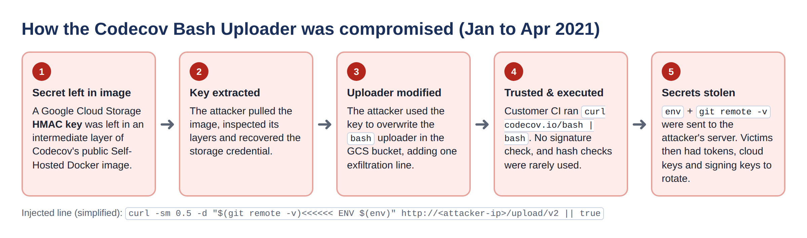
Figure 1: Attack chain of the Codecov Bash Uploader compromise
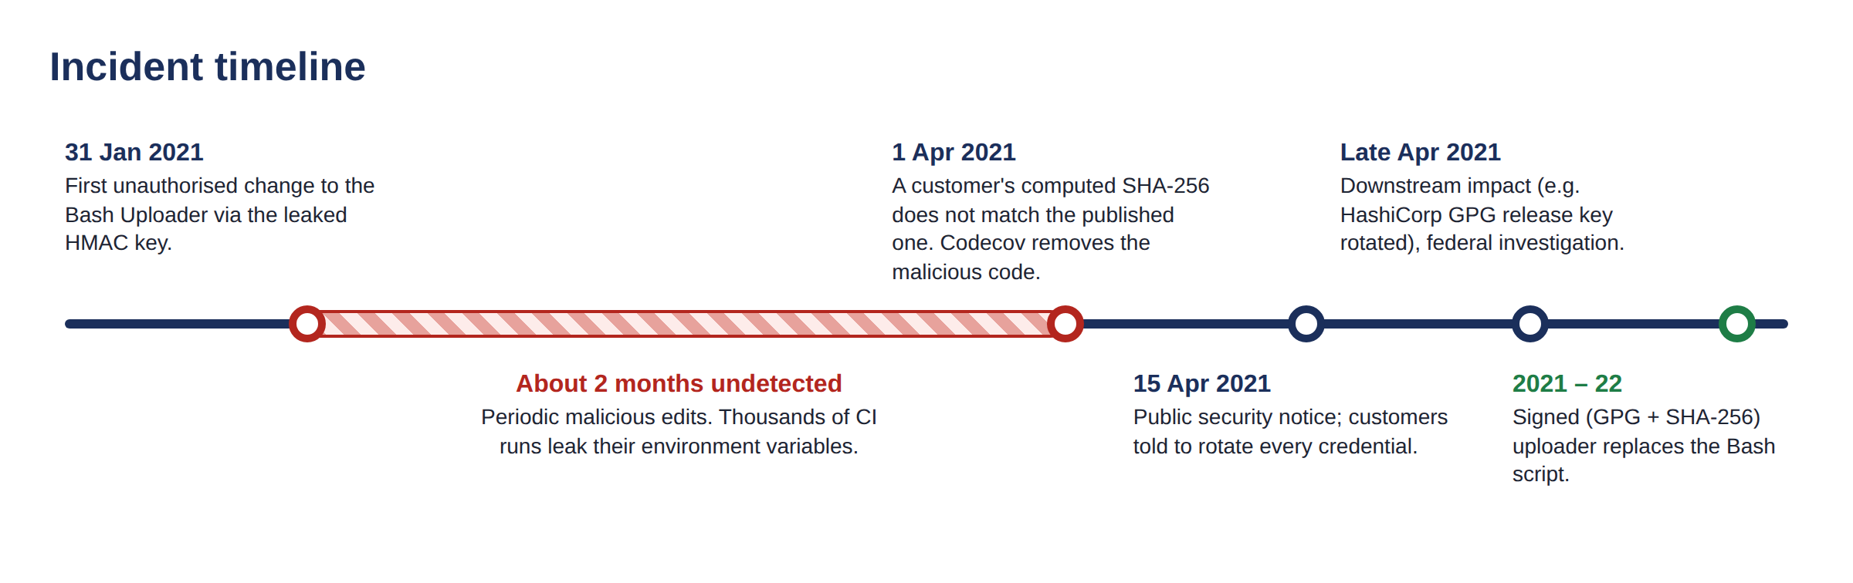
Figure 2: Incident timeline (Jan to Apr 2021 and remediation)
Attack vector. (1) Codecov's public Self-Hosted Docker image contained, in an intermediate layer, an HMAC key for a GCS service account. Deleting a file in a later layer does not remove it from earlier layers. (2) The attacker extracted the key and (3) used it to overwrite the Bash Uploader in the bucket, adding one line that posted $(env) and git remote -v to an external IP address [1], [6]. (4) Customer pipelines downloaded and executed the script with no signature check. (5) Secrets were stolen and later used against downstream organisations [3], [4]. The published SHA-256 was the only integrity control. Because it was not signed, not enforced and rarely checked, it detected the attack only when one customer happened to compare it manually.
5.2 Design Overview: SignGate
The key idea is to move trust from the storage location to cryptographic keys. In 2021, 'the file is in Codecov's bucket' was treated as proof that the file was genuine. SignGate assumes an attacker can write to the bucket, and still makes the tampered file useless, because only the holder of the release key can produce a valid signature. The same design also handles a stolen release key. The architecture has three zones (Figure 3).
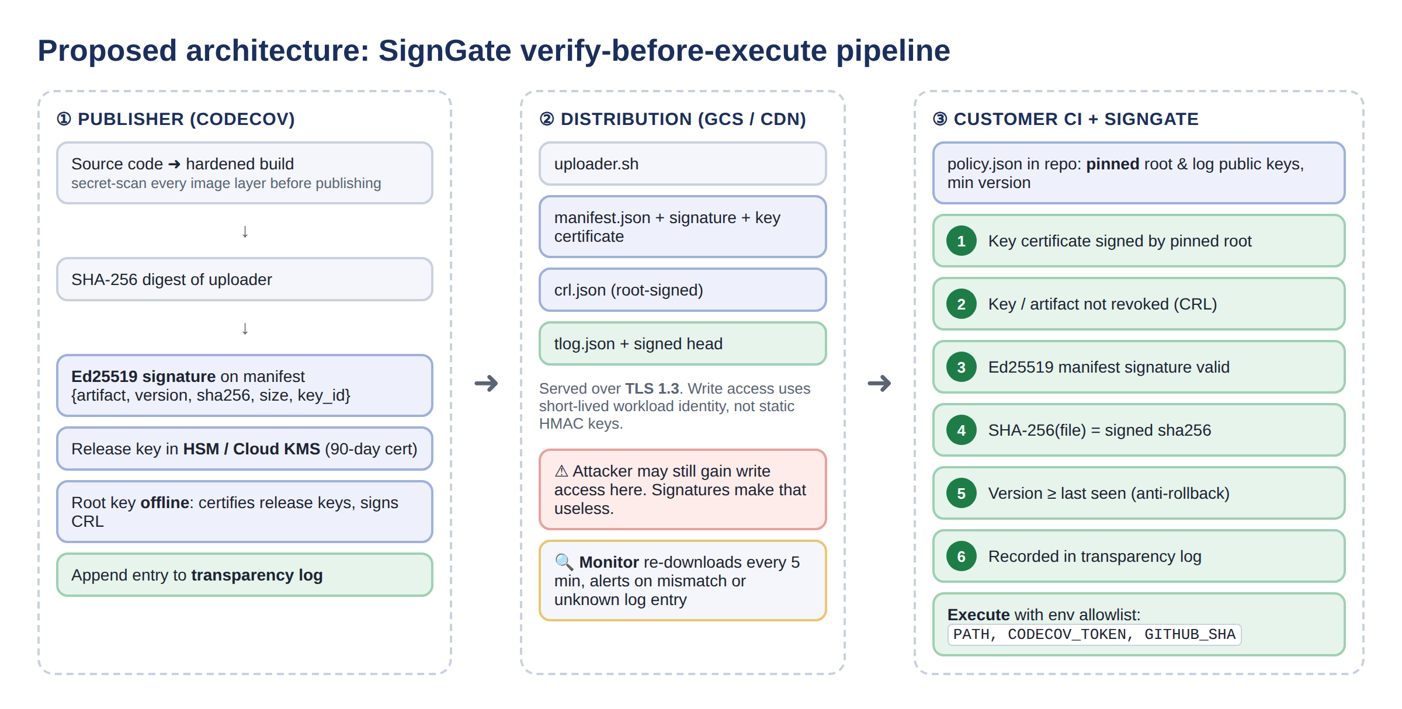
Figure 3: Proposed SignGate architecture: publisher, distribution and customer CI zones
- Publisher (Codecov): hardened build (secret-scan every image layer, fixing V1). SHA-256 digest, Ed25519-signed manifest, release key held in HSM/KMS, offline root key, transparency-log entry.
- Distribution (GCS/CDN): serves the artifact, signed manifest, root-signed revocation list and log over TLS 1.3. Writes use short-lived workload identity instead of static HMAC keys (fixing V2). A monitor re-downloads the artifact every few minutes (fixing V6).
- Customer CI + SignGate: the pinned policy file holds the root and log public keys. The gate runs six checks and then executes with an environment allowlist (fixing V3, V4, V5).
5.3 Cryptographic Building Blocks
Table 6: Algorithms and protocols used and why they fit
Mechanism | Standard | Role in SignGate | Why chosen
SHA-256 | FIPS 180-4 [8] | Artifact digest, log hash chain, key IDs | Collision resistant; a 1-bit change gives a completely different digest
Ed25519 signature | RFC 8032 [7], FIPS 186-5 [9] | Signs manifests, key certificates, CRL, log head | ~128-bit security, 64-byte signatures, fast, deterministic (no nonce-reuse bugs as in ECDSA)
Mini-PKI (root → release key) | X.509-style chain, NIST SP 800-57 [10] | Root certifies 90-day release keys | Leaked key can be revoked or rotated without customer changes
Signed revocation list | Similar to X.509 CRL | Blocks stolen keys / bad artifacts | Fast incident response
Hash-chained transparency log | Idea from Certificate Transparency RFC 6962 [11], Sigstore [12] | Public, append-only record of releases | Makes silent use of a stolen key visible
AES-256 (PKCS#8) | FIPS 197 | Encrypts private keys at rest (demo) | Stands in for HSM protection
TLS 1.3 | RFC 8446 [16] | Transport of the bundle | Confidentiality and server authentication in transit
HMAC key → workload identity | OIDC short-lived tokens | Bucket write access | Removes the long-lived secret that caused the breach

Why a signature and not just a hash? A hash proves 'the file matches the hash'. But an attacker who can change the file can usually change the published hash too. A digital signature ties the hash to a private key the attacker does not have. Verification uses only the public key, which customers pin in their own repository. A signature therefore provides integrity, authenticity and non-repudiation. A hash alone provides only integrity against accidental change.
5.4 Signed Release Manifest
For every release the publisher builds a manifest containing the artifact name, version, SHA-256, size, release time and key ID. The manifest is serialised as canonical JSON (sorted keys) and signed with the release key: σ = Sign(SK_release, canonical(manifest)). The key certificate is attached so that the verifier can build the chain root → release key → manifest.
{ "body": { "artifact": "codecov-uploader.sh", "version": "1.4.0",
"sha256": "ea1d27b7a2f1f4f2d98d5d57c4c02cd6ae59e7ab...",
"size": 347, "released_at": 1790000000, "key_id": "a8f83acbbe9c57a8" },
"signature": "base64(Ed25519 signature over canonical body)",
"key_certificate": { "body": { "key_id", "public_key", "purpose",
"not_before", "not_after" },
"signature": "base64(root signature)" } }

5.5 Key Management
Key management is where Codecov actually failed: a key sat in a public image. SignGate uses a two-level hierarchy with separation of duties (Figure 4), following NIST SP 800-57 [10].
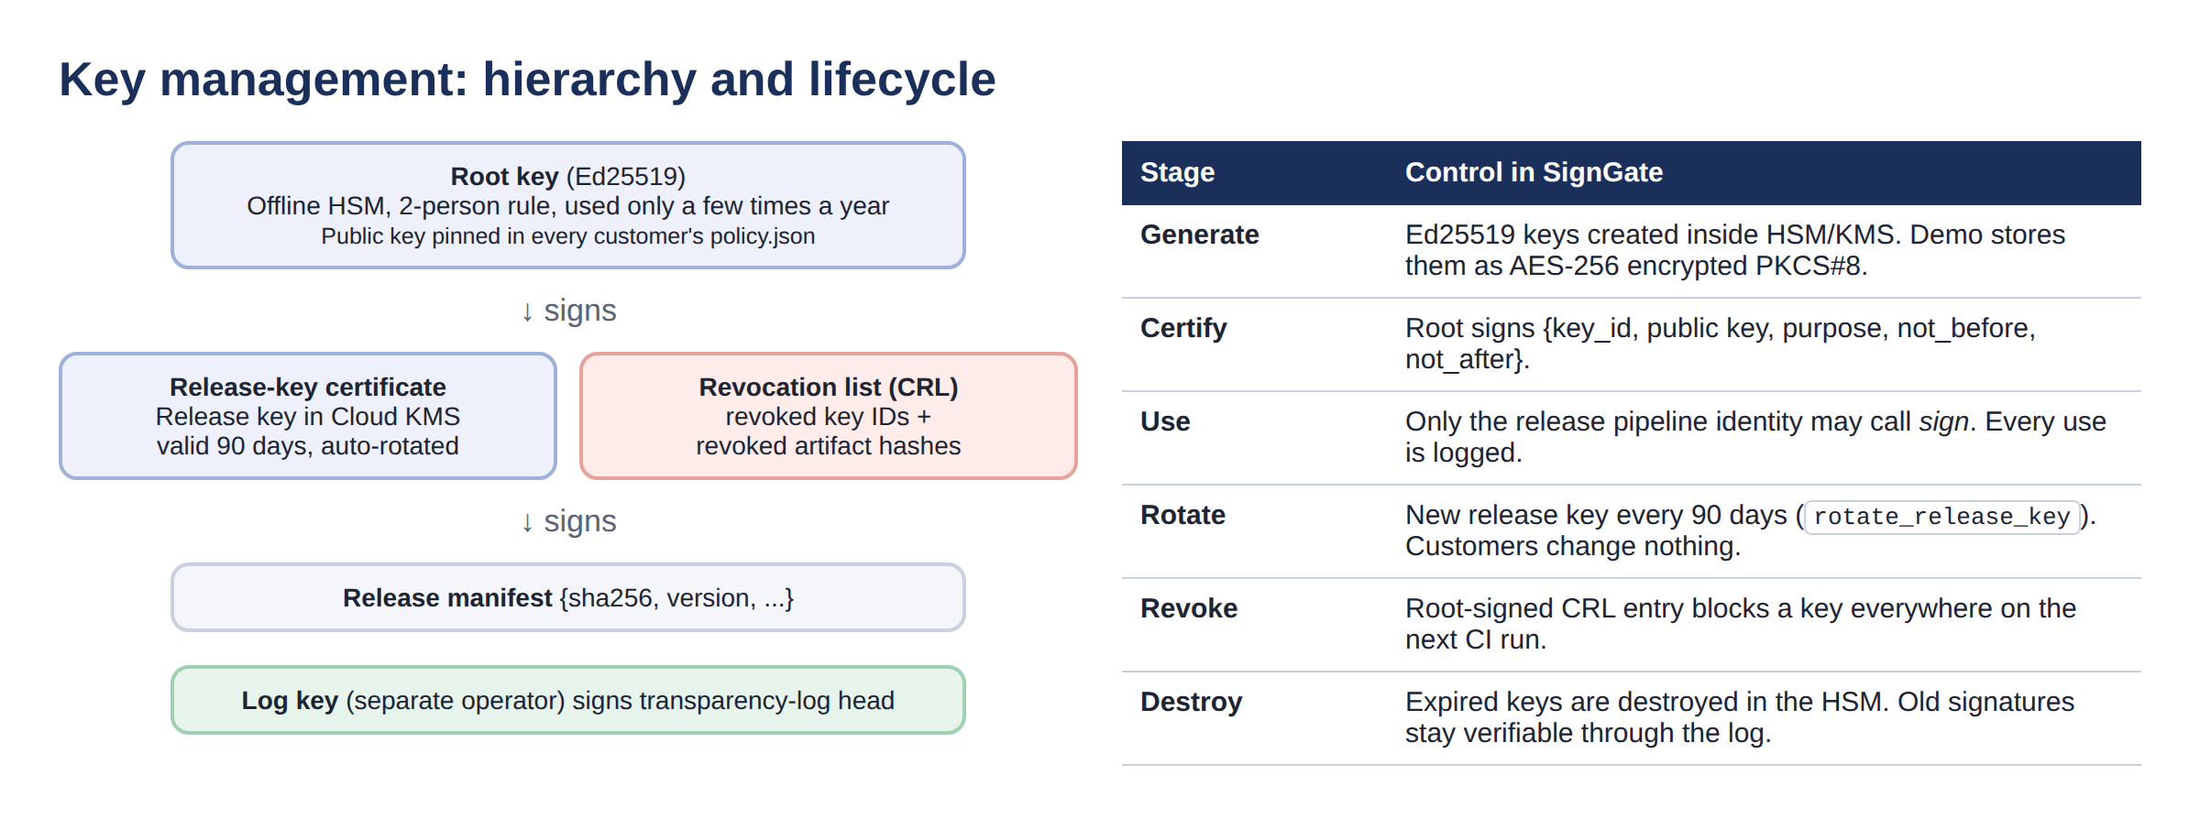
Figure 4: Key hierarchy and key lifecycle
- Root key: generated and kept offline in an HSM under a two-person rule. It is used only to certify release keys and sign the revocation list. Its public key is the trust anchor pinned in every customer's policy.json.
- Release key: kept in Cloud KMS. Only the release pipeline identity may call 'sign'. Its certificate is valid for 90 days and it is rotated automatically (rotate_release_key()).
- Log key: held by a separate log operator, who signs the log head, so one stolen key cannot both sign and log a release.
- Revocation: if a key leaks, the root signs a new CRL. Every CI gate rejects the key on its next run. This is how HashiCorp-style key exposures [4] should be contained.
5.6 Transparency Log
Every legitimate release is appended to a public, append-only log. Each entry stores h_i = SHA-256(h_(i-1) ‖ SHA-256(manifest_i)) with h_0 = 0^256, so editing or deleting any old entry changes every later hash. The log operator signs the head (size, h_n). The gate accepts a release only if its manifest is in the log, the chain recomputes to the signed head, and the log has not shrunk since the last run. So an attacker with a stolen release key has two options. They can skip the log, and every gate rejects the release. Or they can log it, and the publisher's monitor sees a release it never made and revokes the key.
5.7 Verify-Before-Execute Gate
Figure 5 shows the decision flow. The order matters. The cheapest checks that do not depend on the artifact run first, and every failure stops execution immediately (fail-closed).
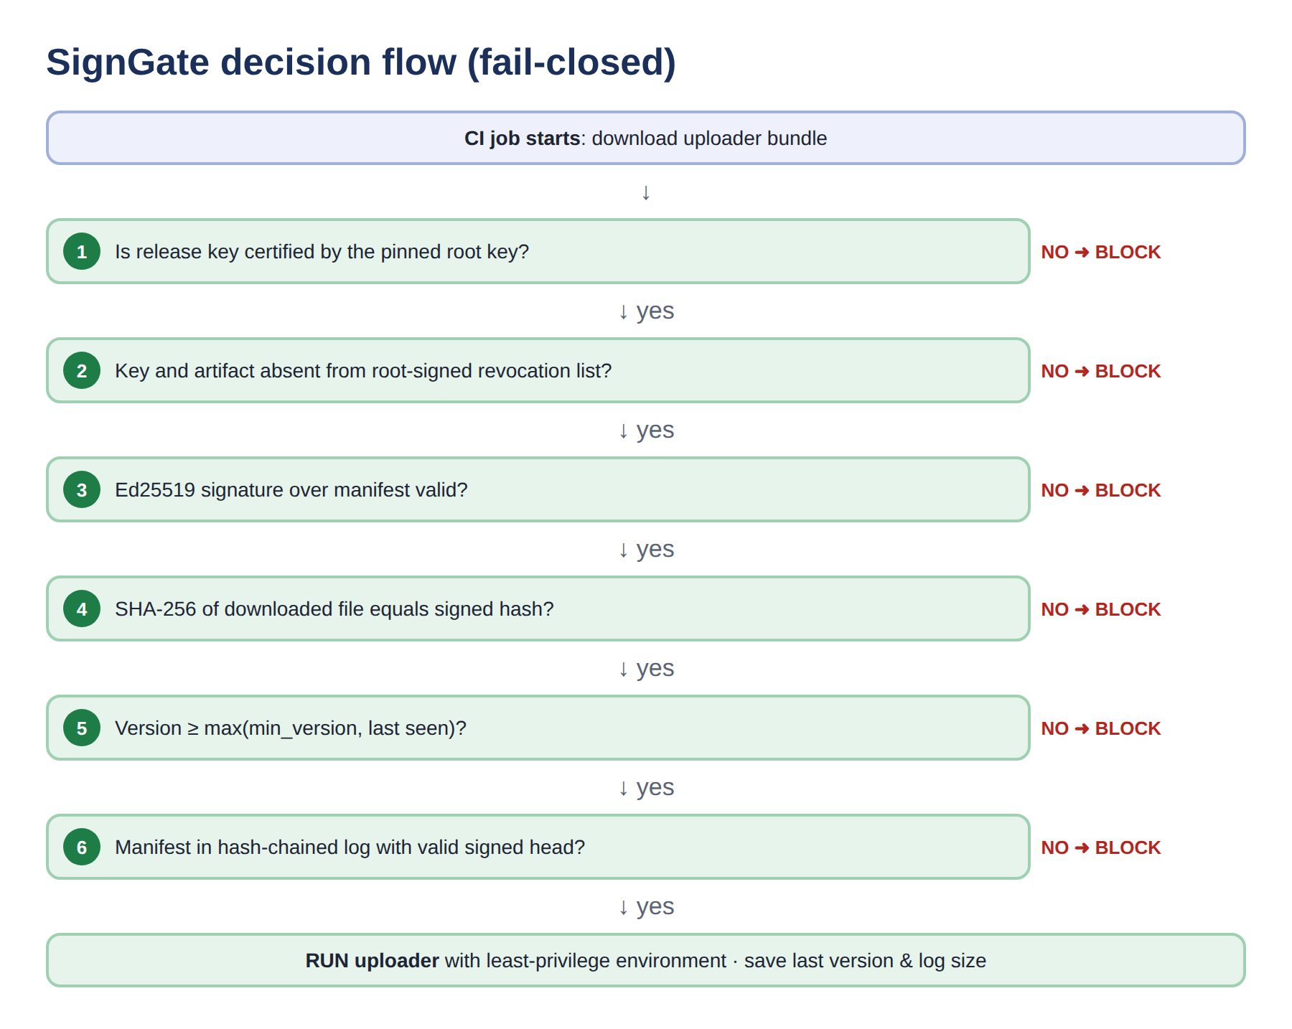
Figure 5: SignGate decision flow executed in the CI job
After all six checks pass, the gate stores the accepted version and log size (state.json) for anti-rollback. It then runs the uploader with only the allow-listed environment variables (e.g. PATH, CODECOV_TOKEN, GITHUB_SHA). Cloud keys, Git tokens and signing keys are simply not visible to the tool, which fixes V5.
5.8 Implementation
The prototype is written in Python 3 using the audited pyca/cryptography library for Ed25519 and key serialisation. Table 7 lists the modules. The 2021 Bash Uploader is simulated with a small shell script, and the malicious line is reproduced, but it writes the stolen variables to a local file instead of sending them to a server.
Table 7: Implementation modules
Module | Responsibility
crypto_utils.py | SHA-256, canonical JSON, Ed25519 key generation / sign / verify, AES-256 encrypted PKCS#8 key storage
pki.py | Root-signed release-key certificates (validity, purpose) and revocation list
tlog.py | Hash-chained append-only log, signed head, chain and inclusion verification
publisher.py | Key ceremony, release (hash → sign → log → publish), rotate, revoke
gate.py | The six-check verifier, env allowlist, fail-closed execution
monitor.py | Publisher-side tamper and unknown-release detection
cli.py | Commands: init, release, run, revoke, monitor
demo/attack_demo.py | Replays the 2021 attack and five stronger variants; measures timing
tests/test_signgate.py | 13 automated unit tests

Core of the gate (simplified from gate.py):
ok, why, release_pub = pki.check_key_certificate(manifest['key_certificate'], ROOT_PUB)
ok, why = pki.check_revocation(crl, ROOT_PUB, body['key_id'], body['sha256'])
ok = crypto.verify(release_pub, body, manifest['signature']) # Ed25519
ok = crypto.sha256_file(artifact) == body['sha256'] # integrity
ok = version(body['version']) >= max(policy.min_version, state.last_version)
ok, why = check_log(log, signed_head, LOG_PUB, body, state.last_log_size)
subprocess.run(['bash', artifact], env=minimal_env(policy.env_allowlist))

CI integration. The vulnerable one-liner bash <(curl -s https://codecov.io/bash) is replaced by: python -m signgate.cli run --bucket bucket/ --policy .signgate/policy.json. The policy file, which contains the pinned public keys, is committed in the customer's repository and never downloaded from the same bucket as the uploader (demo/ci-example.yml).

6. SECURITY ANALYSIS
6.1 Resistance to the Original Attack Vector
In the real attack the adversary had write access to the bucket but not to any signing key. Under SignGate the modified script produces a different SHA-256 (second-preimage resistance of SHA-256), so check 4 fails. If the attacker also rewrites the hash in the manifest, the Ed25519 signature no longer verifies (check 3). Forging it requires the release private key, which is infeasible (about 2^128 operations). The attacker cannot substitute their own key either, because the certificate must chain to the root key pinned in the customer's repository (check 1). The exact 2021 attack is therefore blocked before a single line of the script runs. The monitor would also have raised an alert within minutes of 31 January 2021, instead of about 2 months later.
6.2 Threat Model (STRIDE)
Table 8: STRIDE threat model for the uploader supply chain
STRIDE | Threat | SignGate control | Check
Spoofing | Attacker publishes uploader as 'Codecov' with own key | Key certificate must chain to pinned root | 1
Tampering | Uploader modified in bucket (2021 attack) | SHA-256 bound by Ed25519 signature | 3, 4
Tampering | Old signed version replayed (rollback) | Signed version ≥ last seen | 5
Repudiation | Publisher denies / attacker hides a release | Signed manifests + append-only log | 6
Information disclosure | Malicious code reads CI secrets | Env allowlist (least privilege) | exec
Denial of service | Attacker corrupts files to break builds | Fail-closed (safe); mirror copies restore service | -
Elevation of privilege | Stolen release key used to sign malware | Transparency log + monitor + CRL revocation | 2, 6

6.3 Attacker Capability Analysis
Table 9: What each attacker capability achieves
Attacker controls | Legacy Codecov (2021) | With SignGate
Bucket write only (actual 2021 case) | Full compromise of all pipelines | Blocked (check 4 / 3)
Bucket + published hash | Full compromise | Blocked (check 3)
Bucket + own signing key | Full compromise | Blocked (check 1)
Stolen release key | Full compromise | Blocked unless logged; if logged → alert → revoked
Stolen release key + log key | Full compromise | Monitor detects unknown entry → CRL revocation
Offline root key | n/a | Out of scope: protected by HSM + two-person rule

6.4 Limitations and Residual Risk
- If the publisher's own build system is compromised before signing (as in SolarWinds), a malicious build is signed legitimately. SignGate makes it visible in the log but cannot judge intent. Reproducible builds and SLSA provenance [13] address this.
- The root key is the single point of trust. It is mitigated by offline HSM storage, a two-person rule and rare use.
- Customers must adopt the gate. Codecov's own post-incident signed uploader failed partly because verification was optional [2]. SignGate therefore makes verification the default execution path.
- Fail-closed can cause build failures if the distribution service is unavailable. This is an accepted trade-off of availability for integrity.

7. SYSTEM TESTING
7.1 Test Approach
Testing combines attack simulation (demo/attack_demo.py) with unit tests (tests/test_signgate.py). Each scenario creates a fresh publisher, bucket and customer pipeline in a temporary folder, lets the attacker change something, and then runs the real gate code. A test passes when the gate's decision equals the expected decision.
Table 10: Attack-simulation test cases and results
ID | Scenario | Expected | Actual | Stopped at
S1 | Legitimate signed release | ALLOW | ALLOWED | -
S2 | Codecov 2021 attack: uploader edited in bucket | BLOCK | BLOCKED | 4. SHA-256 integrity
S3 | Attacker also rewrites published SHA-256 | BLOCK | BLOCKED | 3. Ed25519 signature
S4 | Attacker signs with own key + fake cert | BLOCK | BLOCKED | 1. Key certificate (PKI)
S5 | Stolen release key, release not logged | BLOCK | BLOCKED | 6. Transparency log
S6 | Stolen key detected by monitor and revoked | BLOCK | BLOCKED | 2. Revocation list
S7 | Rollback to older signed version | BLOCK | BLOCKED | 5. Anti-rollback

7.2 Results
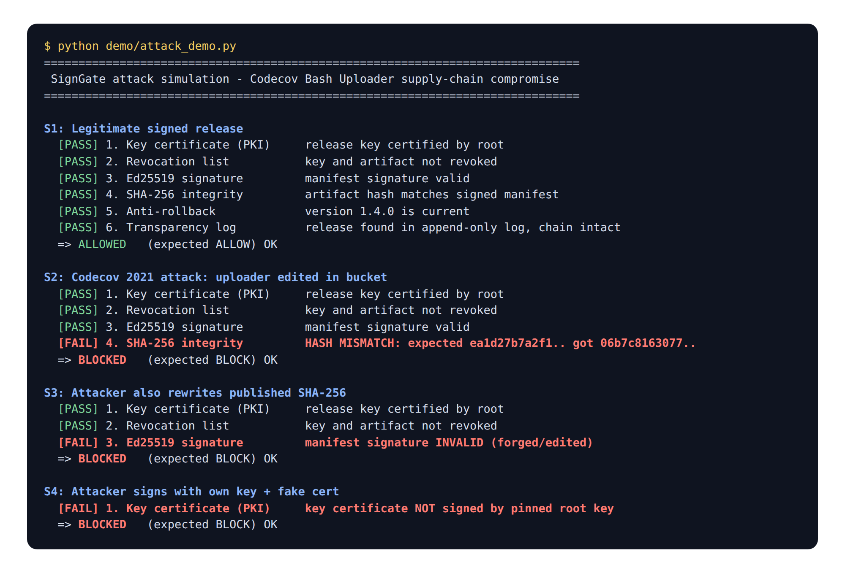
Figure 6: Test output: legitimate release allowed; 2021 attack and forgery variants blocked
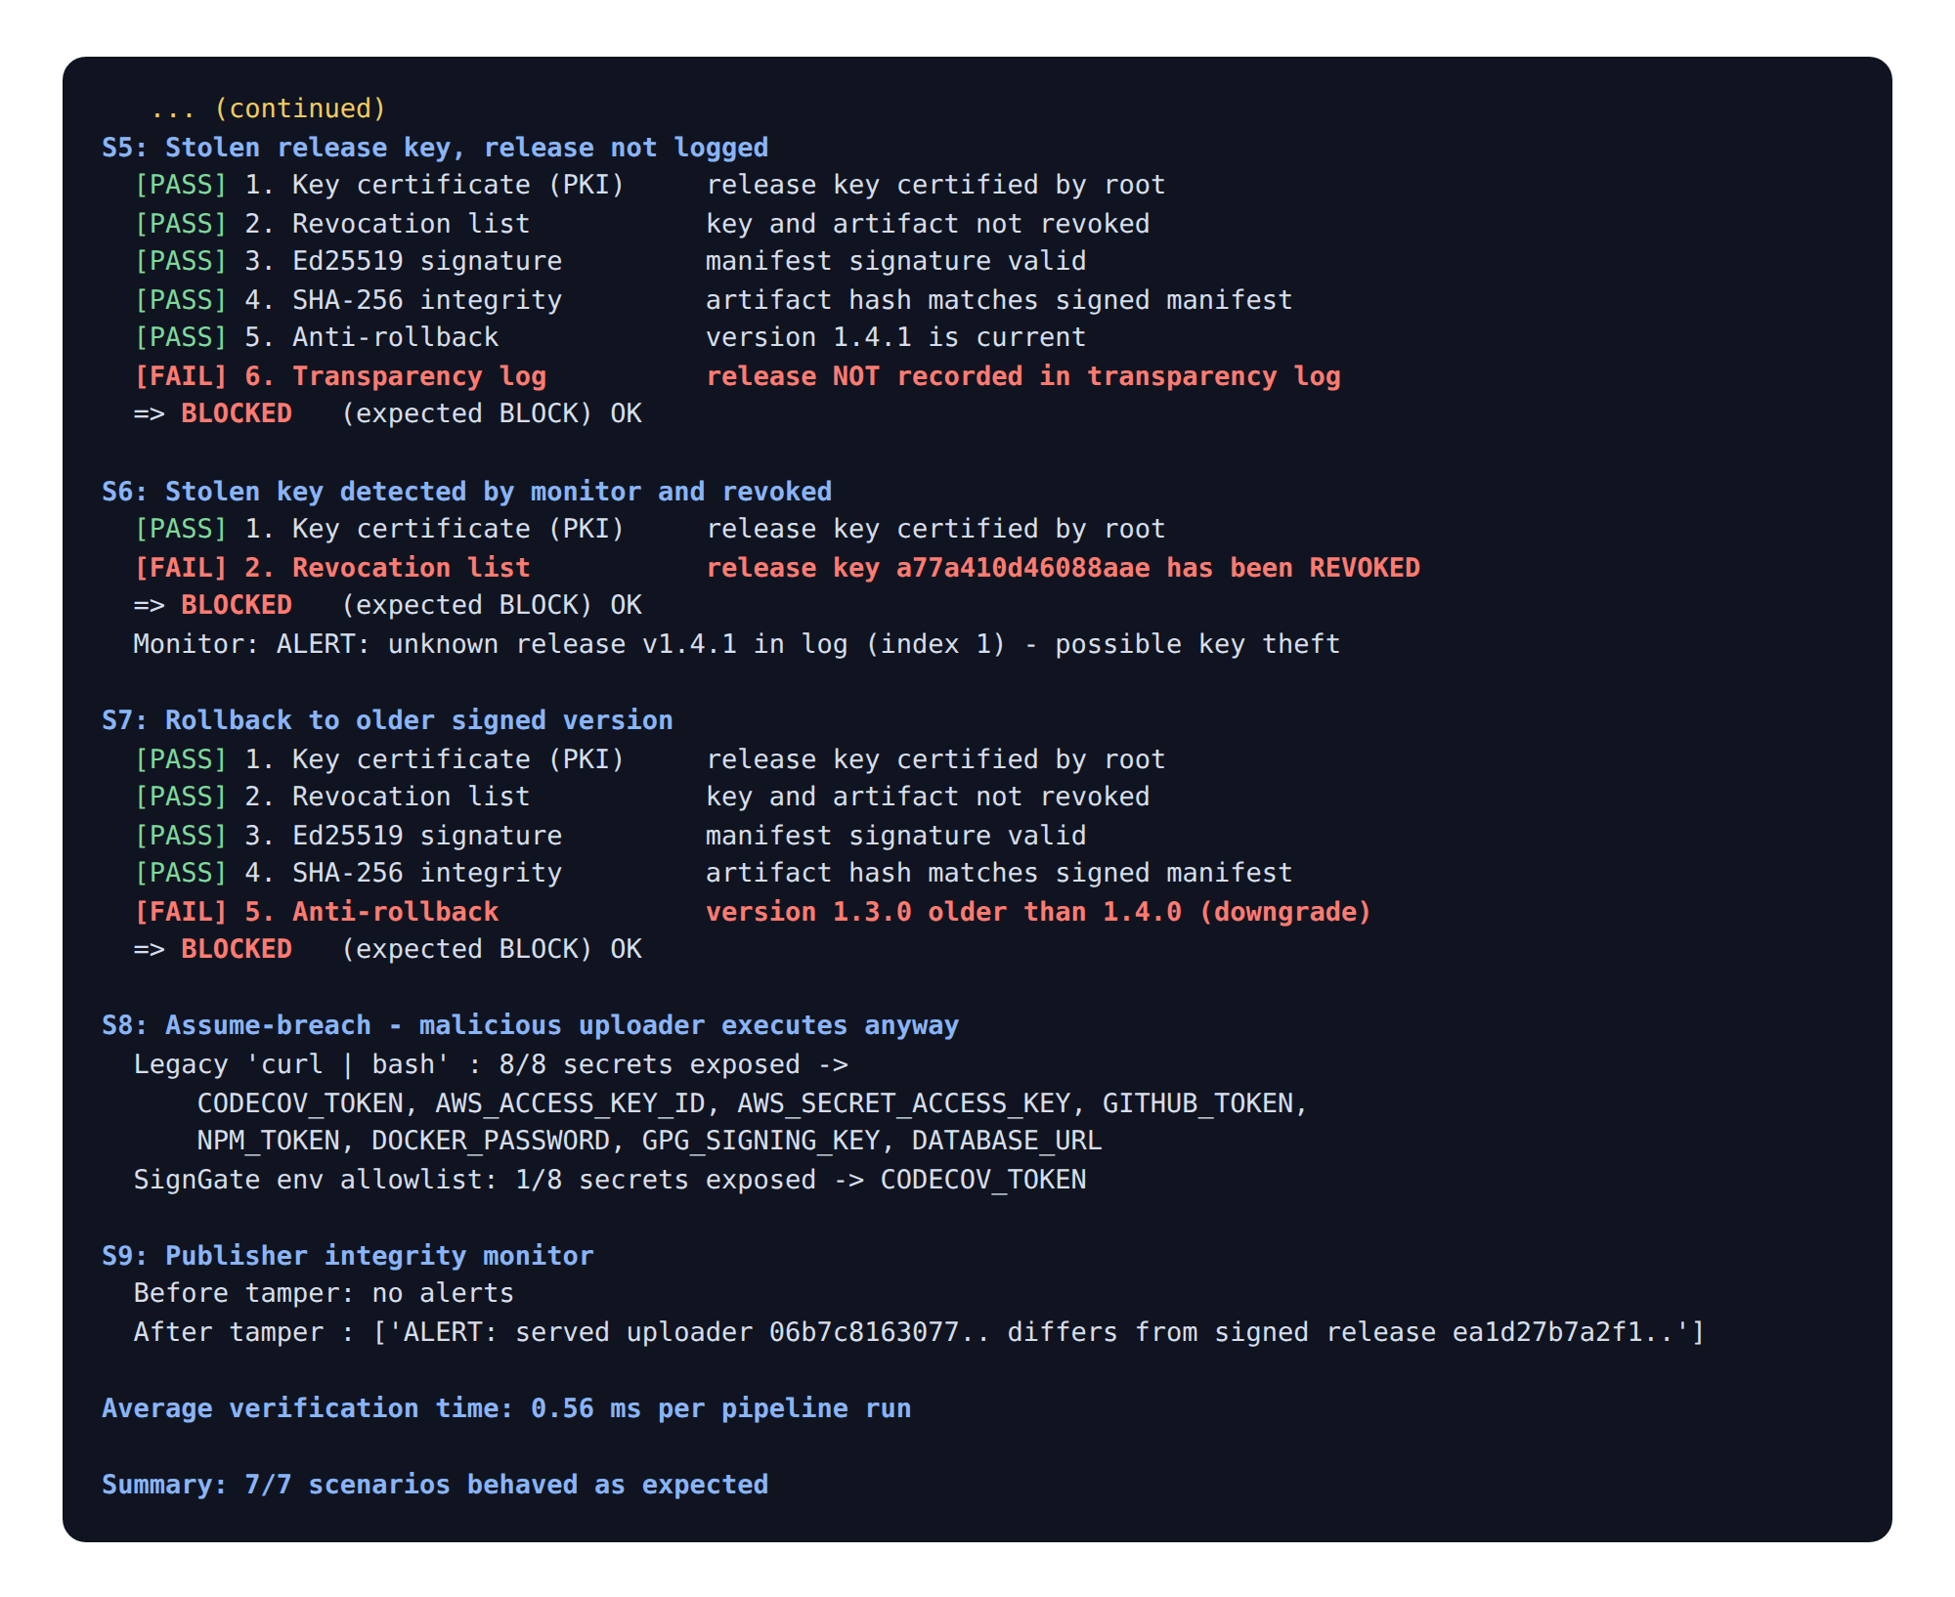
Figure 7: Test output: stolen key, revocation, rollback, assume-breach, monitor and timing
Assume-breach test (S8). To test defence-in-depth, the malicious uploader was executed directly, as if every check had been bypassed. Eight typical CI secrets were placed in the environment. With the legacy method all 8 were captured. With SignGate's allowlist only the low-value, upload-only CODECOV_TOKEN was visible (Figure 8).
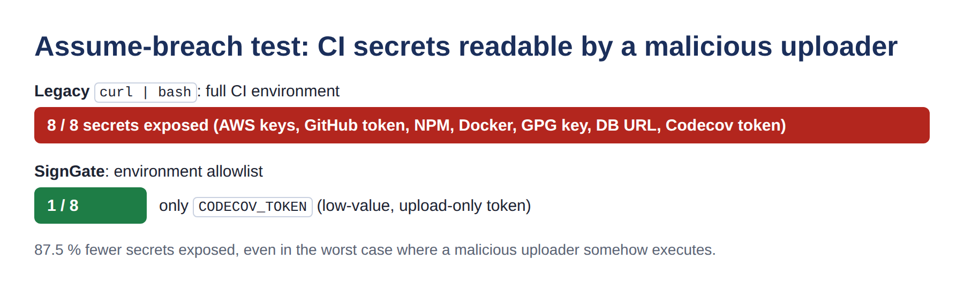
Figure 8: Secrets exposed to a malicious uploader: legacy versus SignGate
Monitor test (S9). The monitor reported no alerts on the genuine bucket. After a one-line change it immediately reported that the served uploader differs from the signed release. Performance. The full six-check verification averaged 0.56 ms over 200 runs on a standard CI container, far below SR6 (50 ms). Unit tests: 13 of 13 passed, covering signature round-trip, one-byte hash change, wrong passphrase on encrypted keys, log history edits and all attack scenarios.
Table 11: Requirement validation summary
Requirement | Validated by | Status
SR1 Integrity | S2 blocked on hash mismatch; unit test one-byte change | Met
SR2 Authenticity | S3, S4 blocked on signature / certificate | Met
SR3 Pinned trust anchor | S4: attacker's self-signed cert rejected | Met
SR4 Key protection | Unit test: encrypted key unusable without passphrase | Met (demo level)
SR5 Fail-closed | Every failing check stopped execution (S2–S7) | Met
SR6 Performance | 0.56 ms average verification | Met

8. INNOVATION AND APPLICATION RELEVANCE
8.1 What is New Compared to the Standard Fix
The standard fix, and what Codecov did after the incident, was to publish a GPG-signed uploader with a SHA-256 checksum [2], [5]. That is necessary but not enough: verification was a manual, optional step that users had to remember, a leaked signing key had no fast recovery path, and nothing limited the damage if verification was skipped. SignGate brings several controls together into one enforced gate:
Table 12: Standard fix versus SignGate
Aspect | Standard fix (signed binary + SHA) | SignGate
Verification | Optional, manual, often skipped | Mandatory: the gate is the only way to run the tool
Trust anchor | Key often fetched from same site | Root key pinned in customer repo
Leaked signing key | Re-issue key; every user must update | Root-signed CRL: automatic on next run
Silent key misuse | Undetectable | Transparency log + monitor
Rollback to old version | Not addressed | Signed version + last-seen state
If malicious code runs | All CI secrets exposed | Env allowlist: 1 of 8 secrets exposed
Detection time | About 2 months (2021) | Minutes (monitor interval)

The novel part is not a new algorithm. It is the combination of standard, well-analysed primitives into a 'verify-before-execute + least-privilege' pattern that also covers key theft and rollback. It borrows ideas from The Update Framework [18], Certificate Transparency [11] and Sigstore [12], but stays small enough (about 500 lines) for any small team to read and adopt.
8.2 Real-World Relevance
- Industry alignment: the design matches SLSA provenance and signing levels [13], the NIST Secure Software Development Framework SP 800-218 [14] and U.S. Executive Order 14028 [15]. EO 14028 was issued in May 2021, partly in response to SolarWinds and Codecov-style supply-chain attacks.
- Current context: supply-chain attacks keep recurring. Examples include SolarWinds (2020), 3CX (2023), the xz-utils backdoor (2024) and the tj-actions/changed-files GitHub Action compromise (2025), which again leaked CI secrets. The verify-before-execute pattern applies directly to GitHub Actions, npm/PyPI packages and container images.
- Cost: all components are open source. A Cloud KMS key costs about US$1 per month, and the root HSM can be a low-cost hardware token. The gate adds under 1 ms per build.
- Feasibility: it needs only Python and one widely used library. It integrates as a single CI step, and customers change one line in their pipeline.

9. CONCLUSION
The Codecov incident shows how a single leaked storage credential, together with unsigned software and the 'curl | bash' habit, let an attacker steal secrets from thousands of CI pipelines for about two months. The main failure was integrity and authenticity: customers had no enforced way to tell the genuine uploader from a modified one. The breach of confidentiality followed from that.
SignGate addresses each weakness with standard cryptography. SHA-256 and Ed25519 signatures bind every release to the publisher's key. A root-certified, rotatable, revocable key hierarchy limits the damage of key theft. A hash-chained transparency log and monitor make misuse visible. A fail-closed gate with an environment allowlist ensures nothing unverified runs and exposes very little if something ever does. The prototype blocked the original attack and five stronger variants, accepted the genuine release, reduced exposed secrets from 8 to 1 and cost about 0.6 ms per build.
Future work: keyless signing with Sigstore/OIDC identities, SLSA build provenance to cover a compromised build server, witness co-signing of the transparency log, and packaging SignGate as a reusable GitHub Action.

10. REFERENCES
[1] Codecov, "Bash Uploader Security Update," Apr. 15, 2021. [Online]. Available: https://about.codecov.io/security-update/
[2] Codecov, "Post-Mortem / Root Cause Analysis (April 2021)," 2021. [Online]. Available: https://about.codecov.io/apr-2021-post-mortem/
[3] J. Menn and R. Satter, "Codecov hackers breached hundreds of restricted customer sites - sources," Reuters, Apr. 19, 2021.
[4] HashiCorp, "HCSEC-2021-12: Codecov Security Event and HashiCorp GPG Key Exposure," HashiCorp Security Bulletin, Apr. 2021. [Online]. Available: https://discuss.hashicorp.com
[5] Cybersecurity Dive, "Codecov to sunset Bash Uploader following April supply chain attack," 2021. [Online]. Available: https://www.cybersecuritydive.com/news/codecov-bash-uploader-supply-chain-attack/601757/
[6] GitGuardian, "Codecov supply chain attack breakdown," 2021. [Online]. Available: https://blog.gitguardian.com/codecov-supply-chain-breach/
[7] S. Josefsson and I. Liusvaara, "Edwards-Curve Digital Signature Algorithm (EdDSA)," IETF RFC 8032, Jan. 2017.
[8] NIST, "Secure Hash Standard (SHS)," FIPS PUB 180-4, Aug. 2015.
[9] NIST, "Digital Signature Standard (DSS)," FIPS PUB 186-5, Feb. 2023.
[10] E. Barker, "Recommendation for Key Management: Part 1 - General," NIST SP 800-57 Part 1 Rev. 5, May 2020.
[11] B. Laurie, A. Langley and E. Kasper, "Certificate Transparency," IETF RFC 6962, Jun. 2013.
[12] Z. Newman, J. S. Meyers and S. Torres-Arias, "Sigstore: Software Signing for Everybody," in Proc. ACM CCS, 2022, pp. 2353-2367.
[13] OpenSSF, "SLSA: Supply-chain Levels for Software Artifacts, Specification v1.0," 2023. [Online]. Available: https://slsa.dev
[14] M. Souppaya, K. Scarfone and D. Dodson, "Secure Software Development Framework (SSDF) Version 1.1," NIST SP 800-218, Feb. 2022.
[15] The White House, "Executive Order 14028: Improving the Nation's Cybersecurity," May 12, 2021.
[16] E. Rescorla, "The Transport Layer Security (TLS) Protocol Version 1.3," IETF RFC 8446, Aug. 2018.
[17] A. Shostack, Threat Modeling: Designing for Security. Indianapolis, IN, USA: Wiley, 2014.
[18] J. Samuel, N. Mathewson, J. Cappos and R. Dingledine, "Survivable key compromise in software update systems," in Proc. ACM CCS, 2010, pp. 61-72.
[19] Python Cryptographic Authority, "pyca/cryptography documentation: Ed25519 signing." [Online]. Available: https://cryptography.io

