Robust Intracardiac Communication under
Pathological Dynamics: Beat-Synchronous 2-DOF
Gain Compensation for Leadless Pacemakers
Dongming Li, Student Member, IEEE,

Abstract—Implantable Medical Devices (IMDs) are evolving into collaborative networks, demanding robust, ultra-low-power communication within dynamic and often pathological biolog- ical environments. Multi-chamber leadless pacemakers (LCPs) present the ultimate test for this robustness, as the intracardiac channel exhibits not only periodic fluctuations during healthy rhythms but also unpredictable, aperiodic fades under patholog- ical conditions like Atrioventricular (AV) block. To address this challenge, an adaptive receiver based on a Super-Regenerative Receiver (SRR) and a hybrid analog-digital Automatic Gain Control (AGC) system is proposed. At its core is a beat- synchronous, two-degree-of-freedom (2-DOF) control strategy that uses the peak RSSI of each beat as an ECG-free proxy for the cardiac rhythm, enabling active signal stabilization via predictive feedforward and incremental Proportional-Integral- Derivative (PID) control. The architecture was validated using a dual-path evaluation methodology: a programmable ex-vivo porcine heart platform was developed to emulate the dynamics of Mobitz Type I Atrioventricular Block (AVB) for end-to-end link assessment, complemented by Hardware-in-the-Loop (HIL) simulations for transient characterization. Experimental results demonstrate that the proposed 2-DOF controller can stabilize the input signal to within 1% of its target amidst channel variations exceeding 15 dB, translating into a Bit Error Rate (BER) reduc- tion of one to two orders of magnitude, with an improvement factor exceeding 60-fold at 5 kbps. This design paradigm provides critical support for reliable communication in multi-chamber LCPs under pathological conditions and is extensible to other networked IMDs operating in dynamic biological environments.
Index Terms—Leadless Pacemakers (LCPs), Galvanic Con- ductive Communication (GCC),two-degree-of-freedom control (2- DOF) Automatic Gain Control (AGC), Super-regenerative Re- ceiver (SRR), Pathological Channel Dynamics, Atrioventricular Block.

I. INTRODUCTION

I
MPLANTABLE Medical Devices (IMDs) are undergoing a paradigm shift from isolated, standalone units to dis- tributed, networked systems [1]–[4]. The future of advanced healthcare will rely on deploying multiple miniature, intel- ligent sensing, monitoring, or therapeutic nodes within the human body, forming cooperative “In-Body Networks” [5]– [7]. To realize this vision, a central technological bottleneck must be overcome: establishing a long-term, stable, and ultra- low-power wireless communication link within the complex and perpetually dynamic biological environment.
To enable cooperation among multi-node IMDs, academia has explored various wireless technologies. However, conven- tional radio-frequency (RF) communication faces severe signal attenuation within the human body, typically necessitating high

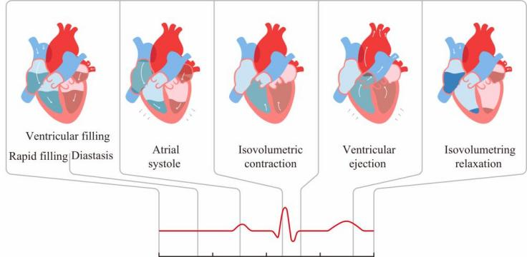
Fig. 1. Illustration of the cardiac cycle, correlating the key electrical events of the electrocardiogram (ECG) with their corresponding mechanical phases, such as atrial systole and ventricular ejection.

power consumption to maintain a link [8]. While magnetic inductive coupling offers lower power, it is constrained by its short communication range and stringent alignment require- ments [9]. Ultrasonic communication, in turn, is hampered by its inherent directionality, making it unreliable for non-line-of- sight scenarios [10]. These intrinsic limitations severely curtail their suitability for the next generation of networked IMDs, which demand miniaturization and ultra-low-power operation. In this context, Galvanic Conductive Communication (GCC) emerges as a promising and potentially disruptive technology. GCC cleverly utilizes human tissue itself as the transmission medium, propagating information via a faint electric field. This approach not only offers the potential for extremely low power consumption and simpler circuit implementation but also provides enhanced security, as the signal is naturally confined within the body. Given these distinct advantages, GCC has become one of the most promising candidates for enabling next-generation networked IMDs [11]–[14].
Among all implantable communication scenarios, the multi- chamber Leadless Pacemakers (LCPs) system represents the ultimate “proving ground” for the robustness of GCC tech- nology [15]–[17]. Consequently, extensive research has been dedicated to characterizing the Intracardiac Communication (CIC) channel. Early investigations predominantly relied on static or quasi-static models, employing finite element anal- ysis, numerical simulations, and in-vivo animal studies to delineate fundamental transmission properties [18]–[21]. More recently, as research has matured, the dynamic nature of the CIC has gained attention. For instance, the work of [22] provided valuable experimental insights into normal cardiac cycle dynamics via an ex-vivo platform, while our group’s

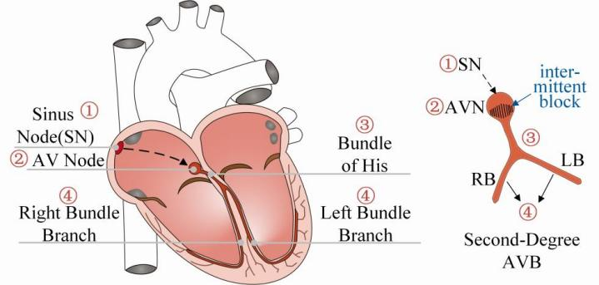
Fig. 2. Schematic diagram of the cardiac conduction system and a represen-
tative Atrioventricular Block (Second-degree Type I).

prior work established a time-varying equivalent circuit model for such dynamic channels [23].
These foundational studies are indispensable first steps. However, a critical challenge emerges as research transitions from theoretical feasibility to clinical robustness. Many exist- ing CIC transceiver designs, in their early stages, inevitably rely on static or averaged channel models [20], [24], [25]. This idealized approximation, while convenient for initial analysis, masks a crucial fact: the intracardiac channel dynamics exist on two distinct levels.The first level is the “healthy dynamic.” As illustrated in Fig. 1, the regular heartbeat induces pre- dictable, periodic fluctuations in channel gain. This baseline dynamic itself precludes the use of static receivers and es- tablishes the fundamental necessity for employing automatic gain control (AGC). However, a second, more severe and clinically significant level is the “pathological dynamic.” A representative form of this condition, an Atrioventricular (AV) block as shown in Fig. 2, is characterized by intermittent con- duction failure that breaks the original predictable rhythm and introduces irregular, abrupt, and deeper channel fades. Under these conditions, a traditional feedback control mechanism, which relies purely on a “post-event” reaction, struggles to maintain link reliability in a timely and stable manner due to its inherent response latency, forming a fundamental barrier to translating prototypes into clinically reliable devices.
The choice of receiver architecture becomes paramount in addressing this ultimate challenge. Given the extremely stringent constraints on power and complexity in LCPs, the Super-Regenerative Receiver (SRR) architecture emerges as one of the most promising candidates, by virtue of its inherent simplicity and immense potential for achieving high sensitivity at very low power [26], [27]. The SRR architecture, however, is a double-edged sword: its performance exhibits extreme sensitivity to variations in the input signal amplitude [28], [29]. While this characteristic can be exploited for high gain under stable channel conditions, it transforms into a critical liability in the dynamic CIC environment we face, necessitating a sophisticated compensatory mechanism to unlock the SRR’s full potential.
Therefore, AGC is an indispensable component for ensur- ing system robustness. Yet, conventional AGC solutions are not directly applicable to LCPs. Fully analog AGC systems, while offering rapid response, often suffer from poor linearity, imprecise gain control, and a fixed-threshold operation that

limits adaptability in complex, varying environments [30]. Conversely, fully digital AGC solutions, while capable of high precision and flexibility, come at the cost of significant computational overhead and power consumption, which is incompatible with the microwatt-level budget of LCPs [31]. Therefore, there is an urgent need for an innovative solution that can achieve a delicate balance among speed, accuracy, and low power consumption, and possess the ability to actively preset rhythmic channel hopping.
In response to this imperative, this paper introduces a novel receiver front-end based on an SRR, deeply co-designed with a hybrid analog-digital AGC architecture. This architecture strategically combines the rapid response of an analog front- end with the fine-grained control of the digital domain to achieve robust compensation for dynamic CIC channel gain fluctuations. The main contributions of this work are as follows:
• A beat-synchronous two-degree-of-freedom control (2- DOF) active compensation strategy is proposed, which operates without an external ECG. The peak RSSI of each beat is used as a proxy for the cardiac rhythm, combining predictive feedforward with incremental PID control to proactively stabilize the gain against aperiodic, pathologically-triggered step changes.
• A programmable ex-vivo platform was developed to emulate the pathological dynamics of Mobitz Type I Atrioventricular Block (AVB). This controllable and re- peatable setup enables the systematic evaluation of the communication link under clinically relevant and repro- ducible adverse channel conditions.
• A dual-path quantitative evaluation framework was estab- lished. By integrating Hardware-in-the-Loop (HIL) for transient characterization with ex-vivo experiments for end-to-end communication assessment, a clear causal link from control metrics to link reliability was built and validated across multiple heart samples.

II. METHODS

A. Challenges of the Dynamic Intracardiac Channel and Its Impact on SRR Performance
The fundamental challenge for efficient communication between multi-chamber LCPs arises from the dynamic and complex physiological environment of the heart. The periodic electromechanical activity of the heart induces significant and time-varying fluctuations in the CIC channel gain, Gc (t) [23]. Under pathological conditions requiring pacing intervention, such as “missed beats” caused by conduction block, the chan- nel dynamics become even more complex and unpredictable than during a normal sinus rhythm. This study, therefore, aims to design an adaptive receiver capable of maintaining robust communication in such a harsh and non-stationary channel.
Given the ultra-low-power constraints of LCPs, the SRR is a favored architecture due to its high sensitivity and simple structure. However, the performance of an SRR is excep- tionally sensitive to the input signal amplitude, Ain (t). This characteristic stems from its operating principle: during the regeneration phase, the net conductance of the oscillator tank

Preamp

Preamp
(AD8421)

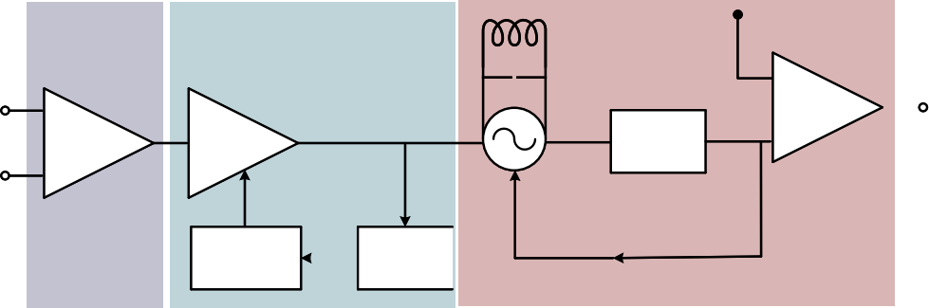  Hybrid-AGC  VGA  2-DOF RSSI  Controller |  | SRR  Vref LC-Based  SRO  Envelope Detector | +  -
Self-quench
signal
Fig. 3. Block diagram of the proposed adaptive receiver architecture. The core Hybrid-AGC module forms a closed loop, using a RSSI and a 2-DOF controller to dynamically adjust the VGA, thereby delivering a stabilized signal to the SRR stage.

is negative (G = Go —GN < 0), causing the voltage envelope Venv (t) to grow exponentially from an initial value set by the input signal Ain (t):
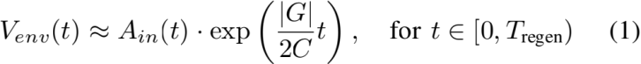
where Tregen is the regeneration period. Consequently, within a fixed quench period, the final detected envelope amplitude is a monotonically increasing function of Ain (t). In a front-end without adaptive control, the SRR’s input amplitude Ain (t) is directly coupled with the time-varying channel:
Ain (t) = Atx · GLNA · Gc (t) (2)
where Atx and GLNA are the transmitted signal amplitude and the low-noise amplifier (LNA) gain, respectively. Fluctuations in channel gain Gc (t) directly translate into variations in Ain (t), which in turn cause drastic changes in the effective signal-to-noise ratio (SNReff ) at the SRR’s decision point. This relationship can be modeled as a monotonic function:
Pe (t) = fBER (SNReff (t)), SNReff (t) Ⅸ An (t) (3)
where fBER (·) is a monotonically decreasing function. During deep channel fades, a sharp drop in SNReff (t) causes the bit error rate Pe (t) to approach 0.5, leading to instantaneous link failure. Therefore, stabilizing Ain (t) is a prerequisite for reliable communication. Notably, the control scheme proposed herein does not rely on an external electrocardiogram (ECG) signal; when the ECG is unavailable, the system can au- tonomously extract rhythmic information from the envelope of the received signal strength indicator (RSSI).

B. Adaptive Receiver Architecture with Hybrid Gain Control
To address the aforementioned challenges, we propose an adaptive receiver architecture centered around a hybrid analog-digital automatic gain control (Hybrid-AGC) loop, as illustrated in Fig. 3. The core objective of this architecture is to dynamically adjust the total front-end gain to precisely compensate for fluctuations in the channel gain Gc (t), thereby providing a constant-amplitude input signal to the subsequent SRR core.
As depicted in the diagram, the receiver chain is divided into three functional stages. The signal first enters a fixed pre- amplification stage (Preamp), followed by the Hybrid-AGC module, which acts as the core regulation unit. This mod- ule forms a sophisticated negative feedback loop: a variable

Algorithm 1 Beat-Synchronous with RSSI Prediction | 2-DOF | Gain | Stabilization
Input: Target level xig , Kf , α, PID gains (Kp , Ki , Kd , Kaw ),
bounds umin , umax , slew limit ∆umax
Output: Vc [k]
1: Initialize: Iprev ← 0, Dprev ← 0, eprev ← 0
2: prev ← xig , ufinal prev ← 0, uPID prev ← 0, uff ← 0
3: while system running do
4: x[k] ← Sample and digitize RSSI dB
5: if new heartbeat detected then
6: xp ← Peak RSSI of previous beat dB
7: ← (1 - α)prev + αxp
8: uff ← Kf (xig - )
9: prev ←
10: end if
:: 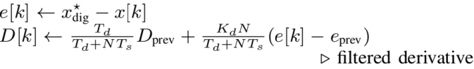
13: uPID [k] ← uPID prev + Kp (e[k] - eprev ) + KiTse[k] + (D[k] - Dprev )
▷ incremental PID
14: utot [k] ← uff + uPID [k]
15: ufinal [k] ← clip(utot [k], ufinalprev ± ∆umax )
16: ▷ slew limit
17: usat [k] ← clip(ufinal [k], umin , umax )
18: ▷ saturation
19: Vc [k] ← DAC(usat [k])
20: Update history for next iteration:
21: Dprev ← D[k], eprev ← e[k]
22: uPID prev ← uPID [k], ufinal prev ← ufinal [k]
23: end while

gain amplifier (VGA) amplifies the signal, and its output is simultaneously routed to the final SRR detection stage and monitored in real-time by a RSSI. The RSSI converts the signal envelope’s strength into a corresponding DC voltage, which is then sampled by an analog-to-digital converter and fed to a digital 2-DOF controller. This controller compares the sampled value against a preset target, computes the error, and generates an updated gain control signal based on its control algorithm. This digital signal is converted back to an analog voltage by a digital-to-analog converter to precisely regulate the VGA’s gain. This completes the closed-loop regulation, ensuring that the signal strength delivered to the SRR remains stable regardless of input channel variations.

C. Loop Modeling, Stability, and Implementation
To ensure the closed-loop system exhibits robust and pre- dictable dynamic performance, we first establish a control- theoretic model for the AGC–SRR system, which guides the controller’s design and tuning. We approximate the entire path from the VGA gain control input to the ADC output in the logarithmic domain as a first-order continuous-time system with a pure delay τd: x.(t) = —(1/τ)x(t) + γcu(t — τd ). Discretization using a zero-order hold yields its discrete-time equivalent model:
x[k + 1] = ϕx[k] + γu[k — d] + w[k] (4)
where x[k] is the sampled RSSI value, u[k] is the VGA gain control signal, and the mapping from continuous to discrete

parameters is:
ϕ = e −Ts /τ , γ = γc τ(1 − e−Ts /τ ), d = ⌈τd /Ts⌉ (5)
The term w[k] represents model uncertainty and noise. The transfer function of the plant, P(z), is therefore:
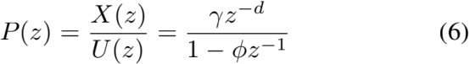
The system’s open-loop transfer function is L(z) = C(z)P(z). Our design objective is to maintain closed-loop stability under all operating conditions, with a specific target of a phase margin ≥ 45◦ . This provides a clear optimization goal for tuning the PID parameters (Kp , Ki , Kd ). The ap- proximate relationship between the settling time tsettle and the controller parameters further reveals their impact on dynamic performance:

To translate this theoretical model into a high-performance practical controller, we integrated several key implementation techniques. To suppress the amplification of high-frequency noise by the derivative term, we employed a first-order low- pass filter to smooth the rate of error change, with its update rule given below (recommended parameters: Td = 2Ts , N = 10):
Simultaneously, to prevent integral windup when the VGA gain saturates, we implemented an anti-windup mechanism via back-calculation, where the integral accumulator is corrected based on the saturation error:
I[k + 1] = I[k] + KiTse[k] + Kaw (usat [k] − u[k]) (9)
where usat [k] is the saturated control output. Furthermore, during the preamble of a data packet, we temporarily freeze the integral and derivative channels, relying solely on proportional control for rapid coarse adjustment to avoid overshoot from the initial step response.

D. Beat-Synchronous 2-DOF Control Algorithm with RSSI Prediction
Despite these optimizations, a conventional feedback-only PID controller is still limited by its loop bandwidth in terms of response speed and overshoot when facing the abrupt, step- like changes in channel gain inherent to the cardiac cycle. While a well-tuned PID can manage the rhythmic, predictable steps of a healthy heart to some degree, its purely reactive nature proves critically insufficient for the chaotic dynamics of pathological conditions. The core challenge shifts from man- aging periodicity to compensating for unpredictability during events like the “missed beats” in an Atrioventricular block. To overcome this bottleneck of unpredictability, we propose a 2-DOF control strategy that combines beat-synchronous feedforward control with PID feedback.
The fundamental principle of this strategy is rooted in the direct mapping between cardiac mechanics and received signal

strength. As established in prior work [17], [32], the heart’s mechanical pumping action, characterized by the cyclical filling and ejection of blood—causes significant changes in both the geometry between the electrodes and the electrical properties of the transmission medium. These hemodynamic shifts directly modulate the channel gain (Gc (t)). The RSSI provides a real-time measurement of this gain, effectively serv- ing as an electrical proxy for the heart’s mechanical rhythm. It is this robust link that allows our system to leverage the heart’s rhythmicity. By analyzing the RSSI envelope, the controller can autonomously identify beat boundaries and characterize each beat’s channel quality by its peak RSSI value forming the basis for prediction.
Based on this, we employ a computationally lightweight Exponential Moving Average (EMA) model to predict the peak RSSI of the next beat:
k+1 = (1 − α)k + αxk , α ∈ [0.2, 0.3] (10)
where k+1 is the prediction for the next beat’s peak RSSI.
Our 2-DOF controller combines predictive compensation for the slowly varying component of the channel (beat-level jumps) with feedback regulation for fast-varying residuals. Ideally, the required VGA gain compensation (in dB) is
gga (t) = x* −(gc (t)+glna +gtx ). Upon detecting the start of
a new beat, the controller first calculates a feedforward control signal, uff :
uff [k + 1] = Kf (x* − k+1), uff ∈ [−8, 8] dB (11)
This feedforward term is added to the incrementally imple- mented PID feedback output, uPID , to form the total control signal:
uPID [k] = uPID [k − 1] + Kp (e[k] − e[k − 1])
(12)
+ KiTse[k] + (D[k] − D[k − 1])
utotal [k] = uff [k] + uPID [k] (13)
To prevent rapid changes from stressing the hardware, we also apply a slew-rate limiter to the total control output:
ufinal [k] = clip(utotal [k], ufinal [k − 1]
(14)
− ∆umax , ufinal [k − 1] + ∆umax )
Furthermore, to enhance robustness, the system includes a de-rating strategy: if the prediction error remains below a threshold for several consecutive beats, the feedforward gain Kf is temporarily zeroed, and the system reverts to a pure PID mode until the next large jump is detected. The complete control logic, which integrates prediction, feedforward, feed- back, and multiple robustness enhancements, is formalized in Algorithm 1.

III. EXPERIMENTAL METHODOLOGY AND SETUP
To rigorously validate the proposed adaptive receiver archi- tecture and its core 2-DOF control strategy, we established a high-fidelity ex-vivo experimental methodology. The cor- nerstone of this methodology is an isolated heart perfusion platform in Fig. 4, which utilizes a freshly excised porcine heart as its biological core to maximally replicate the authentic

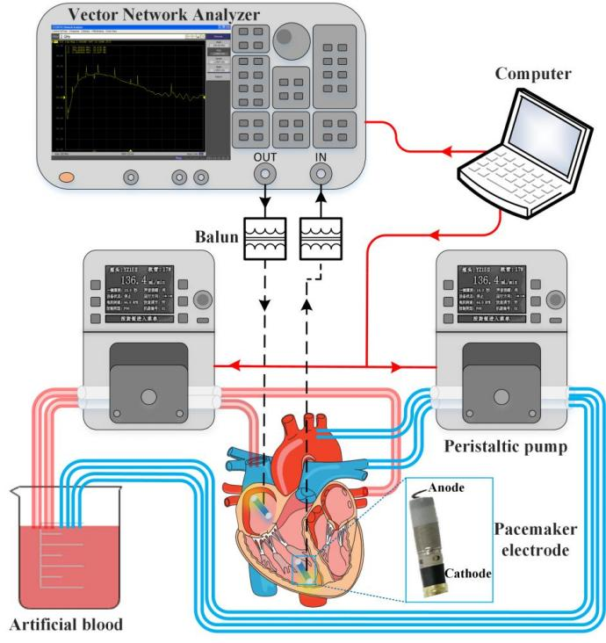
Fig. 4. Photograph of the assembled experimental testbed, showing the peri- staltic pump system, the cannulated isolated porcine heart, signal generation instruments, and the custom-developed receiver module. A 1:1 balun is used for current isolation.
TABLE I
CARDIAC CYCLE PHASES AND CORRESPONDING CHAMBER VOLUMES

Phase | Duration (s) | Left Volume  (mL) | Right Volume  (mL)
Isovolumic Relaxation | 0.07 | 120.00 | 150.00
Rapid Filling | 0.11 | 173.44 | 202.88
Diastasis | 0.22 | 191.25 | 220.50
Atrial Systole | 0.10 | 215.00 | 244.00
Isovolumic Contraction | 0.05 | 215.00 | 244.00
Rapid Ejection | 0.10 | 151.67 | 181.34
Reduced Ejection | 0.15 | 120.00 | 150.00

intracardiac communication environment. A dual-channel peri- staltic pump system circulates a specially formulated blood- mimicking fluid, matched to the conductivity of human blood at 37°C [21], [33]. This setup, governed by a host computer executing precise temporal control over chamber volumes, achieves a high-fidelity simulation of intracardiac hemody- namics.
We contend that a truly robust adaptive system must main- tain performance under harsh channel conditions characterized by both gradual and abrupt variations. Consequently, we deliberately selected and implemented Mobitz Type I AVB as a representative pathological channel model. The key advan- tage of this model is its inherent Wenckebach phenomenon, where channel parameters progressively deteriorate before a “dropped beat,” and the dropped beat itself manifests as an abrupt step-change in channel gain. Our platform was pro- grammed to precisely replicate the hemodynamic signatures of this AVB model, based on published human cardiac volume data [22], [34]–[37], with the specific parameters for each phase of the cardiac cycle detailwith the specific parameters for each phase of the cardiac cycle detailed in Table I. The dynamic mappings for both normal sinus rhythm (NSR) and

our AVB model are illustrated in Fig. 5and Fig. 6, respectively. Upon this high-fidelity platform, we instituted a direct comparative evaluation framework. This framework bench- marks our proposed 2-DOF controller, which integrates beat- synchronous predictive feedforward, against a well-tuned con- ventional feedback-only PID controller (serving as the base- line) and an open-loop configuration with no AGC. System performance was quantified using a suite of key metrics cov- ering both transient dynamics and steady-state communication quality. The former includes settling time (tsettle ) and maximum overshoot, while the latter is assessed by the end-to-end Bit Error Rate (BER). Across all experiments, the physical link setup remained constant: a 1MHz OOK signal with an average power of —10dBm was generated and coupled to the right
atrium, while our custom-developed SRR receiver, integrating the different control strategies, was connected to an electrode in the right ventricle.
Our evaluation strategy was strategically bifurcated into two complementary phases. First, to precisely assess the intrinsic transient response capabilities of the controller, independent of the complexities of the biological specimen, we employed a HIL simulation strategy. In this setup, the controller hardware under test (MCU) and its actuator (VGA) were physical devices, but their RF environment was digitally simulated in real-time by a host computer. The computer calculated the requisite signal strength at the SRR input based on predefined channel gain step sequences (5 dB, 10 dB, 15 dB) and the MCU’s real-time output, then converted this value into an analog RSSI signal via a high-speed DAC to close the loop. Analyzing the controller’s response to these step disturbances allowed for precise quantification of its settling time and maximum overshoot.
Second, communication reliability, the ultimate measure of the system’s practical utility, was evaluated under the contin- uously dynamic pathological channel conditions generated by the isolated heart platform. As depicted in Fig. 7, a complete transceiver and analysis chain was established to conduct long- duration transmissions of a pseudo-random binary sequence (PRBS) for the no-AGC, PID, and 2-DOF configurations under the simulated AVB rhythm, enabling the calculation of BER at various data rates. To ensure the scientific rigor and reproducibility of all findings, the entire set of experiments was repeated in three independent porcine heart preparations (N=3), with five technical replicates for each measurement (n=5).

IV. EXPERIMENTAL RESULTS AND ANALYSIS
A series of systematic ex-vivo experiments were conducted to comprehensively evaluate the proposed adaptive receiver architecture and its core 2-DOF control strategy. This section sequentially constructs a complete argumentative chain: first, by presenting the true characteristics of the dynamic intrac- ardiac channel, we reveal and quantify the core challenges of this research; second, we demonstrate the fundamental necessity of a basic AGC loop as a countermeasure; finally, through rigorous comparison with a traditional PID baseline, we will demonstrate the superior performance of our proposed

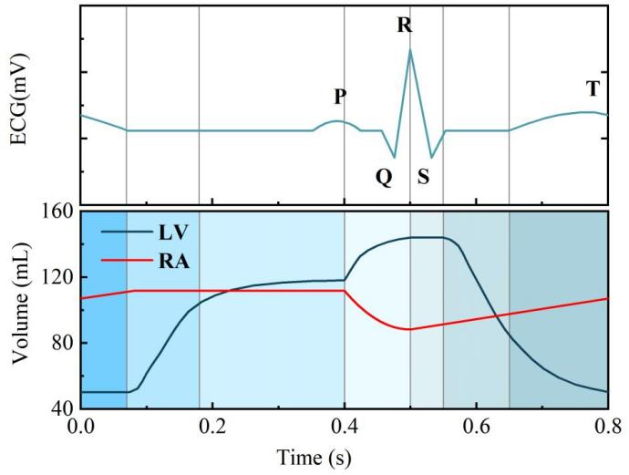
Fig. 5. Dynamic mapping between ECG and right-sided chamber volume for
the simulated NSR, serving as the baseline model for a healthy heart.

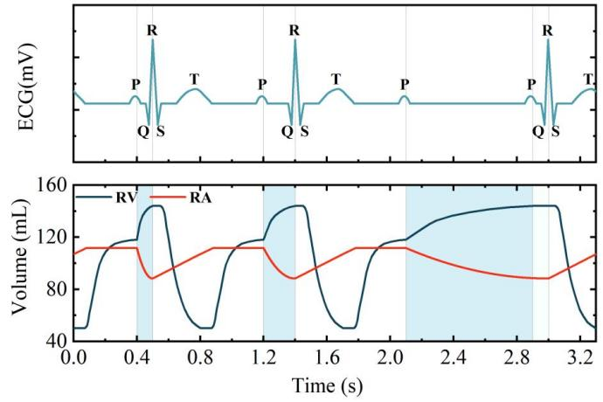
Fig. 6. Pathological cardiac cycle simulation corresponding to our represen- tative Atrioventricular Block (AVB) model. The map illustrates an instance of intermittent conduction failure, where a P-wave is not followed by a QRS complex, leading to an irregular hemodynamic profile.

2-DOF controller in achieving robust communication from both transient response and statistical perspectives.

A. Characterization of Channel Dynamics under Healthy and Pathological Rhythms
Direct experimental characterization of the RA-RV intrac- ardiac communication channel, as depicted in Fig. 8, reveals its inherent dynamic properties, providing a clear rationale for the design of an adaptive receiver. Under simulated healthy heart conditions which is shown Fig. 8(a), the channel path gain exhibits pronounced yet highly periodic fluctuations of up to 10–15 dB, tightly synchronized with the cardiac cycle. This baseline dynamic makes it clear that even under ideal conditions, a static receiver cannot guarantee stable communi- cation quality, thus establishing the fundamental necessity for employing AGC.
However, the core challenge of this research is fully mani- fested when simulating pathological conditions. As shown in Fig. 8(b), under the Mobitz Type I AVB model, the predictable rhythm of the channel is completely disrupted. It is replaced by a harsh environment dominated by irregular, abrupt, and deep

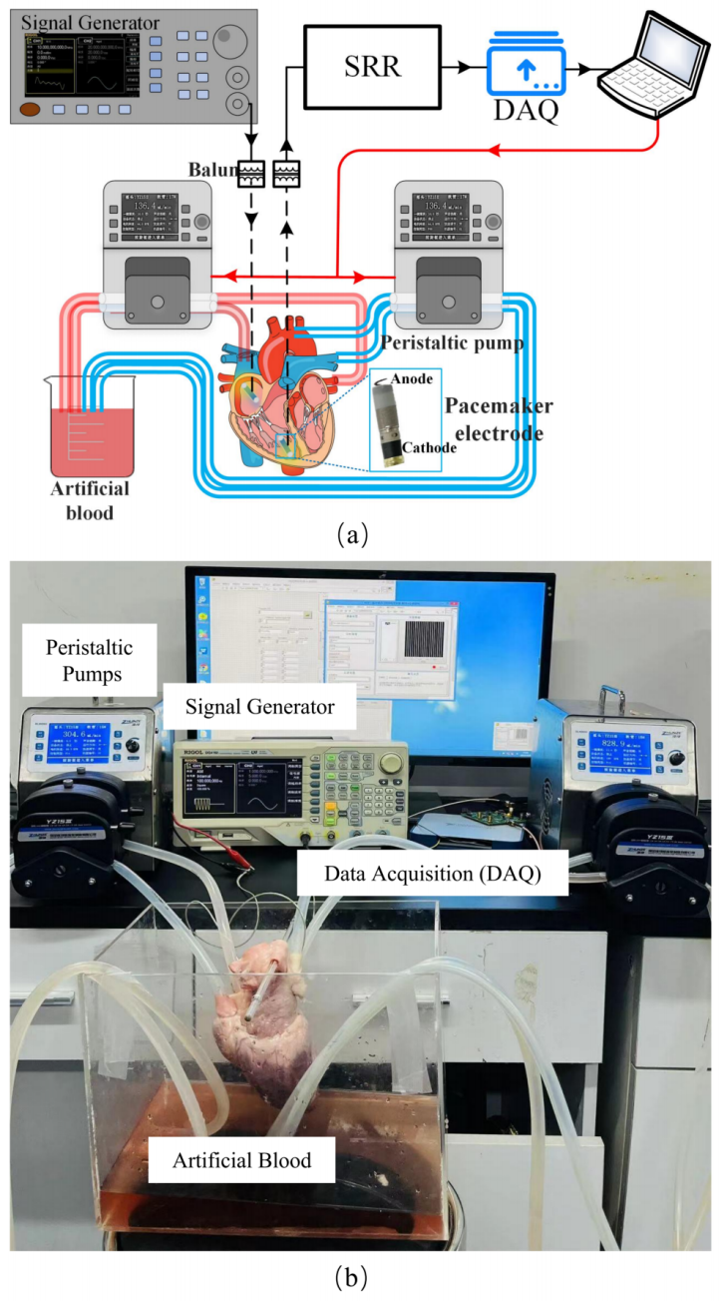
Fig. 7. Schematic of the experimental setup for BER evaluation. The configuration integrates a signal generator (SG), the ex-vivo heart platform, the adaptive SRR, and a data acquisition (DAQ) system.

signal fades. This qualitative shift from periodic fluctuations to unpredictable, event-driven transients imposes requirements on the adaptive system that are far beyond the conventional. It indicates that a traditional feedback controller, which merely reacts to errors, will inevitably suffer from performance degradation when coping with such sudden fades. Therefore, to maintain robust communication link integrity under these extreme conditions, an advanced control strategy capable of predictive and rapid response becomes essential.

B. Fundamental Effectiveness of the AGC System in Signal Stabilization
Before introducing the advanced 2-DOF controller, we first had to establish the fundamental effectiveness of the AGC closed-loop itself as a solution. The basic capability of the AGC loop in stabilizing the severe channel fluctuations caused

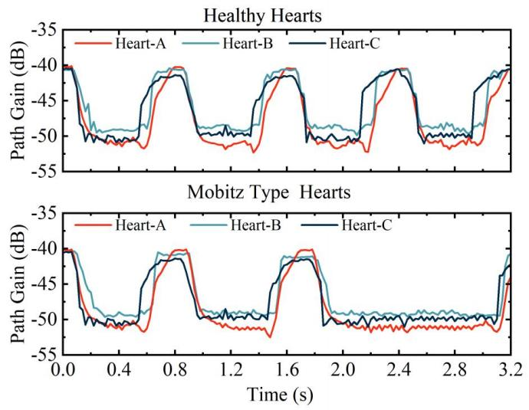
Fig. 8. Dynamic path gain variation of the RA-RV intracardiac channel. (a) Under simulated healthy heart conditions. (b) Under simulated representative pathological (Mobitz Type I AVB) conditions. Results from three different ex-vivo porcine heart preparations are shown.

by heartbeats is illustrated in Fig. 9, which uses the simulated pathological ECG in Fig. 9(a) as a temporal reference.
The waveform in Fig. 9(b) reveals the inherent instability without AGC, where the signal amplitude at the SRR input fluctuates drastically between 1.5 mV and 5.0 mV with the simulated heartbeats; this would directly translate into dete- riorated demodulation performance. In stark contrast, when the AGC loop is activated, the VGA’s control voltage (Vg ) accurately tracks the channel variations in real-time and in an inverse manner, as depicted in the trace of Fig. 9(c). The direct result, visualized in the stabilized waveform of Fig. 9(d), is that the SRR’s input signal amplitude is successfully clamped at the 100 mV target level, with peak-to-peak residual fluctu- ations suppressed to within 1%. This result provides decisive evidence for AGC as a necessary technique to compensate for the dynamic channel.

C. Comprehensive Evaluation of Transient Response Perfor- mance
To quantify the advantages of our proposed 2-DOF strategy over a traditional PID baseline, we evaluated the transient response of the AGC control algorithm under a challenging 15 dB channel step event. The results, depicted in Fig. 10, reveal a stark performance difference. Following a sharp drop in channel gain, the feedback-only PID controller shows sig- nificant undershoot, with its signal amplitude falling to 87.7% of its target, representing a maximum deviation of 12.3%, and requiring 85.2 ms to re-settle. Conversely, thanks to its predictive feedforward path, the 2-DOF controller restricts the maximum deviation to only 9.1% and maintains the signal above 90.9% of its target value. It also dramatically reduces the settling time to just 20.3 ms, which is a greater than four- fold, or 76%, improvement over the baseline.
To generalize this significant advantage from a representa- tive event to a statistically meaningful conclusion, we further performed an aggregate analysis of key dynamic performance metrics measured across repeated experiments under various

(a) ECG Signal
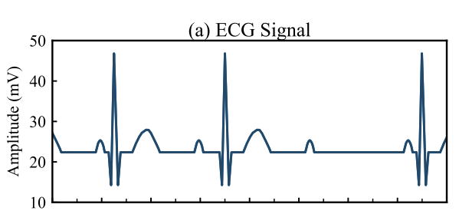
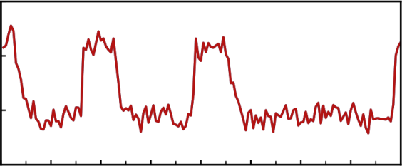
(b) Received Signal Amplitude without AGC
6
Amplitude (mV)
4

2

0
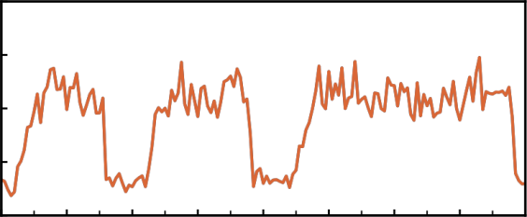
(c) VGA Control Voltage
30

25
Vg (mV)
20
15
10
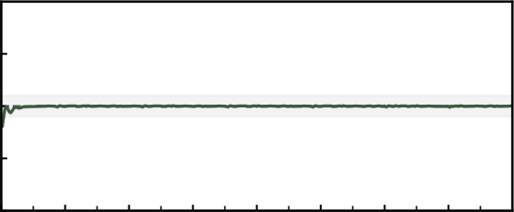
(d) Received Signal Amplitude with AGC
120
Amplitude (mV)
110
100
90
80
0.0 0.4 0.8 1.2 1.6 2.0 2.4 2.8 3.2
Time (s)

Fig. 9. Effectiveness of the hybrid AGC system in stabilizing the receiver input signal. (a) Reference ECG signal. (b) Received signal amplitude at the SRR input without AGC. (c) Dynamic VGA control voltage (Vg). (d) Stabilized signal amplitude at the SRR input with AGC activated.

disturbance scenarios, with the results presented in Fig. 11. The statistical results irrefutably confirm the comprehensive superiority of the 2-DOF controller in dynamic performance, especially in response speed.
The statistical results for settling time, presented in Fig. 11(a), highlight a compelling advantage of the 2-DOF architecture, which reduces the settling time by more than 4 times, a reduction of approximately 76%, across all tested sce- narios. This superior performance extends to the suppression of maximum deviation, where the data in Fig. 11(b) shows a consistent improvement that reduces the deviation by about 20–26% in all scenarios. Thus, the combined evidence from the in-depth analysis of a single typical event and this broader cross-scenario statistical validation robustly proves that the 2- DOF architecture possesses far superior speed and stability in coping with channel transients compared to traditional feedback control.

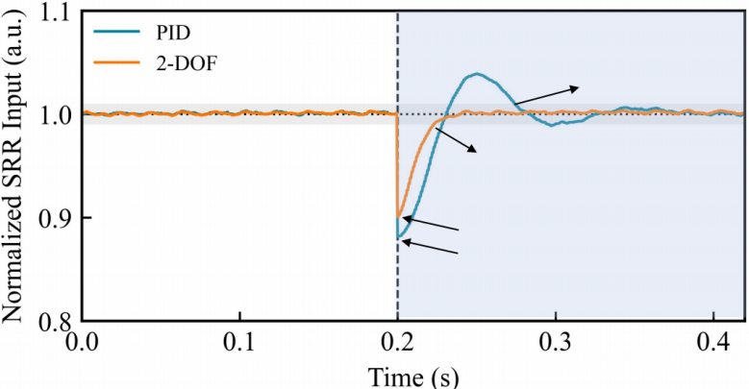
tsettle= 85.2 ms

20.3 ms

Min 87.7% (87.7 mV) Min 90.9% (90.9 mV)

Fig. 10. Transient response comparison between the 2-DOF and PID controllers to a representative 15 dB channel gain step. The normalized SRR input signal demonstrates the superior performance of the 2-DOF controller in terms of both settling time and undershoot suppression.

Settling time (ms) | 150  125  100  75  50  25  0 | 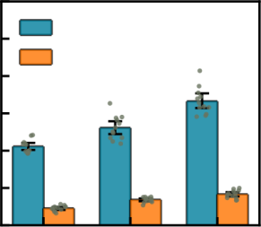  (a) Settling Time  PID  2-DOF  5 dB 10 dB 15 dB | Max Deviation (%) | 20  15  10  5  0 | 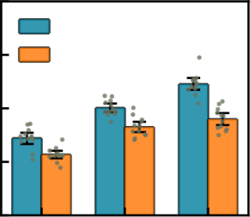  (b) Max Deviation  PID  2-DOF  5 dB 10 dB 15 dB

Fig. 11. Quantitative statistical comparison of transient performance metrics under different channel step disturbances. (a) Settling time (tsettle) comparison. (b) Maximum deviation (%) comparison. Data points represent individual trials, while bars and error whiskers indicate the mean and 95% confidence interval, respectively. The 2-DOF controller significantly outperforms the baseline PID across all scenarios.

D. Final Enhancement in Communication Reliability
The ultimate value of superior signal stability must be manifested in an improvement in actual communication perfor- mance. Fig. 12 first visually demonstrates the AGC system’s assurance of signal integrity in the time domain. Even under a dynamic channel, the envelope of the received OOK signal is maintained at a constant level, ensuring that the subsequent demodulation circuit can flawlessly recover the original base- band signal.
We quantified the final communication performance by the Bit Error Rate (BER), with the results presented in Fig. 13. The experimental results provide compelling evidence for the decisive role of adaptive control. Compared to the configu- ration without AGC, both AGC strategies (PID and 2-DOF) substantially reduced the BER across all tested data rates, with the 2-DOF configuration achieving an average improvement of 98.4% at a 5 kbps data rate.
More importantly, the data further reveals the significant superiority of our proposed 2-DOF controller over the conven- tional PID baseline. Across all data rates, the 2-DOF controller consistently achieved a lower BER. This advantage becomes dramatically more pronounced as the data rate increases, highlighting its resilience to inter-symbol interference. For instance, while the performance improvement factor of the

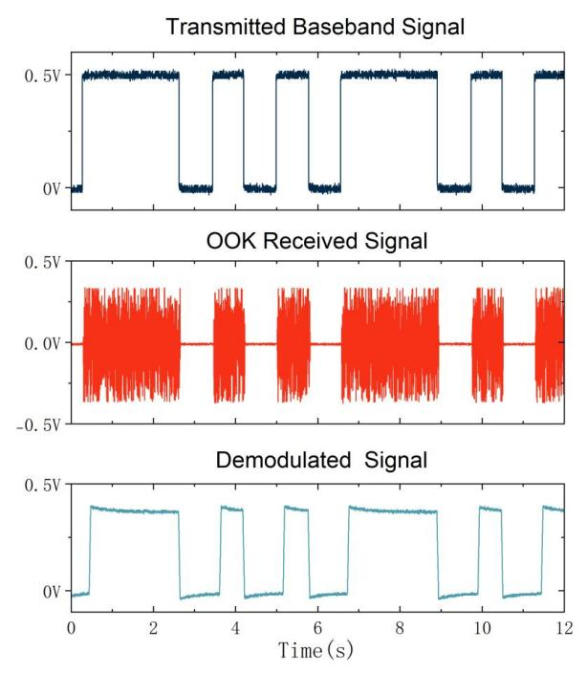
Fig. 12. OOK signal waveforms at different stages of the system with AGC activated. (a) Transmitted baseband signal. (b) Received signal at the SRR input. (c) Demodulated baseband signal at the SRR output.

BER | 1  10  - 2  10  - 3  10  - 4  10  - 5  10 | 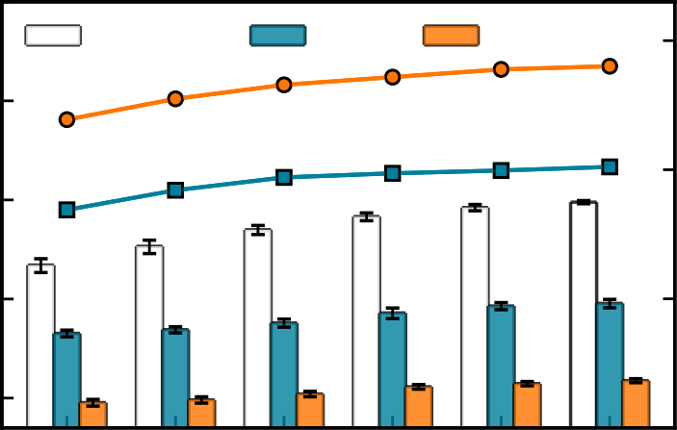  NoAGC PID 2-DOF  500 1k 2k 3k 4k 5k | 100x  10x  1x | Improvement Factor
Data Rate (bps)

Fig. 13. BER performance comparison for No-AGC, PID, and 2-DOF configurations across various data rates under the simulated pathological condition. The plot highlights the significant BER reduction achieved by AGC, with the 2-DOF controller demonstrating superior performance over the traditional PID. Error bars represent the standard deviation across N=3 independent heart preparations.

2-DOF controller over the No-AGC case is approximately 24-fold at 500 bps, this factor escalates to over 63-fold at 5 kbps. At this highest tested data rate, the 2-DOF controller reduced the average BER from the PID’s 9.0 × 10-5 down to 1.5×10-5, representing an additional 83.3% error rate reduc- tion on top of the already-optimized PID. This trend unequiv- ocally demonstrates that the superior transient response of the 2-DOF controller translates into exceptional robustness for high-speed communication. Therefore, the proposed adaptive receiver architecture provides a key technical foundation for ensuring high-reliability communication for LCPs in complex pathological environments.

TABLE II
PERFORMANCE COMPARISON WITH RELATED RECEIVER PROTOTYPES

Metric | Bereuter et al. [25] | Ryser et al. [24] | Khaleghi et al. [20] | Yuk et al. [38] | This Work
Primary focus | In-vivo channel  characterization | Modulation scheme analysis | Broadband channel modeling | Low-power  integrated circuit | Pathological channel robustness
Measurement Type | In-vivo | Ex-vivo | Ex-vivo | In-vivo/Ex-vivo | Ex-vivo
Frequency [MHz] | 1 | 1.5 | 0.01-10 | DC-20 | 1
Receiver Power [mW] | >465 | 152 | 230 | 0.062 | 268
Technology | Discrete components | Discrete components | Discrete components | 110nm CMOS | Discrete components
NSR Dynamics | × | × | × | × | √
Pathological Dynamics | × | × | × | × | √
Adaptive Gain Compensation | × | × | × | × | √

V. DISCUSSION
This study was centered on the core challenge of robust in- tracardiac communication under pathological cardiac rhythms. Experimental results demonstrate that the proposed adaptive receiver maintains a stable signal amplitude and significantly reduces the bit error rate, even in the presence of abrupt and unpredictable channel gain jumps triggered by events such as Atrioventricular block. This highlights a key shift in design philosophy: intracardiac communication systems must evolve from adapting to regular, healthy rhythms to actively tracking and suppressing aperiodic, pathologically-driven events. Our beat-synchronous 2-DOF strategy achieves this by using the RSSI as an ECG-free proxy for the cardiac rhythm, enabling beat-by-beat prediction and feedforward presetting, which is complemented by an incremental PID to suppress intra-beat residual errors. This “predict and correct” combination allows the system to maintain a stable demodulation boundary during sudden transients.
As summarized in Table II, this work’s starting point and evaluation scenario are more aligned with clinical reality compared to prior art [20], [24], [25], [38]. Previous research has largely focused on channel characterization, modulation analysis, or broadband modeling, almost entirely under static or quasi-static assumptions. While excellent progress has been made in low-power integrated circuit implementation, system- atically addressing the communication robustness challenges posed by cardiac dynamics, especially pathological dynamics, remains an open problem. This work focuses on this “patho- logical channel robustness” gap by advancing the evaluation scenario from static to dynamic, and further to pathological conditions. As Table II also makes clear, existing prototypes generally lack adaptive gain compensation for dynamic chan- nels. In contrast, the hybrid architecture and beat-synchronous prediction proposed here are designed to balance response speed and steady-state performance in a highly time-varying channel, directly filling this critical technological gap.
The proposed method, being designed for event-driven aperiodic transients, is expected to be extensible to other scenarios such as dropped beats, intermittent conduction ab- normalities, and highly irregular intervals. It should be noted that the current ex vivo platform cannot cover all in-vivo complexities, such as autonomic nervous regulation, long-term

tissue-electrode interface changes, and respiratory coupling. The prototype was also implemented with discrete components to validate the control concept and architecture, rather than as a final implantable device.
From a clinical perspective, reliable intracardiac commu- nication is fundamental for synchronized pacing and inter- chamber coordination in multi-chamber pacemaker systems. In settings dominated by pathological rhythms, the ability to proactively preset the gain and rapidly stabilize the link helps ensure the accurate delivery of rhythm management and therapeutic sequences. Future work will focus on the CMOS integrated circuit implementation of this architecture, balanc- ing low latency with fixed-point complexity while ensuring stability margins. This will be followed by longer-term large- animal in-vivo studies covering a broader range of pathological types and more complex physiological conditions to further validate the method’s transferability and long-term stability.

VI. CONCLUSION
This paper addressed the critical challenge of maintaining robust intracardiac communication amidst the unpredictable channel fades caused by pathological cardiac events. To over- come the limitations of conventional reactive control, we proposed and validated a novel adaptive receiver architecture featuring a beat-synchronous, 2-DOF Hybrid-AGC controller that proactively compensates for channel variations by using the RSSI as an ECG-free proxy for the cardiac rhythm. Sys- tematic evaluation demonstrated that the controller stabilizes the received signal to within 1% of its target despite channel gain fluctuations exceeding 15 dB. This stabilization translates into a bit error rate improvement of up to 98.4%, which corresponds to a reliability enhancement factor of over 60. This research, therefore, delivers not only a key enabling technology for clinically reliable LCP systems but also offers a rigorously validated and generalizable design paradigm for the next generation of networked IMDs intended to operate robustly in harsh biological environments.

REFERENCES
[1] J. E. Ferguson and D. Redish, “Wireless communication with implanted medical devices using the conductive properties of the body,” Expert Review of Medical Devices, vol. 8, pp. 427 – 433, 2011.

[2] E. Zrenner, “Will retinal implants restore vision?,” Science, vol. 295, no. 5557, pp. 1022–1025, 2002.
[3] P. Laizou, “Signal-processing techniques for cochlear implants,” IEEE Engineering in Medicine and Biology magazine, vol. 18, no. 3, pp. 34– 46, 1999.
[4] W. Germanovix and C. Toumazou, “Design of a micropower current- mode log-domain analog cochlear implant,” IEEE Transactions on Circuits and Systems Ii: Analog and Digital Signal Processing, vol. 47, pp. 1023–1046, 2000.
[5] M. Estudillo, D. Naranjo, L. M. Roa, and J. Reina-Tosina, “Intrabody communications (ibc) as an alternative proposal for biomedical wearable systems,” in Handbook of Research on Developments in E-Health and Telemedicine: Technological and Social Perspectives, pp. 1–28, IGI Global Scientific Publishing, 2010.
[6] S. Warren and B. Natarajan, “Wireless communication technologies for wearable systems,” in Wearable Monitoring Systems, pp. 51–80, Springer, 2010.
[7] Y.-S. Lin, C.-C. Wang, Y.-C. Liao, and S.-S. Lu, “Design and imple- mentation of intrabody communication hub/alarm unit in ibc platform for fall prevention system,” Microwave and Optical Technology Letters, vol. 56, no. 10, pp. 2345–2351, 2014.
[8] P. Bose, A. Khaleghi, M. Albatat, J. Bergsland, and I. Balasingham, “Rf channel modeling for implant-to-implant communication and implant to subcutaneous implant communication for future leadless cardiac pacemakers,” IEEE Transactions on Biomedical Engineering, vol. 65, no. 12, pp. 2798–2807, 2018.
[9] W. Li, Y. Duan, and J. M. Rabaey, “A 200mb/s inductively coupled wireless transcranial transceiver achieving 5e-11 ber and 1.5 pj/b trans- mit energy efficiency,” in 2018 IEEE International Solid-State Circuits Conference-(ISSCC), pp. 290–292, IEEE, 2018.
[10] M. Seyedi, B. Kibret, D. T. Lai, and M. Faulkner, “A survey on intrabody communications for body area network applications,” IEEE Transactions on Biomedical Engineering, vol. 60, no. 8, pp. 2067–2079, 2013.
[11] J. Wu, Y. Liu, Y. Gao, and M. Du, “Equivalent heart model for intracardiac communication channel analysis,” in 2020 Cross Strait Radio Science & Wireless Technology Conference (CSRSWTC), pp. 1–3, IEEE, 2020.
[12] L. H. Opie, Heart physiology: from cell to circulation. Lippincott Williams & Wilkins, 2004.
[13] Wegmueller, Marc, Simon, Oberle, Michael, Felber, Norbert, Kuster, Niels, and F. and, “Signal transmission by galvanic coupling through the human body.,” IEEE Transactions on Instrumentation Measurement, 2010.
[14] A. K. Teshome, B. Kibret, and D. T. H. Lai, “Galvanically coupled intrabody communications for medical implants: A unified analytic model,” IEEE Transactions on Antennas Propagation, vol. 64, no. 7, pp. 2989–3002, 2016.
[15] T. G. Middour, J. H. Chen, and M. F. El-Chami, “Leadless pacemakers: a review of current data and future directions,” Progress in Cardiovascular Diseases, vol. 66, pp. 61–69, 2021.
[16] K. Malaczynska-Rajpold, M. Elliot, N. Wijesuriya, V. Mehta, T. Wong, C. A. Rinaldi, and J. M. Behar, “Leadless cardiac pacing: new horizons,” Cardiology and Therapy, vol. 12, no. 1, pp. 21–33, 2023.
[17] D. Li, Z. Wang, H. Wang, S. H. Pun, P. U. Mak, A. Zhang, Y. Liu, H.-C. Li, Y. Gao, M. Du, et al., “Dynamic path gain compensation for enhancing intracardiac communication in leadless pacemakers,” IEEE Transactions on Instrumentation and Measurement, 2025.
[18] L. Bereuter, T. Kuenzle, T. Niederhauser, M. Kucera, D. Obrist, T. Re- ichlin, H. Tanner, and A. Haeberlin, “Fundamental characterization of conductive intracardiac communication for leadless multisite pacemaker systems,” IEEE transactions on biomedical circuits and systems, vol. 13, no. 1, pp. 237–247, 2018.
[19] H. Wang, D. Li, M. I. Vai, S. H. Pun, J. Yang, H. C. Li, and Y. Gao, “Analysis and circuit design of imbalanced impedance channels for con- ductive intracardiac communication,” IEEE Transactions on Biomedical Circuits and Systems, 2024.
[20] A. Khaleghi, R. Noormohammadi, and I. Balasingham, “Conductive im- pulse for wireless communication in dual-chamber leadless pacemakers,” IEEE Transactions on Microwave Theory and Techniques, vol. 69, no. 1, pp. 443–451, 2020.
[21] M. Maldari, M. Albatat, J. Bergsland, Y. Haddab, C. Jabbour, and P. Desgreys, “Wide frequency characterization of intra-body commu- nication for leadless pacemakers,” IEEE Transactions on Biomedical Engineering, vol. 67, no. 11, pp. 3223–3233, 2020.
[22] L. Chen, Y. Liu, Z. Chen, S. H. Pun, M. I. Vai, and Y. Gao, “An in- vestigation on conductive intracardiac communication dynamic channel gain during the cardiac cycle for leadless pacemakers,” IEEE Journal of

Electromagnetics, RF and Microwaves in Medicine and Biology, vol. 7, no. 1, pp. 82–89, 2022.
[23] Z. Wei, H. Wang, D. Li, M. I. Vai, S. H. Pun, J. Yang, M. Du, and Y. Gao, “A time-varying equivalent circuit modeling and measuring approach for intracardiac communication in leadless pacemakers,” IEEE Transactions on Biomedical Circuits and Systems, vol. 18, no. 4, pp. 872–884, 2024.
[24] A. Ryser, T. Schmid, L. Bereuter, J. Burger, T. Reichlin, T. Niederhauser, and A. Haeberlin, “Modulation scheme analysis for low-power leadless pacemaker synchronization based on conductive intracardiac communi- cation,” IEEE transactions on biomedical circuits and systems, vol. 16, no. 3, pp. 419–429, 2022.
[25] L. Bereuter, T. Niederhauser, M. Kucera, D. Loosli, I. Steib, M. Schild- knecht, A. Zurbuchen, F. Noti, H. Tanner, T. Reichlin, et al., “Leadless cardiac resynchronization therapy: An in vivo proof-of-concept study of wireless pacemaker synchronization,” Heart rhythm, vol. 16, no. 6, pp. 936–942, 2019.
[26] D. R. Frey, “Improved super-regenerative receiver theory,” IEEE Trans- actions on Circuits and Systems I: Regular Papers, vol. 60, no. 12, pp. 3267–3278, 2013.
[27] G. MacFarlane and J. Whitehead, “The theory of the super-regenerative receiver operated in the linear mode,” Journal of the Institution of Electrical Engineers-Part III: Radio and Communication Engineering, vol. 95, no. 35, pp. 143–157, 1948.
[28] J.-Y. Chen, M. P. Flynn, and J. P. Hayes, “A fully integrated 1.9-ghz auto- calibrated super-regenerative receiver in 0.13-μm cmos,” IEEE Journal of Solid-State Circuits, vol. 42, no. 9, pp. 1976–1985, 2007.
[29] M. Vidojkovic, X. Huang, P. Harpe, S. Rampu, C. Zhou, L. Huang, J. van de Molengraft, K. Imamura, B. Busze, F. Bouwens, et al., “A 2.4 ghz ulp ook single-chip transceiver for healthcare applications,” IEEE transactions on biomedical circuits and systems, vol. 5, no. 6, pp. 523– 534, 2011.
[30] W. Zhao, D. Li, J. Wang, S. H. Pun, M. I. Vai, and Y. Gao, “An analog front-end with automatic gain control for galvanic-coupled human body communication,” 2023 Cross Strait Radio Science and Wireless Technology Conference (CSRSWTC), pp. 1–3, 2023.
[31] Y. Li, L. Yang, L. Yu, B. Liao, and P. Xu, “Digital agc circuit design based on fpga,” Journal of Physics: Conference Series, vol. 1654, 2020.
[32] D. Li, J. Wang, H. Wang, X. Huang, J. Yang, Y. Gao, H.-C. Li, M. I. Vai, and S. H. Pun, “A dynamic high-fidelity equivalent circuit phantom for intracardiac communication in pacemaker indications,” IEEE Transactions on Instrumentation and Measurement, 2025.
[33] S. Gabriel, R. Lau, and C. Gabriel, “The dielectric properties of biological tissues: Iii. parametric models for the dielectric spectrum of tissues,” Physics in medicine & biology, vol. 41, no. 11, p. 2271, 1996.
[34] A. M. Maceira, J. Cosn-Sales, M. Roughton, S. K. Prasad, and D. J.
Pennell, “Reference left atrial dimensions and volumes by steady state free precession cardiovascular magnetic resonance,” Journal of cardio- vascular magnetic resonance, vol. 12, no. 1, p. 65, 2010.
[35] A. Maceira, S. Prasad, M. Khan, and D. Pennell, “Normalized left ventricular systolic and diastolic function by steady state free precession cardiovascular magnetic resonance,” J Cardiovasc Magn Reson, vol. 8, no. 3, pp. 417–426, 2006.
[36] A. M. Maceira, S. K. Prasad, M. Khan, Pennell, and D. J., “Reference right ventricular systolic and diastolic function normalized to age, gender and body surface area from steady-state free precession cardiovascular magnetic resonance,” European Heart Journal, vol. 27, no. 23, pp. 2879– 2888, 2006.
[37] A. M. Maceira and J. Cosn-Sales. . . , “Reference right atrial dimensions and volume estimation by steady state free precession cardiovascular magnetic resonance,” Journal of Cardiovascular Magnetic Resonance, vol. 15, no. 1, pp. 29–29, 2013.
[38] B. Yuk, B. Kim, S. Park, Y. Huh, and J. Bae, “An implantable body channel communication system with 3.7-pj/b reception and 34-pj/b transmission efficiencies,” IEEE Solid-State Circuits Letters, vol. 3, pp. 50–53, 2020.

