**B6B36PCC - Programming in C++**

**Project Documentation - Tetris**

**Stanislav Sadílek**

You can find the instructions to compile and run in README.

**Assignment**

The assignment for my term paper is the game Tetris. The aim of Tetris is to clear rows of blocks. There are seven types of blocks, named after their shape. The blocks are chosen at random. The game always shows the next block that comes into play after the current one has been placed.

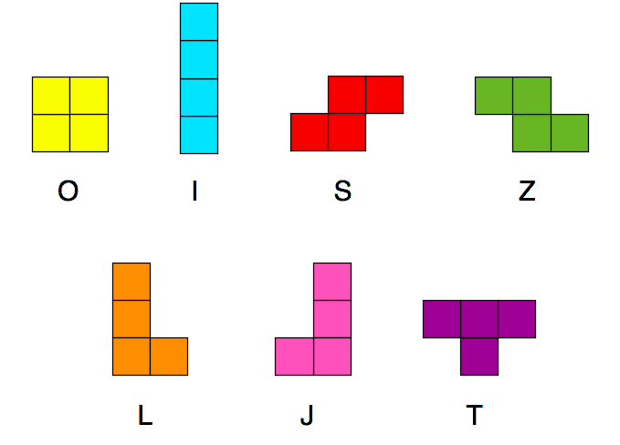

Every 5 rows cleared will result in a level increase. The higher the level, the faster the game refreshes and the more difficult the game becomes.

Points earned for cleared rows increase with level. It also depends on the number of rows filled in one step, in a non-linear way. A player gets significantly more points for filling four rows at once than for filling one row four times. The points earned are scored according to the following formula.

| **Cleared rows** | **Points** |
| --- | --- |
| one | (n+1) * 40 |
| two | (n+1) * 100 |
| three | (n+1) * 300 |
| four | (n+1) * 1200 |

n … game level

The game ends if the top row is not empty when a new block is generated, or by pressing the Q key.

**Game settings**

The game can be configured with three parameters before starting the game, which are the height and width of the playing area and the initial level. The game can also be started with --help parameter that shows a quick tutorial on how to control the game.

| **Parameter** | **Argument at launch** | **Default value** | **Range** |
| --- | --- | --- | --- |
| Game board width | -w, -width | 10 | 5 to 15 |
| Game board height | -h, -height | 20 | 15 to 25 |
| Initial level | -l, -level | 1 | 1 to 20 |

**Controls**

The game is controlled by either the arrow keys or the WASD keys to move and rotate the current block. The Q key ends the game.

| **Key** | **Action** |
| --- | --- |
| A, Left Arrow | Move one column to the left |
| S, Down Arrow | Move one column to the right |
| D, Right Arrow | Move one row down |
| W, Up Arrow | Rotate 90° clockwise |
| Q | Quit the game |

**Threads**

The game uses a total of three threads. The first thread is used to retrieve input from the user, the second thread is used for calculations and game state updates, and the third thread is responsible for displaying the output.

**Testing**

The game is tested using Catch tests. In particular, motion validation and block movement itself, rotation validation and rotation itself, adding points according to the cleared rows and game termination are tested.

