Daniel Standage

CS 525 Homework 5

Mar 10, 2011

The following pages contain the source code for my solution to homework 5. This page shows the results (combined with results from homework 4) and some discussion.

|  |  |  |  |  |
| --- | --- | --- | --- | --- |
| **Barrier** | **4** | **8** | **16** | **32** |
| **vendor** | 24.40 | 44.04 | 63.60 | 84.66 |
| **send/recv** | 43.24 | 124.03 | 266.95 | 564.17 |
| **bcast** | 48.73 | 152.08 | 396.59 | 986.83 |
| **gather/scatter** | 20.31 | 36.72 | 52.80 | 69.73 |
| **alltoall** | 39.87 | 61.35 | 87.88 | 123.40 |
| **isend/irecv** | 6.45 | 13.55 | 28.57 | 60.54 |
| **centman** | 26.71 | 66.53 | 145.62 | 304.87 |

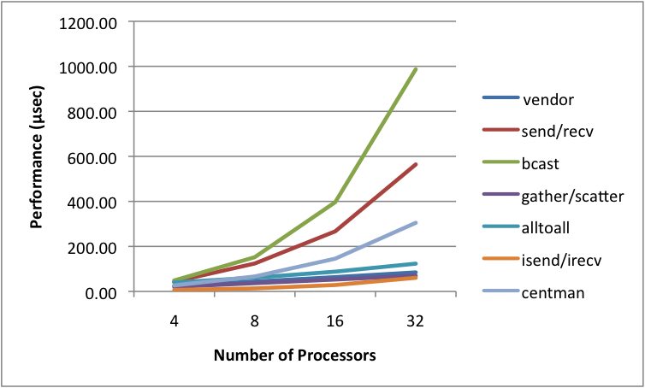

It was surprising to see that both the **gather/scatter** barrier and the **isend/irecv** barrier outperformed the vendor **mpi_barrier** for all tests. The **alltoall**barrier had similar scaling properties, whereas the other three barriers (**bcast**, **send/recv**, and **central manager**) have very poor scaling properties.