Classic Oxo game and recursive game composed of 9 sub-games:
When run, you get first Simple Game
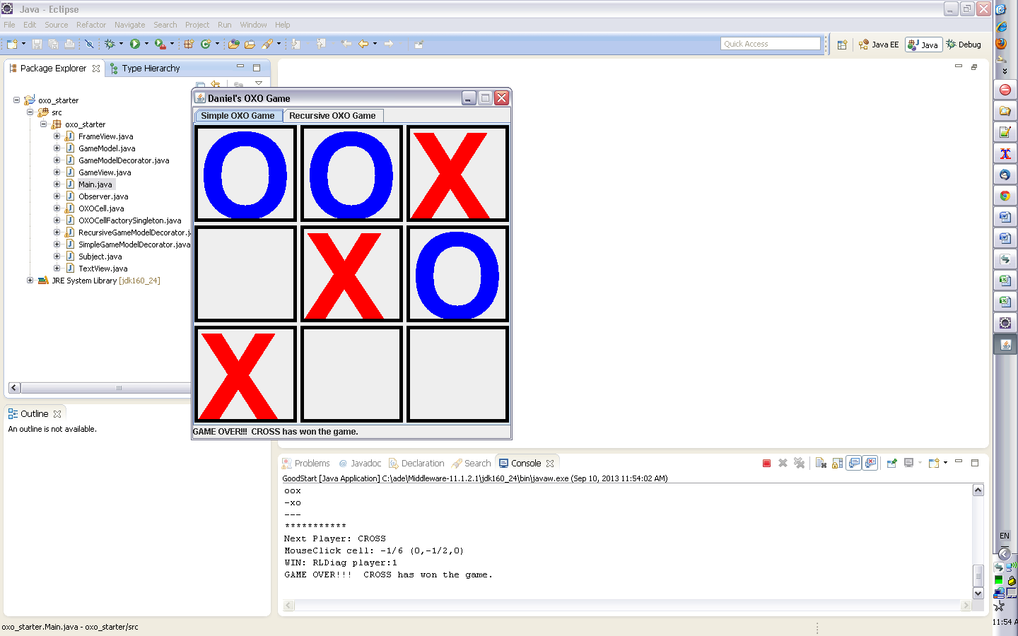

For the Recursive Game you need to switch to the other tab:
