# Task 1: Linux questions

## Counting files

find /path/to/directory -maxdepth 1 -type f -name "*.bin" | wc –l

* **find /path/to/directory**: This specifies the directory in which to search. Replace /path/to/directory with the actual path to your folder.
* **-maxdepth 1**: This option ensures that find only searches in the specified directory and does not recurse into subdirectories.
* **-type f**: This restricts the search to regular files only, excluding directories and other types of files.
* **-name** "*.bin": This filters the files to include only those with the .bin extension.
* **| wc -**l: This counts the number of lines output by find, which corresponds to the number of .bin files found.

The example in Figure 1 shows the use of a command that counts how many .bin files are in a folder.

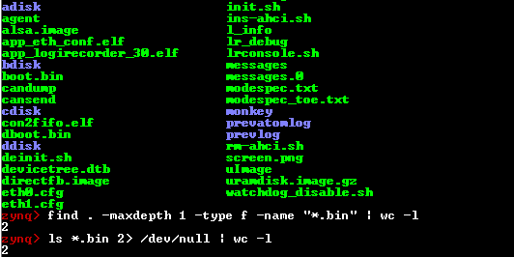

Figure 1. Counting .bin files

## Comparing files

I would use a hash function to hash a 100GB file and get it's value and tell my friend to do it also so we can compare both hash key values to check if they are equal. If the values ​​are equal, it means that his copy is the same as mine and is not corrupted. An example of file hashing using the sha256sum command is shown in Figure 2.

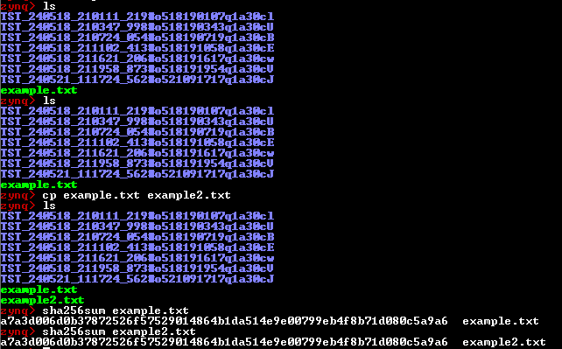

Figure 2. Compare two hash keys

## Log filtering

grep -v '^INFO' logfile.log

* grep: The command-line tool used for searching text.
* -v: Inverts the match, meaning it will exclude lines that match the pattern.
* '^INFO': The pattern to match lines that start with "INFO". The ^ character is used to indicate the beginning of a line.
* logfile.log: The path to your log file.

An example of filtering a log where only those lines that start with INFO are filtered is shown in Figure 3.

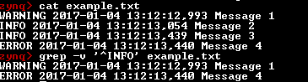

Figure 3. Filtering log