# Team "Jataaka" project – Space Game

1. Team information

*Team name:* "Jataaka"

*Team members:*

Georgi Prodanov - *georgiwe*

Svetoslav Georgiev - *vodkatini*

Plamen Georgiev - *plamen.georgiev*

Plamen Stanev - *stanev.plamen*

Konstantin Severy - *ksevery*

Georgis Andonis - *LovechGuy*

1. Project purpose and description

The project is three dimensional space game where the user is a pilot of a spaceship which fights with enemy ships and space rocks just like in the “Star Wars” type games.

The purpose of the current project is to create a Javascript game, which in our case is a Space Game. Player enters is in a space ship, travelling in our Galaxy and picking up targets to destroy. Player should avoid collision with other ships, obstacles and planets, has limited ammo and armor.

The project consists of two main views: presentation view and game view.

The presentation view consists of start animated screen, instructions, information about the authors and pause navigation screen with an option to pause the game play.

The game view is based on the three.js space environment and it is implemented with the Three.js, Canvas and WebGL technologies. The spaceship, pilot cockpit and the earth clouds are elements based on the Canvas technology. The planets, rocks, the enemy ships and all the 3D objects are elements based on the WebGL technology.

The ship can fly in the space and between planets, producing fire over the enemy ships and the rocks. When a rock or an enemy ship is hit, the player gets points, when the player ship crashes into a rock, the ship loses part of its armor. There are also bonus points and bonus weapon units.

All presentation and game views are designed with appropriate sound effects.

1. Project URL

Repository: <https://github.com/stanevplamen/JataakaTeamworkProject>

Demo: <http://gdesignsbg.com/wp-content/uploads/demo06/splashscreen/splashscreen.html>

Commits: https://github.com/stanevplamen/JataakaTeamworkProject/commits/master

1. Additional information.

4.1 Presentation main view:

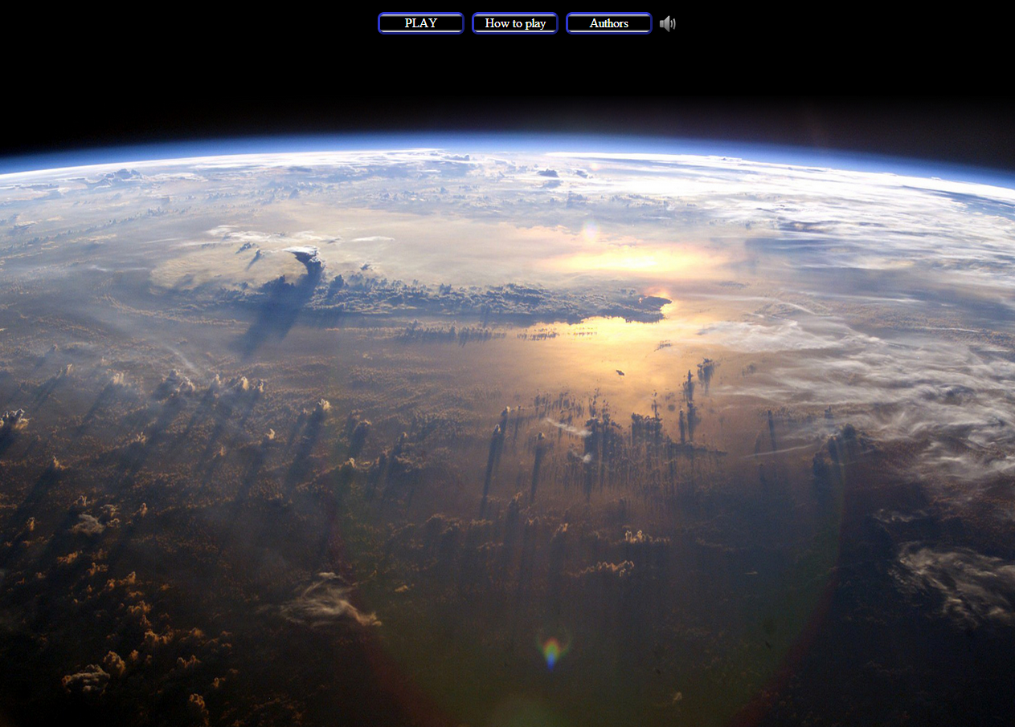

4.2 Presentation pause view:

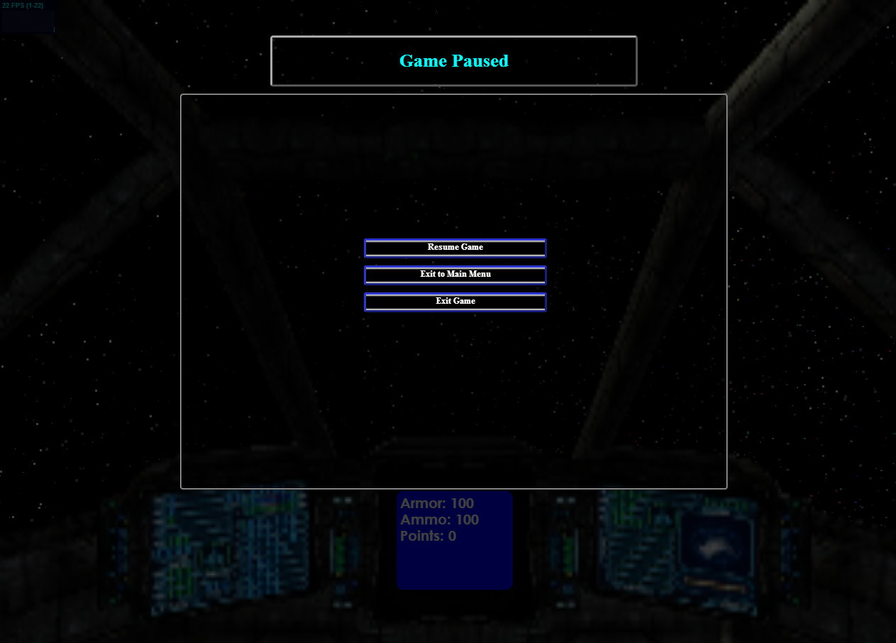

4.3 Game view:

