10/12/2012

10:30am, Meeting begins
Jamie (JJ), Ali (AB), Robyn (RD), Rosemary (RK), Liz Hadly (L)Andy (AP)

- Courses don’t need to have both humans and environment, either would be OK.
- Look into goals/mission of EESS
- Begin to review the old “iEarth Course Form”
  - Reason for iEarth: students are drawn into the global debates on questions like climate change, water etc, but they don’t have the science background. iEarth aims to fill that gap (RK).
- The draw for student to iEarth will be crisis on earth, conflicts
- EESS
  - No “human dimension”
  - iEarth isn’t for EESS majors; it is for others (aka everyone else).
- iEarth needs to teach “factual information”
- Science/technology incentive – first year requirement “SME”
- Use the 7 categories from SUES report to start listing “what the students should know”
- 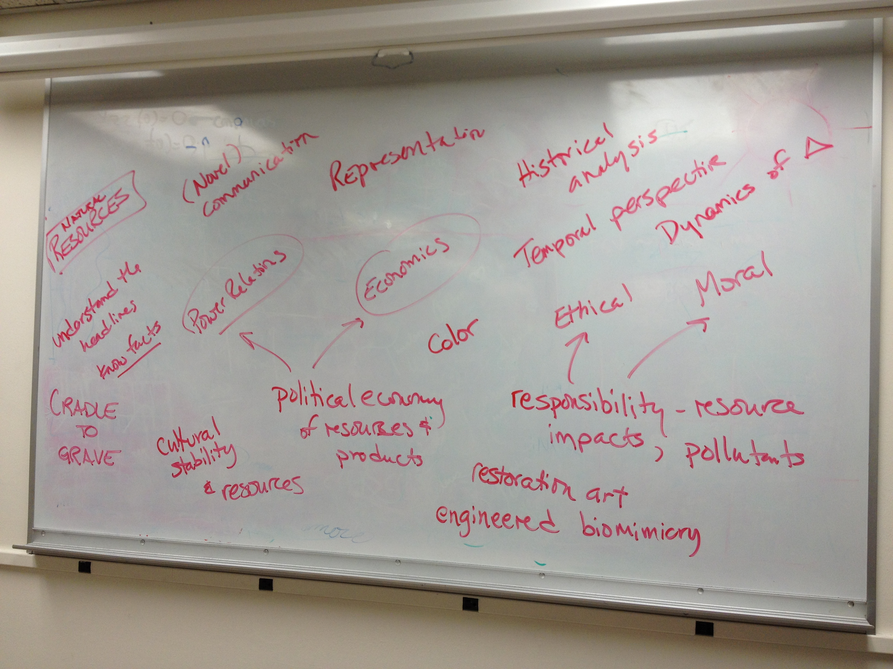
- English major reference letter:
  - Historical analysis
  - Temporal perspective
  - Dynamics of change
  - Novel ways of communicating
  - Understand the headlines
- What would an anthropology major (ex) “do” with that knowledge?
- Cultural stability and resources
- How do we draw the arts student in?
- Restoration art
- Yellowstone hotspot (LH)
- Biomimicry – engineered to solve and environmental problem
- Draw broad lessons from narrow topics
- Geography of surfing
- Anthropology of zombies
- The color red (color in general)
- Integrative courses
- Engineering perspective
- Facts about the earth
- “Lonely Planet: Guide to Planet Earth”
  - course for aliens coming to earth
- Thinking matters
- Slide party analogy for anthropology
- (not so lonely planet)
- Students don’t need to solve problem, just to engage them.
- Multidimensional scaling

Notes as recorded by ADP
Please note: these are the notes as I recorded during the meeting and may not be exact quotations. If you find something incorrect or would otherwise like revisions made, please just let me know.

