Ground Station Overview

# Durand

The Durand Ground station is located at 496 Lomita Mall, Stanford, CA 94305 (37.4269° N, 122.1733° W). A UHF Yagi with a weatherized rotator is affixed to the roof of the building, and a locked interior room serves as the command and control center.

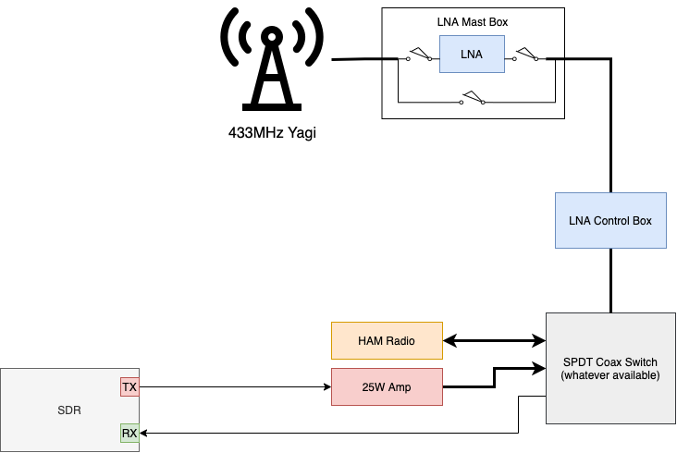

# Mobile Ground Station

The Mobile Ground Station is limited to Stanford University internet, but can be configured to connect to any Wi-Fi connection. The mobile ground station is made up of 3 RFM95 433MHz band Featherwing radios, and 1 FeatherS2 board, all powered via a battery.

