The overall goal of the Sapling mission is to prove critical subsystems of the Sapling CubeSat Bus. The Sapling project is entirely open source and developed by members of the Stanford Student Space Initiative, a primarily undergraduate volunteer student engineering organization at Stanford University. Secondary mission goals are demonstrating autonomous cloud filtering and smart downlinking of images, and proving that the inexpensive COTS Google Coral Edge computing platform is more efficient at image processing and makes up for use of silicon cells that are less efficient than much higher priced GaAS cells.

Sapling Sempervirens (referred to as “Sapling”) is a 1U CubeSat, with an overall size of 10 cm x 10 cm x 11 cm. The Sapling 1U bus is intended to operate in LEO, and be commissioned from a standard CubeSat deployer. Sapling is manifested on Orbiter SN1, an orbiter transfer vehicle slated for launch aboard SpaceX’s Transporter 6 mission on November 7, 2022.

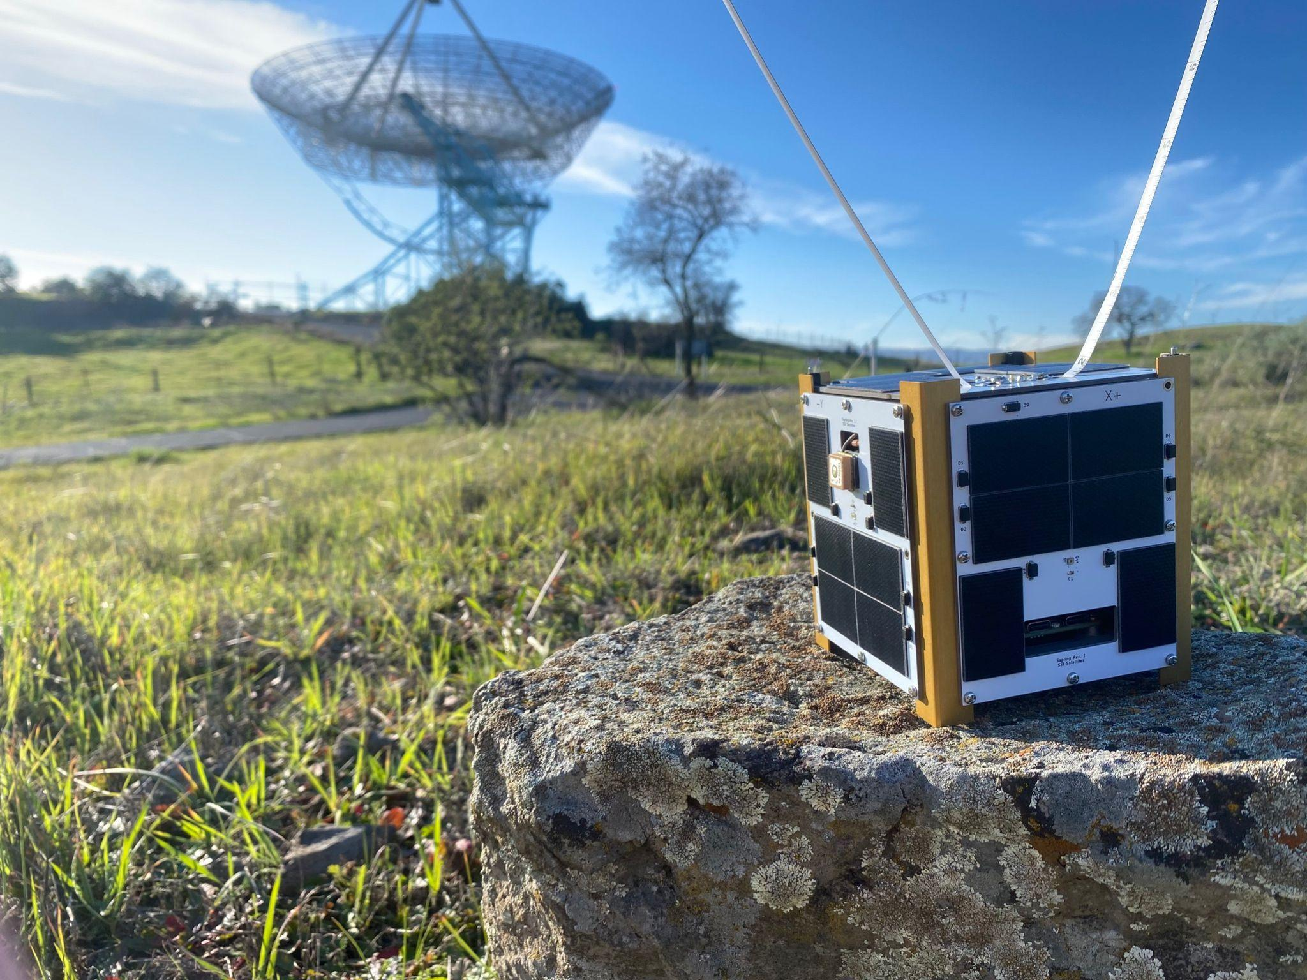

*Sapling Sempervirens* range testing

# Subsystems

## Structure

Sapling has a custom 1U structure made of 6061 Aluminum, consisting of anodized “angle iron” rails and laser cut top and bottom plates, fastened with machine screws. The side panels consist of custom solar panel/antenna PCBs. The total mass of each flight unit is expected to be 0.88kg, and the CoM is -0.856mm, -1.953mm, 3.859mm from the geometric center of the CubeSat. Reference drawings attached.

## Communications

Sapling is equipped with a UHF LoRa radio and an omnidirectional tape measure dipole antenna. Sapling will interface with the TinyGS LoRa network of 100+ amateur ground stations for telemetry, and will be commanded via the Durand ground station on Stanford Campus.

## Electrical Power Subsystem

The EPS system consists of the PyCubed Battery board, developed at Stanford and flight proven on the NASA V-R3x mission. The PyCubed battery board meets ISS specifications. The PyCubed Battery board may be trickle charged via a USB-C charger on the PyCubed flight computer, and is equipped with 6 Panasonic NCR18650B lithium-ion cells. Sapling has 6 custom solar panel PCBs which each host 6 AnySolar / IXYS high efficiency silicon solar cells.

## Command and Data Handling

The flight computer is a PyCubed V5, developed at Stanford University and flight proven on the NASA V-R3x mission. It is a SAMD51 based, careful COTS designed board with a watchdog timer for TID resistance and SEU tolerance. The PyCubed performs overall command of the spacecraft and commands all other subsystems.

## Attitude Determination and Control

The attitude and orbit determination system consists of 5 light sensors mounted on the exterior faces of the CubeSat and a 3-axis IMU for attitude determination (~20° accuracy) and a Skytraq GPS with dual antennas for orbit determination. Sapling is equipped with air-coil PCB magnetorquers for detumbling and coarse attitude control.

## Payload

Sapling’s payload consists of a Google Coral Edge TPU payload processor, and a Google Coral camera. The Google Coral processes images six times more efficiently than the raspberry pi 4, according to benchmarks.