Pregnancy Due Dates Calculator

INPUTS
Cycle length | Options:
Dates to enter  "Last menstrual period" should be first day of LMP; EGA on other date can be taken from a past ultrasound | Options:  - Last menstrual period  - Estimated gestational age (EGA) as of today  - EGA as of another date  - Estimated date of conception  - Estimated due date
Date | Options:
Date of EGA (e.g. date of ultrasound) | Options:
EGA  Format: e.g. 7w3d | Options:

FORMULA
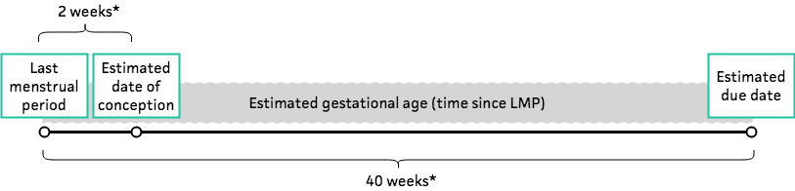
Estimated gestational age (EGA) = time since 1st day of last menstrual period (LMP)
Estimated date of conception (EDC) = two weeks* since 1st day of LMP
Estimated due date (EDD) = 1st day of LMP + 40 weeks* (Naegele's Rule)
*Assumes 28 day cycle. If cycle is longer than 28 days, this calculator adds the number of days more than 28 to obtain EDD. Example: if cycle length is 35 days, add 7 days (= 35 – 28) to 40 weeks.

FACTS & FIGURES

EVIDENCE APPRAISAL

