Fibrosis-4 (FIB-4) Index for Liver Fibrosis

INPUTS
Age  Use with caution in patients <35 or >65 years old, as the score has been shown to be less reliable in these patients | Options:
AST  Aspartate aminotransferase | Options:
ALT  Alanine aminotransferase | Options:
Platelet count | Options:

FORMULA
FIB-4 Score = (Age* x AST) / (Platelets x √(ALT))
*Use with caution in patients <35 or >65 years old, as the score has been shown to be less reliable in these patients.

FACTS & FIGURES
Interpretation:
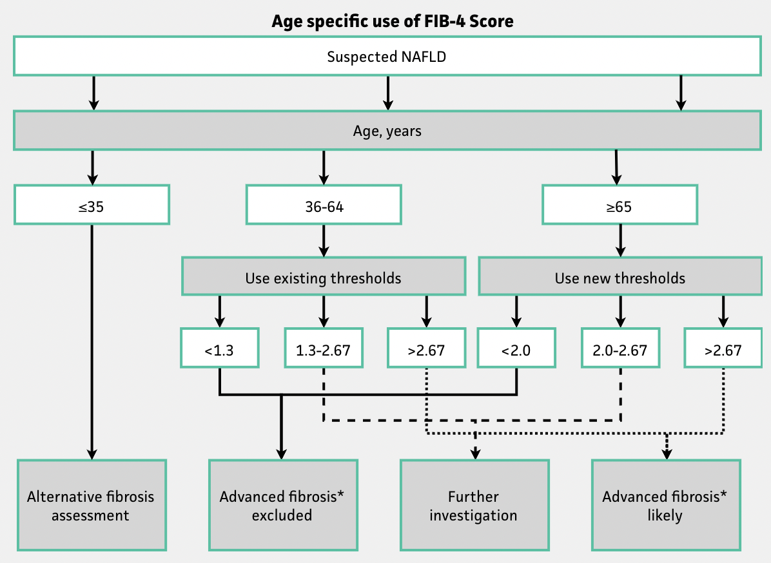
*"Advanced fibrosis" was defined as METAVIR stage F3-F4 (McPherson 2017).
FIB-4 Score | Approximate fibrosis stage*
<1.45 | 0-1
1.45-3.25 | 2-3
>3.25 | 4-6
*Based on Ishak fibrosis staging (Sterling et al 2006).

EVIDENCE APPRAISAL

