Corrected QT Interval (QTc)

INPUTS
Formula | Options:  - Bazett  - Fridericia  - Framingham  - Hodges  - Rautaharju
Heart rate/pulse | Options:
Paper speed, mm/sec | Options:  - 25  - 50
QT interval  Toggle unit to use msec or small boxes; 1 small box = 40 msec (see below for example where QT interval = 4 small boxes) | Options:
QT interval  Toggle unit to use msec or small boxes; 1 small box = 20 msec (see below for example where QT interval = 4 small boxes) | Options:

FORMULA
RR interval = 60 / HR
Bazett Formula: QTc = QT interval / √ (RR interval)
Fridericia Formula: QTc = QT interval / (RR interval)^{1/3}
Framingham Formula: QTc = QT interval + 154 x (1 - RR interval)
Hodges Formula: QTc = QT interval + 1.75 x [(60 / RR interval) − 60]
Rautaharju Formula: QTc = QT interval x (120 + HR) / 180

FACTS & FIGURES
Normal QTc ≤440 msec. A longer QTc puts the patient at increased risk for torsade de pointes.
Some causes of prolonged QT:
- Electrolyte abnormalities:
  - Hypocalcemia.
  - Hypokalemia.
  - Hypomagnesemia.
- Intrinsic cardiac causes:
  - Myocardial ischemia.
  - After cardiac arrest.
  - CAD.
  - Cardiomyopathy.
  - Severe bradycardia, high-grade AV block.
  - Congenital long QT syndrome.
- Central causes:
  - Raised intracranial pressure.
  - Autonomic dysfunction.
  - Hypothyroid.
  - Hypothermia.
- Medications:
  - Anti-arrhythmics.
  - Psychotropic drugs.
  - Other drugs.
QT Nomogram:
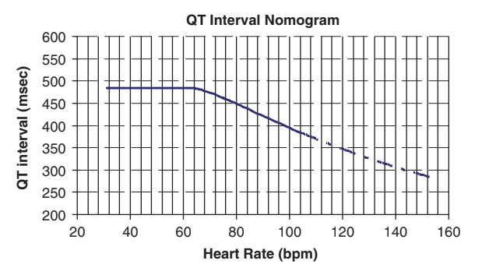

EVIDENCE APPRAISAL

