# Pregnancy Due Dates Calculator

## INPUTS

|  |  |
| --- | --- |
| Cycle length | **Options:** |
| Dates to enter  *"Last menstrual period" should be first day of LMP; EGA on other date can be taken from a past ultrasound* | **Options:**   * Last menstrual period * Estimated gestational age (EGA) as of today * EGA as of another date * Estimated date of conception * Estimated due date |
| Date | **Options:** |
| Date of EGA (e.g. date of ultrasound) | **Options:** |
| EGA  *Format: e.g. 7w3d* | **Options:** |

## FORMULA

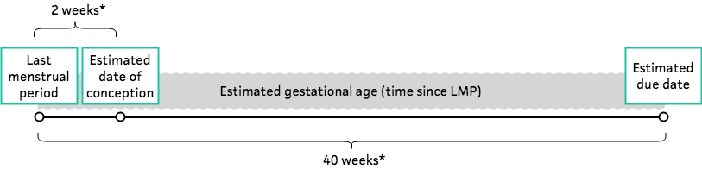  
  
Estimated gestational age (EGA) = time since 1st day of last menstrual period (LMP)

Estimated date of conception (EDC) = two weeks* since 1st day of LMP

Estimated due date (EDD) = 1st day of LMP + 40 weeks* (Naegele's Rule)

*Assumes 28 day cycle. If cycle is longer than 28 days, this calculator adds the number of days more than 28 to obtain EDD. Example: if cycle length is 35 days, add 7 days (= 35 – 28) to 40 weeks.

## FACTS & FIGURES

## EVIDENCE APPRAISAL