# Fibrosis-4 (FIB-4) Index for Liver Fibrosis

## INPUTS

|  |  |
| --- | --- |
| Age  *Use with caution in patients <35 or >65 years old, as the score has been shown to be less reliable in these patients* | **Options:** |
| AST  *Aspartate aminotransferase* | **Options:** |
| ALT  *Alanine aminotransferase* | **Options:** |
| Platelet count | **Options:** |

## FORMULA

FIB-4 Score = (Age* x AST) / (Platelets x √(ALT))

*Use with caution in patients <35 or >65 years old, as the score has been shown to be less reliable in these patients.

## FACTS & FIGURES

Interpretation:

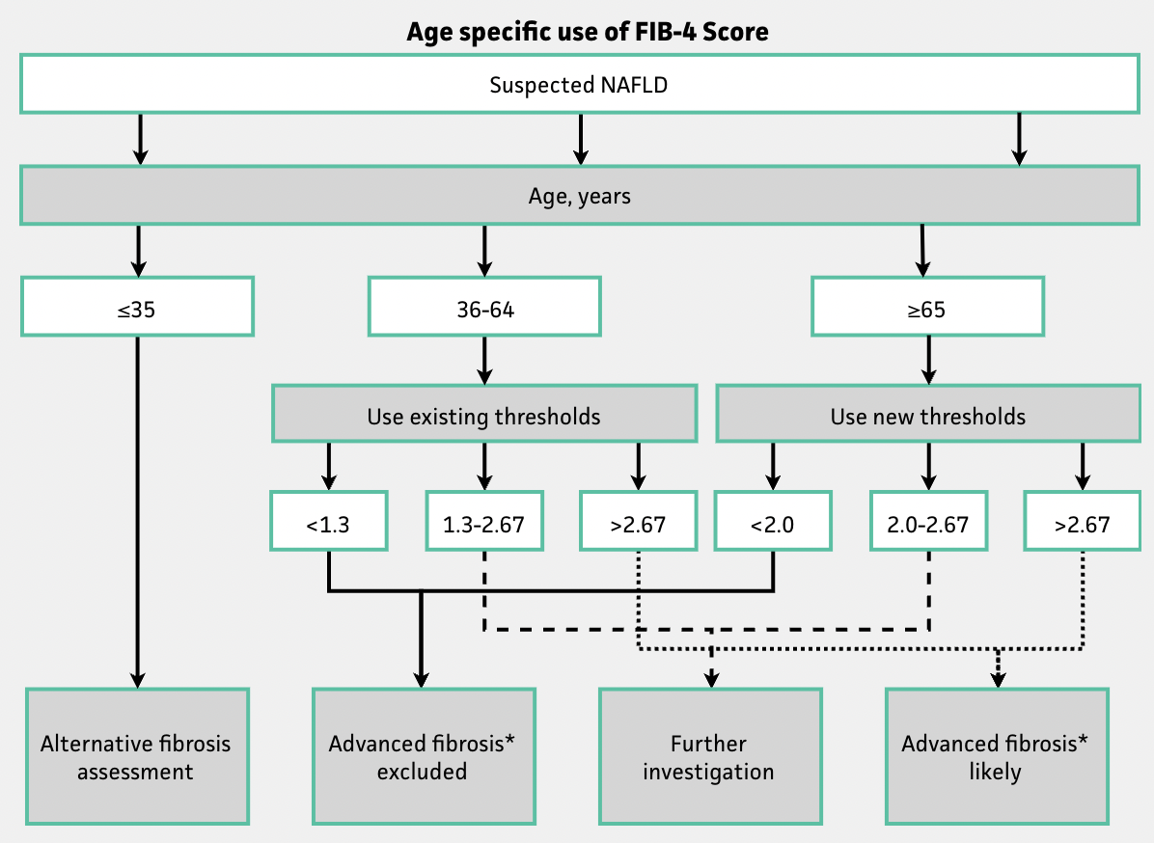

*"Advanced fibrosis" was defined as METAVIR stage F3-F4 ([McPherson 2017](https://boris.unibe.ch/93541/1/Age%20as%20a%20Confounding%20Factor%20for%20the%20Accurate.pdf)).

|  |  |
| --- | --- |
| **FIB-4 Score** | **Approximate fibrosis stage\*** |
| <1.45 | 0-1 |
| 1.45-3.25 | 2-3 |
| >3.25 | 4-6 |

*Based on Ishak fibrosis staging ([Sterling et al 2006](https://onlinelibrary.wiley.com/doi/10.1002/hep.21178/full)).

## EVIDENCE APPRAISAL