# NIH Stroke Scale/Score (NIHSS)

## INPUTS

|  |  |
| --- | --- |
| 1A: Level of consciousness  *May be assessed casually while taking history* | **Options:**   * Alert; keenly responsive (0) * Arouses to minor stimulation (1) * Requires repeated stimulation to arouse (2) * Movements to pain (2) * Postures or unresponsive (3) |
| 1B: Ask month and age | **Options:**   * Both questions right (0) * 1 question right (1) * 0 questions right (2) * Dysarthric/intubated/trauma/language barrier (1) * Aphasic (2) |
| 1C: 'Blink eyes' & 'squeeze hands'  *Pantomime commands if communication barrier* | **Options:**   * Performs both tasks (0) * Performs 1 task (1) * Performs 0 tasks (2) |
| 2: Horizontal extraocular movements  *Only assess horizontal gaze* | **Options:**   * Normal (0) * Partial gaze palsy: can be overcome (1) * Partial gaze palsy: corrects with oculocephalic reflex (1) * Forced gaze palsy: cannot be overcome (2) |
| 3: Visual fields | **Options:**   * No visual loss (0) * Partial hemianopia (1) * Complete hemianopia (2) * Patient is bilaterally blind (3) * Bilateral hemianopia (3) |
| 4: Facial palsy  *Use grimace if obtunded* | **Options:**   * Normal symmetry (0) * Minor paralysis (flat nasolabial fold, smile asymmetry) (1) * Partial paralysis (lower face) (2) * Unilateral complete paralysis (upper/lower face) (3) * Bilateral complete paralysis (upper/lower face) (3) |
| 5A: Left arm motor drift  *Count out loud and use your fingers to show the patient your count* | **Options:**   * No drift for 10 seconds (0) * Drift, but doesn't hit bed (1) * Drift, hits bed (2) * Some effort against gravity (2) * No effort against gravity (3) * No movement (4) * Amputation/joint fusion (0) |
| 5B: Right arm motor drift  *Count out loud and use your fingers to show the patient your count* | **Options:**   * No drift for 10 seconds (0) * Drift, but doesn't hit bed (1) * Drift, hits bed (2) * Some effort against gravity (2) * No effort against gravity (3) * No movement (4) * Amputation/joint fusion (0) |
| 6A: Left leg motor drift  *Count out loud and use your fingers to show the patient your count* | **Options:**   * No drift for 5 seconds (0) * Drift, but doesn't hit bed (1) * Drift, hits bed (2) * Some effort against gravity (2) * No effort against gravity (3) * No movement (4) * Amputation/joint fusion (0) |
| 6B: Right leg motor drift  *Count out loud and use your fingers to show the patient your count* | **Options:**   * No drift for 5 seconds (0) * Drift, but doesn't hit bed (1) * Drift, hits bed (2) * Some effort against gravity (2) * No effort against gravity (3) * No movement (4) * Amputation/joint fusion (0) |
| 7: Limb Ataxia  *FNF/heel-shin* | **Options:**   * No ataxia (0) * Ataxia in 1 Limb (1) * Ataxia in 2 Limbs (2) * Does not understand (0) * Paralyzed (0) * Amputation/joint fusion (0) |
| 8: Sensation | **Options:**   * Normal; no sensory loss (0) * Mild-moderate loss: less sharp/more dull (1) * Mild-moderate loss: can sense being touched (1) * Complete loss: cannot sense being touched at all (2) * No response and quadriplegic (2) * Coma/unresponsive (2) |
| 9: Language/aphasia  *Describe the scene; name the items; read the sentences (see* *Evidence**)* | **Options:**   * Normal; no aphasia (0) * Mild-moderate aphasia: some obvious changes, without significant limitation (1) * Severe aphasia: fragmentary expression, inference needed, cannot identify materials (2) * Mute/global aphasia: no usable speech/auditory comprehension (3) * Coma/unresponsive (3) |
| 10: Dysarthria  *Read the words (see* *Evidence**)* | **Options:**   * Normal (0) * Mild-moderate dysarthria: slurring but can be understood (1) * Severe dysarthria: unintelligible slurring or out of proportion to dysphasia (2) * Mute/anarthric (2) * Intubated/unable to test (0) |
| 11: Extinction/inattention | **Options:**   * No abnormality (0) * Visual/tactile/auditory/spatial/personal inattention (1) * Extinction to bilateral simultaneous stimulation (1) * Profound hemi-inattention (ex: does not recognize own hand) (2) * Extinction to >1 modality (2) |

## FORMULA

Addition of the selected points, as above.

## FACTS & FIGURES

**Language/aphasia test**

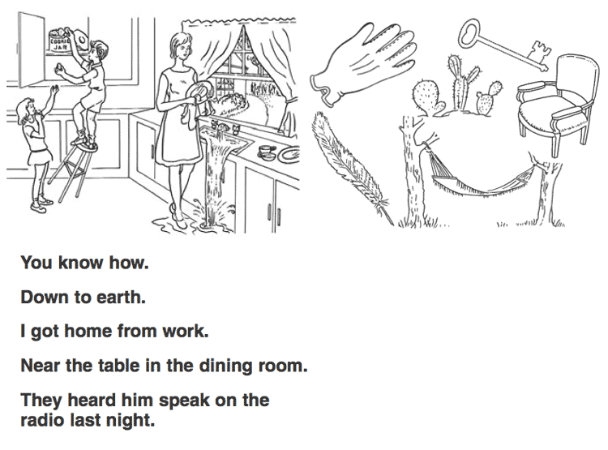

**Dysarthria test**

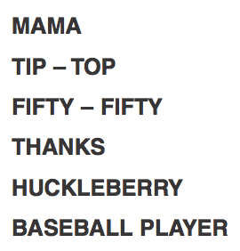

For more information see the [NIH Stroke Scale Website](https://nihstrokescale.org/).

## EVIDENCE APPRAISAL

* The first iteration of the NIH stroke scale was derived by Brott et al in a pilot study of 10 patients who were evaluated within 3-weeks of having an ischemic stroke.  Authors applied the Toronto Stroke Scale, the Oxbury Initial Severity Scale and the Cincinnati Stroke Scale to these patients, analysed the results and then created a composite scale. This was intended for use in an NIH-sponsored trial of naloxone for stroke ([Brott 1989](https://www.ncbi.nlm.nih.gov/pubmed/2749846)).
* Brott’s Cincinnati/Naloxone stroke scale was modified by Lyden and colleagues (1994) for use in the National Institute of Neurological Disorders and Stroke (NINDS) study on tissue plasminogen activator (tPA) in patients with ischemic stroke ([NINDS 1995](https://www.nejm.org/doi/full/10.1056/NEJM199512143332401)).
* A retrospective review of 1281 subjects with ischemic stroke found that for every 1 point increase in the NIHSS decreased the likelihood of an excellent outcome by 24% at 7 days and 17% at 3 months ([Adams 1999](https://www.ncbi.nlm.nih.gov/pubmed/10408548)).
* In a trial of 94 patients, authors found that  each 1 point increase in the NIHSS when performed within 24 hours of the stroke correlated with a decreased likelihood of the patient being discharged ([Schlegel 2003](https://www.ncbi.nlm.nih.gov/pubmed/12511764)).
* A study of 893 patients found that their initial NIHSS score (performed within 72 hours of the ischemic event) was predictive of whether the patient would need to be placed in a nursing home or need to be sent to rehabilitation.  Patients with moderate (6-13 points) or severe (>14 points) NIHSS scores were 3 times more likely to be placed in a nursing home after discharge and 8 more times likely to require rehabilitation therapy ([Rundek 2000](https://www.ncbi.nlm.nih.gov/pubmed/11071497)).
* A study of 377 patients found that when performed 24-48 hours after an ischemic stroke, that the NIHSS was broadly predictive of group outcomes at 1-year, with 75% of patients who had a score of 4 or less being functionally independent ([Appelros 2004](https://www.ncbi.nlm.nih.gov/pubmed/14530634)).
  + Median score in this study was 6, with 33% of patients dying within the first year after their event.
* A prospective trial of 54 patients found that combining diffusion weighted MRI imaging with the NIHSS score was more predictive of clinical outcomes at 3 months (70%) than with using the score (43%) or imaging (54%) alone ([Yoo 2010](https://www.ncbi.nlm.nih.gov/pubmed/20595665)).
* In an analysis of 312 subjects from the NINDS trials, authors found that an NIHSS of >20 was associated with a 17% rate of intracranial hemorrhage with tPA vs. a 3% hemorrhage rate in patients with a score of <10 ([The NINDS t-PA Stroke Study Group 1997](https://www.ncbi.nlm.nih.gov/pubmed/9368550)).