# Corrected QT Interval (QTc)

## INPUTS

|  |  |
| --- | --- |
| Formula | **Options:**   * Bazett * Fridericia * Framingham * Hodges * Rautaharju |
| Heart rate/pulse | **Options:** |
| Paper speed, mm/sec | **Options:**   * 25 * 50 |
| QT interval  *Toggle unit to use msec or small boxes; 1 small box = 40 msec (see below for example where QT interval = 4 small boxes)* | **Options:** |
| QT interval  *Toggle unit to use msec or small boxes; 1 small box = 20 msec (see below for example where QT interval = 4 small boxes)* | **Options:** |

## FORMULA

RR interval = 60 / HR

**Bazett Formula:** QTc = QT interval / √ (RR interval)

**Fridericia Formula:** QTc = QT interval / (RR interval)1/3

**Framingham Formula:** QTc = QT interval + 154 x (1 - RR interval)

**Hodges Formula:** QTc = QT interval + 1.75 x [(60 / RR interval) − 60]

**Rautaharju Formula:** QTc = QT interval x (120 + HR) / 180

## FACTS & FIGURES

Normal QTc ≤440 msec. A longer QTc puts the patient at increased risk for torsade de pointes.

Some causes of prolonged QT:

* Electrolyte abnormalities:
  + Hypocalcemia.
  + Hypokalemia.
  + Hypomagnesemia.
* Intrinsic cardiac causes:
  + Myocardial ischemia.
  + After cardiac arrest.
  + CAD.
  + Cardiomyopathy.
  + Severe bradycardia, high-grade AV block.
  + Congenital long QT syndrome.
* Central causes:
  + Raised intracranial pressure.
  + Autonomic dysfunction.
  + Hypothyroid.
  + Hypothermia.
* Medications:
  + Anti-arrhythmics.
  + Psychotropic drugs.
  + Other drugs.

**QT Nomogram:**

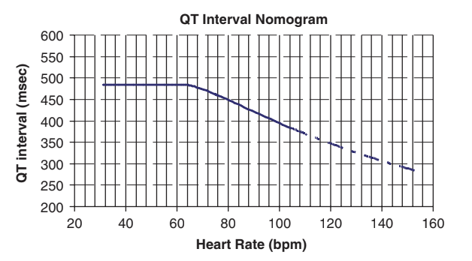

## EVIDENCE APPRAISAL