1. **Download the GitHub code**: <https://github.com/stanfordmlgroup/methane-gapfill-ml/tree/FL?tab=readme-ov-file>

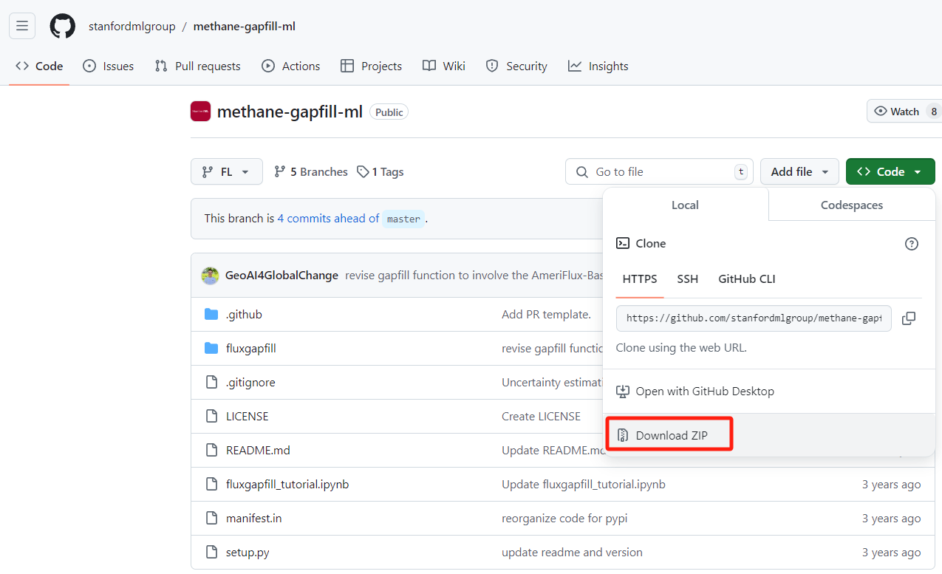

1. **Save and unzip the code into the directory of a project folder** in your PC, for example: “D:\CH4_gap_filling/methane-gapfill-ml-FL”

In the folder of “D:\CH4_gap_filling/methane-gapfill-ml-FL”, the files are organized like:

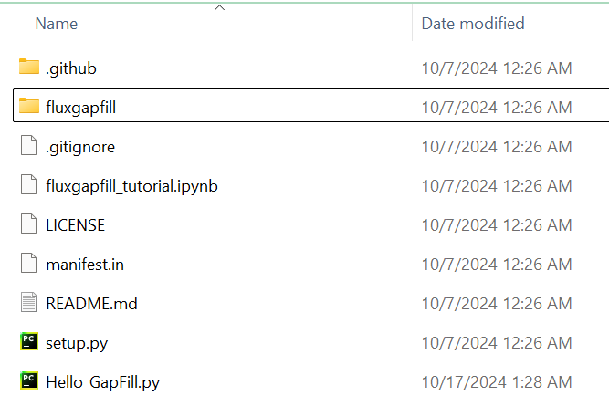

1. **Create or specify a folder for your data to be processed**. For example: “D:\CH4_gap_filling/methane-gapfill-ml-FL/data” as the **data folder**.
2. **Prepare site data**. For example, download site data from AmeriFlux with the variable of CH4 flux (i.e., FCH4): <https://ameriflux.lbl.gov/sites/site-search/>. Here we download the CA-Bou site data as an example:

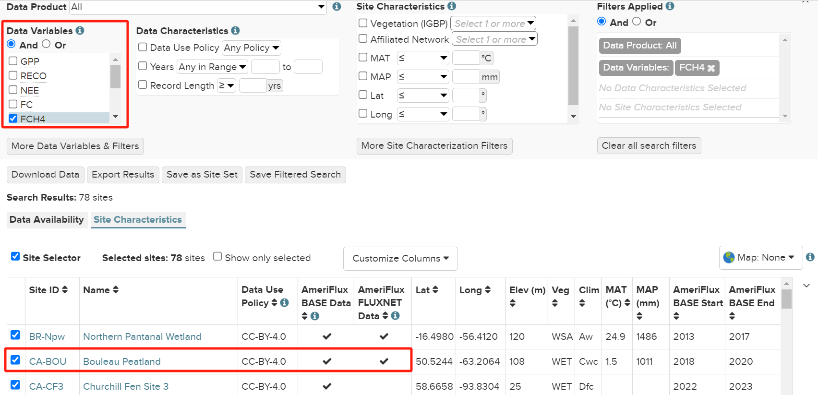

1. **Save the downloaded site data** of CA-Bou into the **data folder**: “D:\CH4_gap_filling/methane-gapfill-ml-FL/data” and organize the site data in a .csv file and name it as "raw.csv".

After doing this, we will have the data organized like “D:\CH4_gap_filling/methane-gapfill-ml-FL/data/CABou/raw.csv”. The “raw.csv” is the raw data for gap-filling shown as below. You can replace this raw.csv with your eddy-covariance data that needs to be gap-filled.

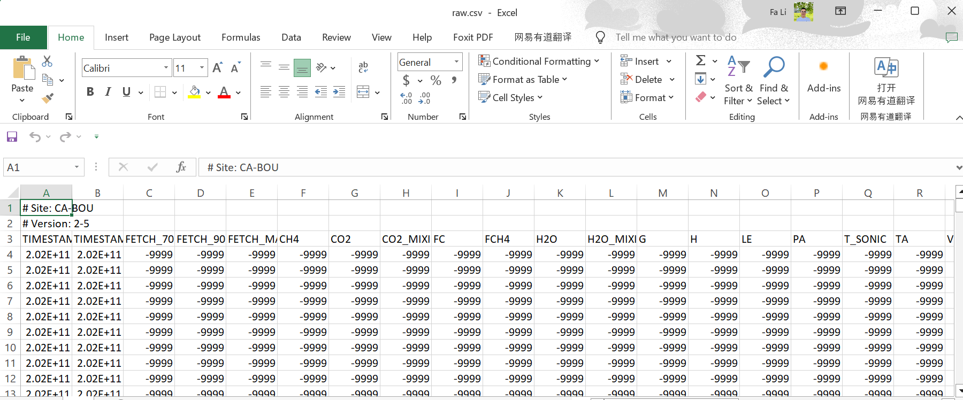

1. **Now, everything is ready and you can run** “D:\CH4_gap_filling/methane-gapfill-ml-FL/Hello_GapFill.py” to gap-fill the missing values for the file “D:\CH4_gap_filling/methane-gapfill-ml-FL/data/CABou/raw.csv”. Please check the detailed comments in the “Hello_GapFill.py” to learn more about the parameter settings for each function for the gap-filling.
2. **Congrats for your successful run** of the gap-filling pipeline.