Microsoft Planner
Regional Readiness
NPI Projects
Procedure & Implementation Guide

Version 1.0 | January 2026 | Draft

Quick Start: Find Your Role
This document serves three audiences. Find your role and start with that section.

- 👤 I am a User (Regional PM, SME, Coordinator)
- Start with: Part III (User Pathway)
- You'll learn: Day-to-day tasks, card management, procedures

- 📊 I am a Project Manager
- Start with: Part II & IV

- 👔 I am a People Leader
- Start with: Part V

PART III: User Pathway - Complete Procedures

III.A: Getting Started with Planner Premium

Access & Setup
- Step 1: Contact your Regional PM or Main PM for access
- Step 2: Accept the email invitation and log in
- Step 3: Visit planner.cloud.microsoft.com to verify access

First Login
- 1. Go to planner.cloud.microsoft.com and log in
- 2. Find your project board (ex: "PLC - RR - Calima - 01 Singapore")
- 3. Board view opens showing cards organized by phase
- 4. Personalize settings (Language, Notifications, Theme)
- 5. Set up Teams integration by adding Planner tab to channel

Supporting Diagrams

NPI Lifecycle Process Flow
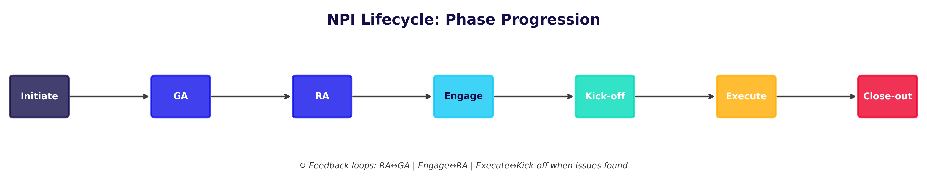

Card Hierarchy
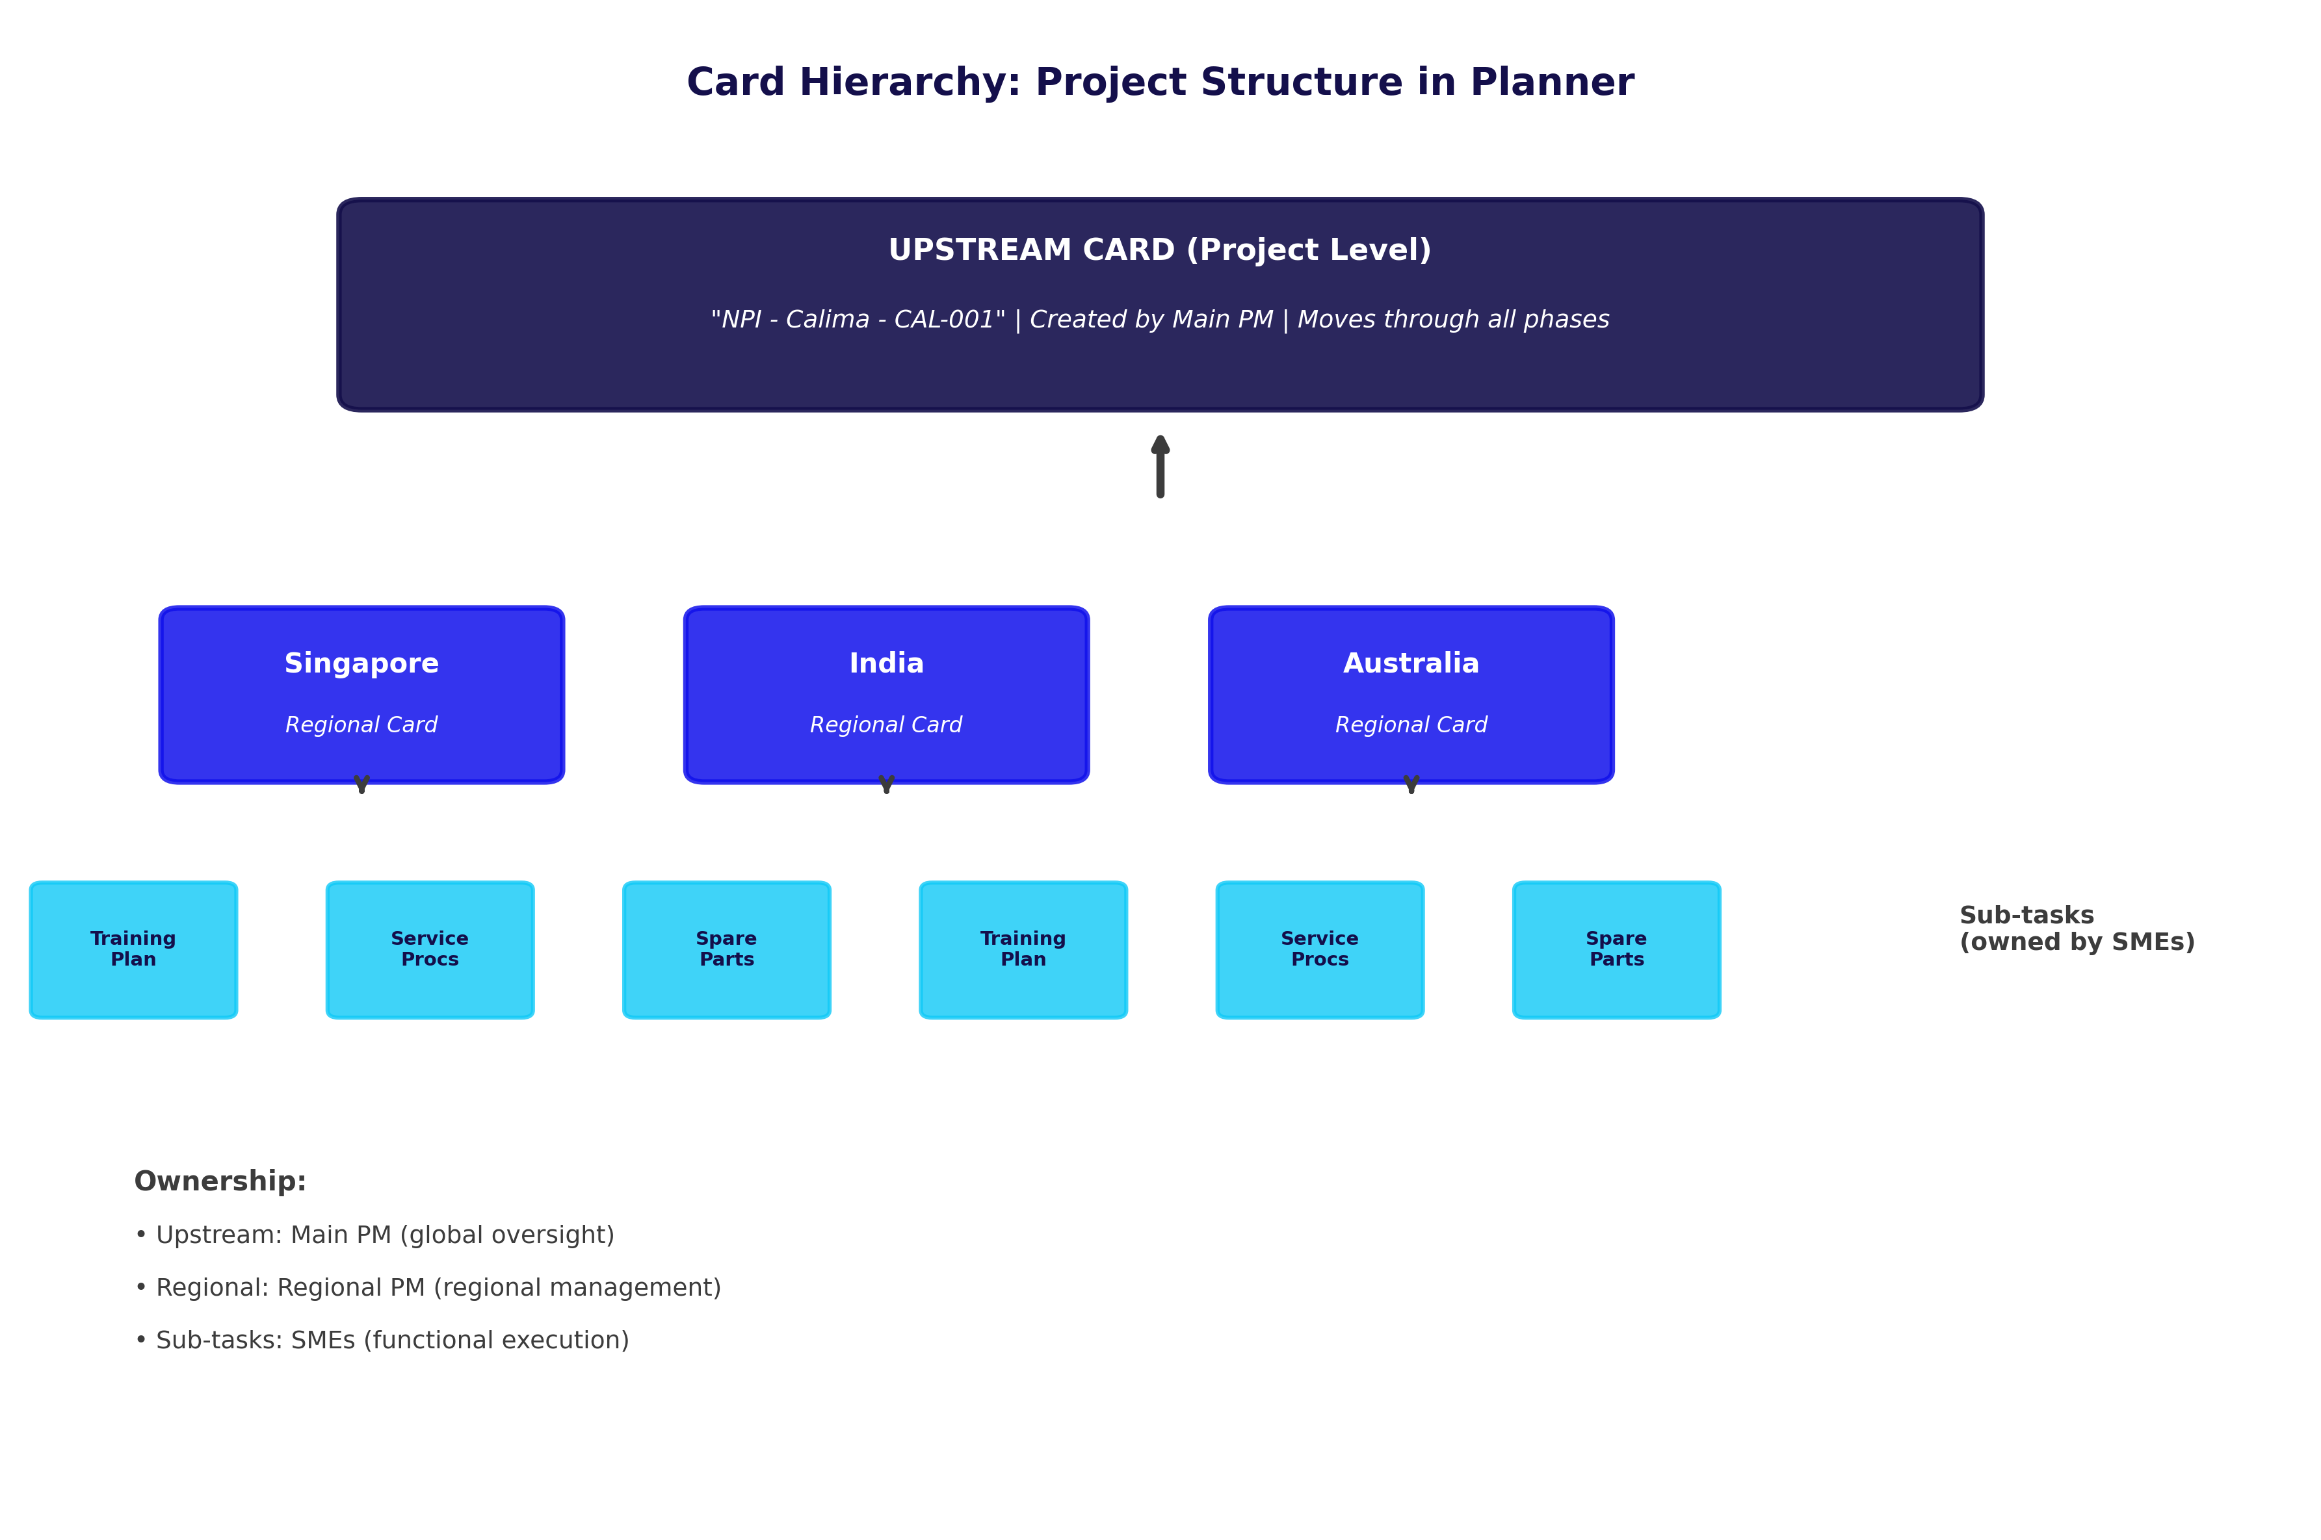

Phase Gate Decision
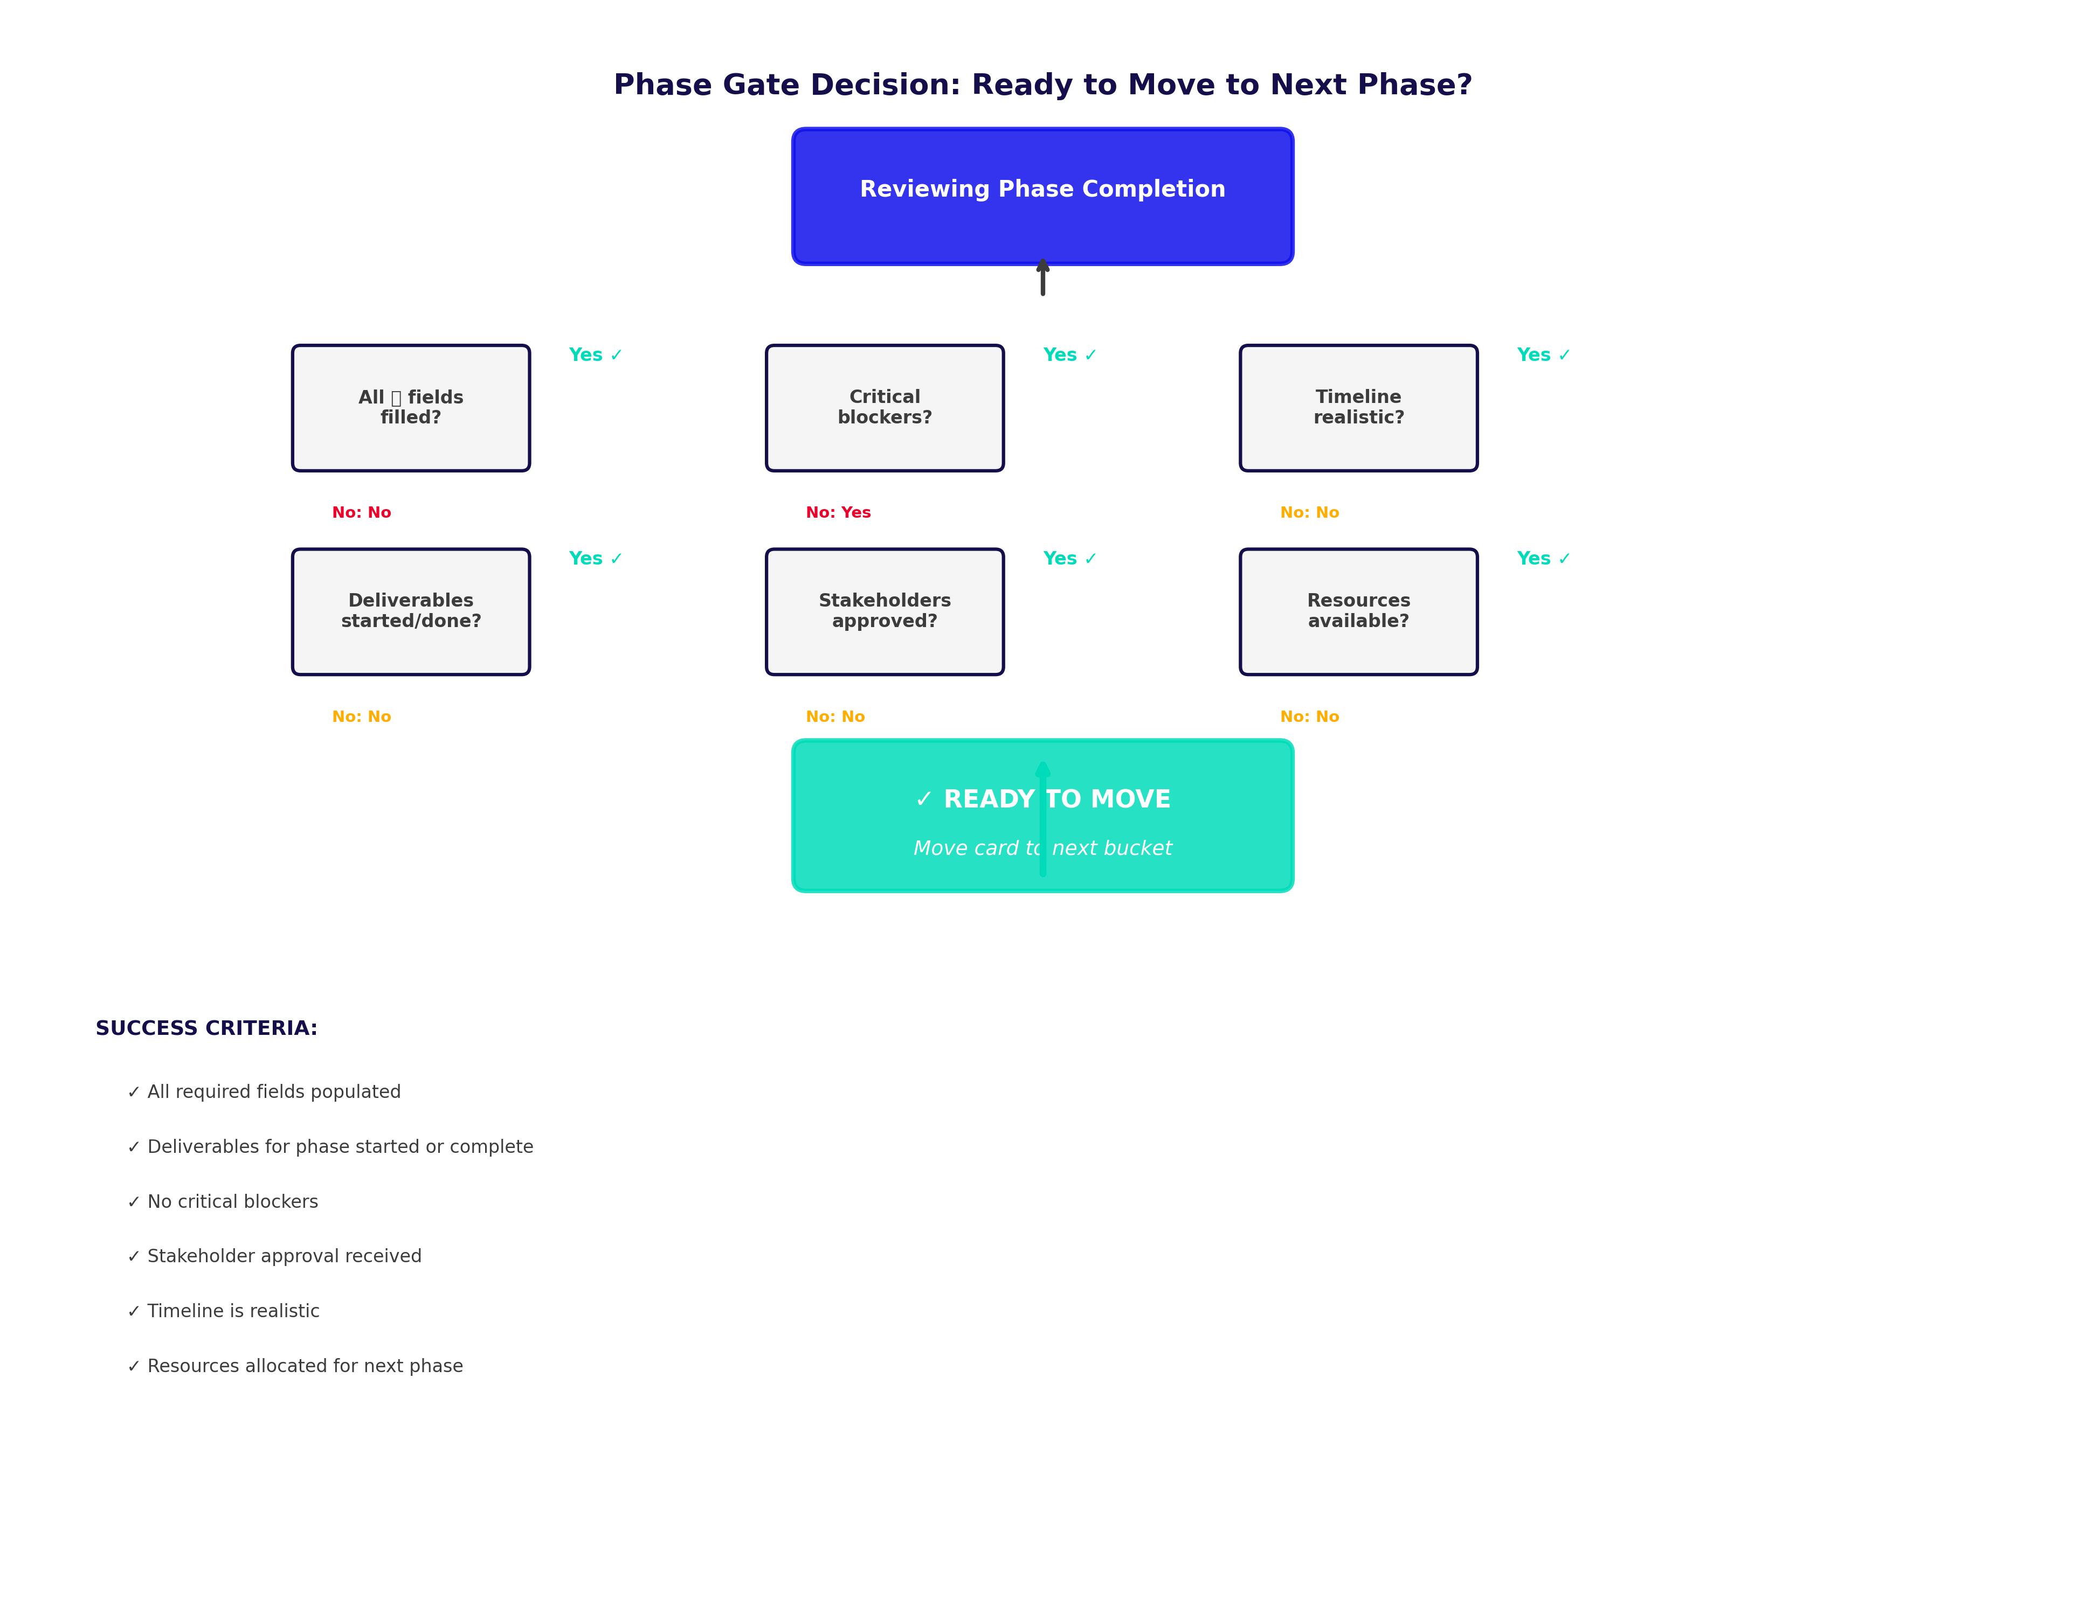

Escalation Decision Tree
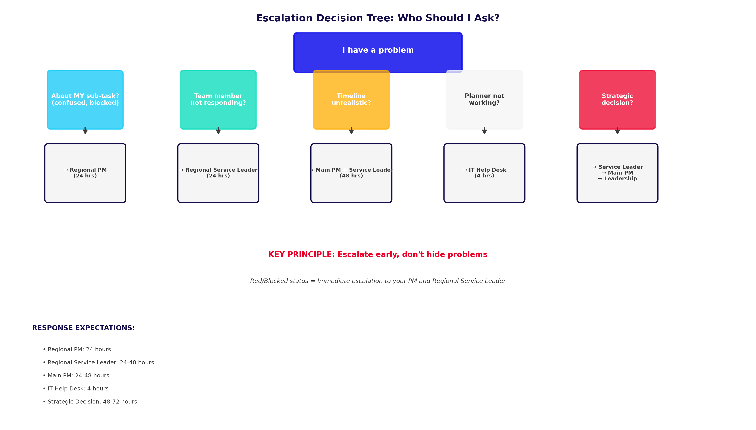

System Integration Architecture
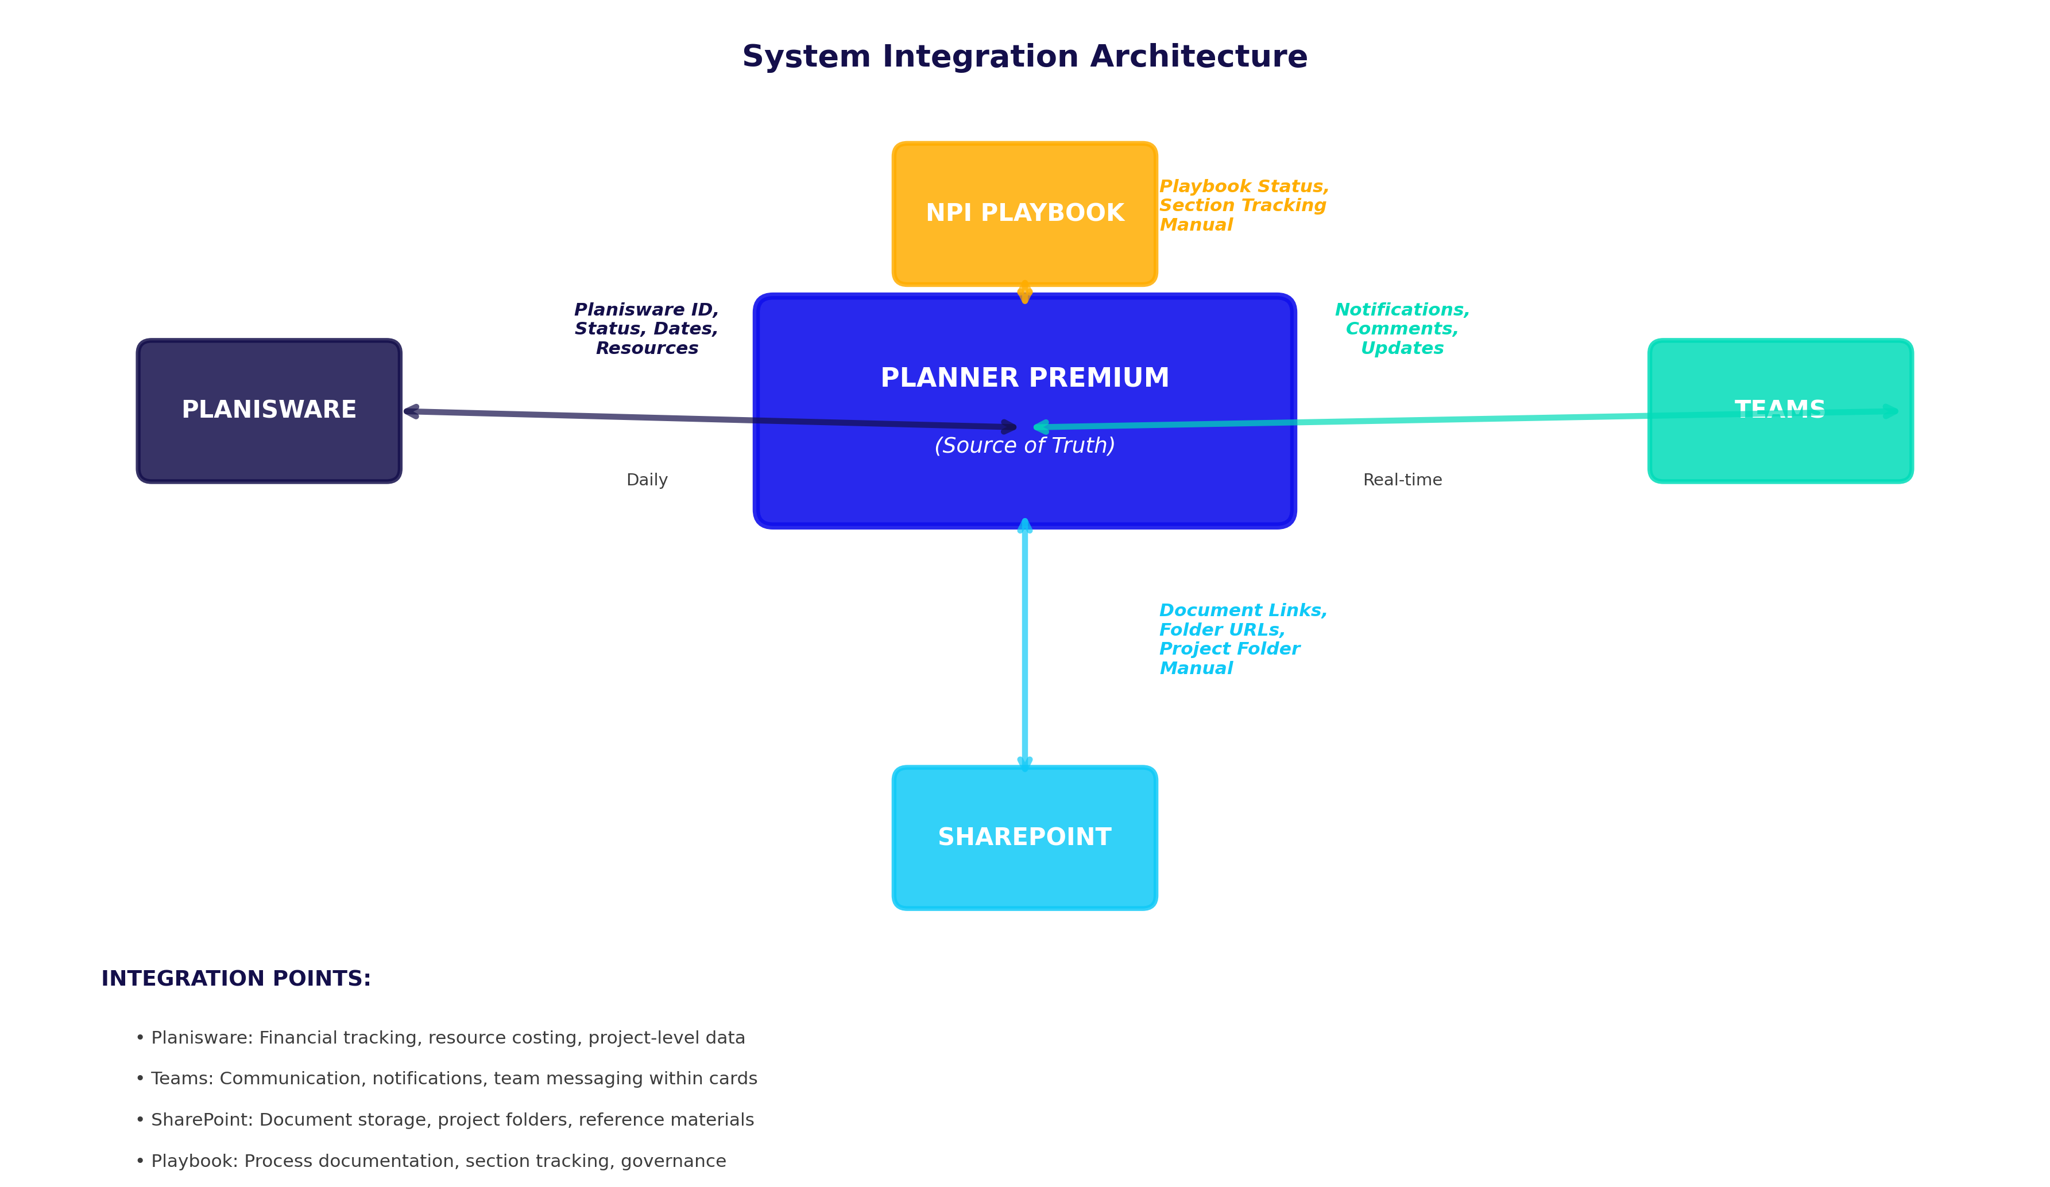

Organizational Roles & Responsibilities
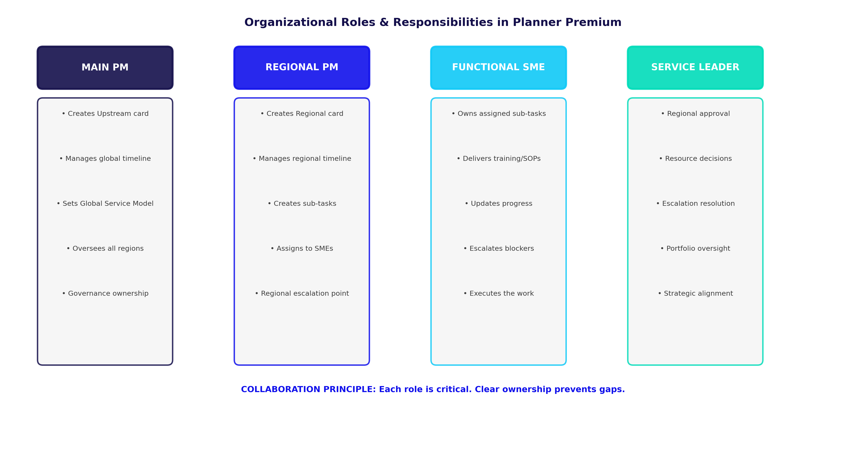

Part IV: Project Manager Pathway
[PM governance, oversight, quality standards, reporting - To be completed]

Part V: People Leader Pathway
[Leader strategic alignment, portfolio health, resource decisions - To be completed]

Part VI: Shared Resources
[Templates, glossary, contact directory, checklists - To be completed]

Part VII: Appendices
[Licensing, change log, shortcuts, feedback - To be completed]

PART IV: Project Manager Pathway - Governance & Oversight

Part IV: Project Manager Pathway

Complete Governance, Oversight & Reporting for Main PMs and Regional PMs
**Purpose:** Framework for managing NPI projects end-to-end, ensuring quality standards, and maintaining governance
**Audience:** Main PMs, Regional PMs (in PM role), Portfolio Leads
---

IV.A: PM Role in Planner Premium

IV.A.1: Your Responsibilities as PM

Main PM Responsibilities
Project Ownership:
- Create and own the Upstream card from Pipeline through Close-out
- Manage global timeline and launch date
- Define Global Service Model and complexity rating
- Coordinate across all regions
- Escalate global issues and make strategic decisions
Governance Oversight:
- Establish quality gates for phase progression
- Conduct governance calls (weekly/bi-weekly)
- Monitor regional progress across portfolio
- Identify and escalate risks early
- Report portfolio health to leadership
Stakeholder Management:
- Align with corporate/OU stakeholders
- Communicate major changes (timeline, scope, complexity)
- Justify resourcing decisions
- Ensure compliance with NPI playbook
---

Regional PM Responsibilities
Regional Project Management:
- Create and own regional cards (one per region)
- Manage regional timeline and launch date
- Define Regional Service Model
- Assign and track regional deliverables (sub-tasks)
- Escalate regional blockers
Regional Governance:
- Monitor sub-task progress (training, service, ops deliverables)
- Conduct mini-governance calls with regional team
- Report regional status to Main PM
- Identify risks 30+ days in advance
Stakeholder Alignment:
- Get Regional Service Leader approval at key gates
- Communicate with regional SMEs
- Manage resource commitments
- Ensure regional readiness confirmation before launch
---

IV.A.2: Governance Framework

Phase-Based Governance
Quality Gates: When Can You Move to Next Phase?
GATE 1: Pipeline → GA
- **Who approves:** Main PM (with OU/leadership input)
- **Checklist:**
- ✓ Project concept clearly defined
- ✓ Business case approved
- ✓ Estimated global launch date confirmed
- ✓ Estimated complexity rated (SM/Med/LRG/XL)
- ✓ Stakeholder sponsorship obtained
- ✓ Planisware ID assigned
- **Deliverable:** Upstream card created with all basic fields
- **Timeline:** GA phase is 8-12 weeks
---
GATE 2: GA → RA
- **Who approves:** Main PM + OU Leadership
- **Checklist:**
- ✓ Global Service Model finalized and approved
- ✓ Playbook Section 1 (Global Details) complete
- ✓ Global stakeholder alignment confirmed
- ✓ Regional list confirmed (which regions participate)
- ✓ No critical global blockers
- ✓ Complexity re-validated (may have increased)
- **Deliverable:** Upstream card updated, Playbook Section 1 signed
- **Sign-off:** Main PM moves Upstream card to RA bucket
- **Timeline:** RA phase is 4-8 weeks
---
GATE 3: RA → Engage
- **Who approves:** Regional PM + Regional Service Leader
- **For each region, verify:**
- ✓ Regional Service Model confirmed
- ✓ Playbook Section 2 (Regional Forecasts) complete
- ✓ Regional complexity rated
- ✓ Regional launch date realistic and approved
- ✓ No critical blockers to proceeding
- ✓ Planisware regional line created
- **Deliverable:** Regional card created with all required fields
- **Sign-off:** Regional PM moves regional card to Engage bucket
- **Timeline:** Engage phase is 4-8 weeks
---
GATE 4: Engage → Kick-off
- **Who approves:** Regional PM + Regional Service Leader
- **Checklist:**
- ✓ All SME names collected and confirmed available
- ✓ Initial team commitments received
- ✓ Training plan draft completed
- ✓ Service procedures draft completed
- ✓ All sub-tasks created and assigned
- ✓ No critical blockers
- ✓ Regional readiness assessment positive
- **Deliverable:** Regional card updated, sub-tasks visible
- **Sign-off:** Regional PM moves regional card to Kick-off bucket
- **Timeline:** Kick-off phase is 2-4 weeks
---
GATE 5: Kick-off → Execute
- **Who approves:** Regional PM + Main PM + Regional Service Leader
- **Checklist:**
- ✓ Playbook Section 3 (Detailed Service Plan) complete
- ✓ Project plan reviewed and approved by all SMEs
- ✓ Timelines reviewed and realistic
- ✓ All sub-task owners confirm readiness
- ✓ Resources allocated and committed
- ✓ Risk mitigation plans in place for any Yellow/Red items
- **Deliverable:** Regional card updated, all sub-tasks have start dates
- **Sign-off:** Regional PM moves regional card to Execute bucket
- **Timeline:** Execute phase is 4-12 months (varies by complexity)
---
GATE 6: Execute → Hypercare
- **Who approves:** Regional PM + Regional Service Leader
- **Checklist:**
- ✓ All deliverables 100% complete
- ✓ Playbook Section 4 (Training & Readiness) complete
- ✓ All regional staff trained and confirmed ready
- ✓ Go-live communications sent
- ✓ Support team briefed and on standby
- ✓ Regional Service Leader confirmation: "Ready to launch"
- **Deliverable:** Regional card moved, hypercare team assigned
- **Sign-off:** Regional PM moves regional card to Hypercare bucket
- **Timeline:** Hypercare phase is 30 days (post-launch support)
---
GATE 7: Hypercare → Close-out
- **Who approves:** Regional PM + Main PM
- **Checklist:**
- ✓ Go-live successful (no critical issues)
- ✓ 30-day monitoring complete
- ✓ All support tickets closed
- ✓ Lessons learned documented
- ✓ Team debriefing completed
- ✓ Resources released (team can move to next project)
- **Deliverable:** Lessons learned document, archived in project folder
- **Sign-off:** Regional PM moves regional card to Close-out bucket
- **Timeline:** Close-out phase is 1-2 weeks
---

IV.A.3: Board Management Best Practices

Creating and Maintaining Boards
Board Naming Convention:
- Format: "PLC - RR - [Project Name] - [Region]"
- Example: "PLC - RR - Calima - 01 Singapore"
- Why: Consistent, sortable, professional, clear ownership
Board Structure:
- **Buckets (Phases):** Pipeline, GA, RA, Engage, Kick-off, Execute, Hypercare, Close-out
- **One Upstream card** per project (in PLC-specific board)
- **Multiple Regional cards** (one per region, same board as Upstream)
- **Sub-tasks** organized under each Regional card
Teams Integration:
- Create project channel: "npi-[project-code]" (ex: "npi-calima")
- Add Planner tab linking to board
- Post announcements in channel when phases progress
- Use channel for team discussions, Planner for project data
SharePoint Folder Structure:
```
Project Folder: [PLC] - [Project Code]
├── 01_Global_Alignment
│ ├── Business Case
│ ├── Service Model Decision
│ └── Playbook Section 1
├── 02_Regional_Alignment
│ ├── Region_Singapore
│ │ ├── Playbook Section 2
│ │ └── Regional Plan
│ ├── Region_India
│ │ └── ...
├── 03_Execution_Artifacts
│ ├── Training Materials
│ ├── Service Procedures
│ └── Go-Live Communication
└── 04_Close-Out
└── Lessons Learned
```
---

Permission Management
Who Gets What Access:
| Role | Access Level | Can Create Cards | Can Move Cards | Can Edit Fields |
|------|--------------|------------------|----------------|-----------------|
| Main PM | Full Admin | Yes | Yes | Yes |
| Regional PM | Full Edit | Yes | Yes (own region) | Yes |
| SME | Limited | No | No | No (only assigned sub-tasks) |
| Regional Service Leader | View | No | No | No |
| Executive | View | No | No | No |
---

IV.A.4: Custom Field Quality Standards

Maintaining Data Integrity
Weekly Field Audit:
Every Friday, scan all cards for:
- ✓ All ⭐ fields populated (none blank)
- ✓ Planisware IDs match expected format
- ✓ Dates are realistic (not duplicated, not in past)
- ✓ Risk Status current (not stale)
- ✓ Complexity ratings reasonable (not changed without explanation)
Common Data Quality Issues:
| Issue | Impact | How to Fix |
|-------|--------|-----------|
| Blank Planisware ID | Can't track to financial system | Get from Finance, update immediately |
| Wrong date format | Causes sorting/filtering errors | Standardize to MM/DD/YYYY |
| "TBD" in required field | Blocks governance approval | Set deadline for when info available |
| Risk Status = Green but card is late | Misleading status | Update to Yellow/Red with explanation |
| Complexity downgraded without note | Appears like you're reducing scope | Document why in comment |
Communicating Changes:
When you find an error in a card:
1. **Document it** in a comment: "Found: [Issue]. Cause: [Why]. Fixed: [Action taken]."
2. **Correct it** immediately
3. **Notify affected people** (Regional PM or SME who will be confused)
---

IV.A.5: Risk Management

Identifying Risk Early
Risk Indicators to Watch:
| Red Flag | What It Means | Action |
|----------|--------------|--------|
| Sub-task not started, due in 2 weeks | Resource issue, timeline at risk | Escalate to Regional PM |
| Card hasn't been updated in 1 month | Stalled, no owner engagement | PM needs to contact owner |
| Risk Status = Yellow for 3+ weeks | Issue not resolving, needs help | Escalate to Regional Service Leader |
| Regional PM missing governance call | Possible critical blocker | Call to check in immediately |
| Playbook section overdue | Governance gate can't be approved | Escalate, document blocker |
| New complexity discovered mid-project | Scope increased, resources insufficient | Re-baseline timeline |
Risk Assessment Framework:
| Risk Level | Definition | Escalation Path | Response Time |
|-----------|-----------|-----------------|----------------|
| **Green** | On track, no issues | None | Monthly review |
| **Yellow** | Minor issue, recoverable | Regional PM → Service Leader | 1-2 weeks to resolve |
| **Red** | Major issue, likely to miss deadline | Regional PM → Service Leader → Main PM | Immediate decision needed |
| **Blocked** | Can't proceed at all | Main PM → Leadership | Same day escalation |
---

Risk Mitigation Strategies
When Risk = Yellow (Minor Issue):
1. Identify the root cause (resource, timeline, dependency)
2. Propose 2-3 mitigation options:
- Extend timeline (by how much?)
- Reduce scope (what gets cut?)
- Add resources (what's the cost/availability?)
3. Present to Regional Service Leader with pros/cons of each
4. Make decision and update plan
5. Monitor closely (weekly check-ins)
When Risk = Red (Major Issue):
1. Stop. Don't try to hide it.
2. Escalate immediately to Main PM + Regional Service Leader
3. Get leadership on a call (same day if possible)
4. Present options and financial/schedule impact clearly
5. Leadership decides direction (proceed, delay, reduce scope, add resources)
6. Update Planner with decision and new plan
---

IV.A.6: Status Reporting & Communication

Weekly Governance Call Structure
**Frequency:** Weekly or bi-weekly (depending on phase)
**Duration:** 30-45 minutes
Agenda:
1. **Portfolio Overview** (5 min)
- How many projects total?
- How many Green/Yellow/Red/Blocked?
- Any escalations since last week?
2. **Project-by-Project Review** (25 min)
- Status of each project (on track, at risk, blocked)
- Key updates from past week
- Decisions needed
- Timeline changes
- Resource issues
3. **Risk Escalations** (10 min)
- Any cards moved to Red/Blocked since last week?
- What's the issue?
- What are we doing about it?
- Who needs to be involved?
4. **Next Steps & Decisions** (5 min)
- What happens between now and next call?
- Who's responsible?
- Any approvals or decisions needed?
---

Executive Summary Template
Use this format for leadership briefings:
```
PORTFOLIO STATUS: [Date]
📊 OVERVIEW
- Total Active Projects: [X]
- Green (On Track): [X]
- Yellow (At Risk): [X]
- Red (Critical): [X]
- Blocked: [X]
🎯 KEY ITEMS NEEDING ATTENTION
1. [Project Name]: [Specific issue/decision needed]
Impact: [What happens if not resolved?]
Recommendation: [What should leadership do?]
2. [Project Name]: [Issue]
Impact: [Impact]
Recommendation: [Recommendation]
📅 UPCOMING MILESTONES (Next 30 Days)
- [Project]: GA completion → RA start (1/25)
- [Project]: Regional Kick-off all regions (2/1)
- [Project]: First regional launch (2/15)
💡 SUCCESS METRICS
- On-time launch rate: [X%] (target: 85%+)
- Field completion compliance: [X%] (target: 100%)
- Governance gate approvals: [X days avg] (target: <5 days)
```
---

IV.B: Timeline & Dependency Management for PMs

IV.B.1: Building Project Schedules

Timeline Fundamentals
Start with Launch Date (Immovable)
1. Global launch date is set by business (marketing, sales, customers)
2. Work backwards from launch date to determine phase timelines
3. Build in buffers (don't assume everything finishes on time)
Phase Duration Estimates:
- Pipeline → GA: 8-12 weeks (depends on complexity)
- GA → RA: 4-8 weeks
- RA → Engage: 4-8 weeks
- Engage → Kick-off: 2-4 weeks
- Kick-off → Execute: 4-12 months (depends on training scope)
- Execute → Hypercare: 30 days (fixed)
- Hypercare → Close-out: 1-2 weeks
Critical Path Analysis:
1. Identify what must happen first (dependencies)
2. Identify what can happen in parallel
3. Find the longest chain of dependent activities (critical path)
4. Focus risk mitigation on critical path items (if one slips, whole project slips)
**Example:**
- Global launch: 6/15/2025
- Work backwards:
- Hypercare needs 30 days: 5/15 - 6/15
- Execute needs 6 months minimum: 11/15/2024 - 5/15/2025
- Kick-off needs 3 weeks before Execute: 11/1/2024
- And so on...
---

Buffer Planning
The 20% Buffer Rule:
- If a phase normally takes 8 weeks, plan for 10 weeks (20% buffer)
- If 6 months, plan for 7-7.5 months
- Buffer absorbs unexpected delays without catastrophic timeline slips
Where to Apply Buffer:
- ✓ Between major phases (4-8 week phases get 1 week buffer)
- ✓ Before critical dates (launch gets 2-week buffer minimum)
- ✓ For new regions (first time is slower, build in extra time)
- ✗ NOT in project plan (don't tell team they have extra time; keeps them accountable)
Why Buffer Matters:
- One region delayed? You have buffer to catch up.
- One SME gets sick? Team can adjust.
- One deliverable takes longer? You still hit launch.
---

IV.B.2: Managing Dependencies Across Regional Cards

Sequencing Regions
Sequential (One After Another):
- First region launches, you get feedback, apply to next region
- Pros: Learn and improve, less resource contention
- Cons: Takes longer, market may need coordinated launch
- Use when: New product, high training requirements
Parallel (All at Once):
- All regions launch on same date
- Pros: Single launch event, faster to market, less customer confusion
- Cons: More resources, less learning time, higher risk
- Use when: Market demands coordinated launch, mature service model
Mixed (Staggered):
- Early adopter regions first (1-2 weeks), then main regions
- Pros: Balance between learning and speed
- Cons: More complex to coordinate
- Use when: You need some learning but also need speed
---

Dependency Chains
Example Dependency Chain:
```
Upstream (GA complete)
↓ (FS dependency)
Regional Card SG (RA starts)
↓ (internal: Training → Training Delivery)
Regional Card SG (Training delivery before Execute)
↓ (FS dependency)
Regional Card SG (Execute can start)
↓ (FS dependency: SG must complete before India)
Regional Card India (RA can start, learning from SG)
```
Managing Chains:
- Create explicit dependencies in Planner
- Review Timeline view regularly (watch for red dependency lines)
- Flag predecessor delays immediately (dependent cards now at risk)
- Never proceed with dependent card if predecessor is at risk
---

IV.B.3: Schedule Risk Management

Red Lines in Timeline = Broken Dependencies
When Timeline View Shows Red Line:
1. **Find the predecessor card** (card on left side of red line)
2. **Check its status:**
- Is it delayed? How many days?
- Is it still at risk? Or just slightly behind?
3. **Impact assessment:**
- If predecessor is 1 week late, is dependent card still OK? (maybe, if has buffer)
- If predecessor is 3 weeks late, dependent card is now at critical risk
4. **Mitigation:**
- Can dependent card start anyway (in parallel)?
- Should we adjust timeline for dependent card?
- Do we need to escalate?
---

Schedule Recovery
If You're Behind Schedule:
1. **Assess the gap:**
- How many days behind? (2 days vs. 2 weeks = very different)
- Which phase? (early phases have less impact than execution)
- Critical path? (on critical path = urgent; off critical path = manageable)
2. **Consider options:**
- **Compress phase:** Start next phase before this one ends (overlapping)
- Pros: Recover some time
- Cons: Increases risk (not fully ready for next phase)
- **Add resources:** More people, more equipment
- Pros: May catch up
- Cons: Cost, ramp-up time, management overhead
- **Reduce scope:** Cut non-critical deliverables
- Pros: Achievable, lowers risk
- Cons: May reduce quality, disappoint stakeholders
- **Extend timeline:** Push launch date back
- Pros: Everything gets more time, lower risk
- Cons: Business/market impact, cost
3. **Make the call:**
- Decide which option with leadership
- Document the decision in Planner
- Communicate clearly (no surprises)
---

IV.C: Reporting & Portfolio Visibility

IV.C.1: Standard Reports

Portfolio Health Dashboard
Weekly One-Pager for Leadership:
```
NPI PROJECT PORTFOLIO - [Week of 1/20/2025]
SUMMARY
- ✓ 12 Active Projects
3 Green (On Track)
7 Yellow (Minor Risk)
1 Red (Major Risk)
1 Blocked (Can't Proceed)
PROJECT STATUS
[Table with columns: Project | Phase | Launch Date | Status | Next Gate | Action Items]
ESCALATIONS & DECISIONS NEEDED
1. Project Calima (Red): Training SME vacancy → Need contract trainer approval by 1/22
2. Project Delta (Blocked): Waiting on Marketing approval of service model → Escalate if no response by 1/25
METRICS
- On-time launch rate (last quarter): 88% (target 85%) ✓
- Field completion compliance: 92% (target 100%) 🔶
- Avg time to gate approval: 4 days (target 5 days) ✓
- Resource utilization: 78% (sustainable level)
FORECAST (Next 30 Days)
- 3 projects moving from RA → Engage (1/25)
- 2 projects entering critical execution phase (2/1)
- 1 project going live (2/15)
```
---

Detailed Project Report (Monthly)
For each project:
```
PROJECT: [Name] | CODE: [Code] | LEAD PM: [Name]
EXECUTIVE SUMMARY
Status: [Green/Yellow/Red/Blocked]
Current Phase: [Which phase]
Launch Date: [Confirm or note if changed]
Key Issue: [If Yellow/Red, what's the problem?]
Decision Needed: [What does leadership need to decide?]
TIMELINE
- Estimated completion of current phase: [Date]
- Next phase start: [Date]
- Launch readiness date: [Date]
- Launch date: [Date] (on track / at risk / delayed)
REGIONAL STATUS (if applicable)
| Region | Phase | Launch | Status | Risk |
| Singapore | Execute | 6/8 | Green | Green |
| India | RA | 6/15 | Yellow | Training SME issue |
| Australia | RA | 6/22 | Green | Green |
DELIVERABLES
- Playbook Section 1: Complete (1/10) ✓
- Playbook Section 2: 75% Complete (due 1/30)
- Training Materials: In Progress (due 2/15)
- Service Procedures: Not Started (due 2/28)
RESOURCE UTILIZATION
- Main PM: [X hours/week]
- Regional PMs: [X hours/week each]
- Total Team: [X FTE equivalent]
RISKS & ISSUES
| Risk | Impact | Mitigation | Status |
| Training SME delay | Timeline 2 weeks | Hire contractor | In Progress |
| New regional requirement | Scope increase | Evaluate by 1/25 | Pending |
FINANCIAL
- Estimated cost to completion: $[Amount]
- Budget remaining: $[Amount]
- Cost variance: +/- $[Amount] (% over/under)
DECISIONS / APPROVALS NEEDED
[ ] Regional Service Leader approval of service model (needed by 1/22)
[ ] Executive decision on budget increase (needed by 1/25)
[ ] Scope change approval (waiting on requirements)
NEXT STEPS
- 1/22: Regional Service Leader meeting to confirm model
- 1/25: Governance call to review progress
- 1/30: Phase gate review before RA → Engage
```
---

IV.C.2: Using the Project Manager Agent

AI-Powered Insights (Planner Premium Feature)
The Project Manager Agent can:
- Generate automated status reports from card data
- Identify at-risk projects based on patterns (overdue cards, stalled progress)
- Suggest next actions based on project stage
- Summarize weeks of progress in one comment
- Highlight missing information (blank fields, overdue deliverables)
How to Use It:
1. **Ask for status update:**
- "Summarize progress on Project Calima this week"
- Agent pulls all updates and creates summary
2. **Ask for risk analysis:**
- "Which projects are most at risk?"
- Agent analyzes: Red cards, overdue items, stalled progress
3. **Ask for next steps:**
- "What should happen on Project Delta next?"
- Agent suggests: Next gate requirements, missing info, upcoming deadlines
Limitations:
- Agent uses data in Planner only (doesn't know external factors)
- Still requires human judgment for decisions (agent recommends, you decide)
- Only as good as the data entered (garbage in = garbage out)
---

IV.D: PM Checklist & Tools

Quick Reference: Weekly PM Routine
```
EVERY MONDAY
☐ Review all projects in portfolio
☐ Update Risk Status if changed from last week
☐ Note any new Yellow/Red cards
☐ Identify projects needing escalation
EVERY WEDNESDAY
☐ Prepare governance call agenda
☐ Draft status summaries for each project
☐ Flag upcoming decisions that need approval
☐ Prepare escalation briefing (if any Red/Blocked)
EVERY FRIDAY (Before Governance Call)
☐ Update "Next Activity Date" on all cards
☐ Verify all ⭐ custom fields populated
☐ Confirm no project is in an "unknown" state
☐ Verify all recent comments are read (catch surprises)
☐ Print or review portfolio one-pager
☐ Confirm governance call participants
MONTHLY (1st Friday)
☐ Generate detailed project reports
☐ Review Playbook completion status
☐ Assess resource utilization
☐ Identify trends (patterns in delays, issues)
☐ Plan next month's priorities
```
---

Phase Gate Approval Checklist
Before Approving Phase Progression:
```
PIPELINE → GA
☐ Business case approved
☐ Estimated complexity rated
☐ Planisware ID created
☐ OU/Leadership sponsorship confirmed
☐ No critical blockers
→ Approve: Move Upstream to GA
GA → RA
☐ Global Service Model finalized
☐ Playbook Section 1 complete
☐ Regions confirmed
☐ Stakeholder alignment confirmed
☐ No global blockers
→ Approve: Move Upstream to RA
RA → ENGAGE (Per Region)
☐ Regional Service Model confirmed
☐ Playbook Section 2 complete
☐ Regional complexity rated
☐ Regional launch date approved
☐ No critical blockers
☐ Regional Service Leader sign-off obtained
→ Approve: Move Regional card to Engage
ENGAGE → KICK-OFF (Per Region)
☐ All SME names collected
☐ SME commitments confirmed
☐ Training/Service plans drafted
☐ All sub-tasks created & assigned
☐ No critical blockers
☐ Regional readiness positive
→ Approve: Move Regional card to Kick-off
KICK-OFF → EXECUTE (Per Region)
☐ Playbook Section 3 complete
☐ Project plan reviewed by all SMEs
☐ Timelines realistic (team confirmed)
☐ All resources allocated & committed
☐ Risk mitigation plans in place for Yellow/Red items
☐ Regional Service Leader final approval
→ Approve: Move Regional card to Execute
EXECUTE → HYPERCARE (Per Region)
☐ All deliverables 100% complete
☐ Playbook Section 4 complete
☐ All staff trained & confirmed ready
☐ Go-live communications sent
☐ Support team briefed
☐ Regional Service Leader: "Ready to launch"
→ Approve: Move Regional card to Hypercare
HYPERCARE → CLOSE-OUT (Per Region)
☐ Launch successful (no critical issues)
☐ 30-day monitoring complete
☐ All support tickets closed
☐ Lessons learned documented
☐ Team debriefing complete
☐ Resources released
→ Approve: Move Regional card to Close-out & Archive
```
---

PM Decision Tree: Should I Escalate This?
```
Problem identified. Should I escalate?
Is this a resource issue (can't get people)?
├─ YES → Escalate to Regional Service Leader (they approve resources)
└─ NO ↓
Is this a timeline issue (will we miss launch)?
├─ YES → Escalate to Regional Service Leader + Main PM (they adjust timeline/scope)
└─ NO ↓
Is this a scope/service model issue?
├─ YES → Escalate to Regional Service Leader (they approve changes)
└─ NO ↓
Is this a multi-region dependency issue (one region impacts another)?
├─ YES → Escalate to Main PM (they coordinate across regions)
└─ NO ↓
Is this a financial/budget issue?
├─ YES → Escalate to Finance + Regional Service Leader
└─ NO ↓
Can I solve this with my team (within my authority)?
├─ YES → Solve it, document in Planner, report progress
└─ NO → Escalate to your manager (PM or Service Leader)
```
---
End of Project Manager Pathway (IV.A - IV.D)
This completes the comprehensive PM governance framework with all phase gates, reporting requirements, and decision-making protocols.

PART V: People Leader Pathway - Strategic Alignment & Portfolio Health
This section covers:
- • Strategic alignment of NPI portfolio with organizational goals
- • Portfolio health assessment and resource allocation
- • Decision-making frameworks for project prioritization
- • Leadership reporting and communication templates
- • Coaching and development for Project Managers
[Detailed content to be added]

PART VI: Shared Resources - Templates, Tools & References
This section includes:
- • Phase Gate Approval Templates (downloadable checklists)
- • Governance Call Agendas and Meeting Templates
- • Status Report Templates and Portfolio Dashboard examples
- • Risk Management and Escalation Decision Trees
- • Glossary of NPI-specific terms and acronyms
- • Contact Directory (Main PM, Regional PMs, Service Leaders)
- • Frequently Asked Questions (FAQs) by role
[Detailed templates and resources to be added]

PART VII: Appendices - Additional References
This section includes:
- • Licensing and Access Information for Planner Premium
- • Change Log and Version History
- • Keyboard Shortcuts and Tips for Power Users
- • Troubleshooting Guide: Common Issues and Solutions
- • Feedback and Improvement Suggestions
[Detailed appendices to be added]

